Hydraulics & Irrigation engg.

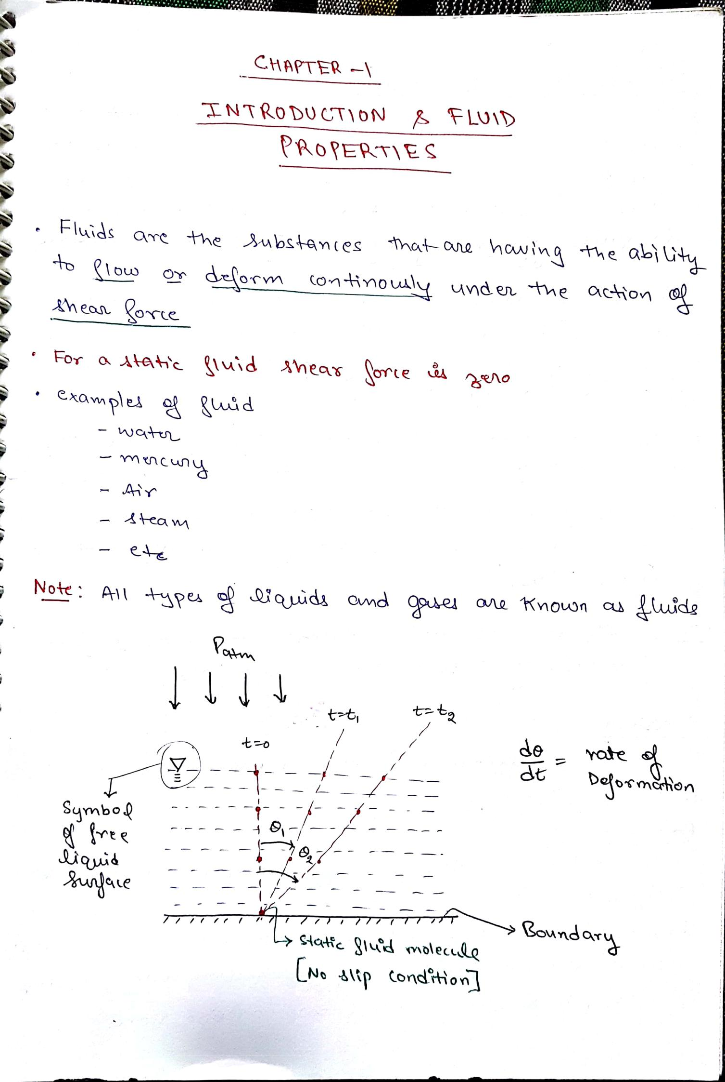
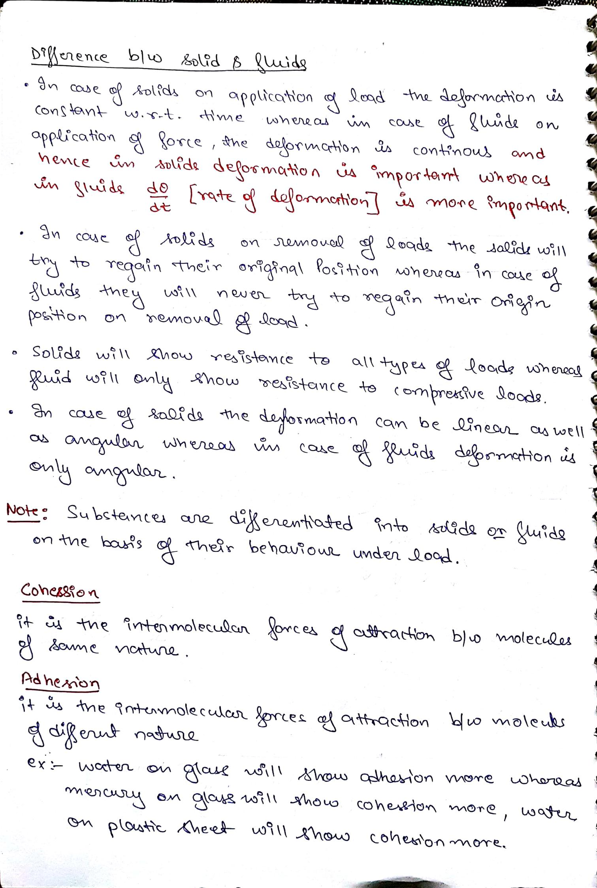
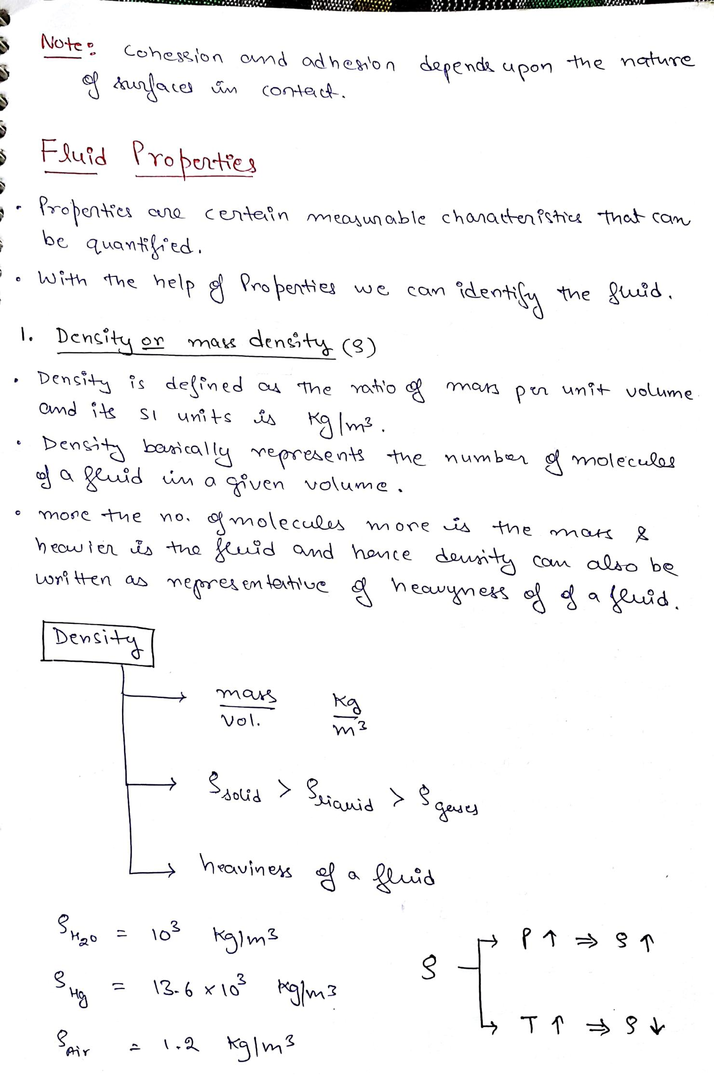
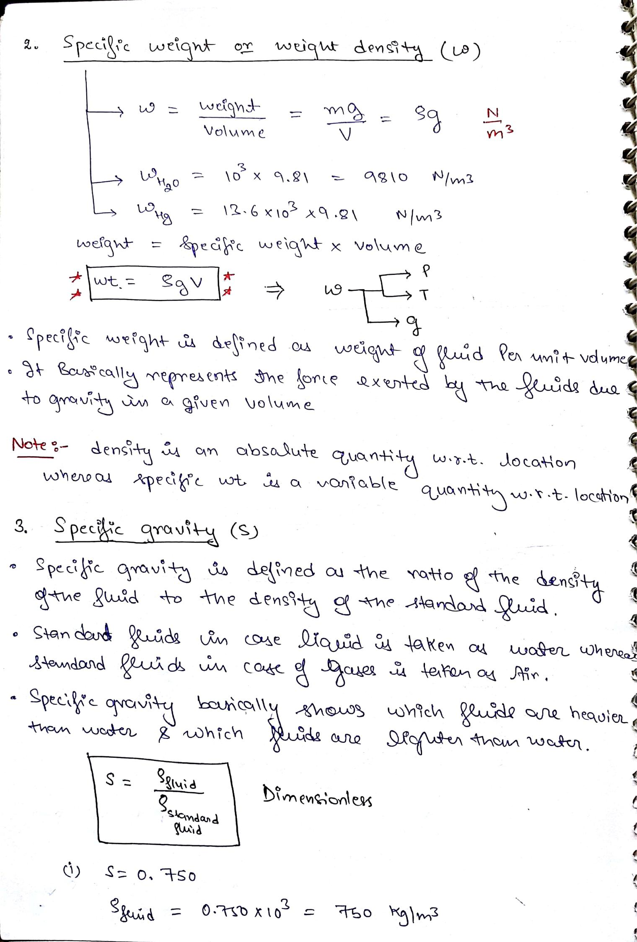
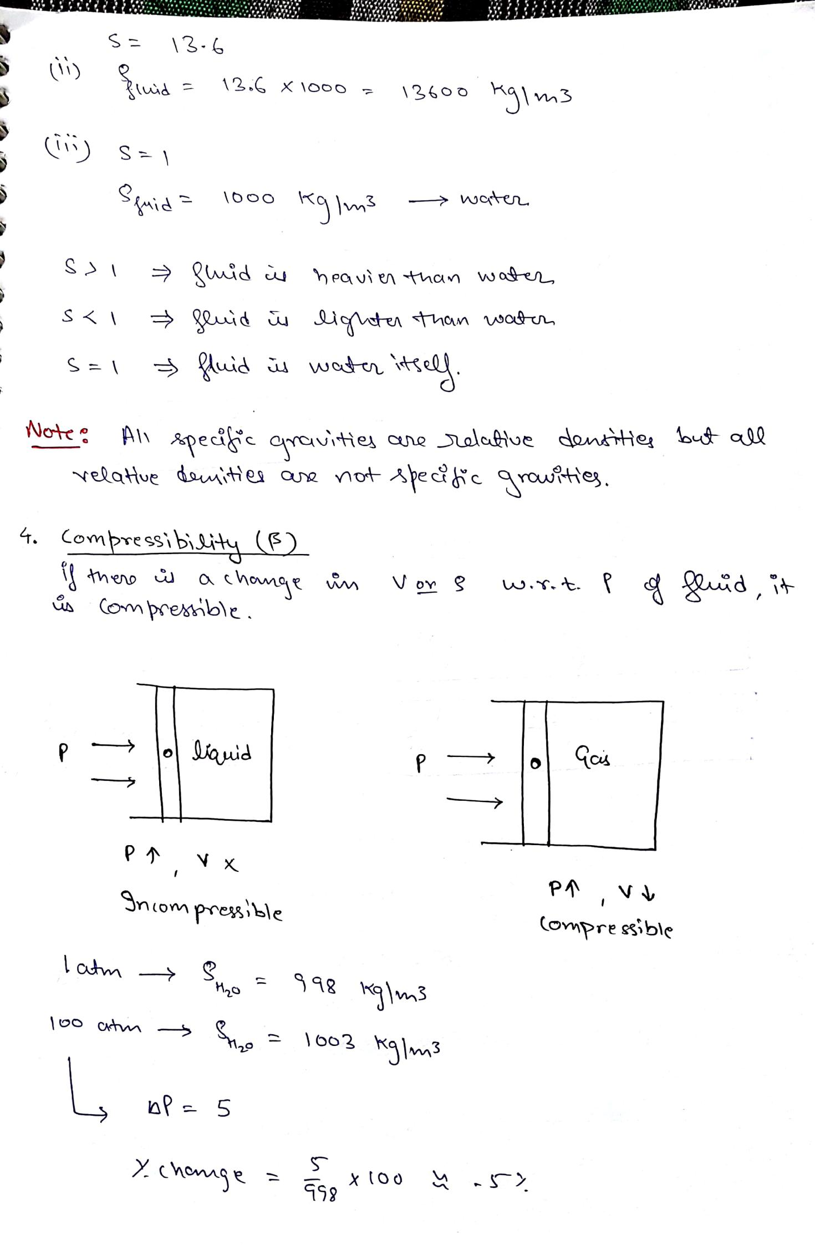
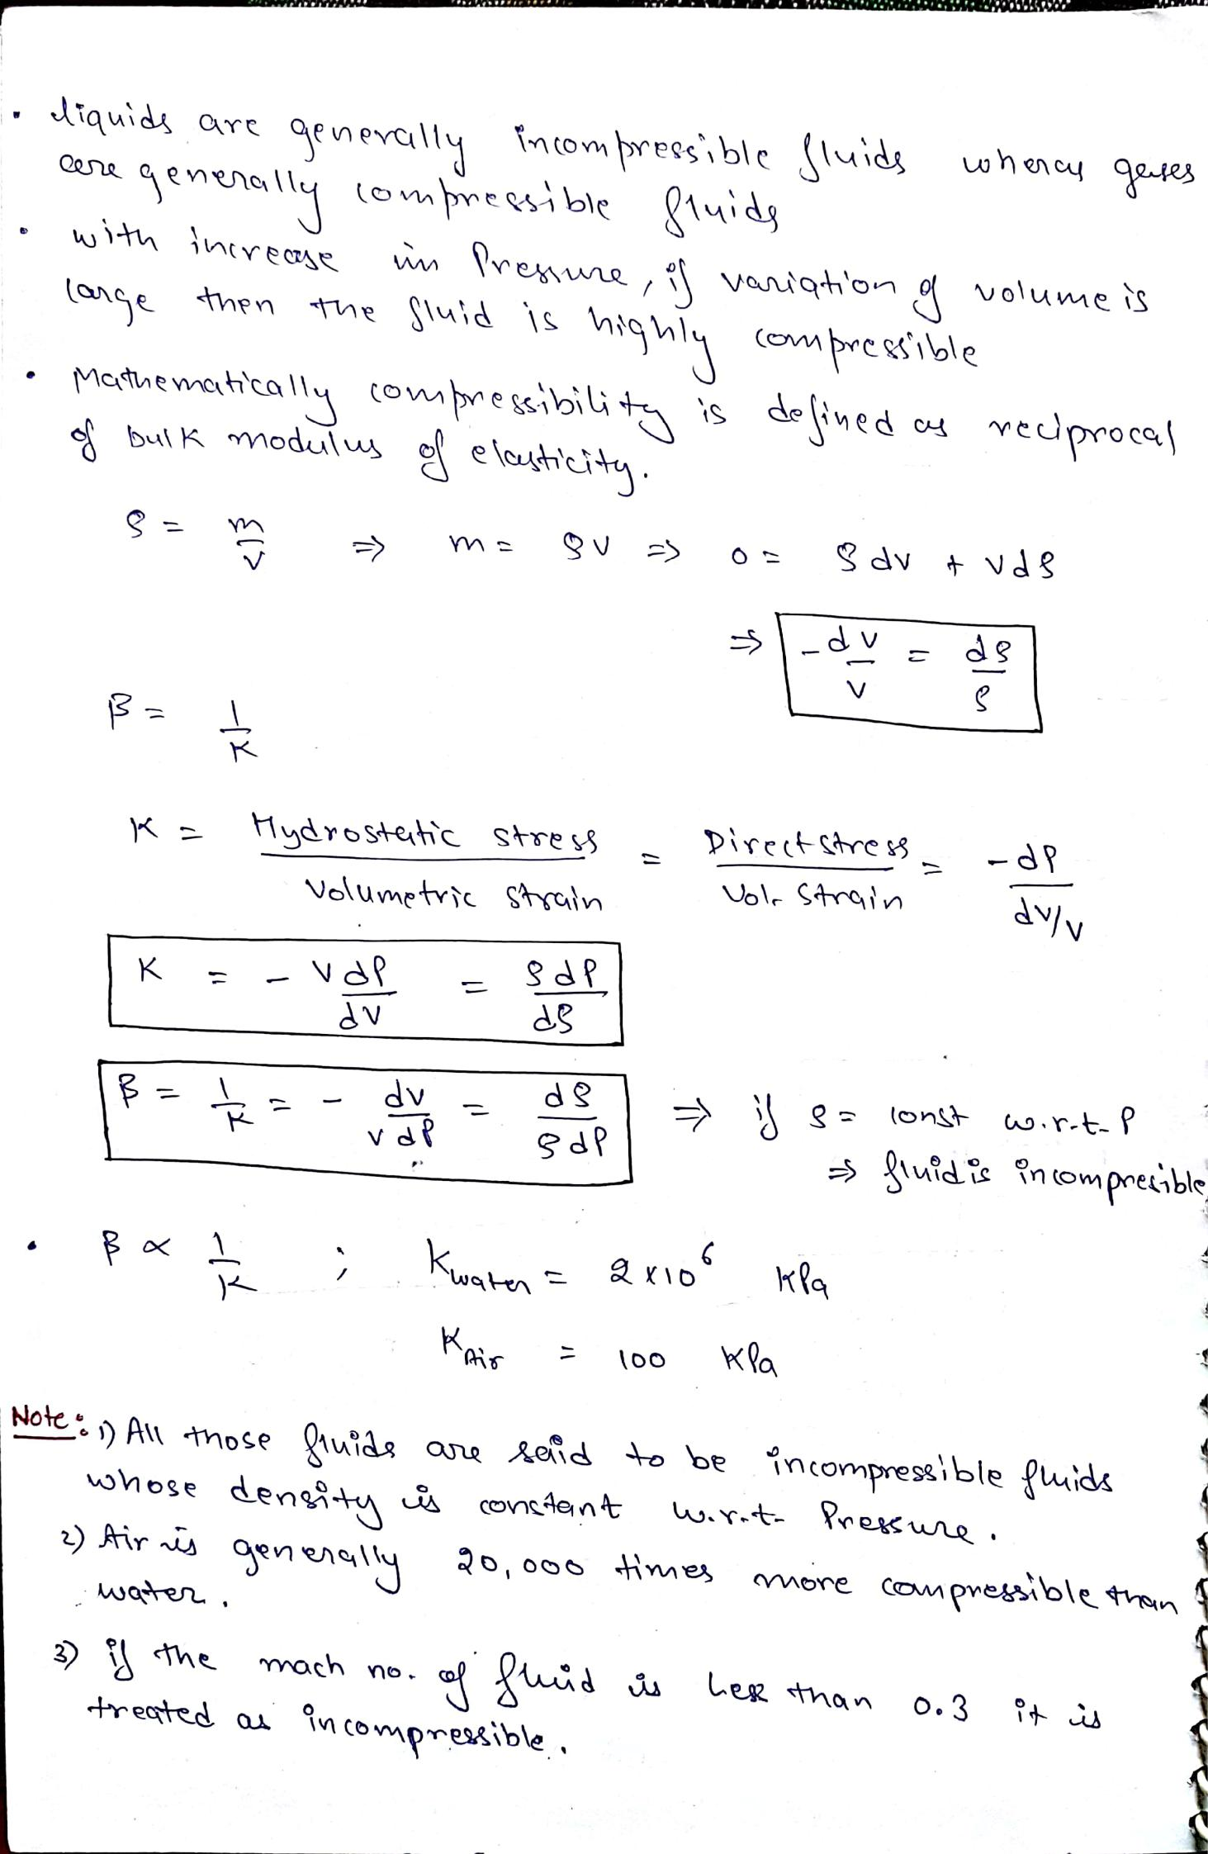
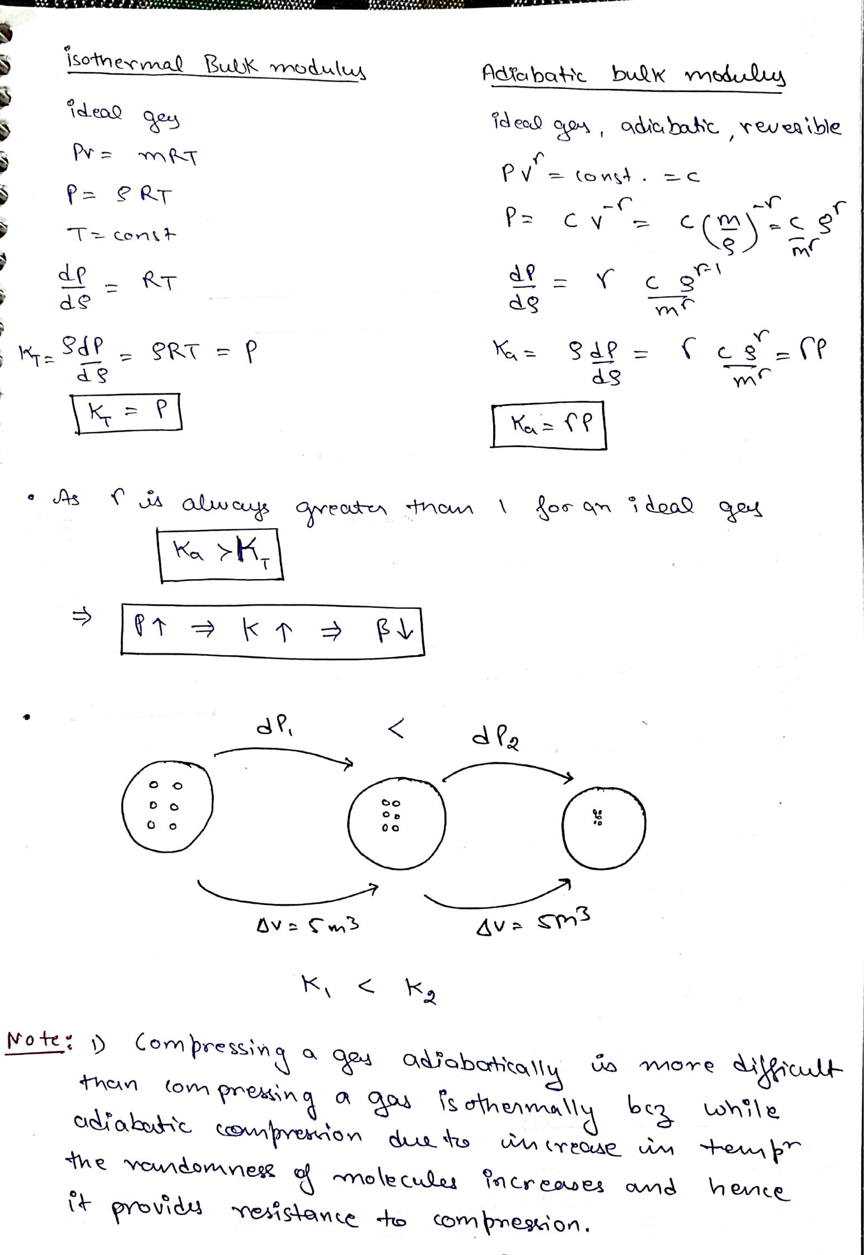
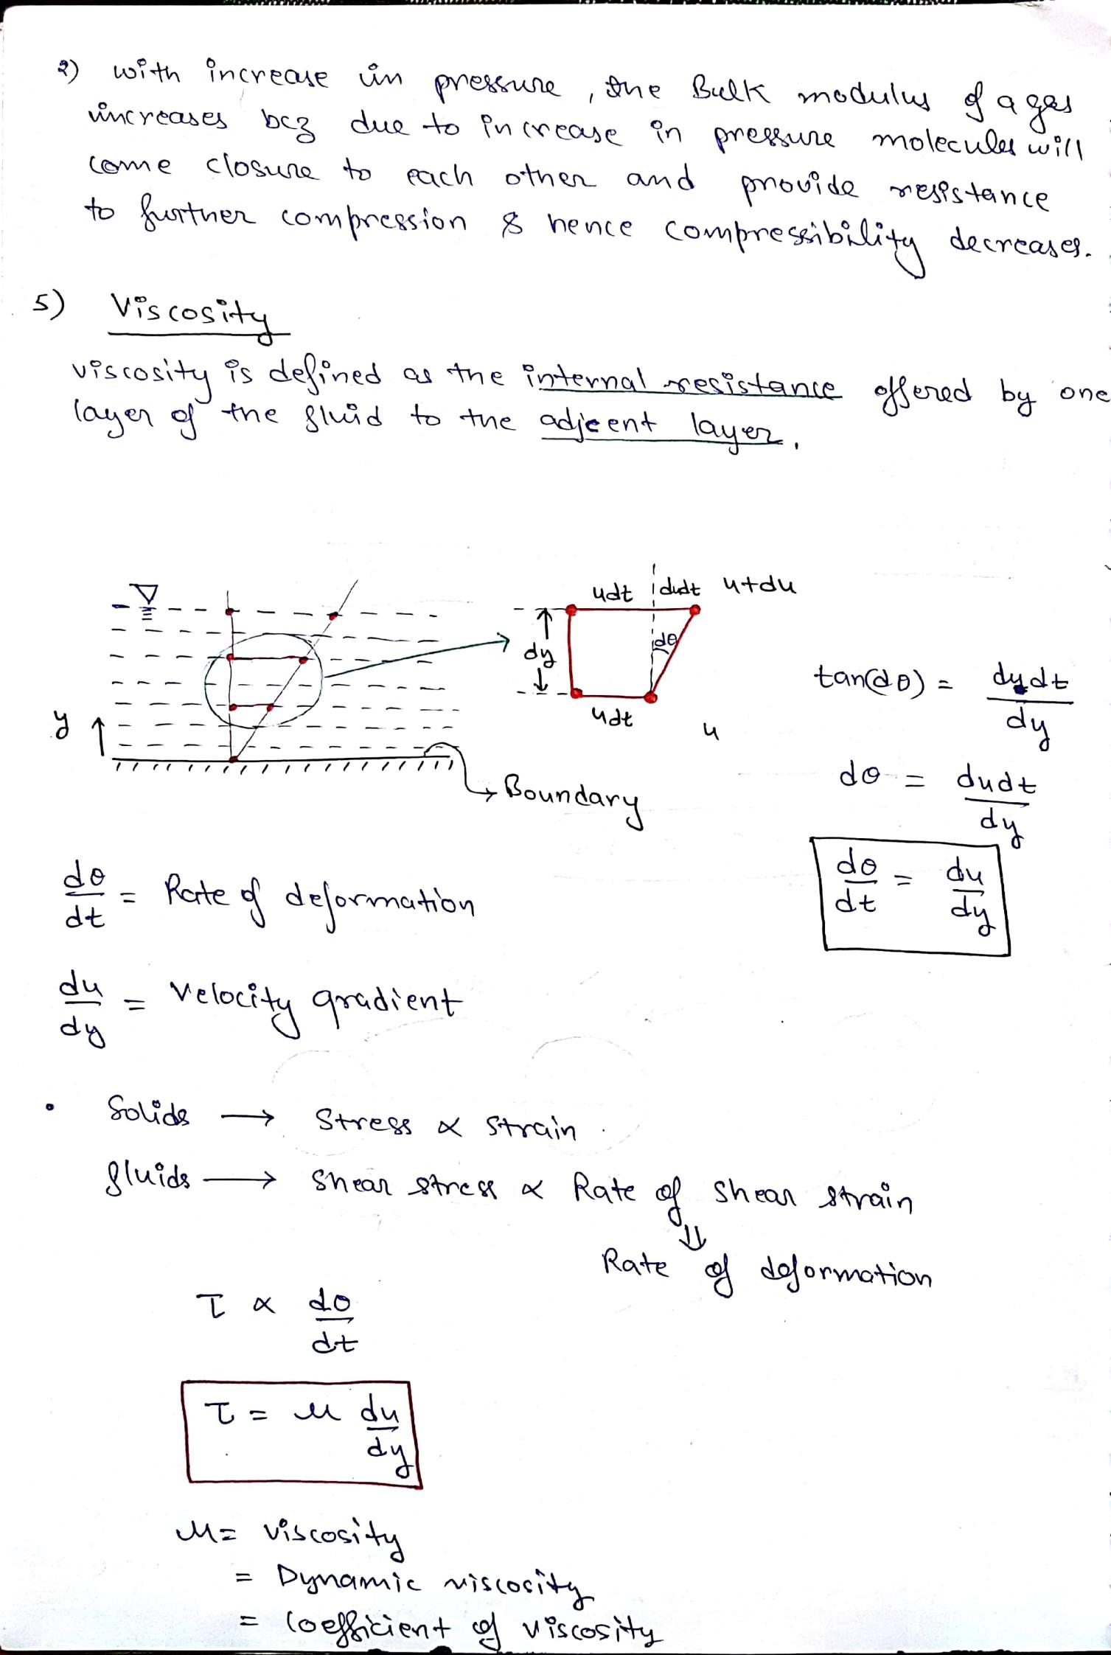
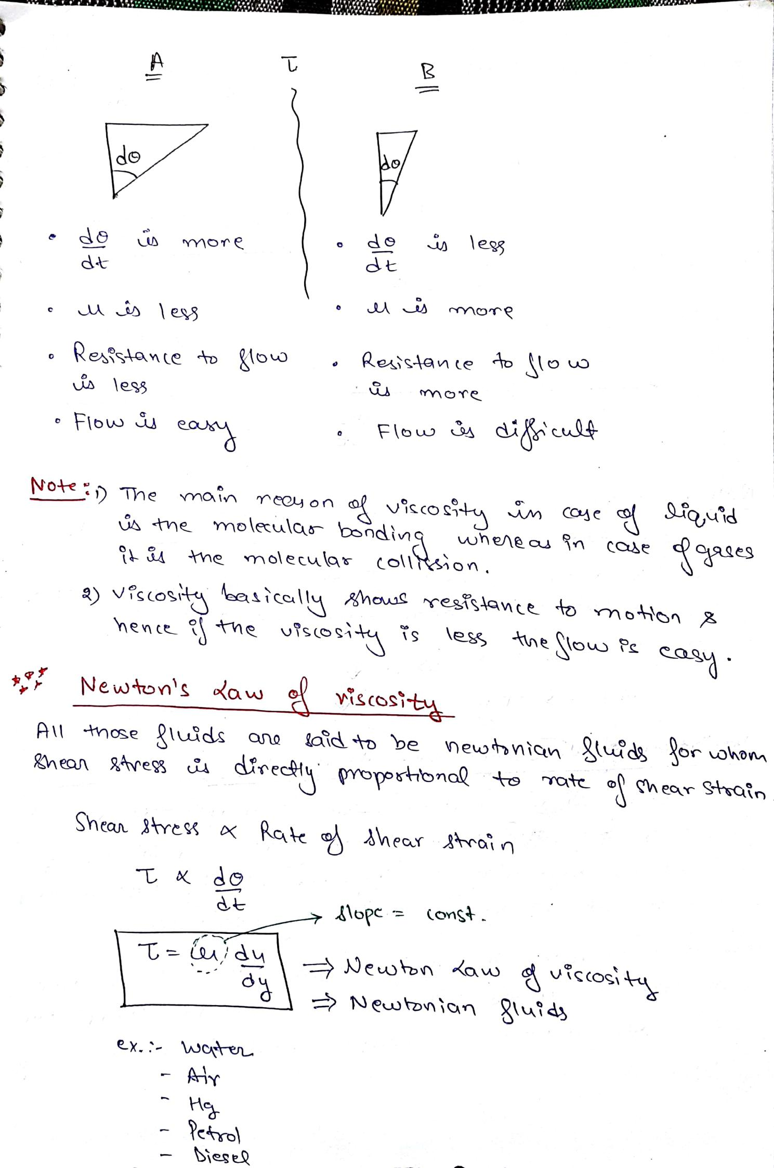
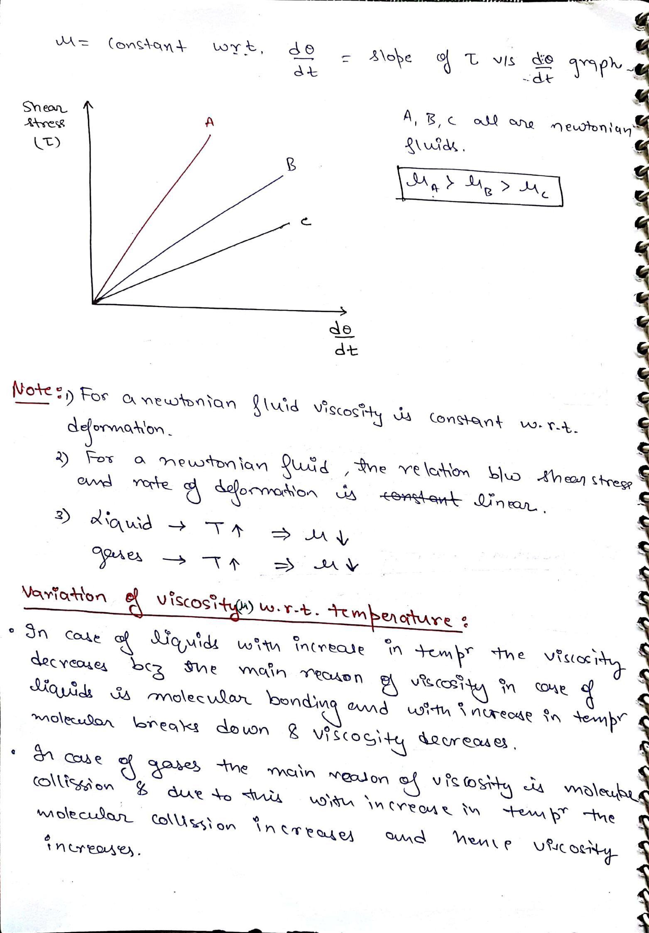
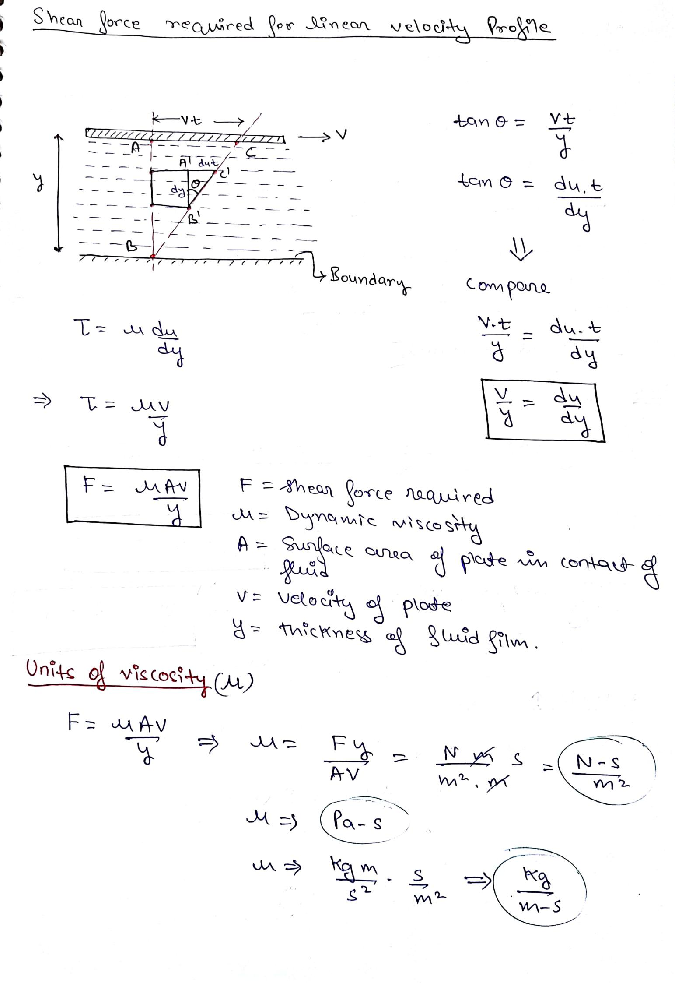
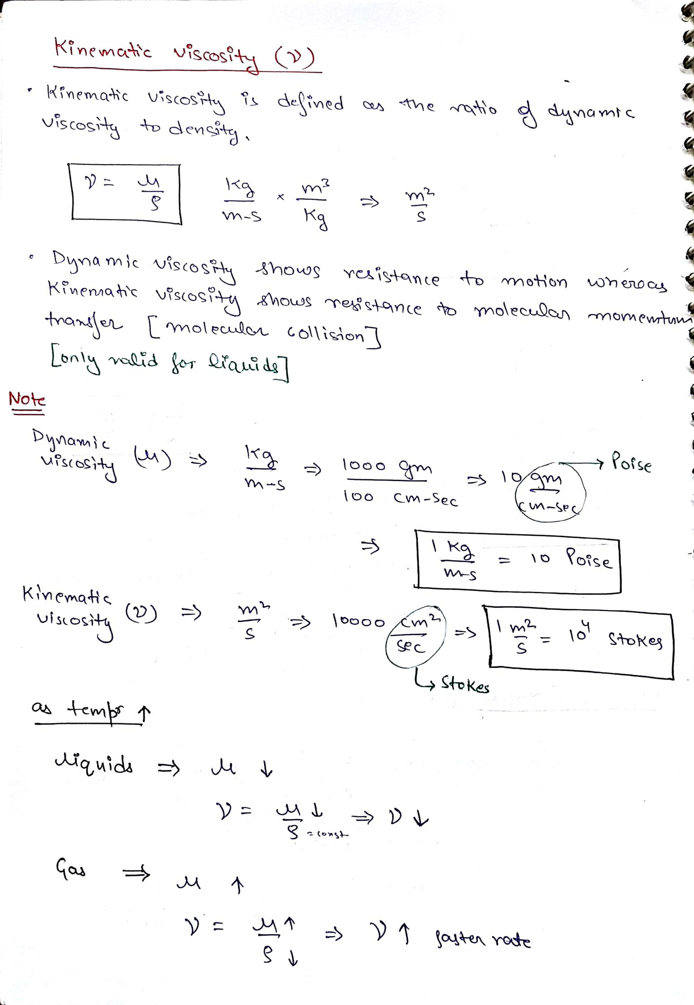
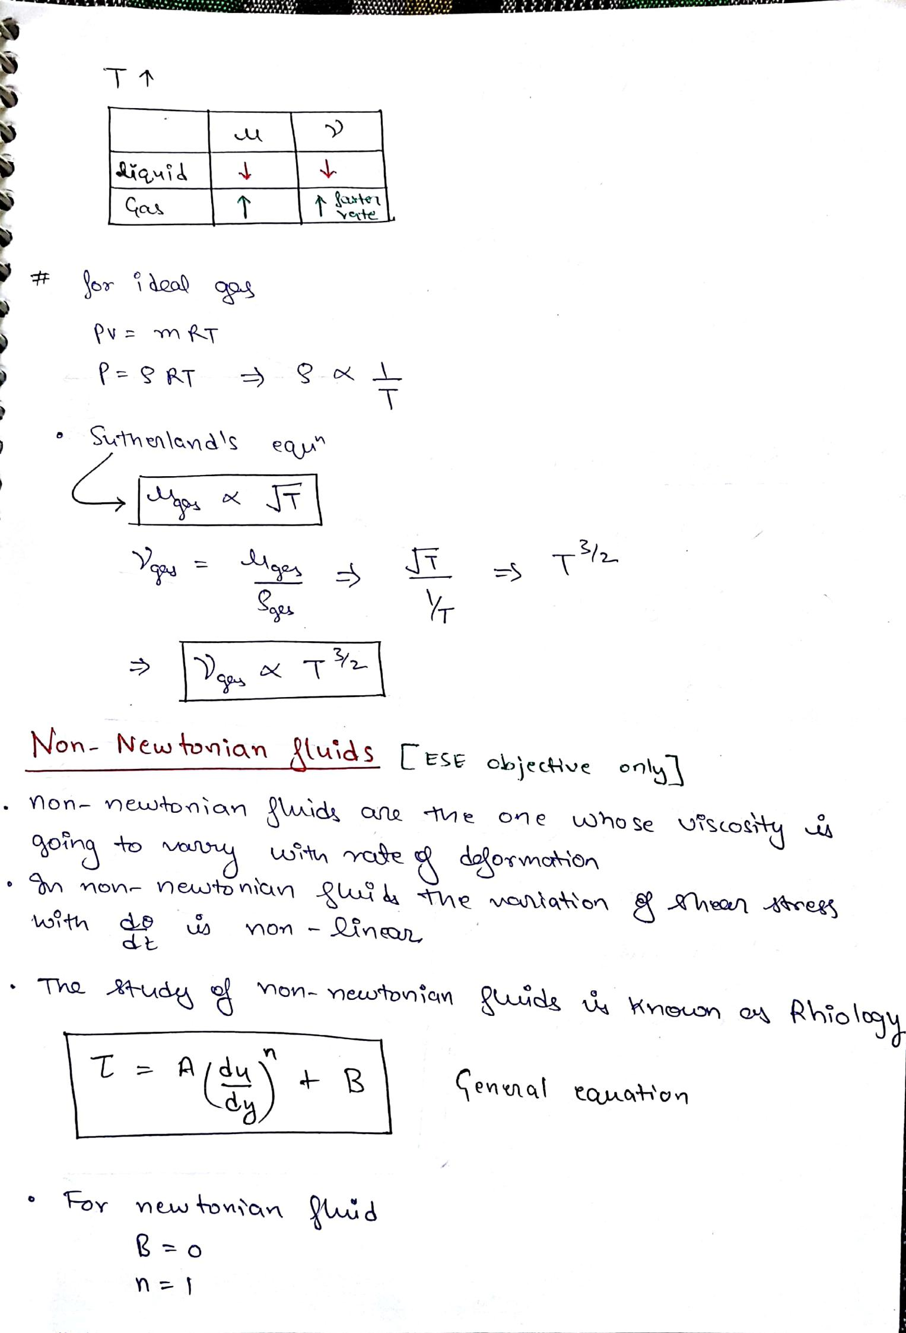
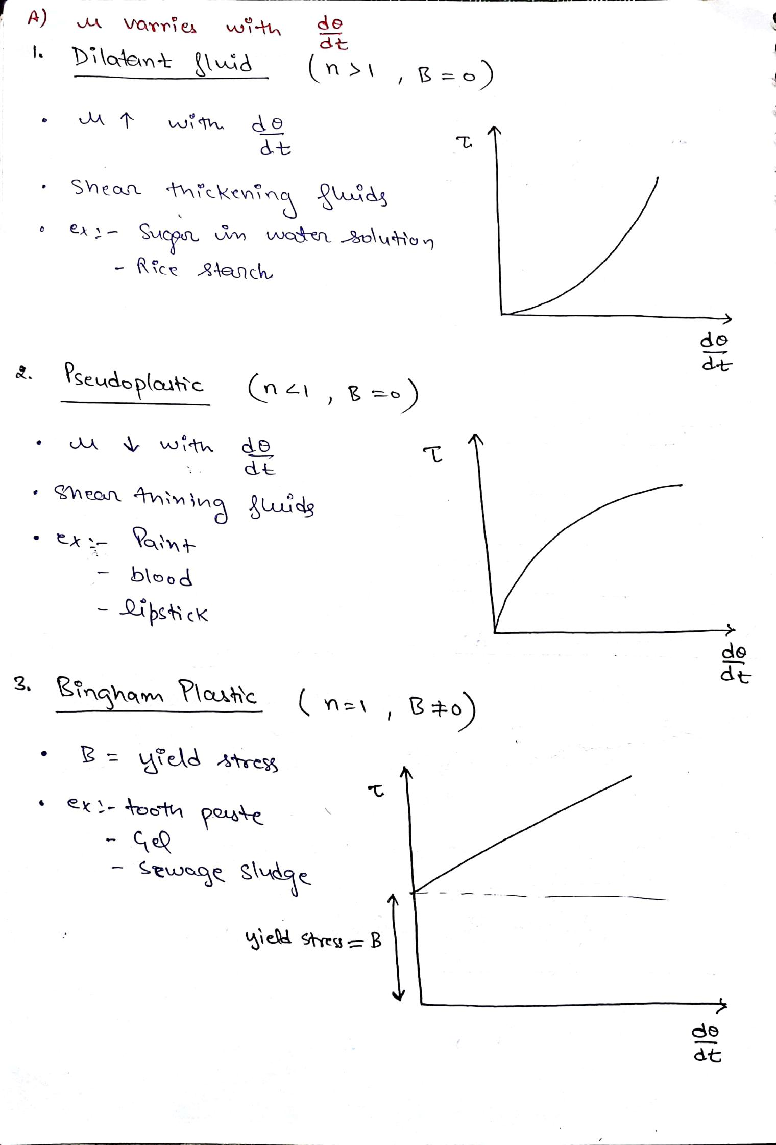
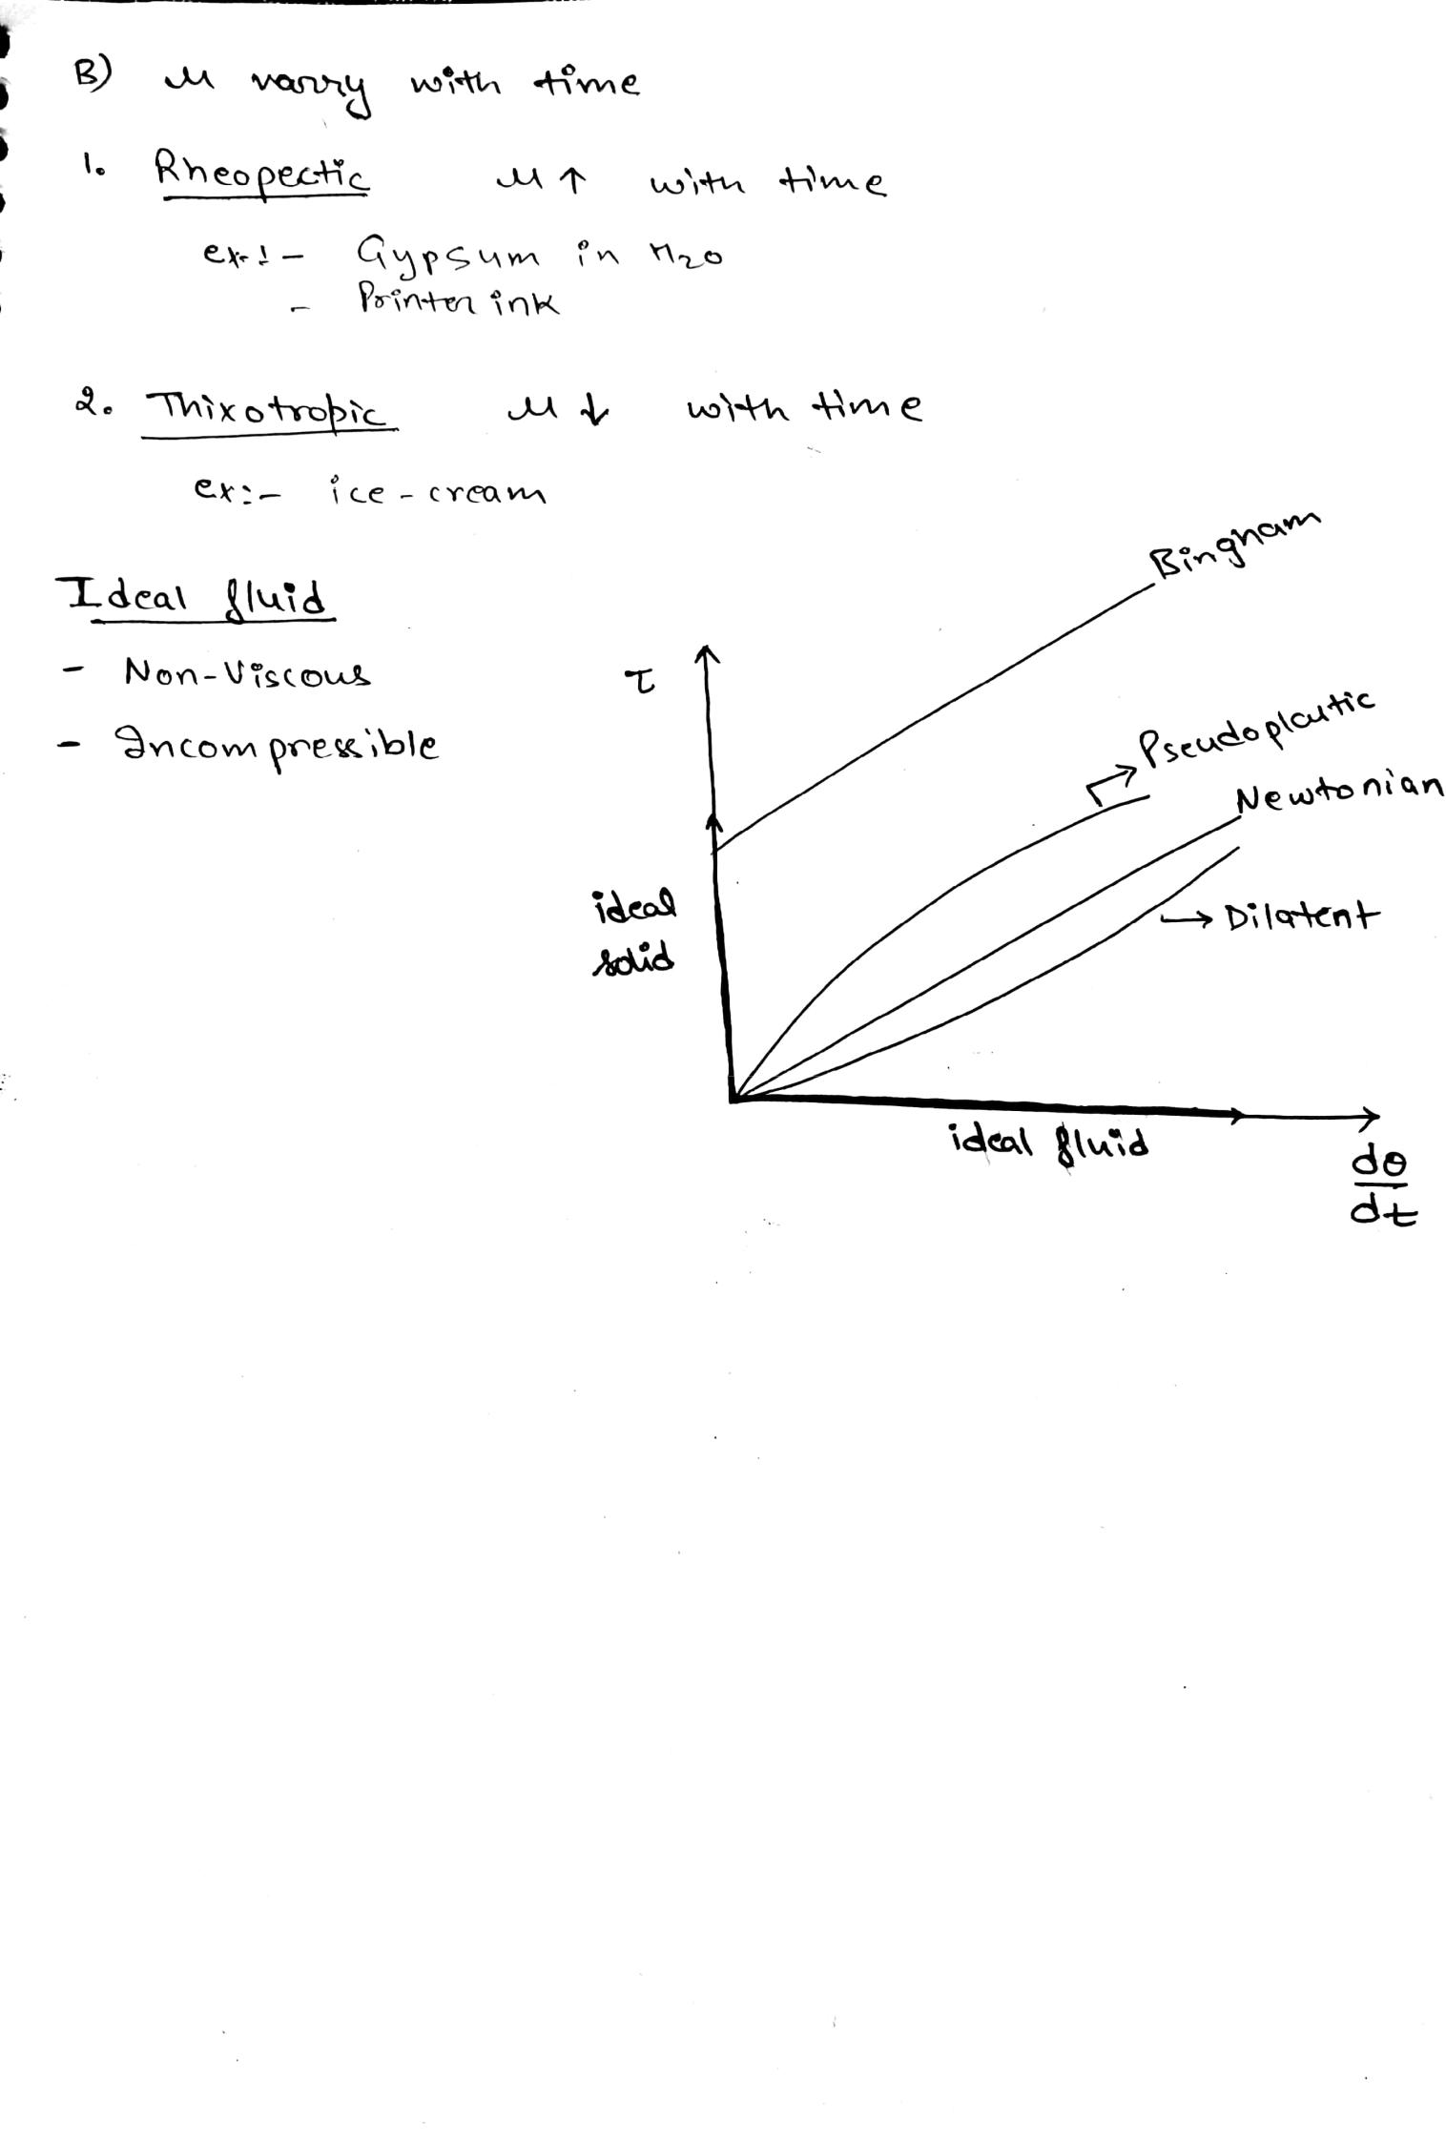
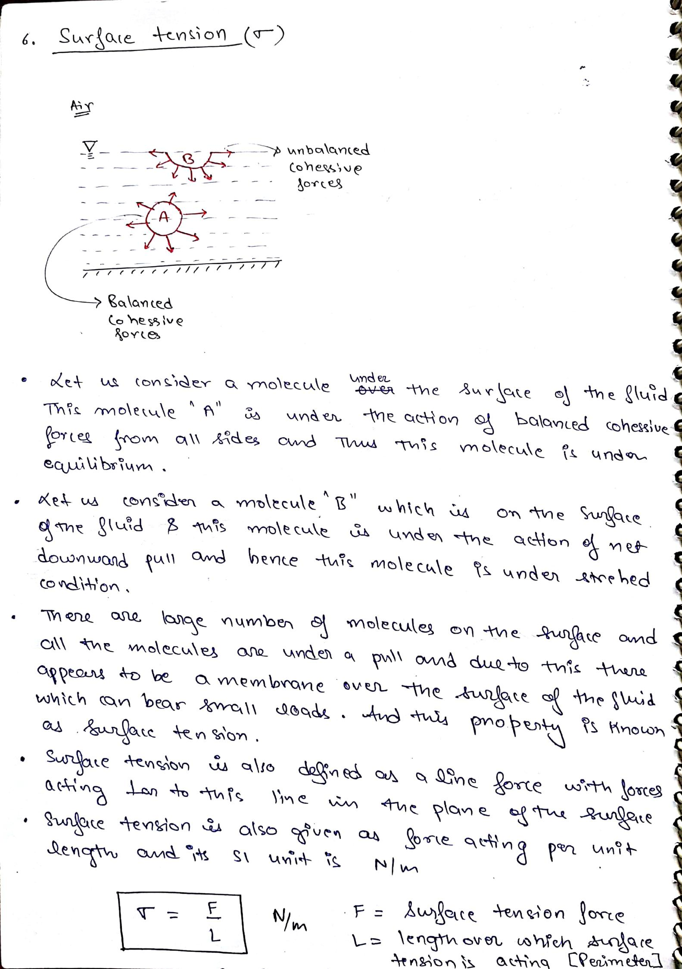
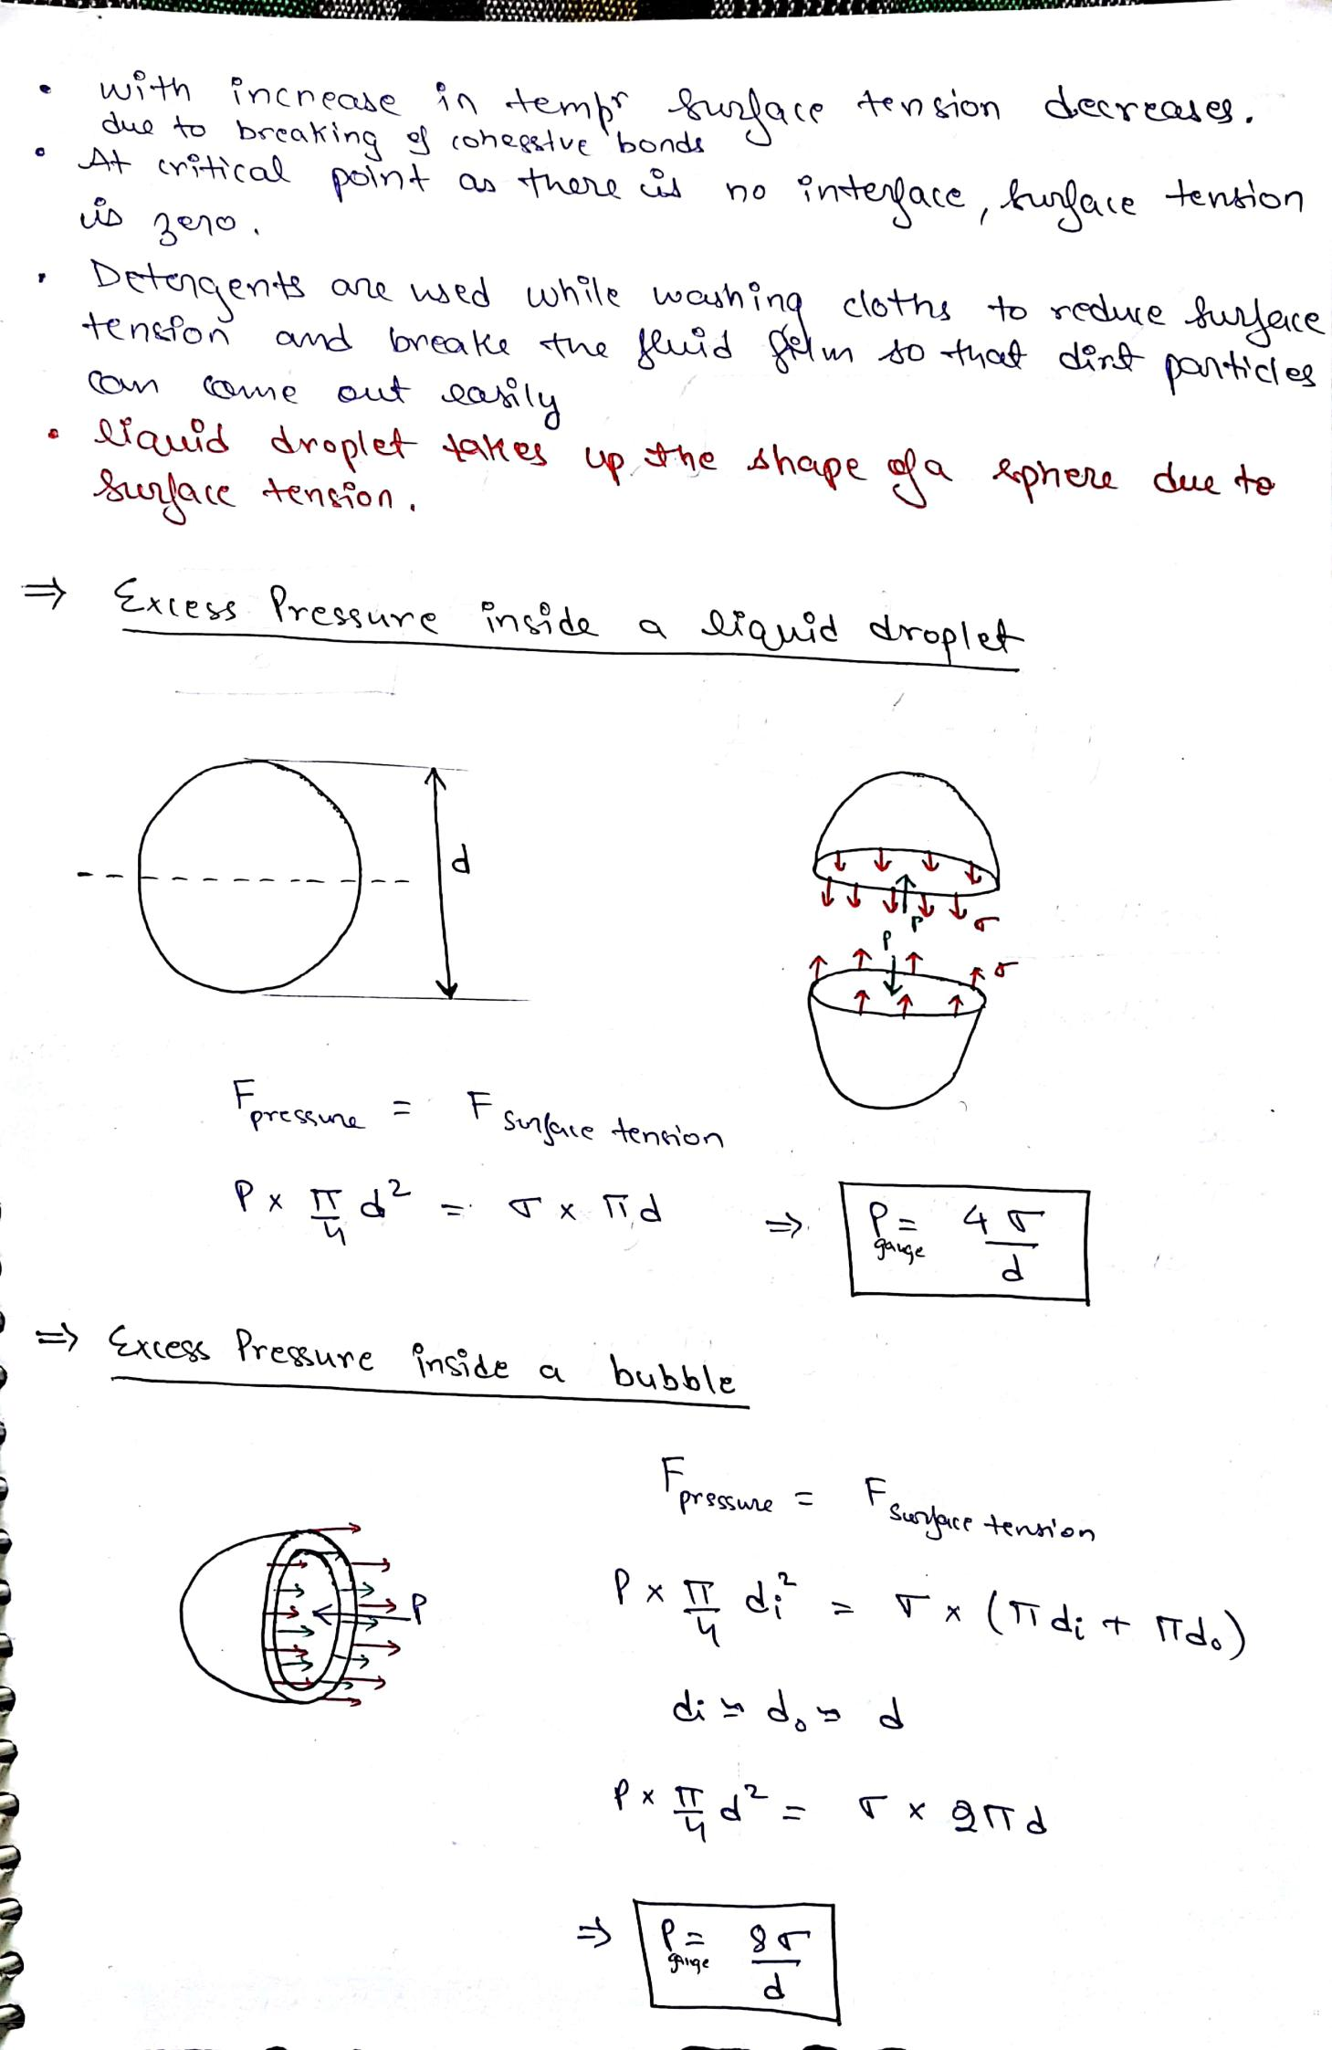
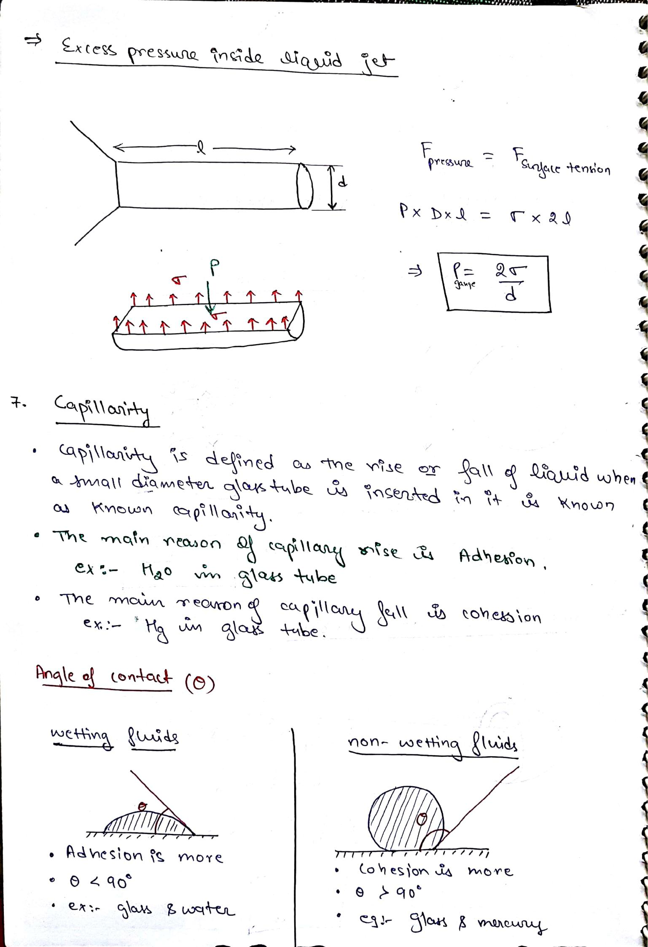
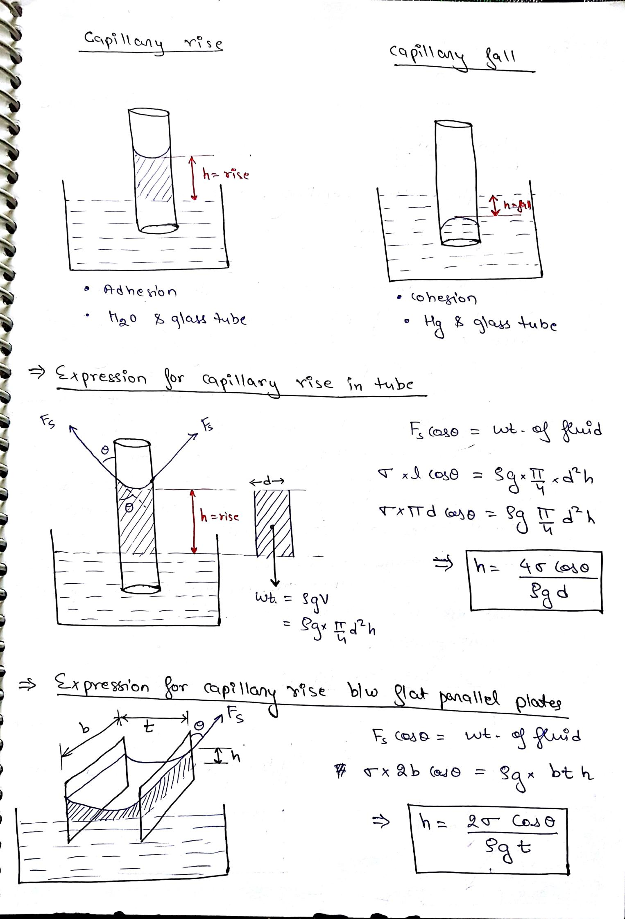
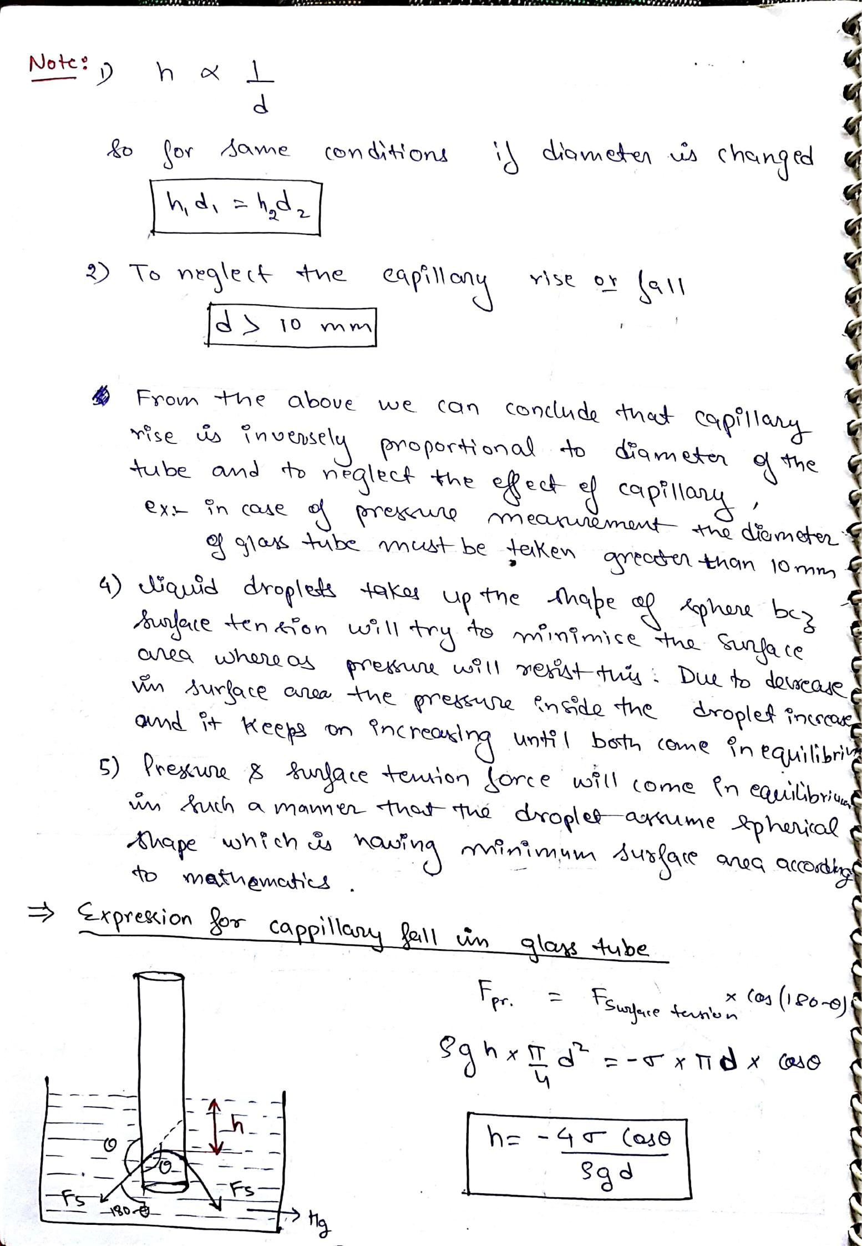
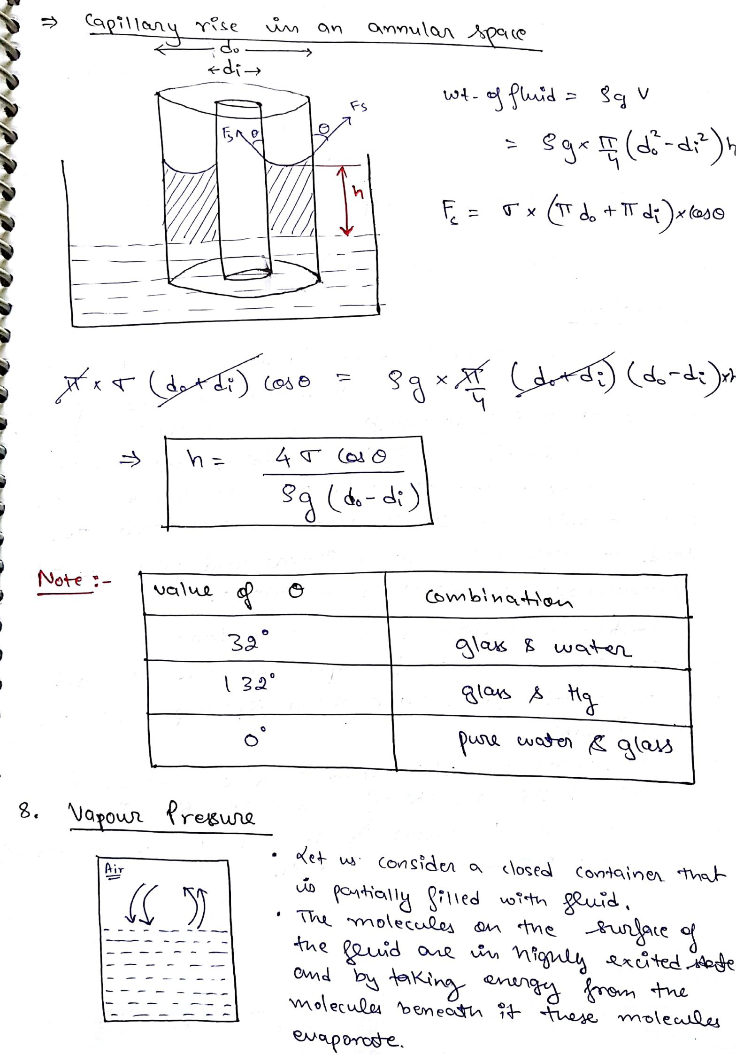
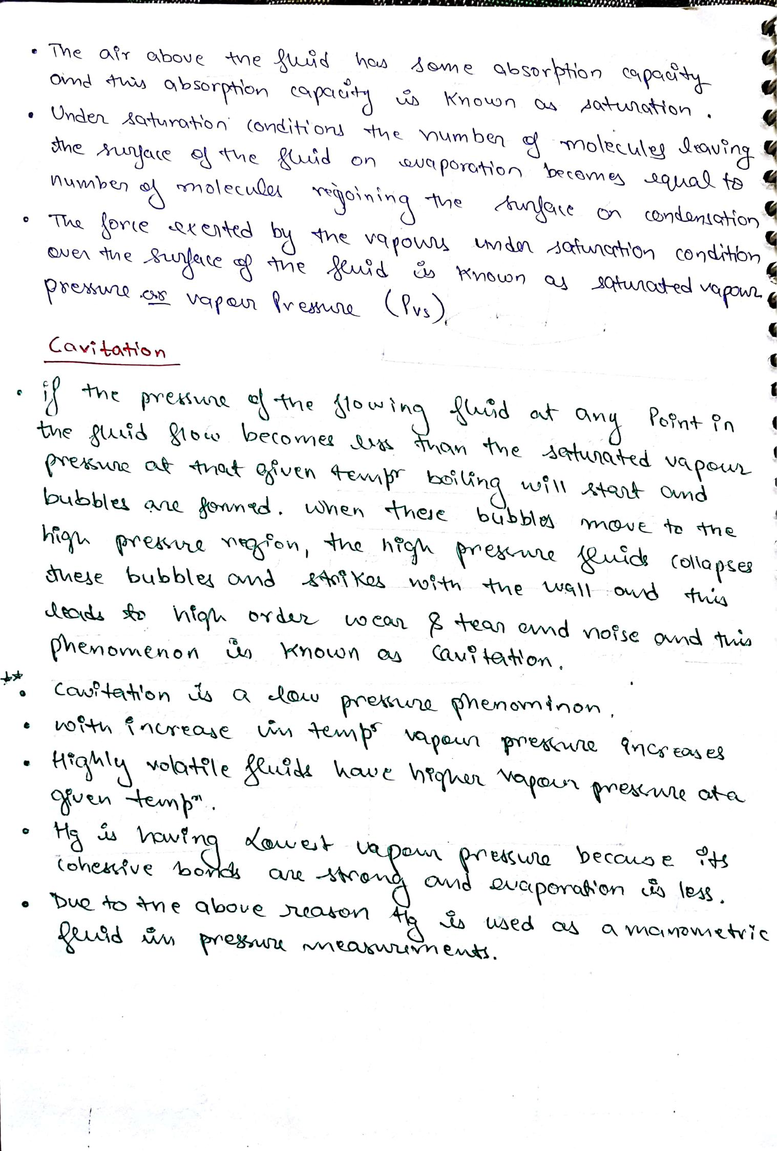
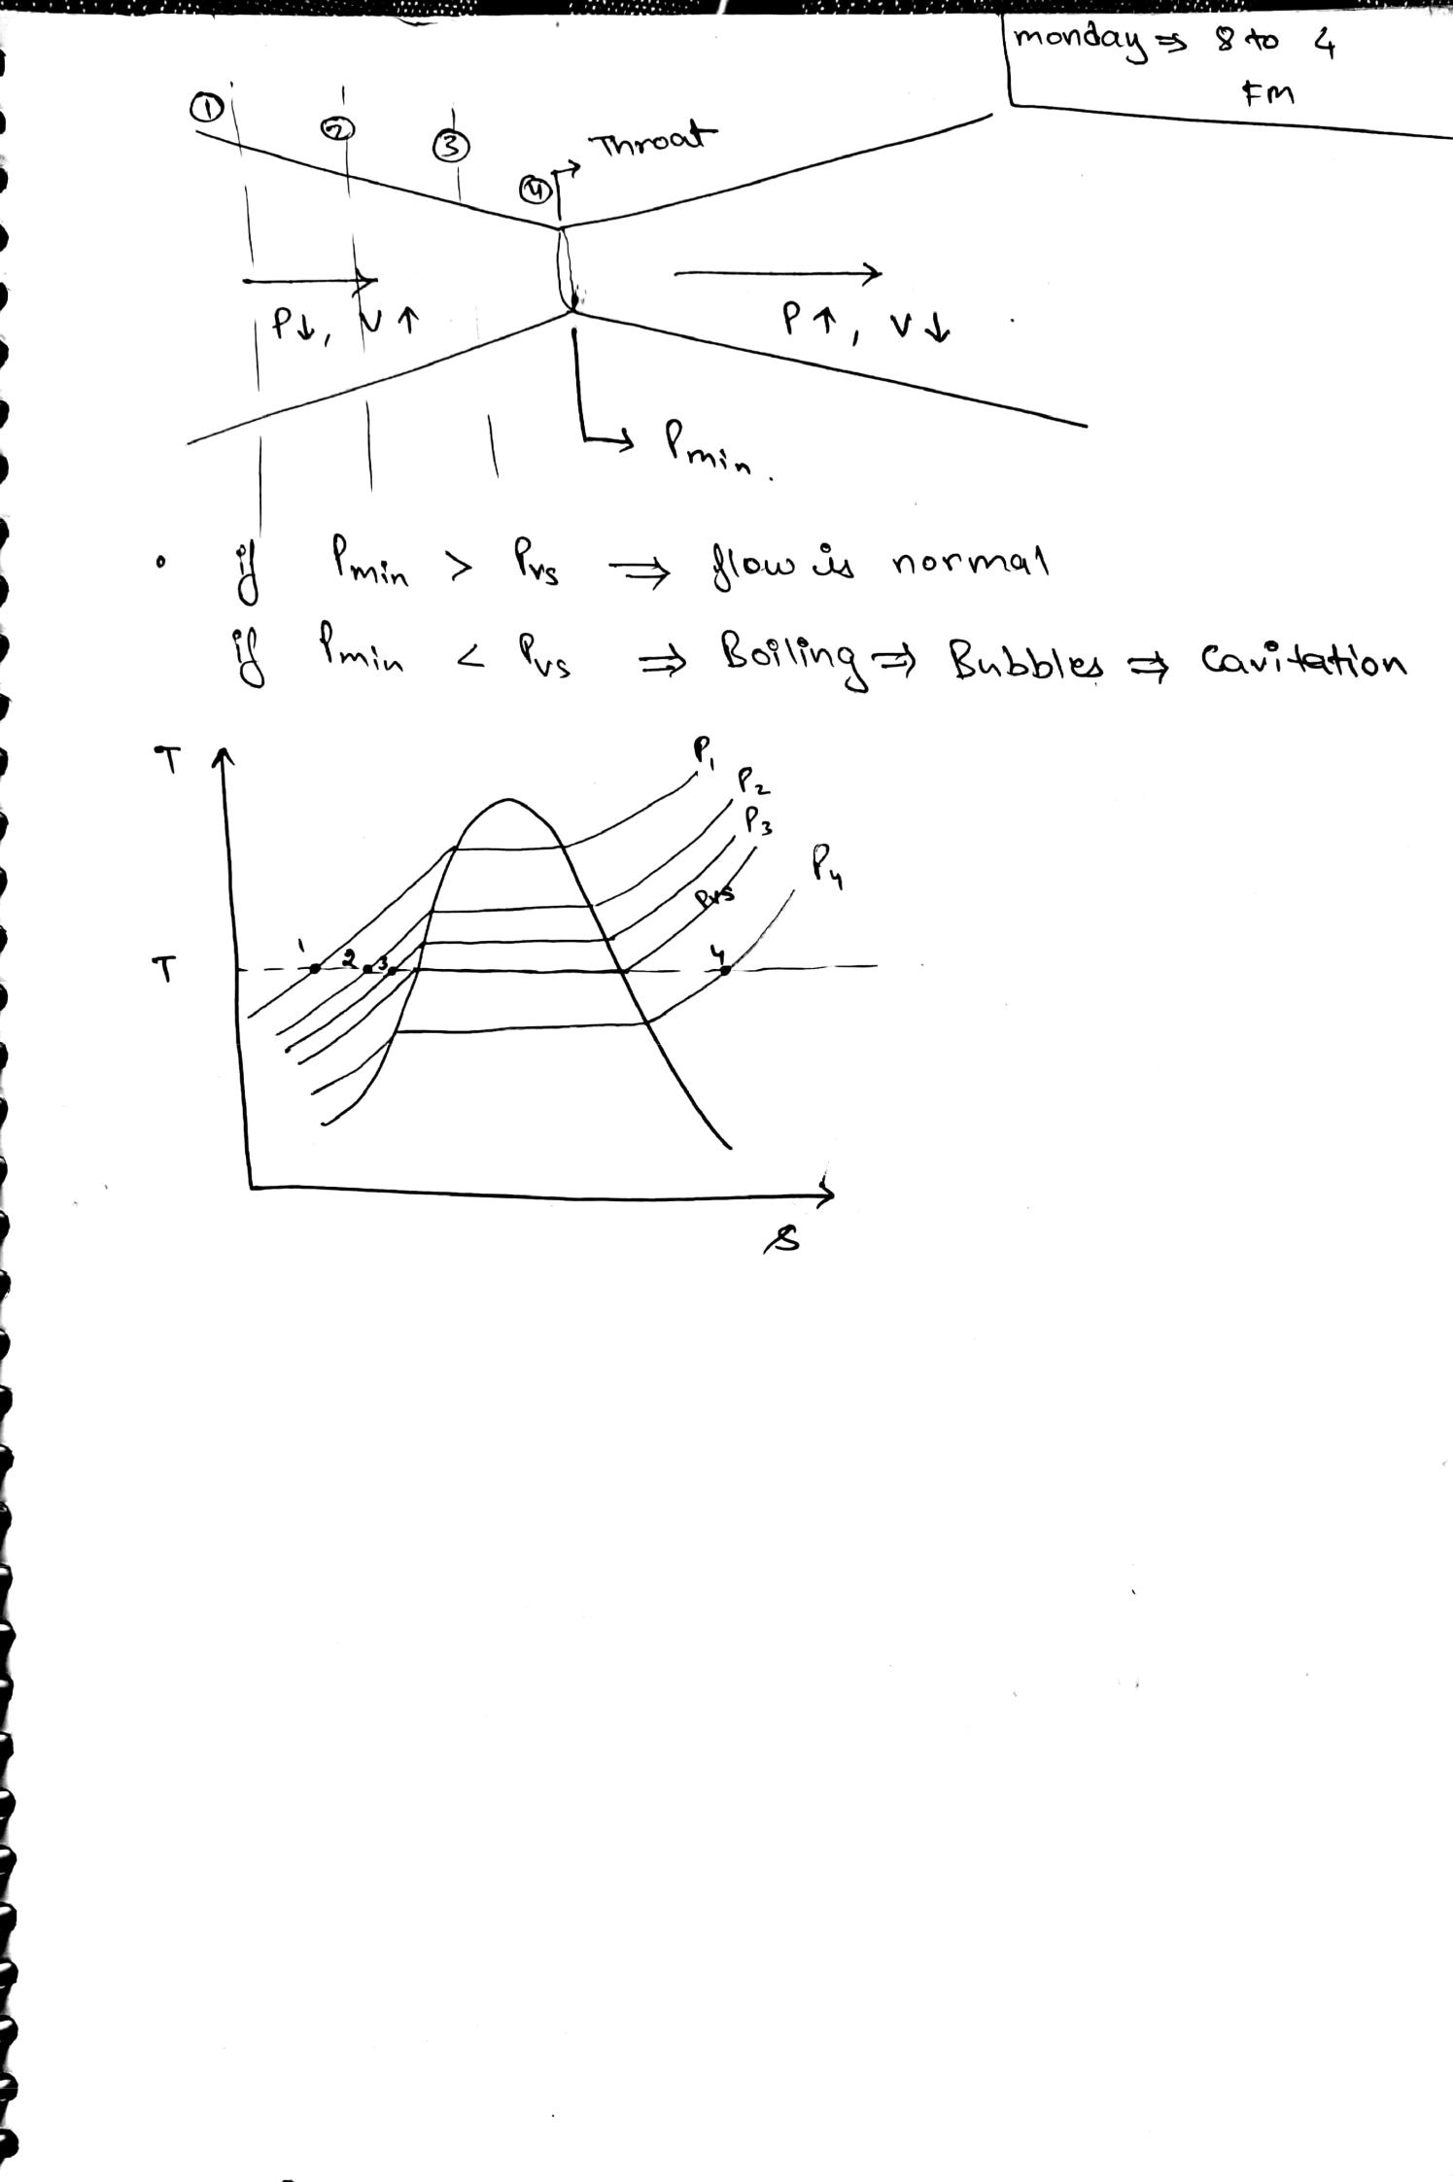
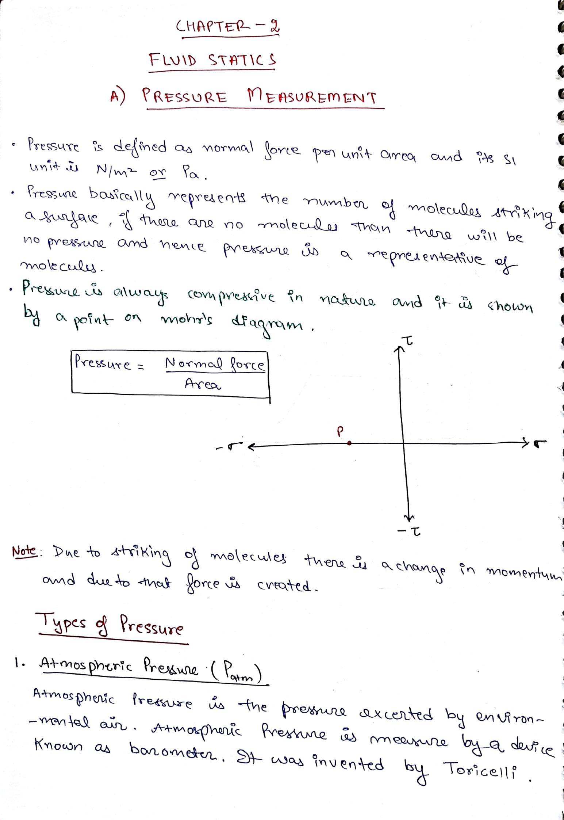
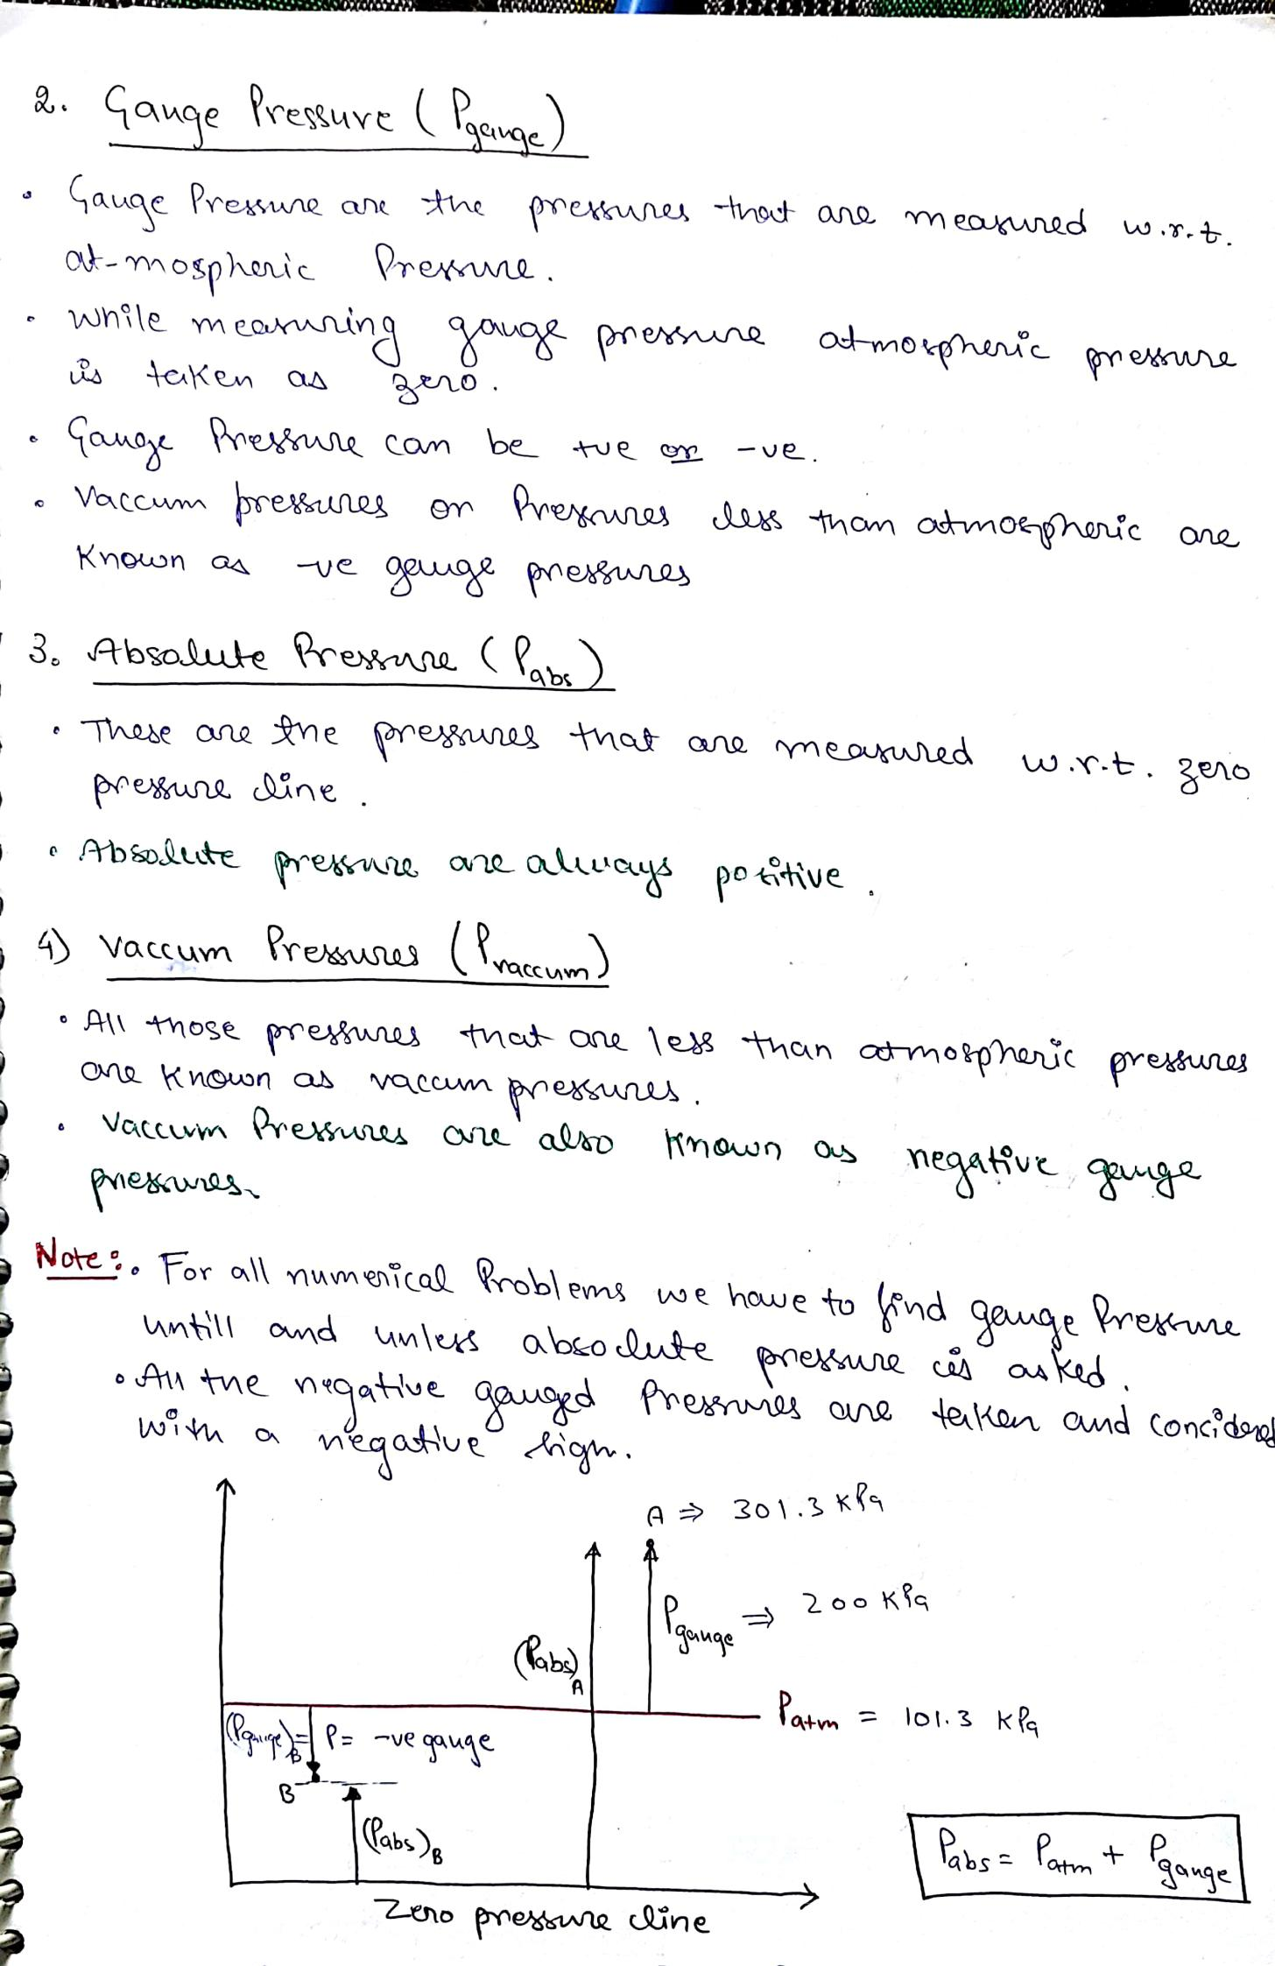
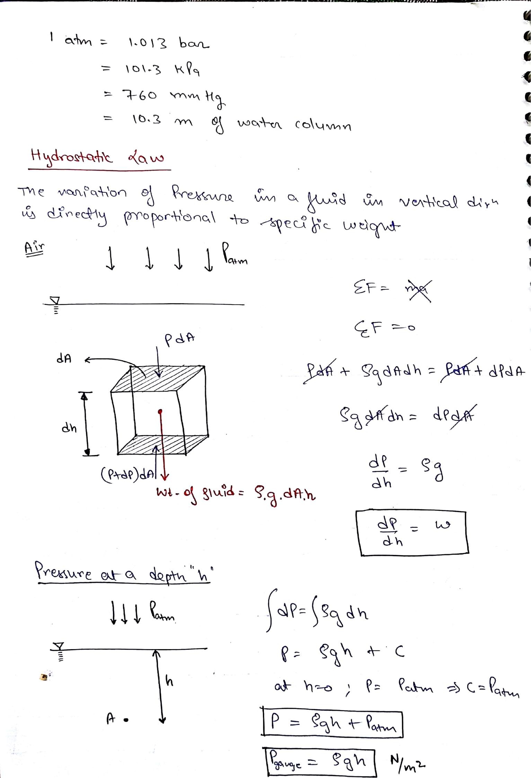
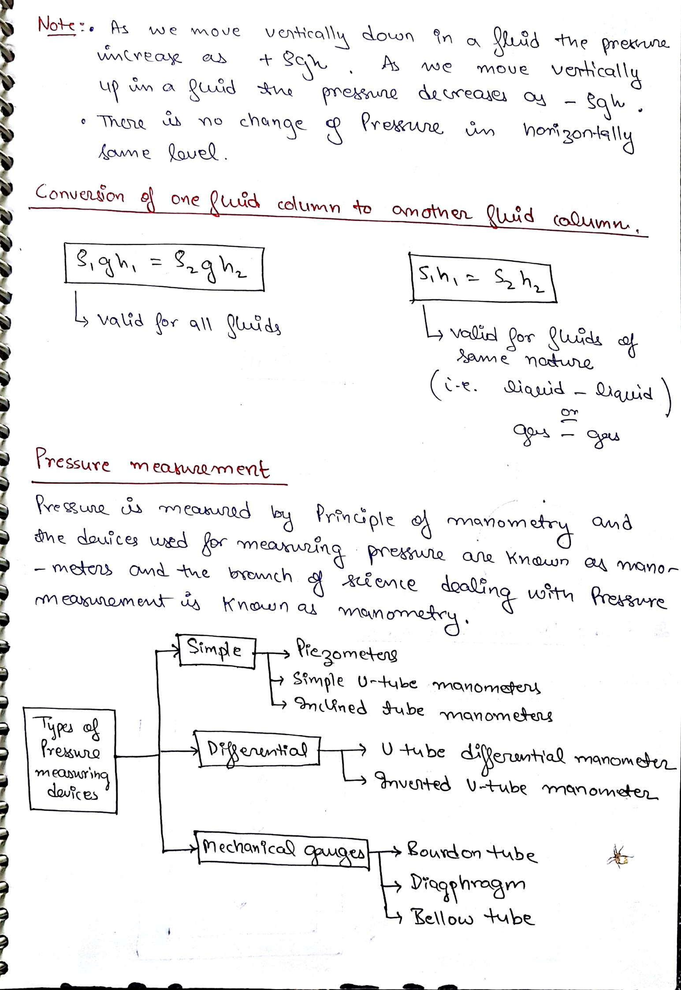
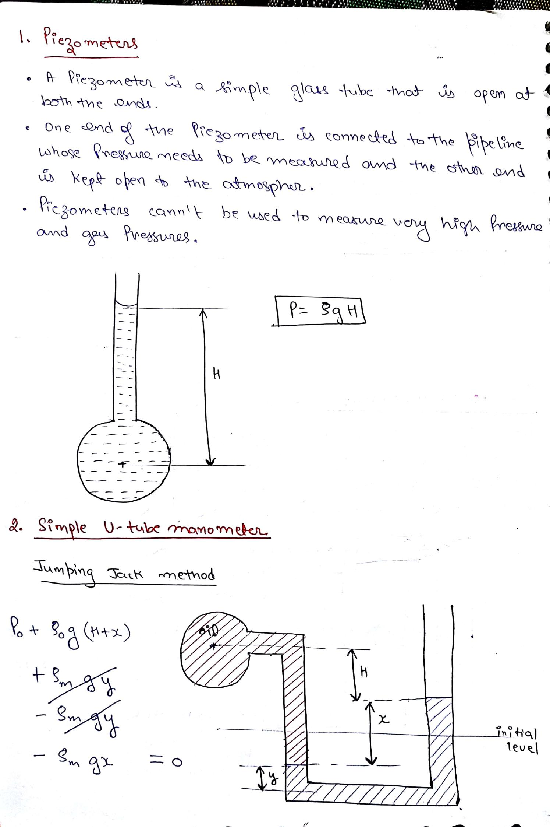
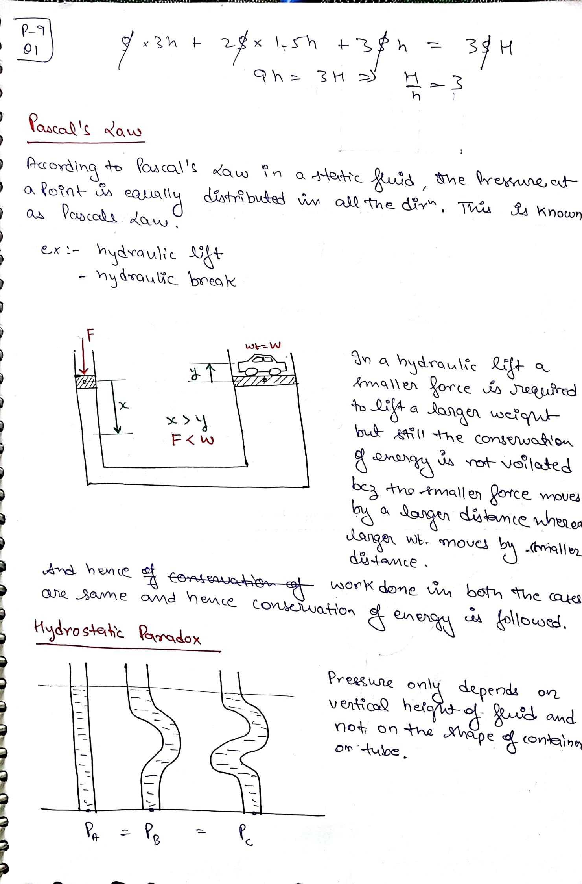
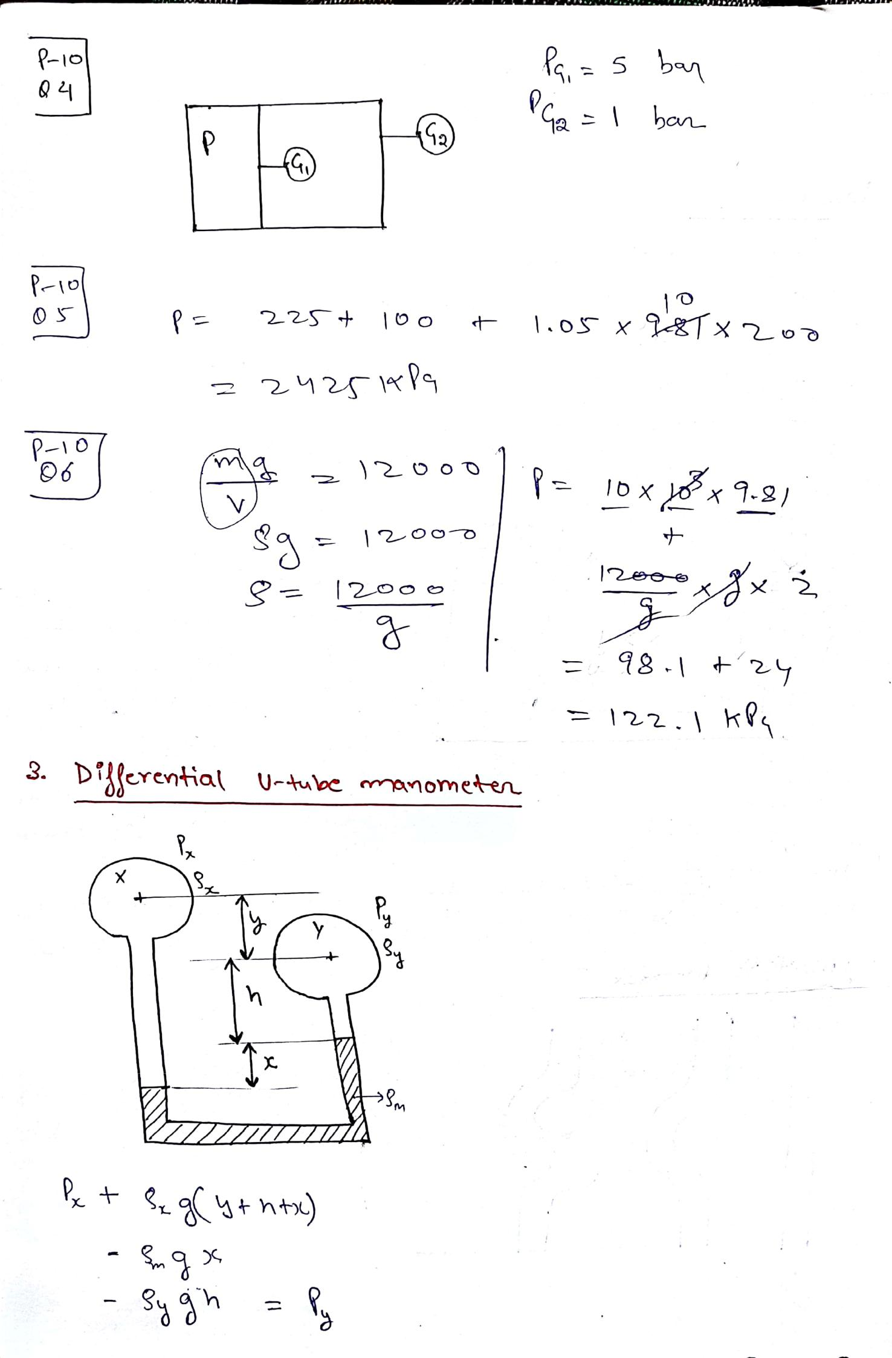
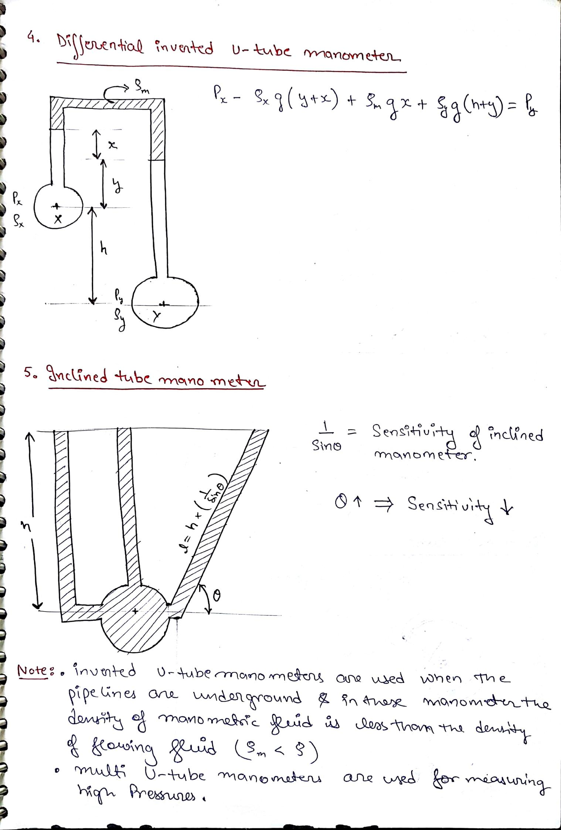
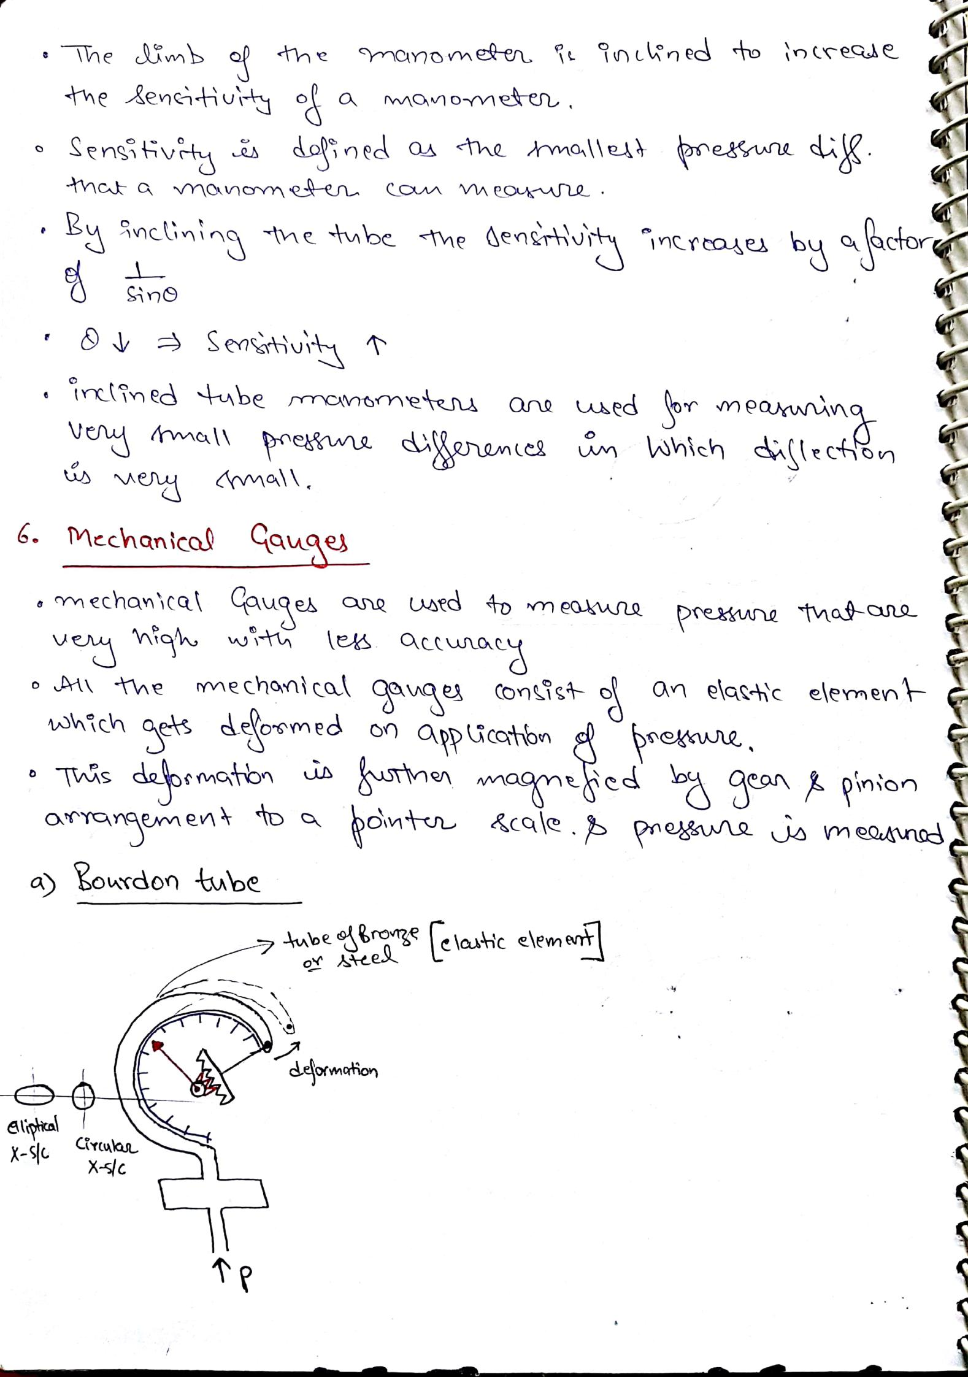
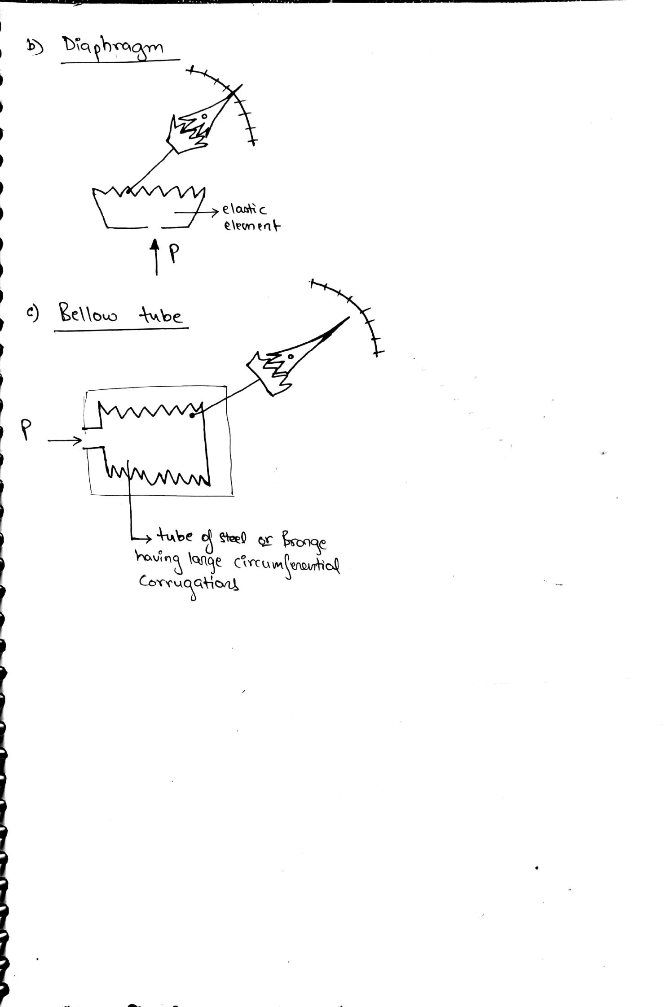
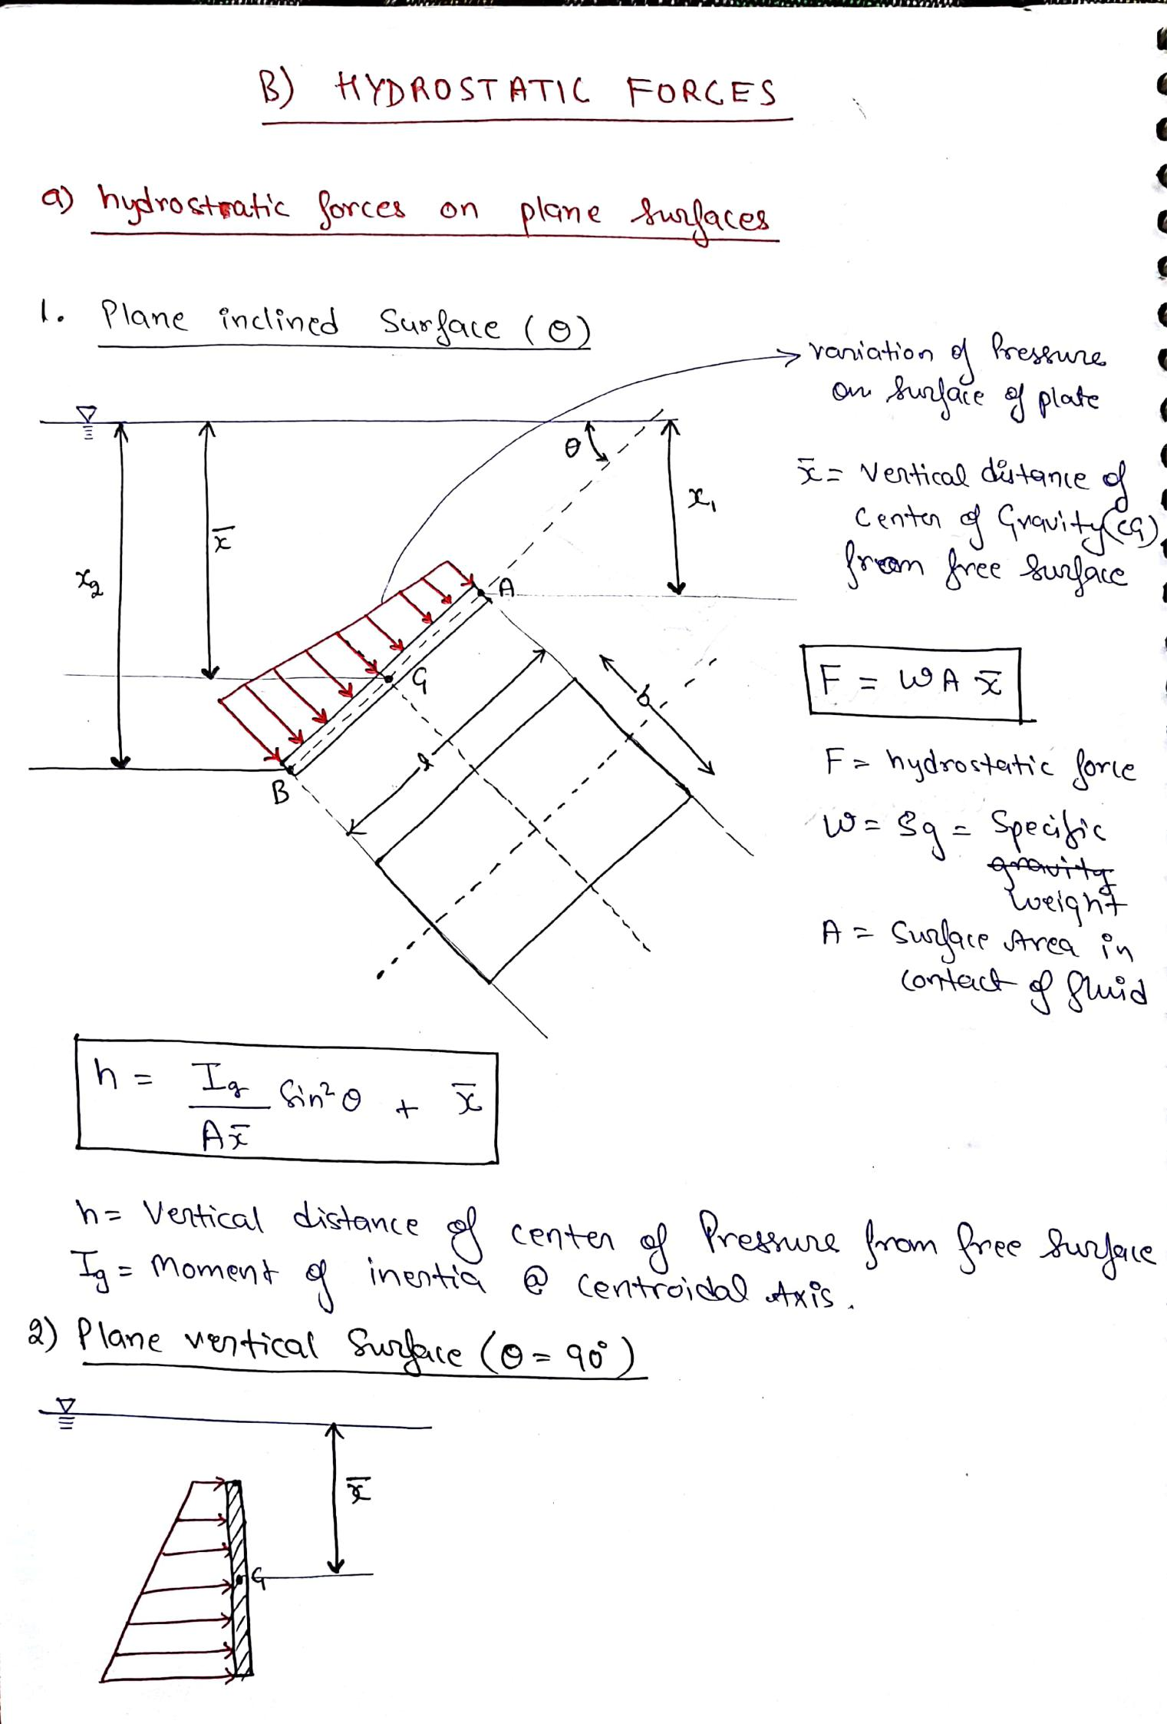
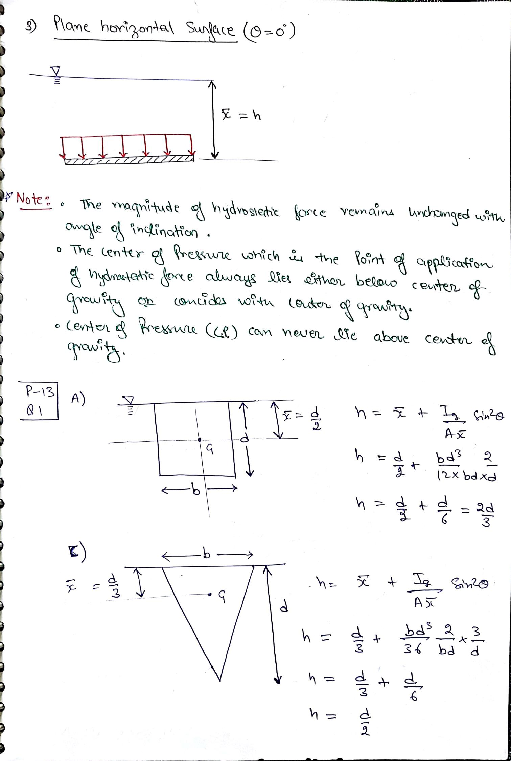
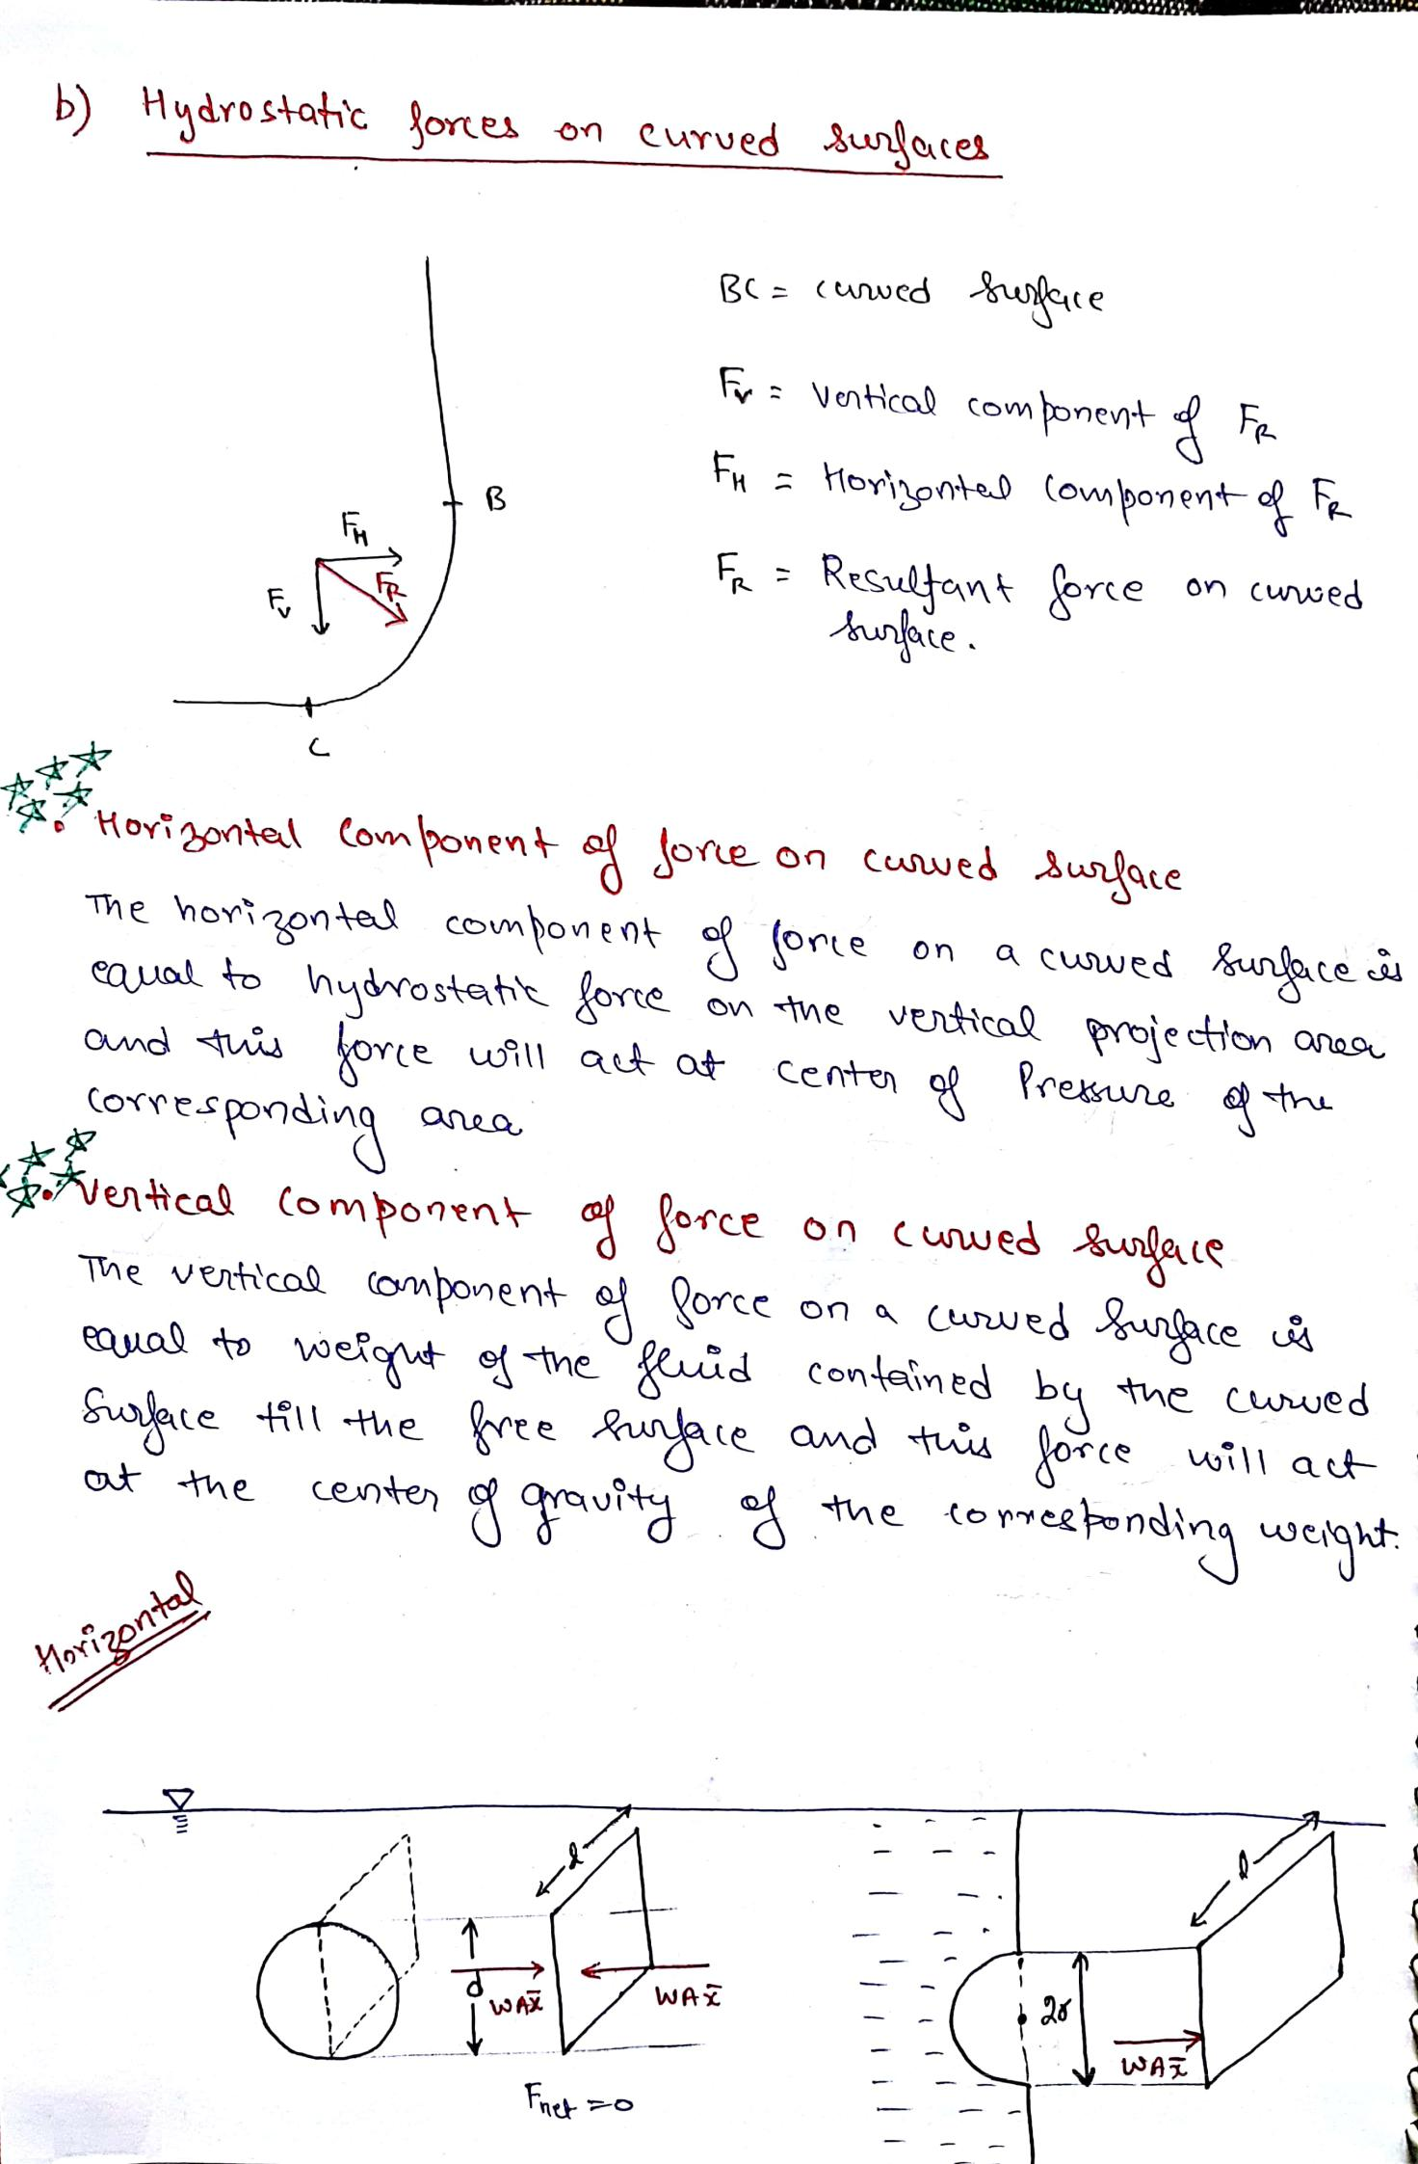
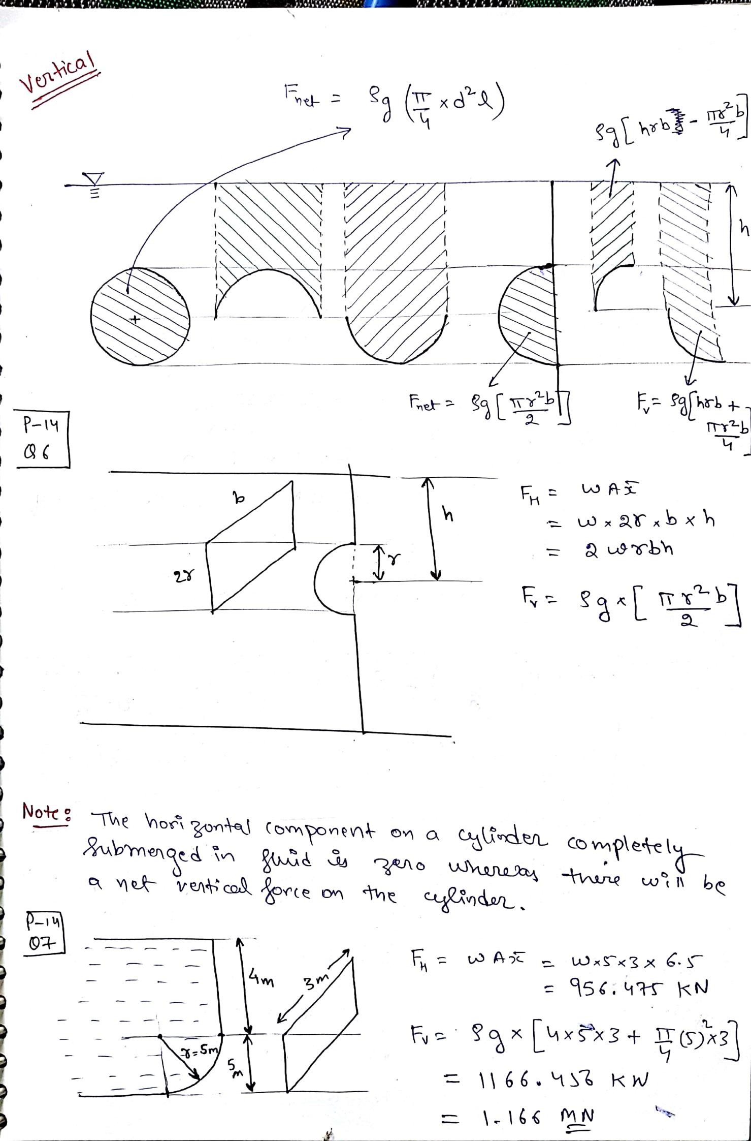
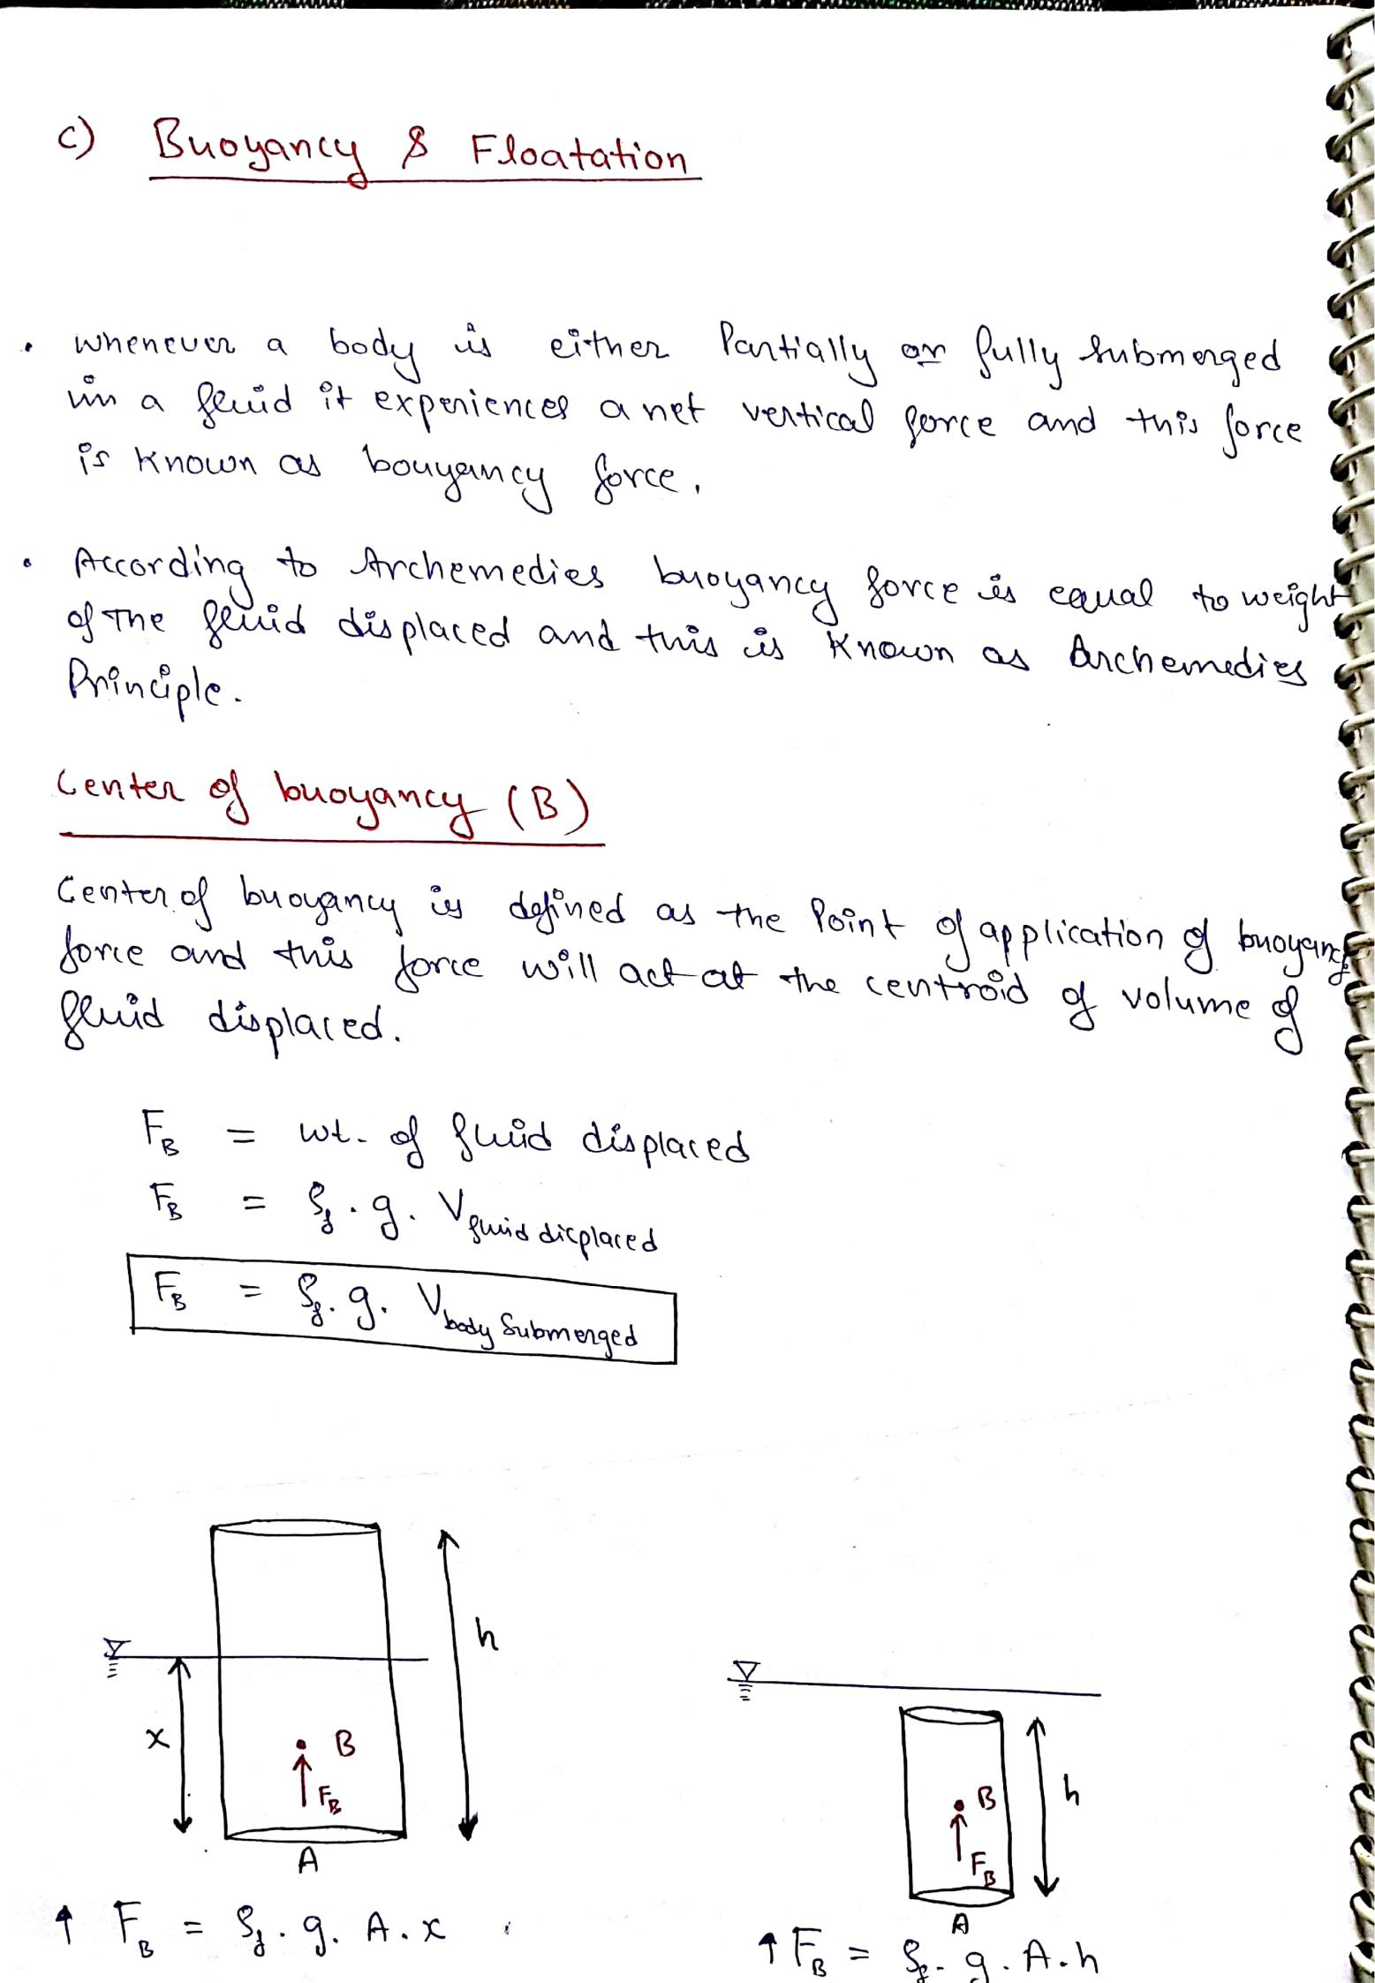
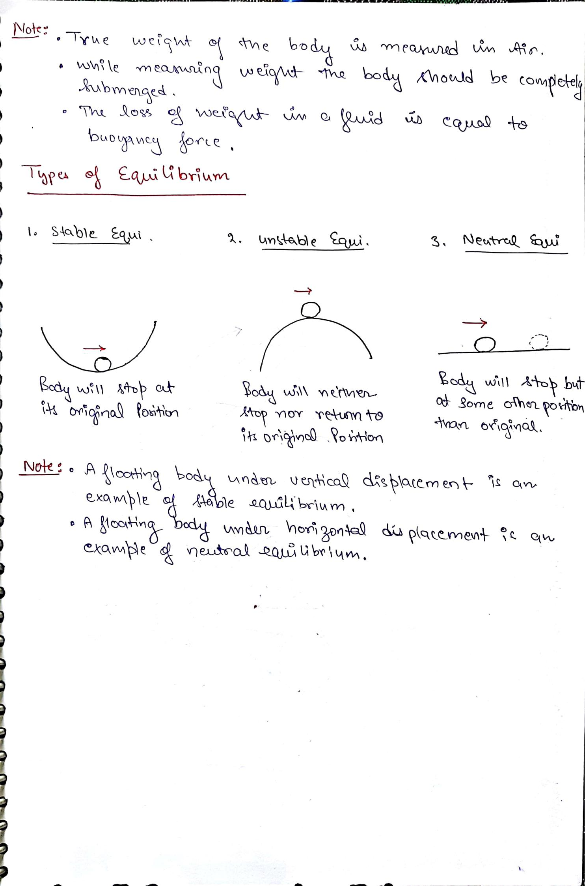
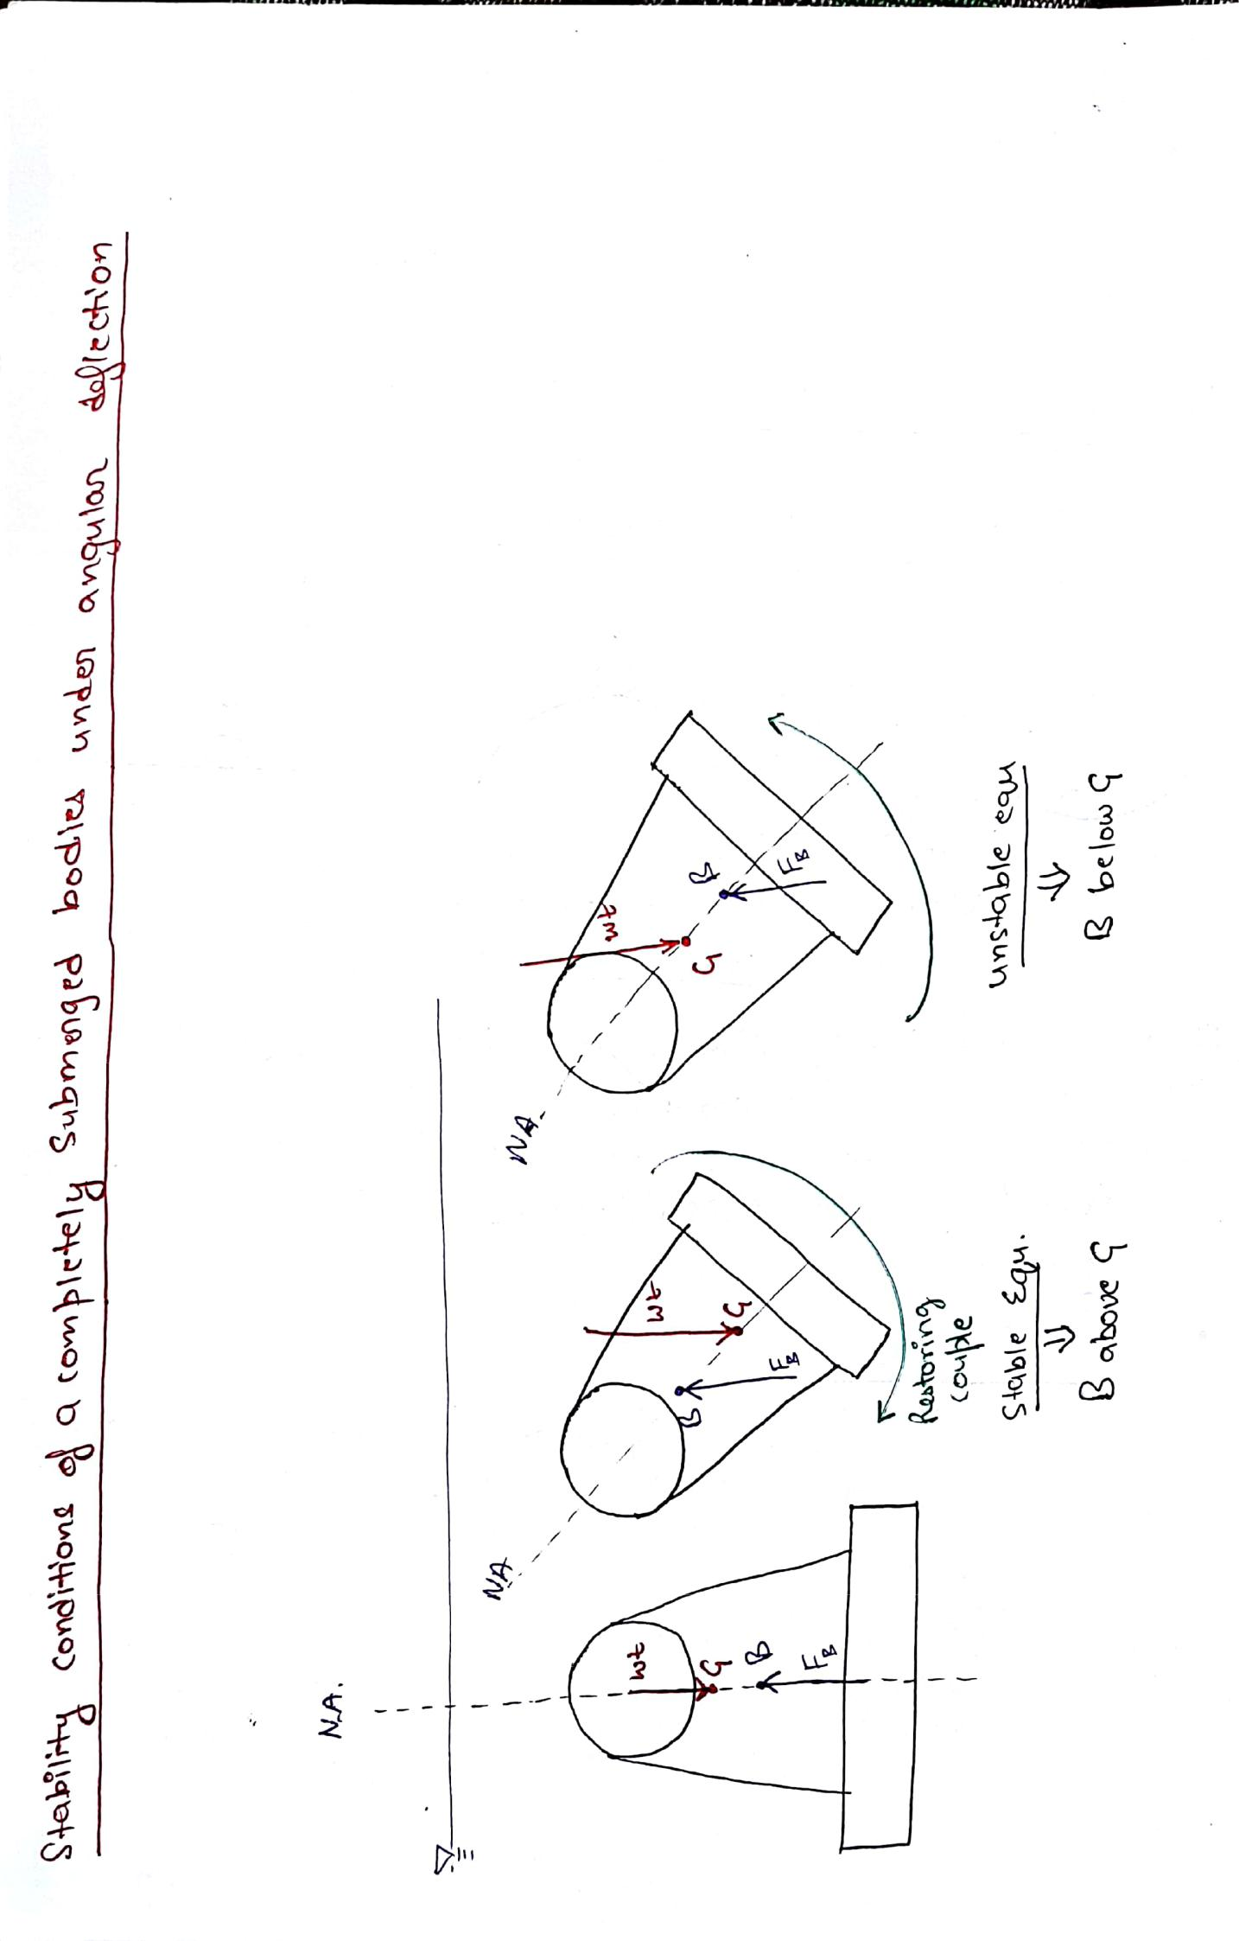
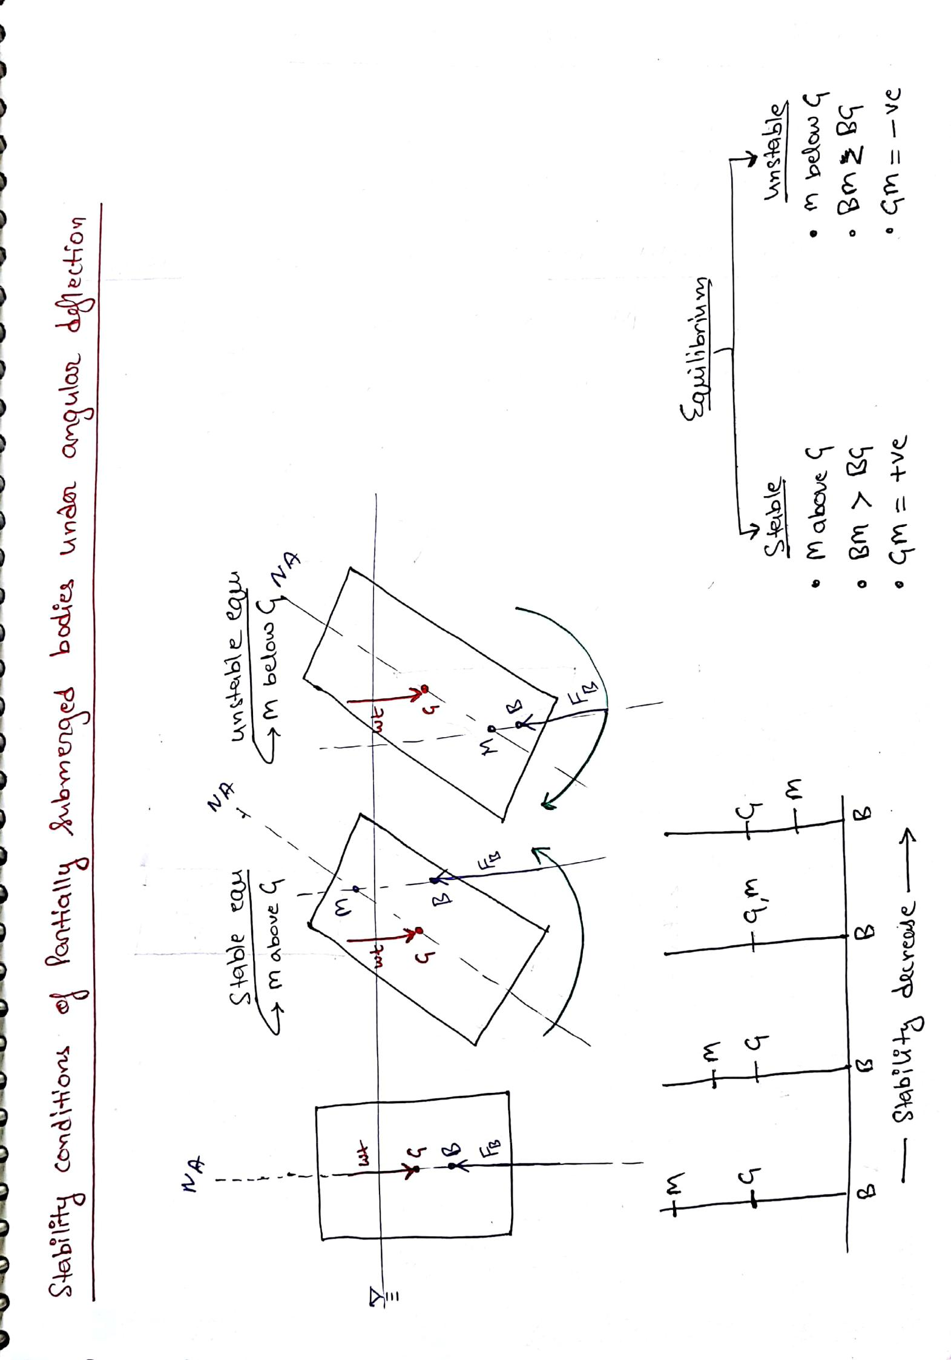
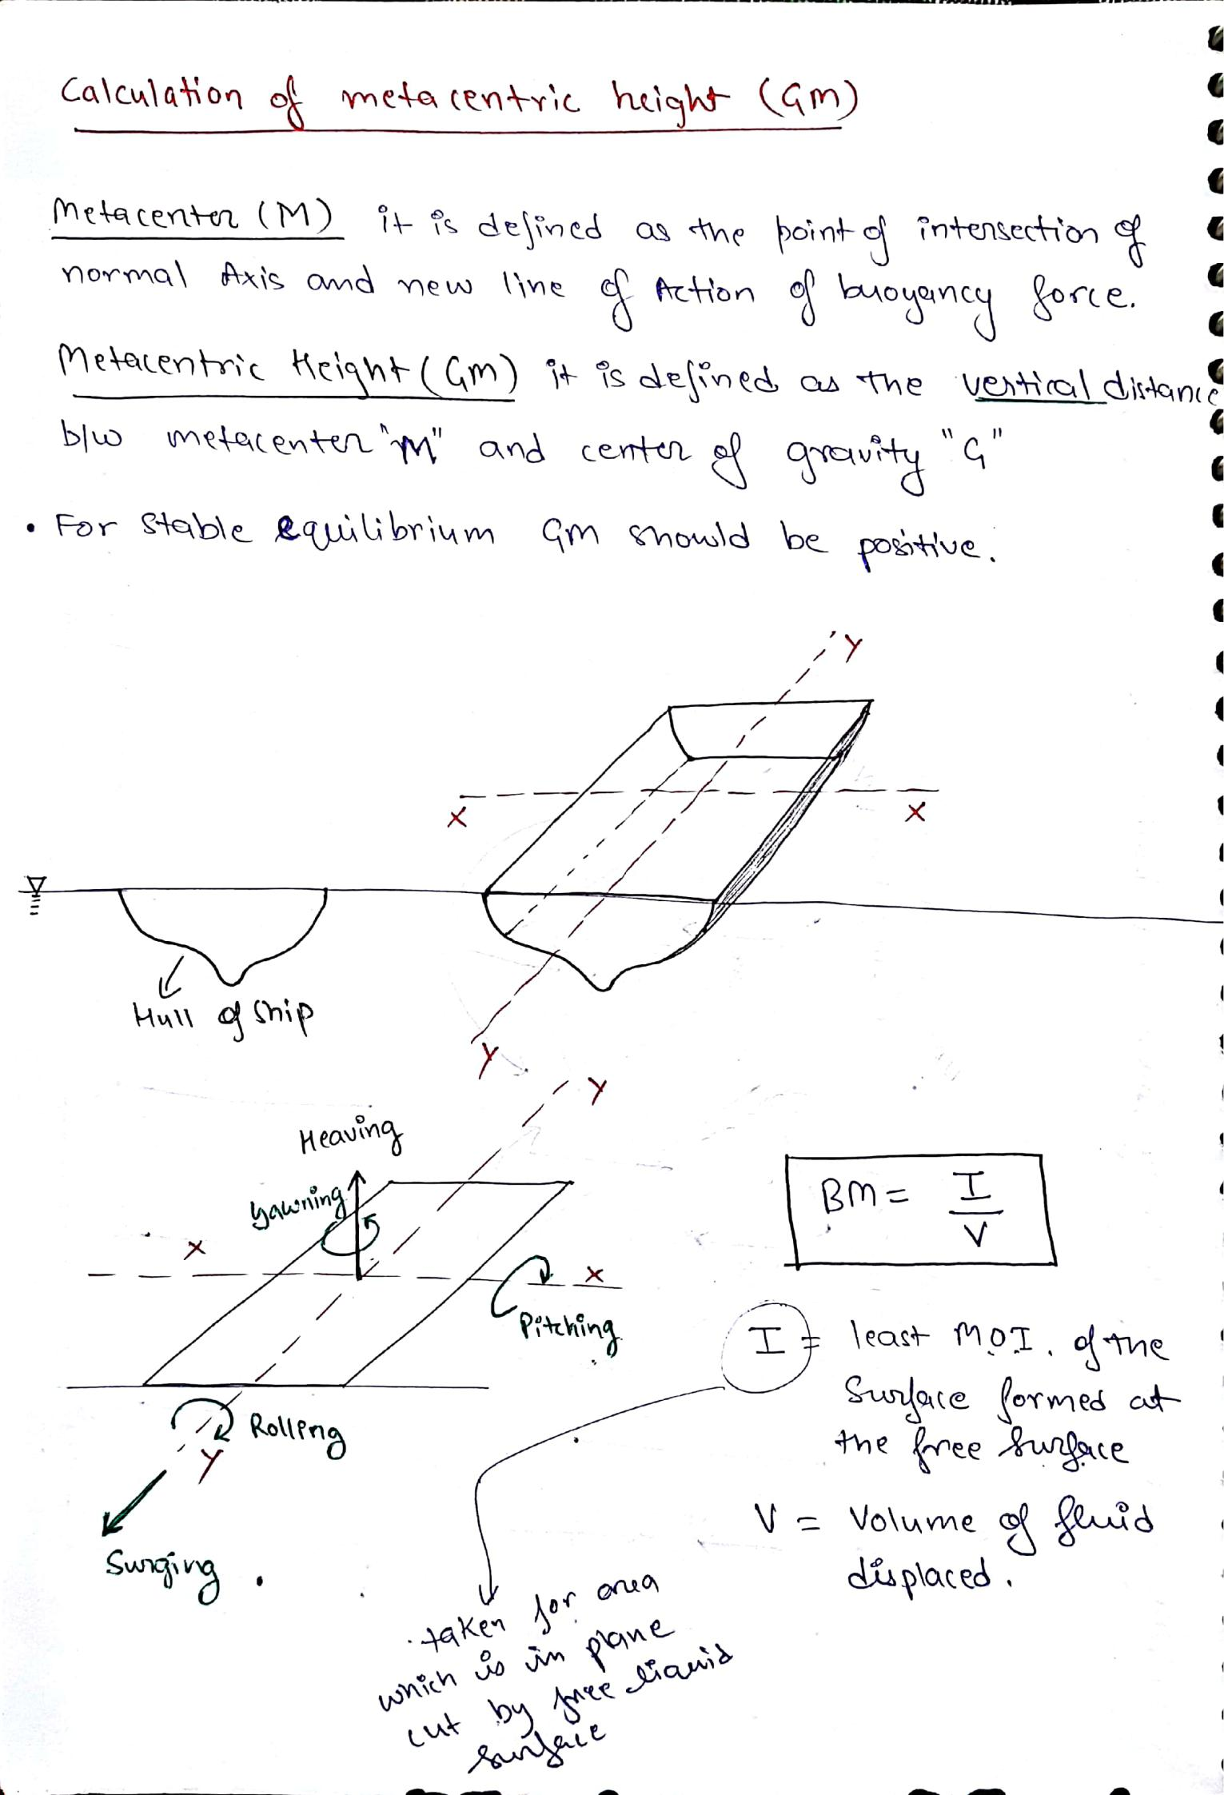
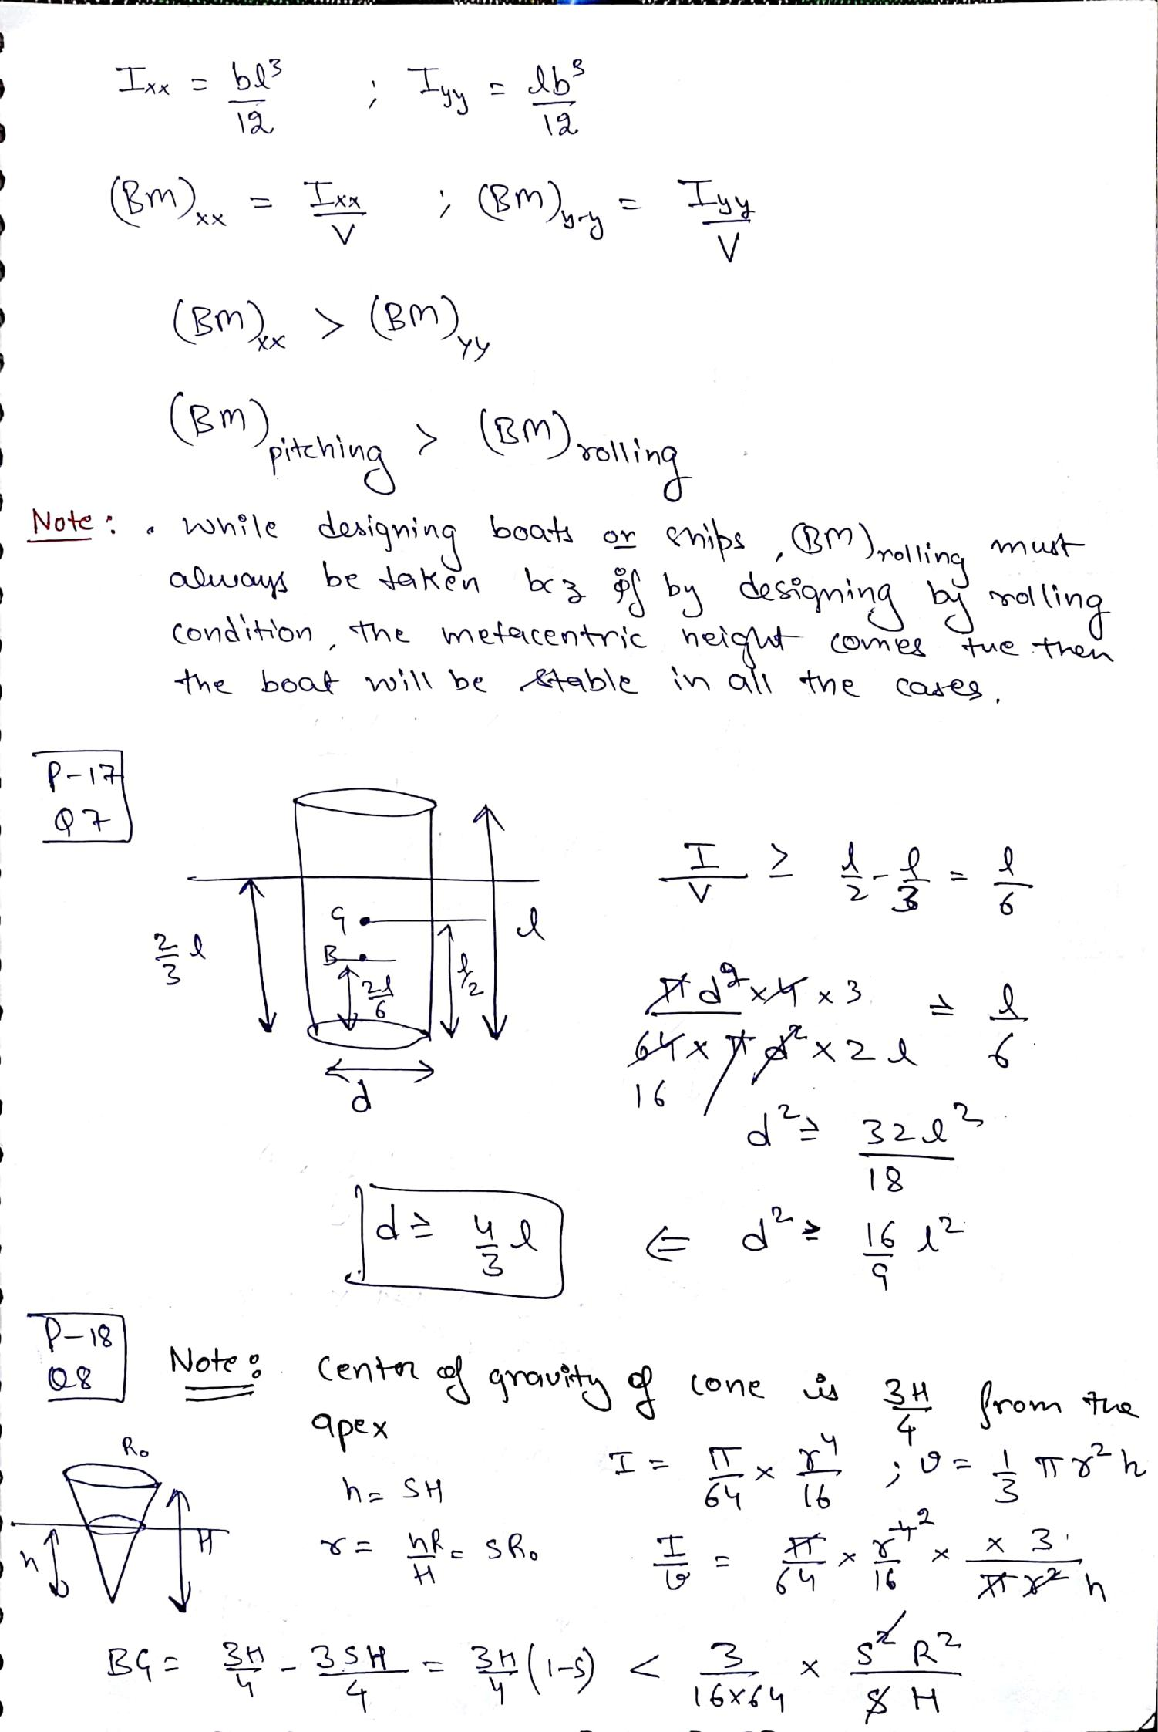
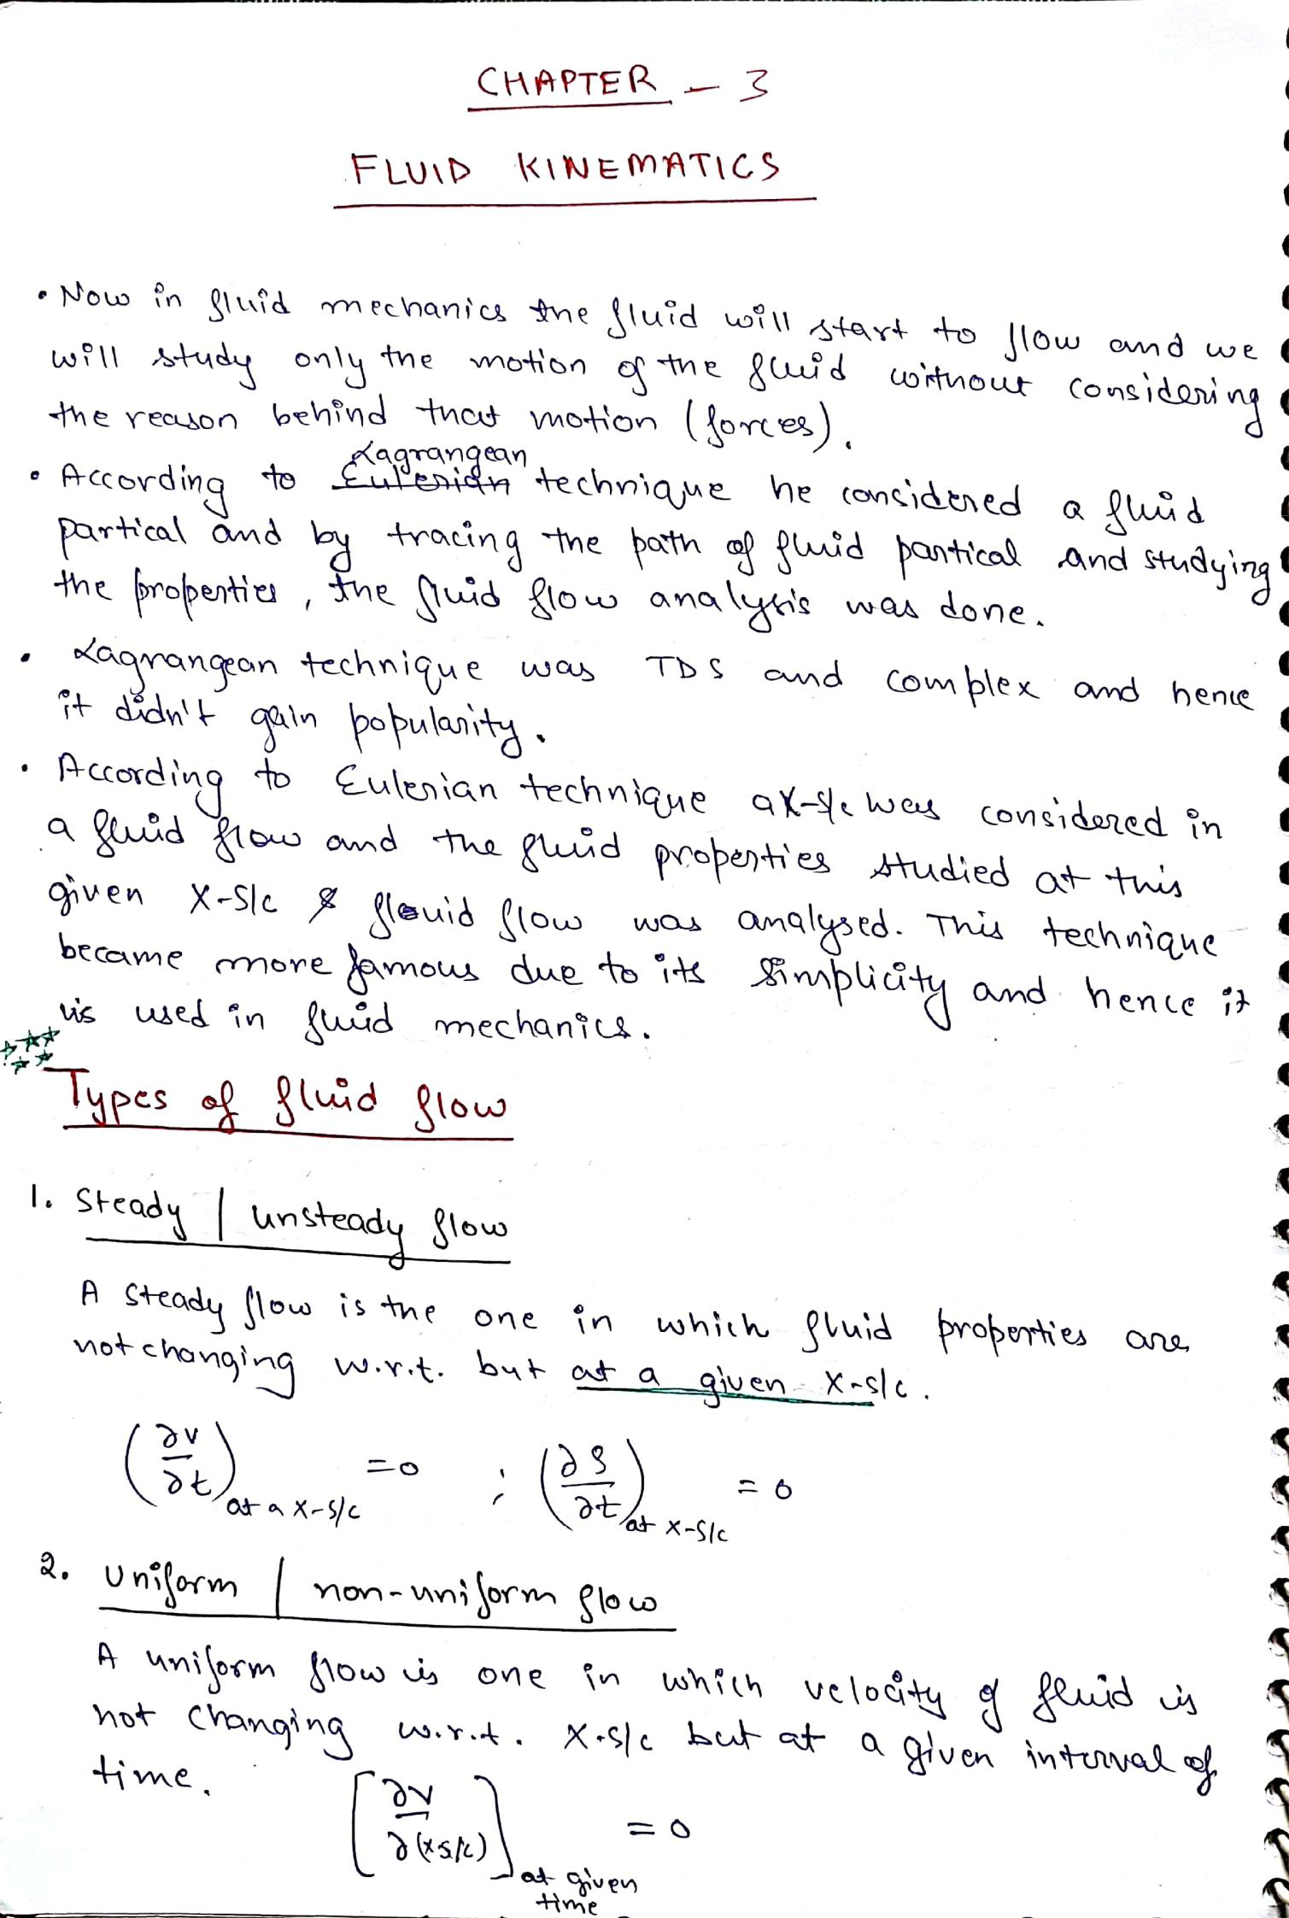
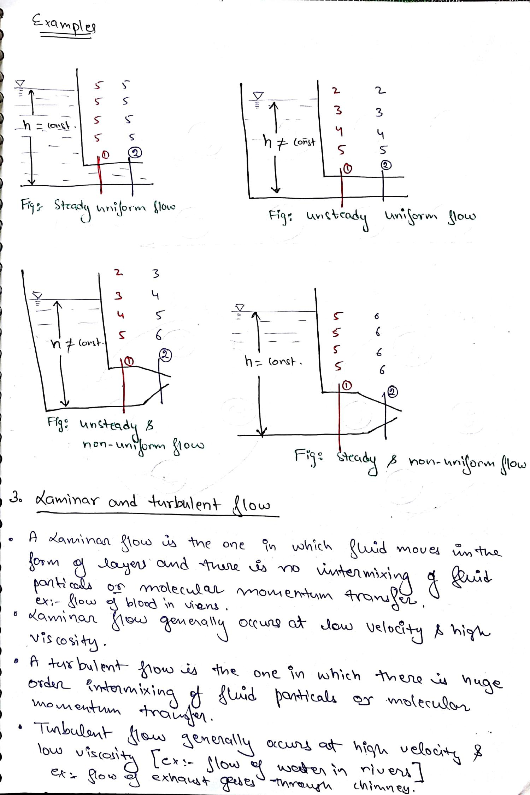
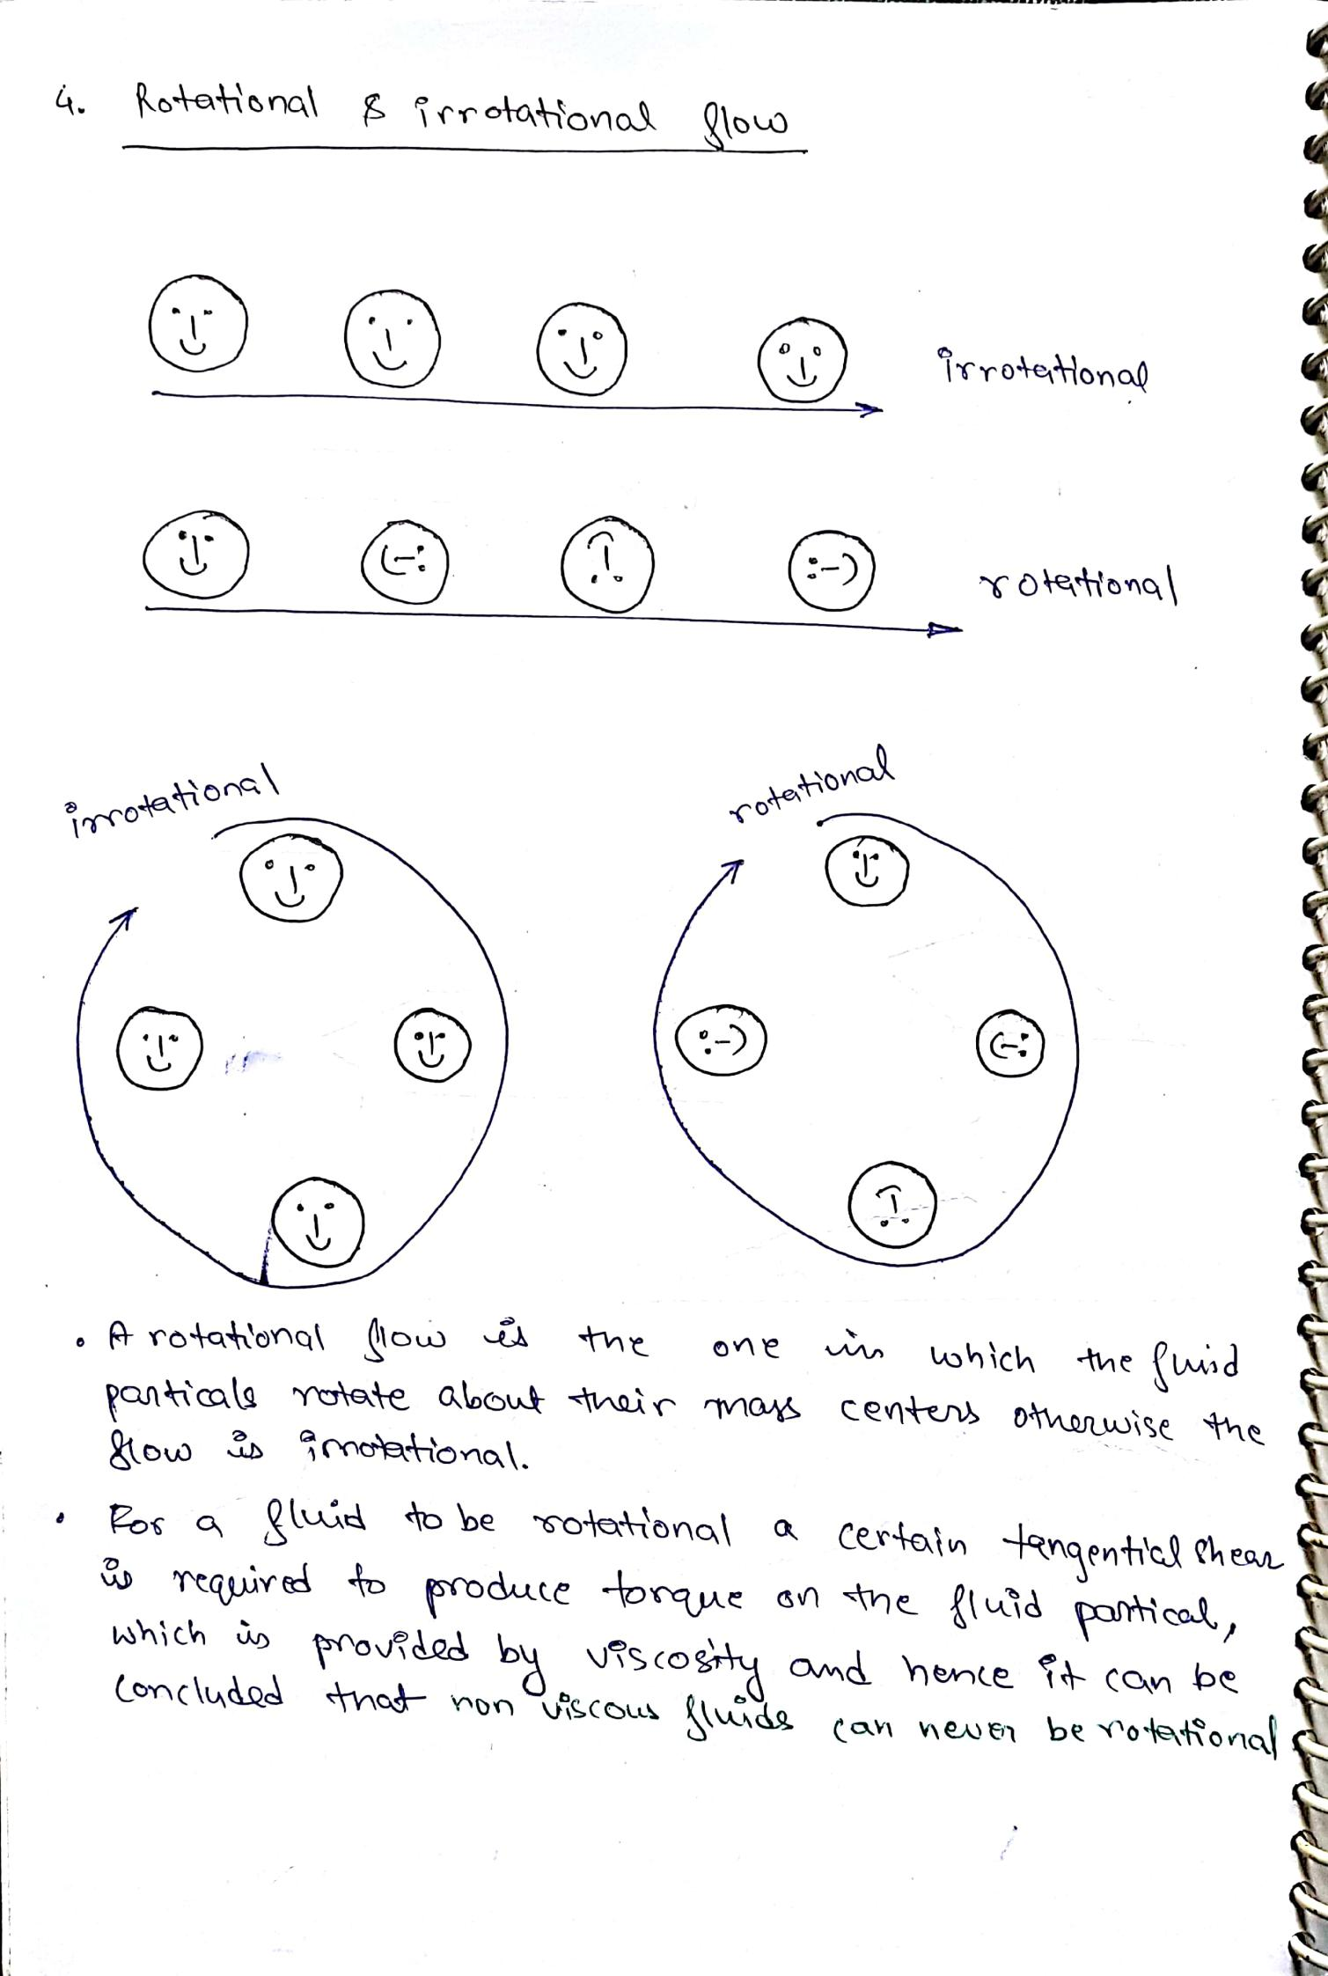
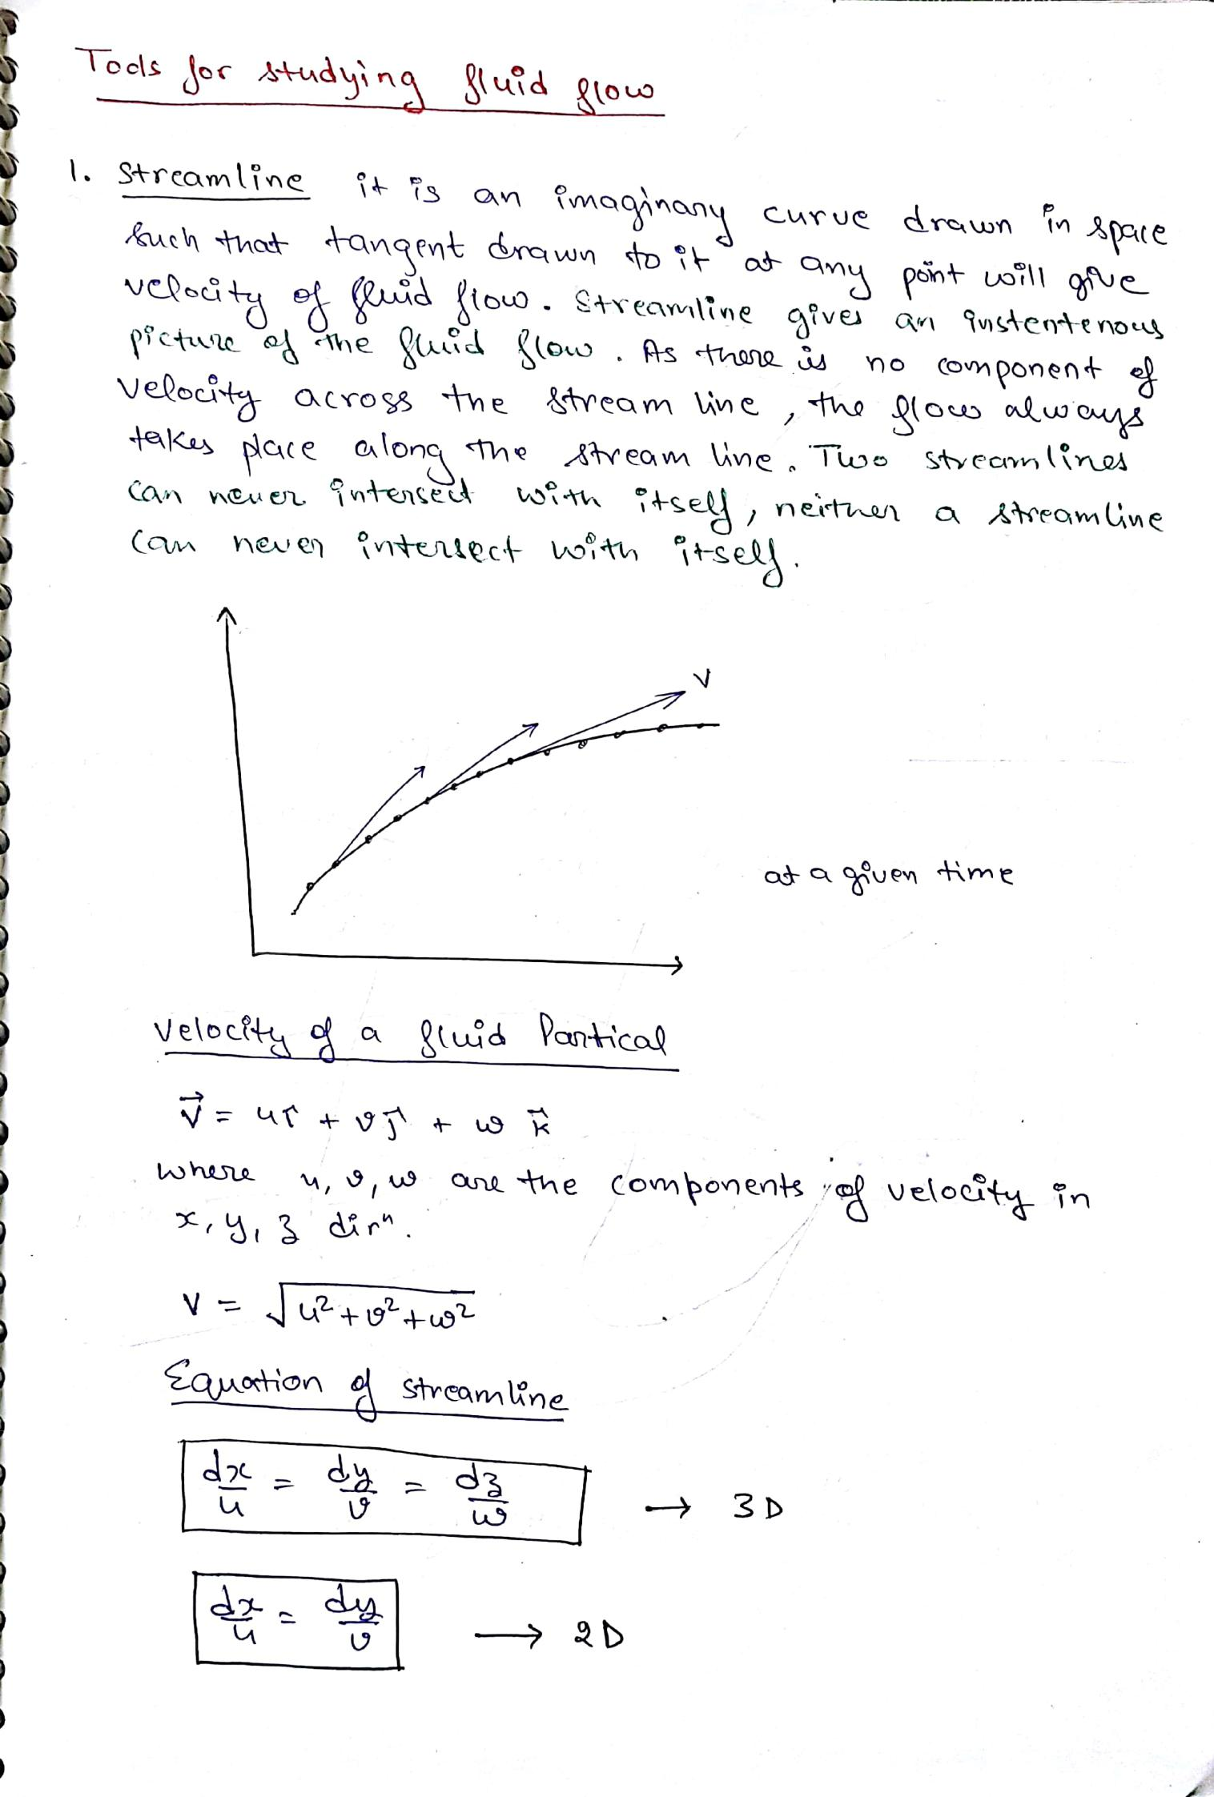
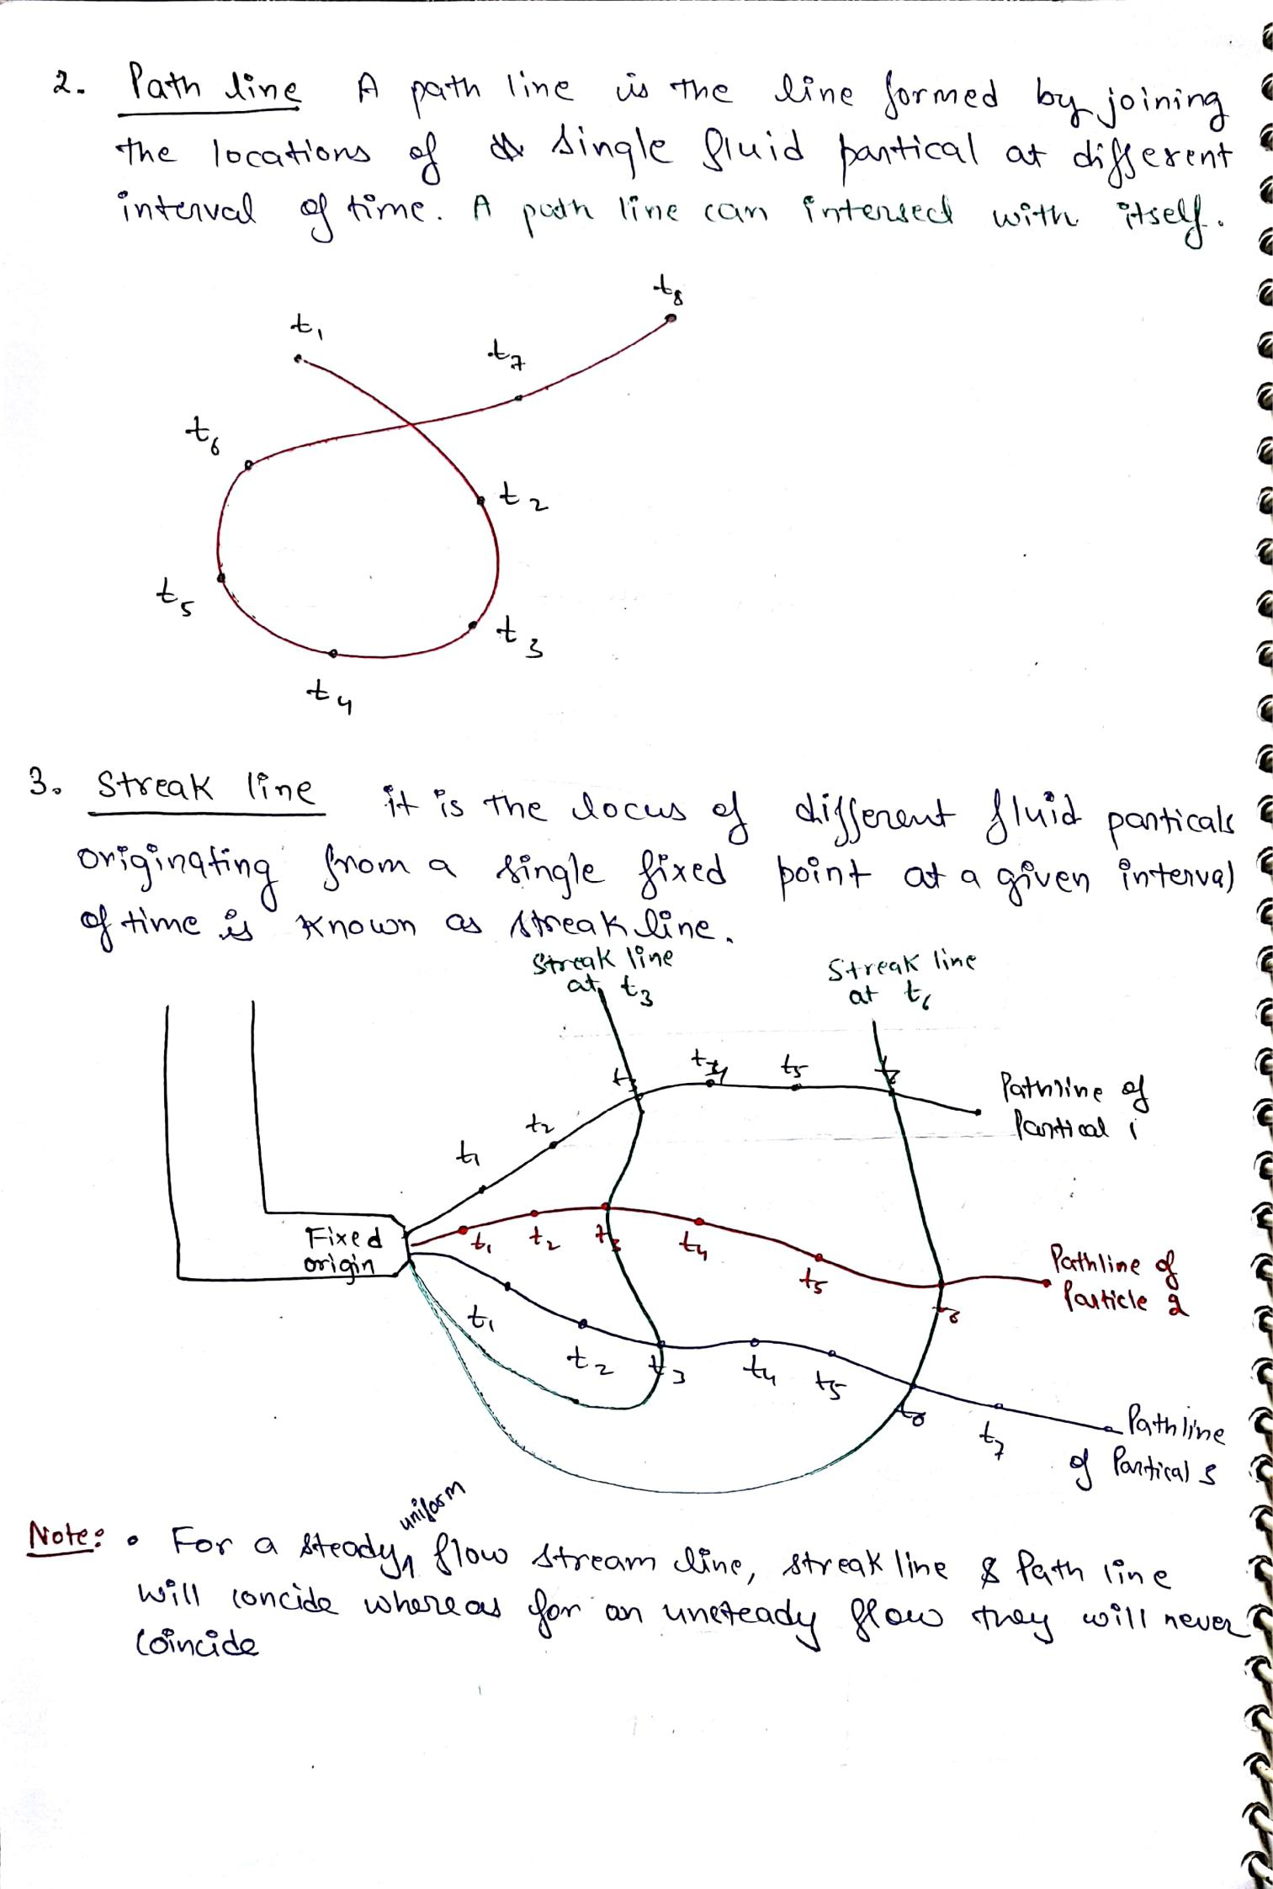
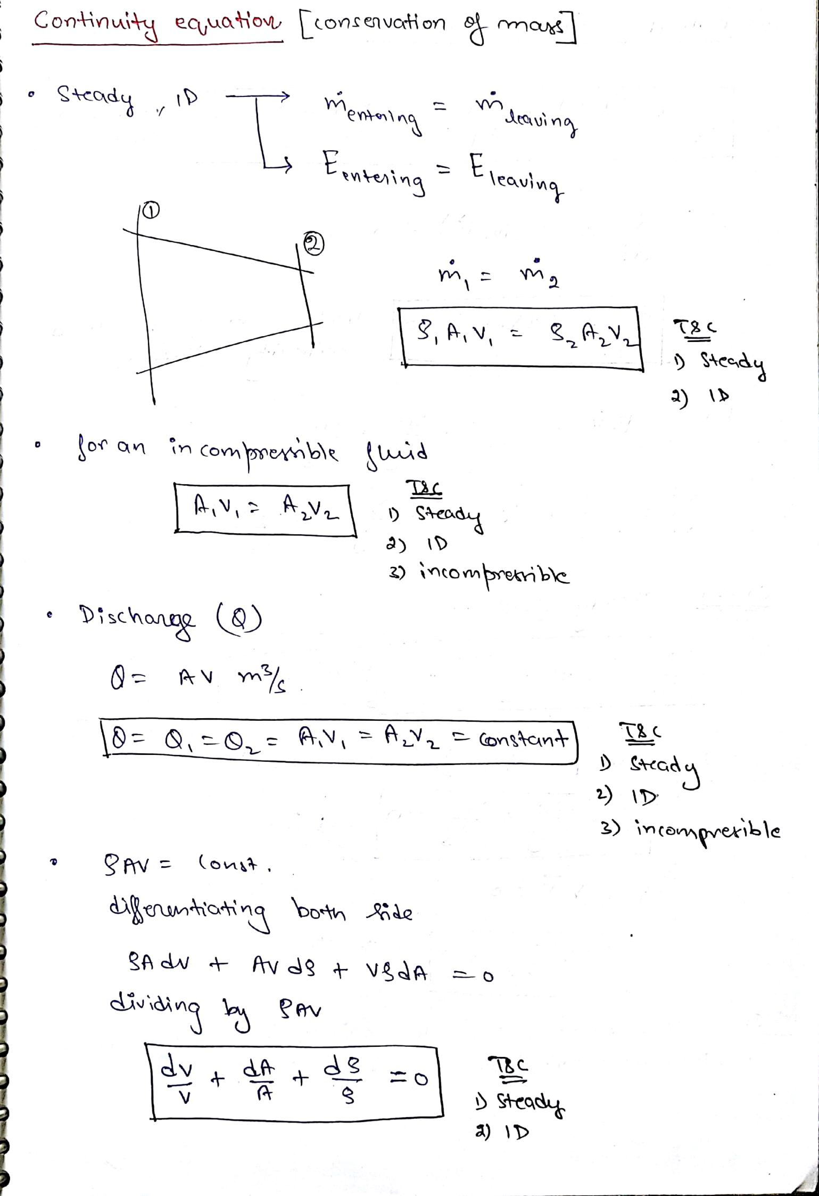
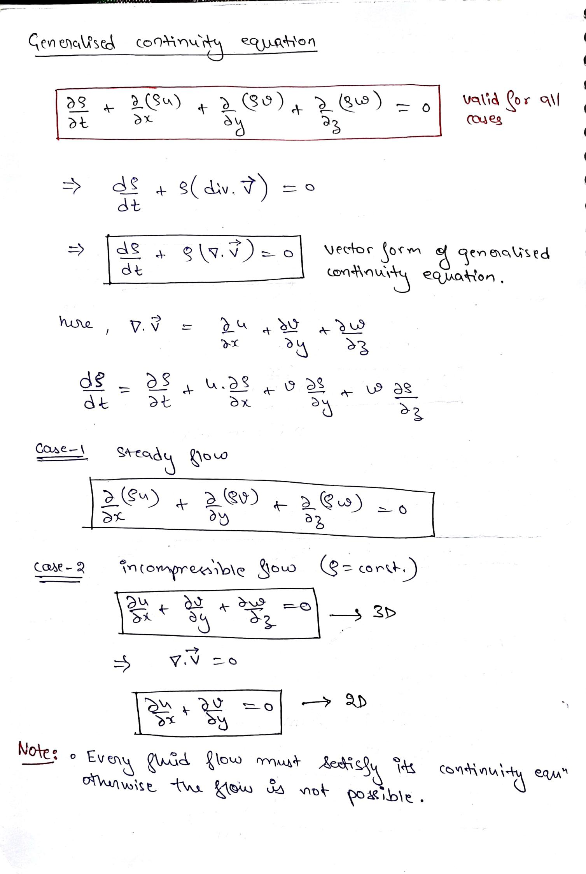
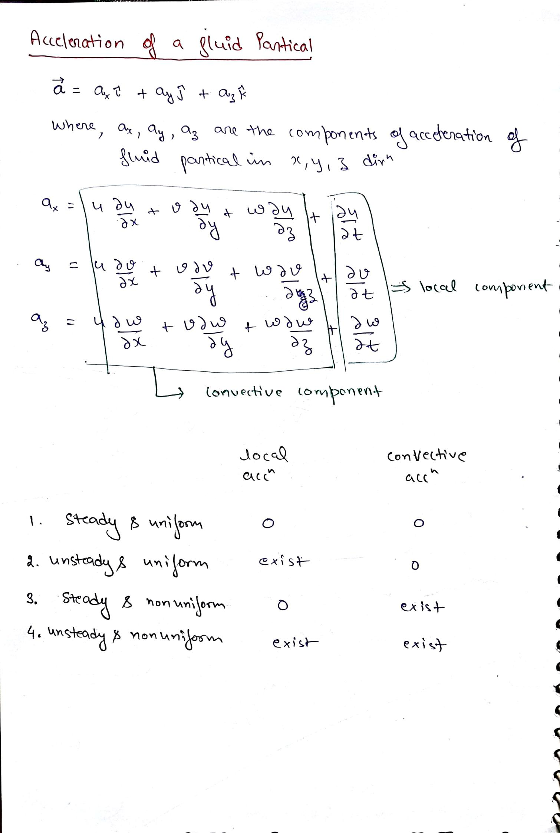
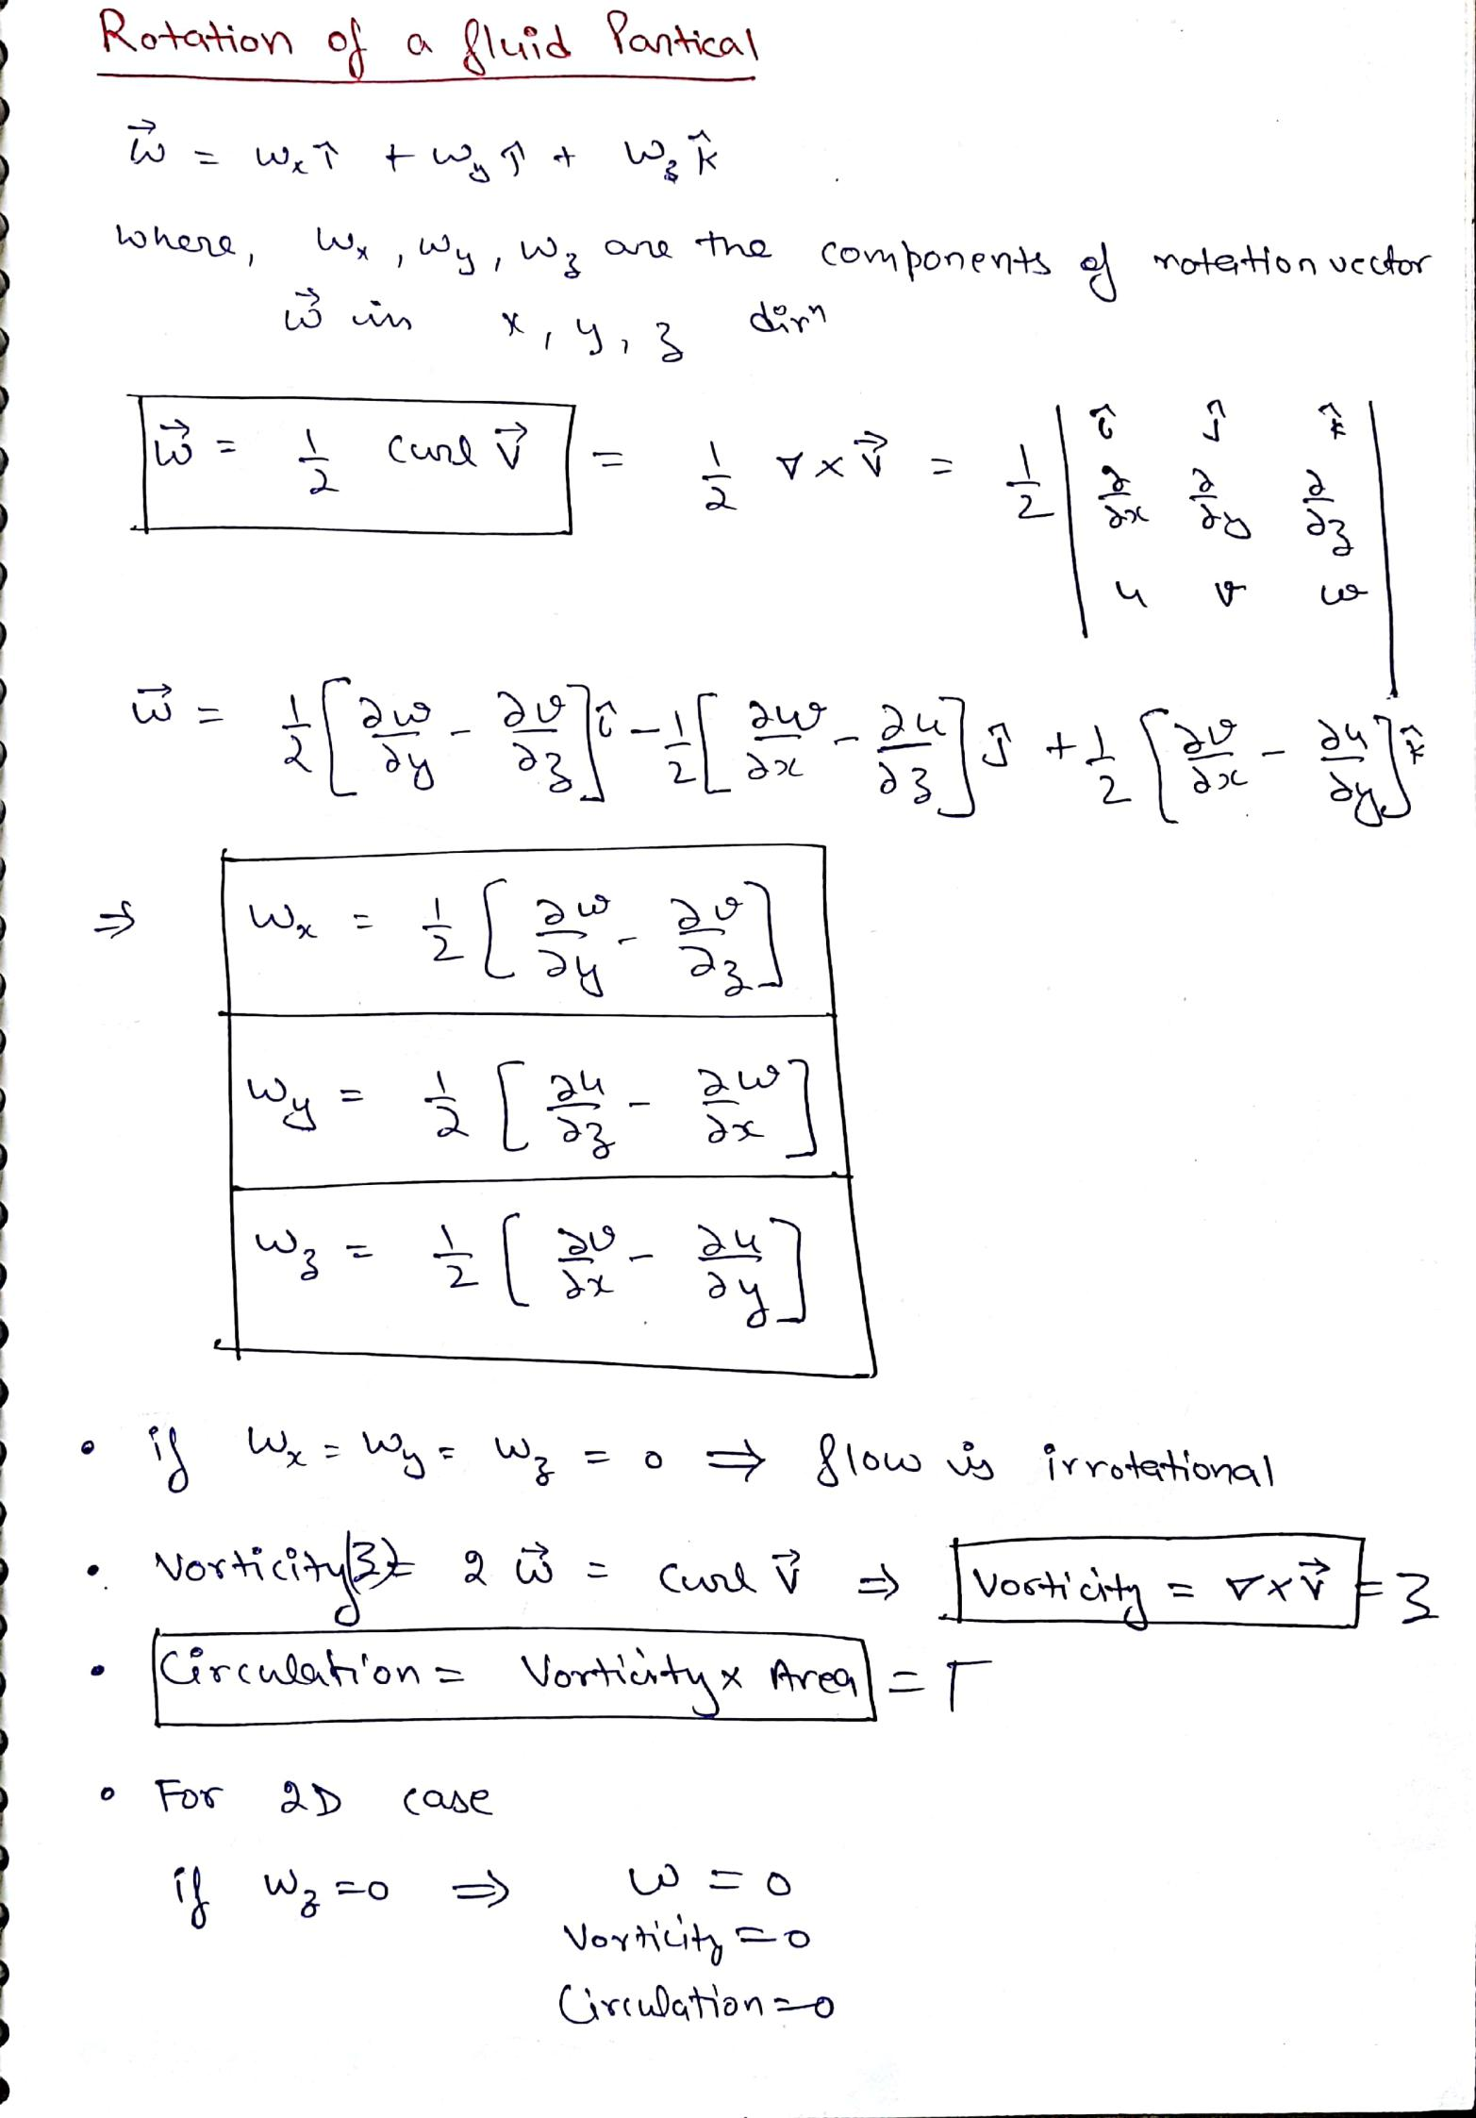
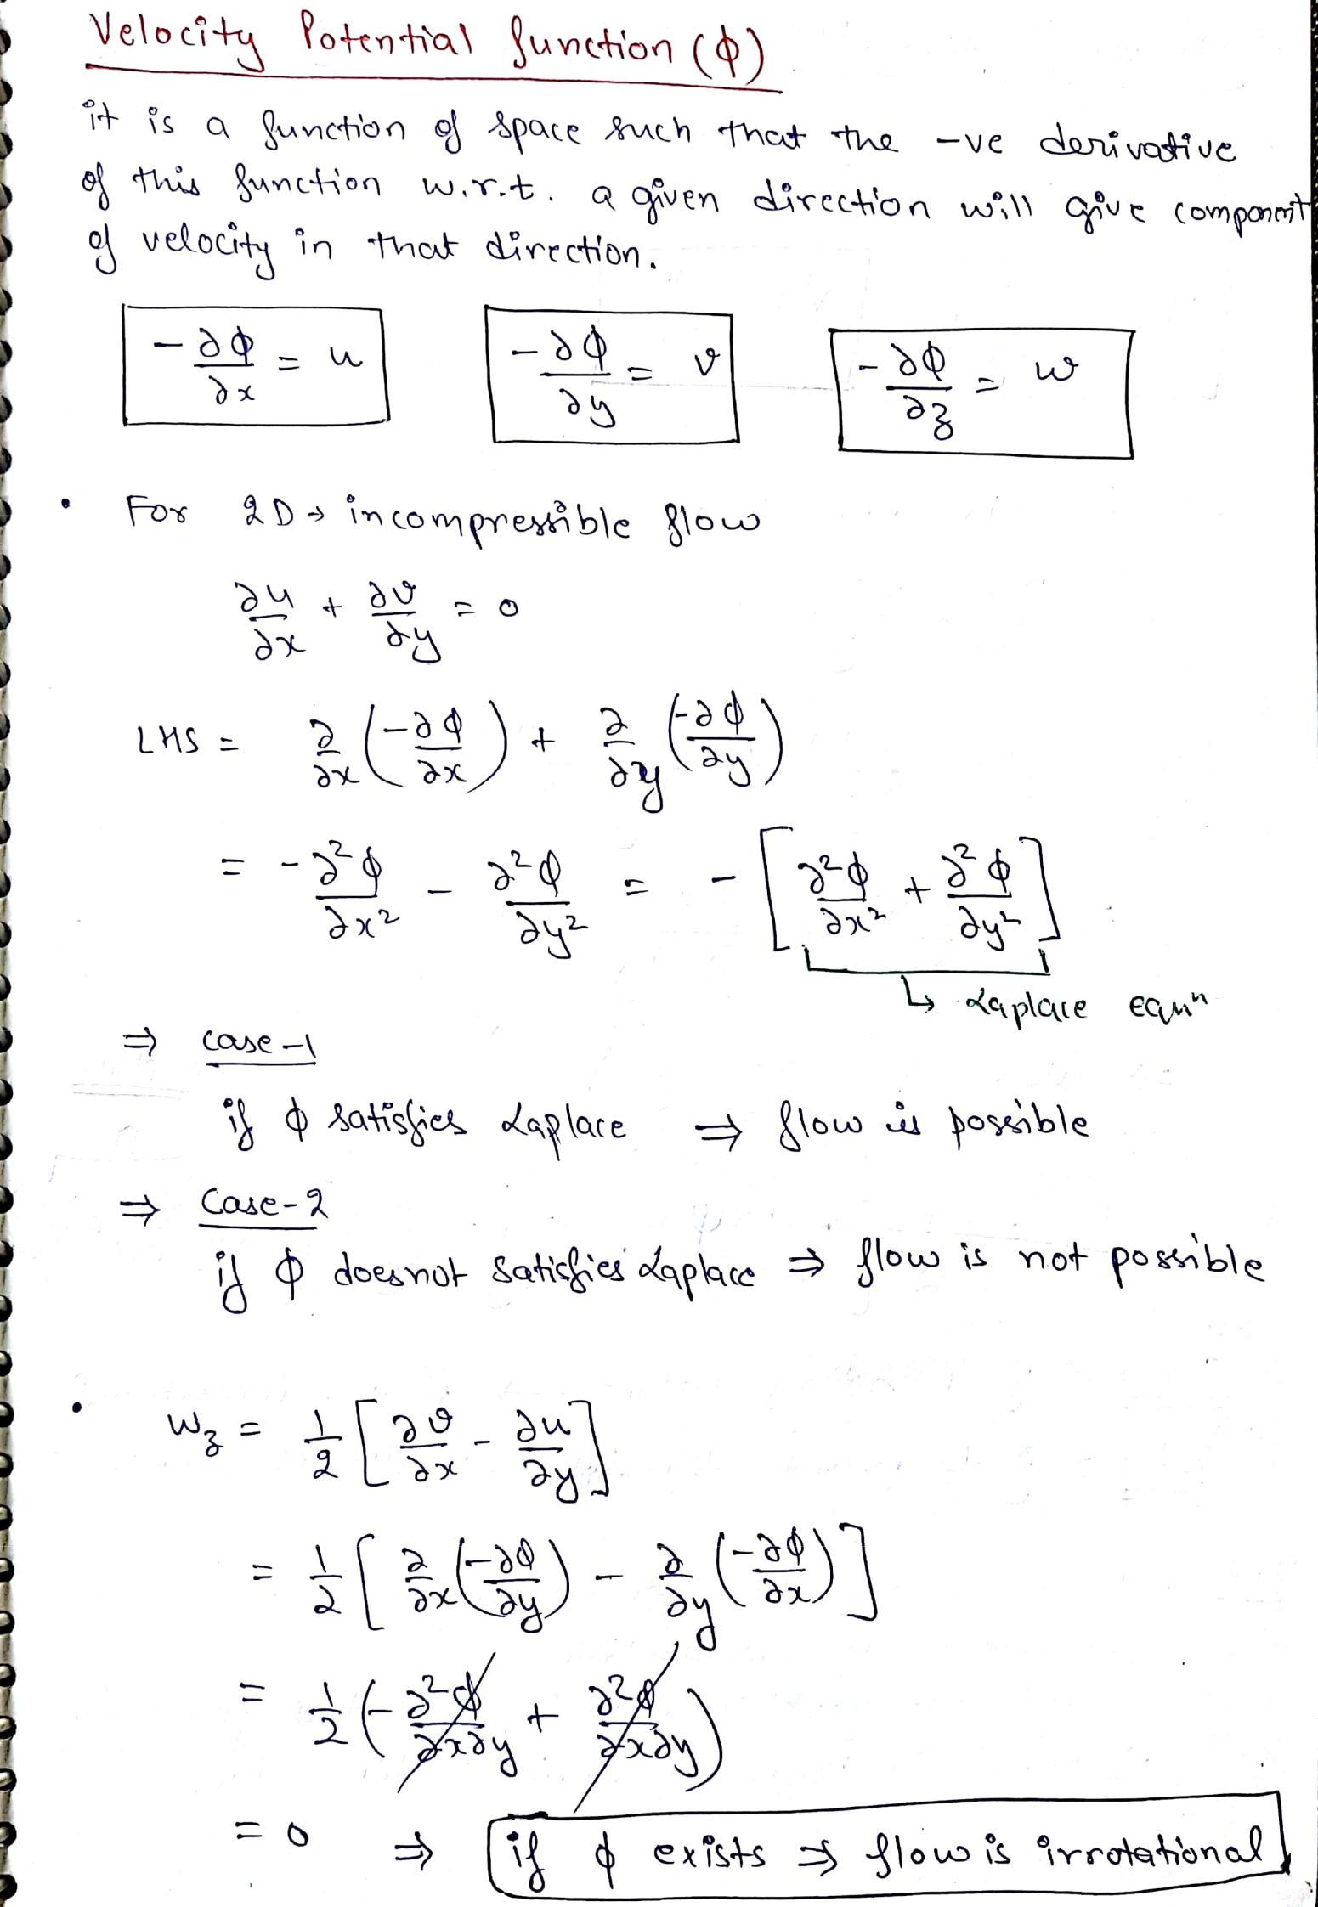
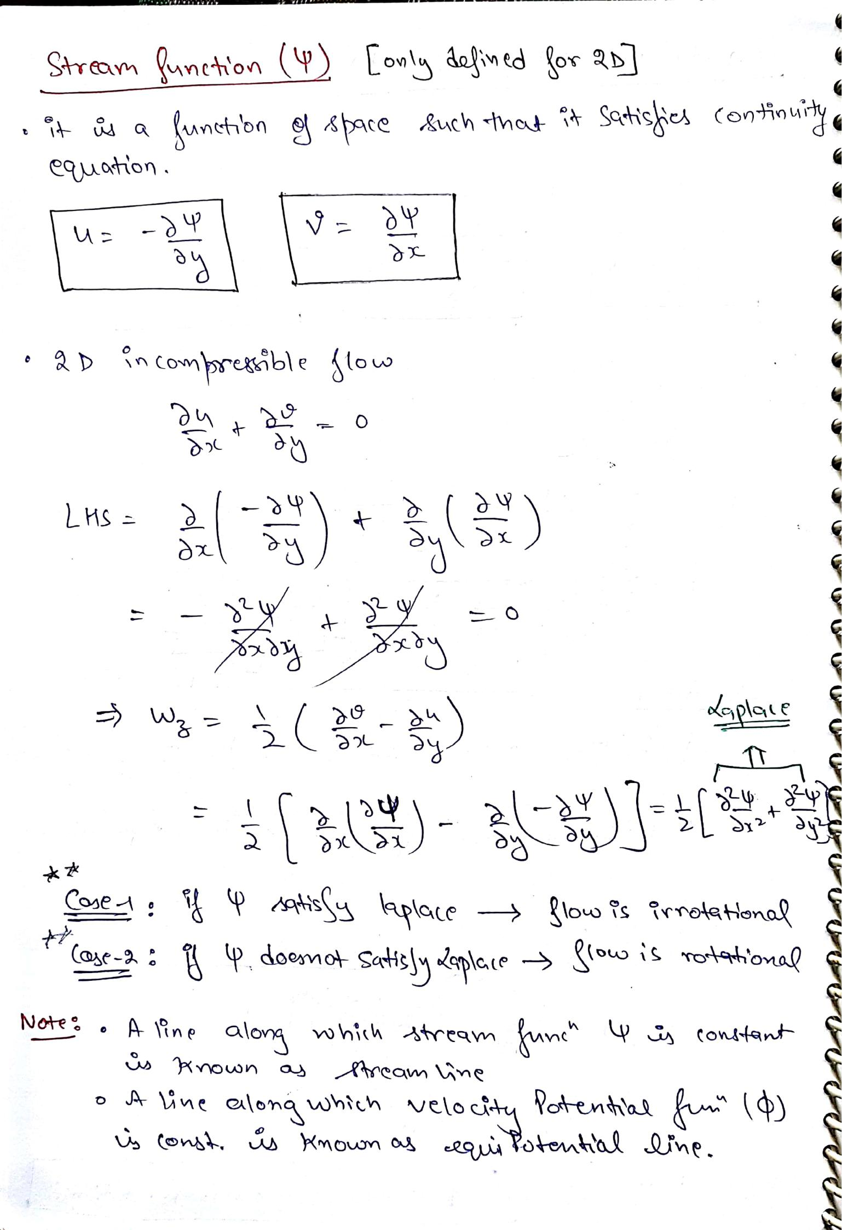
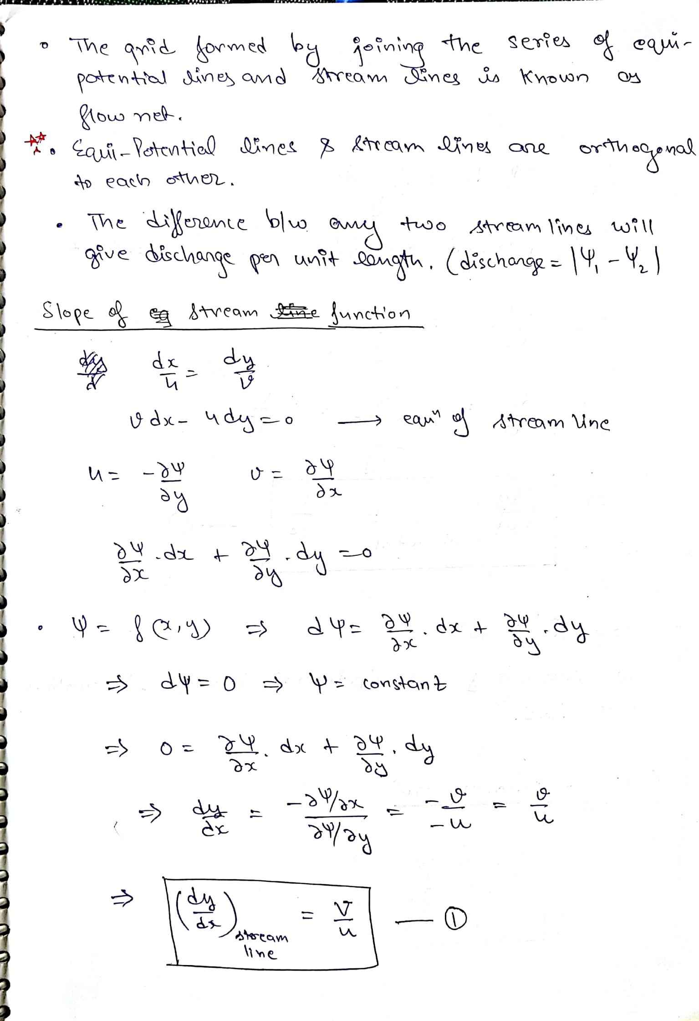
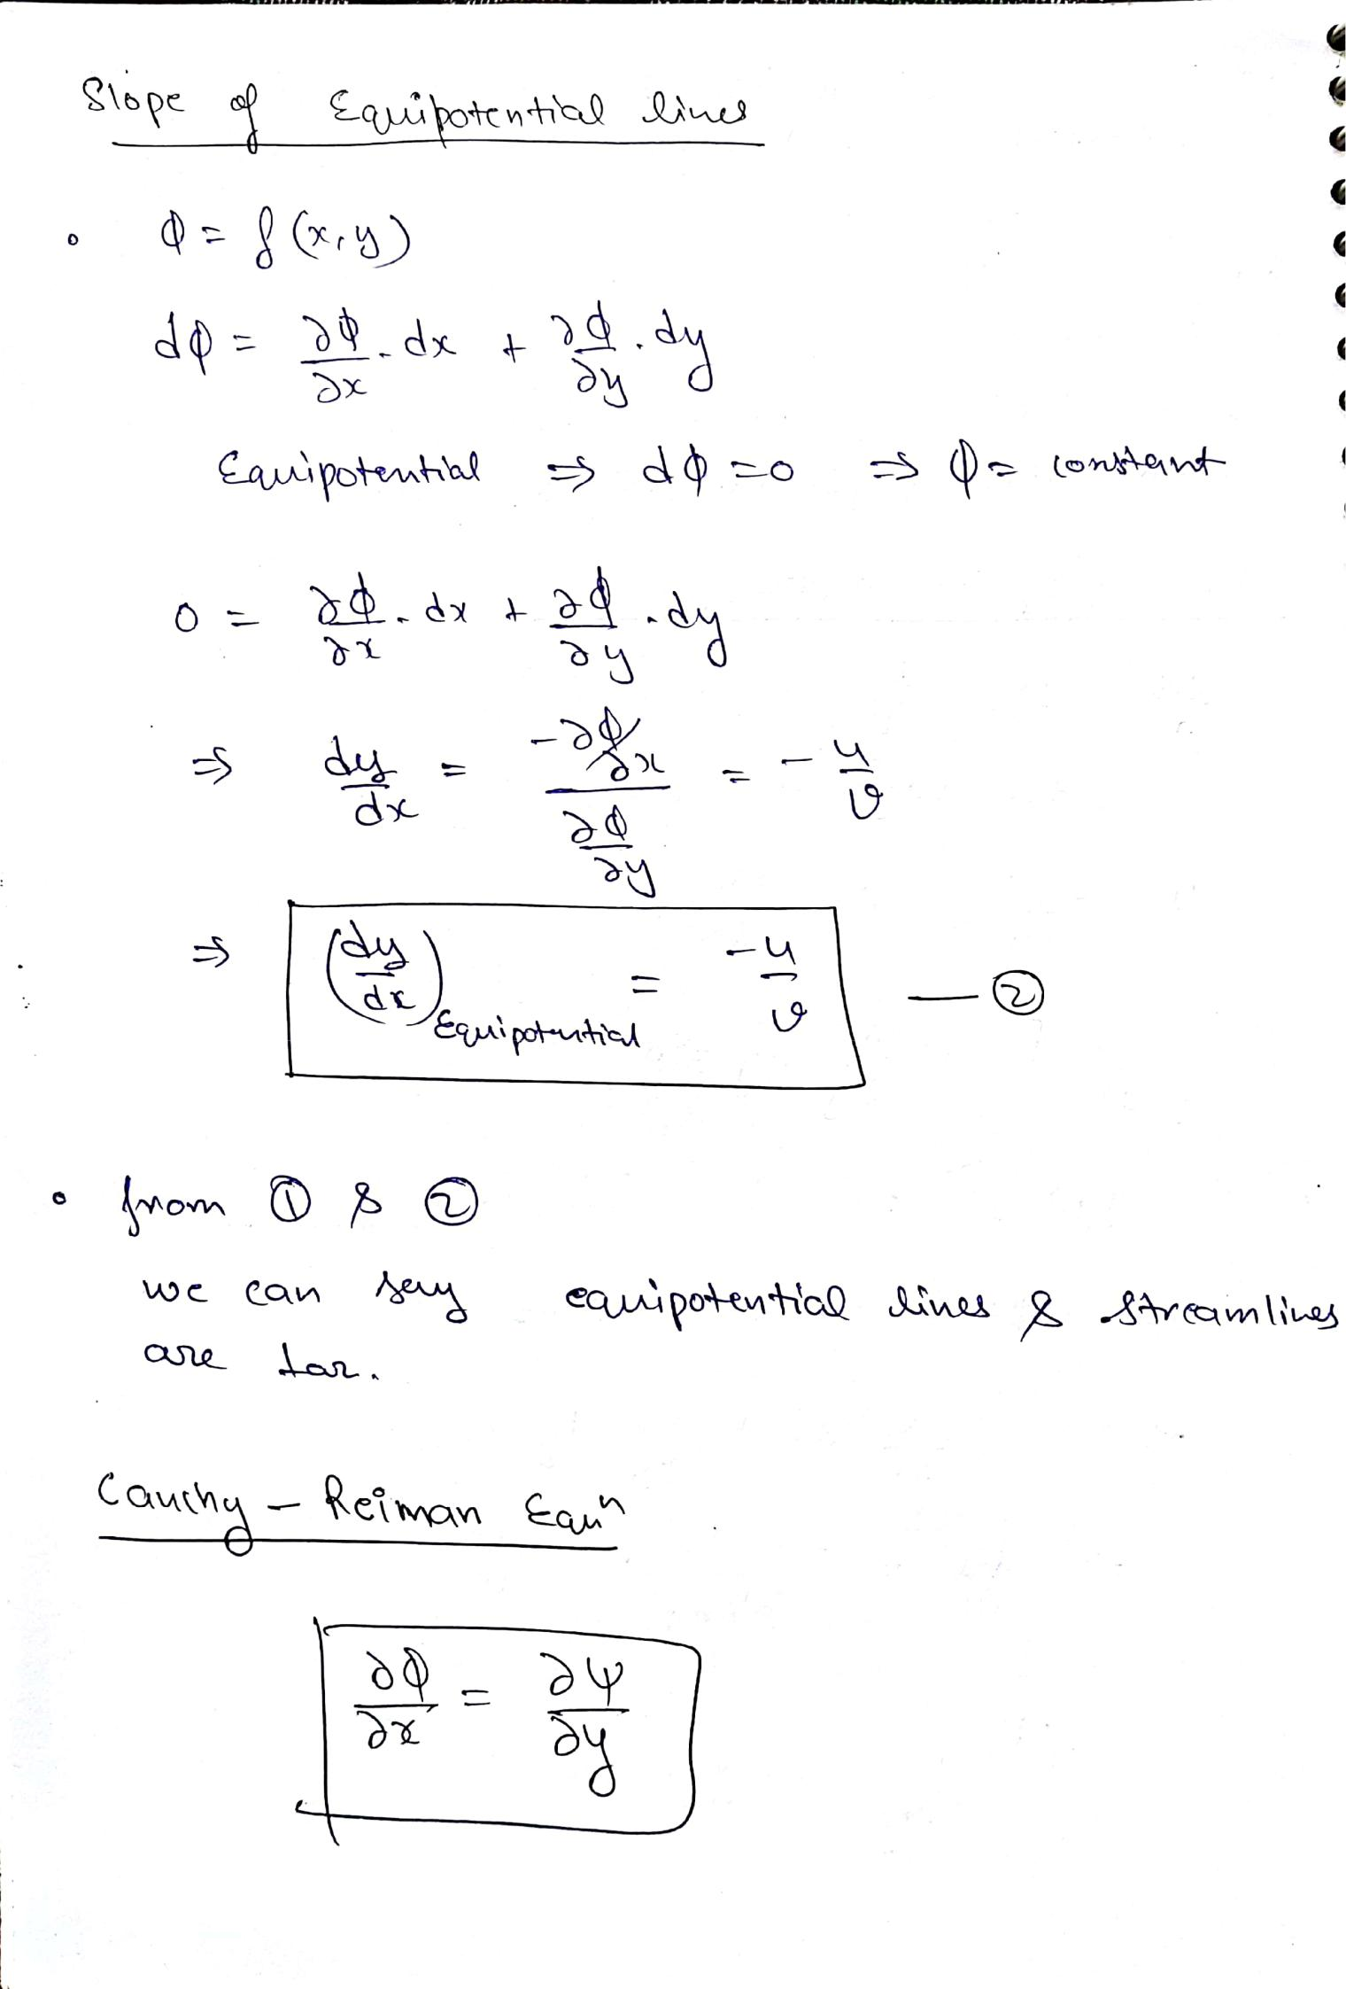
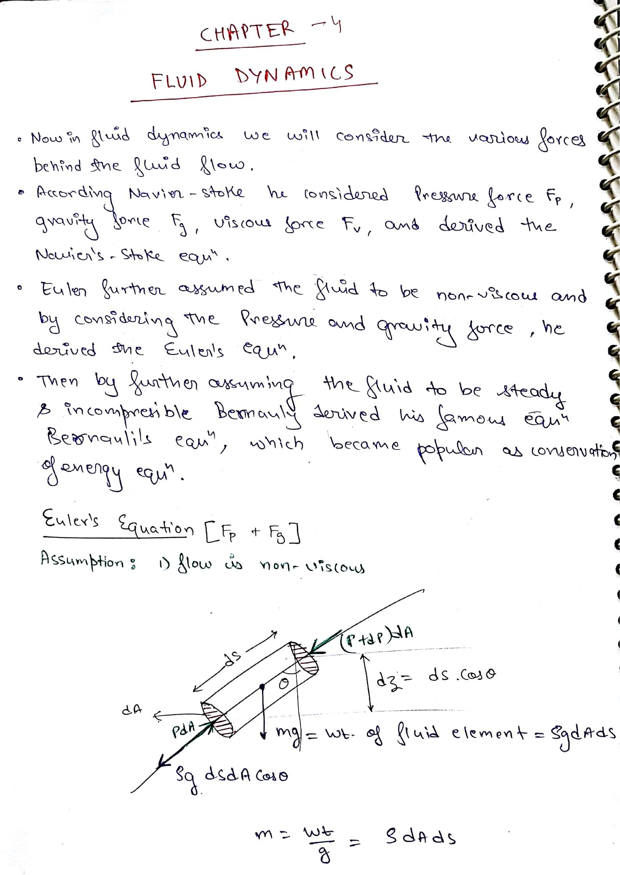
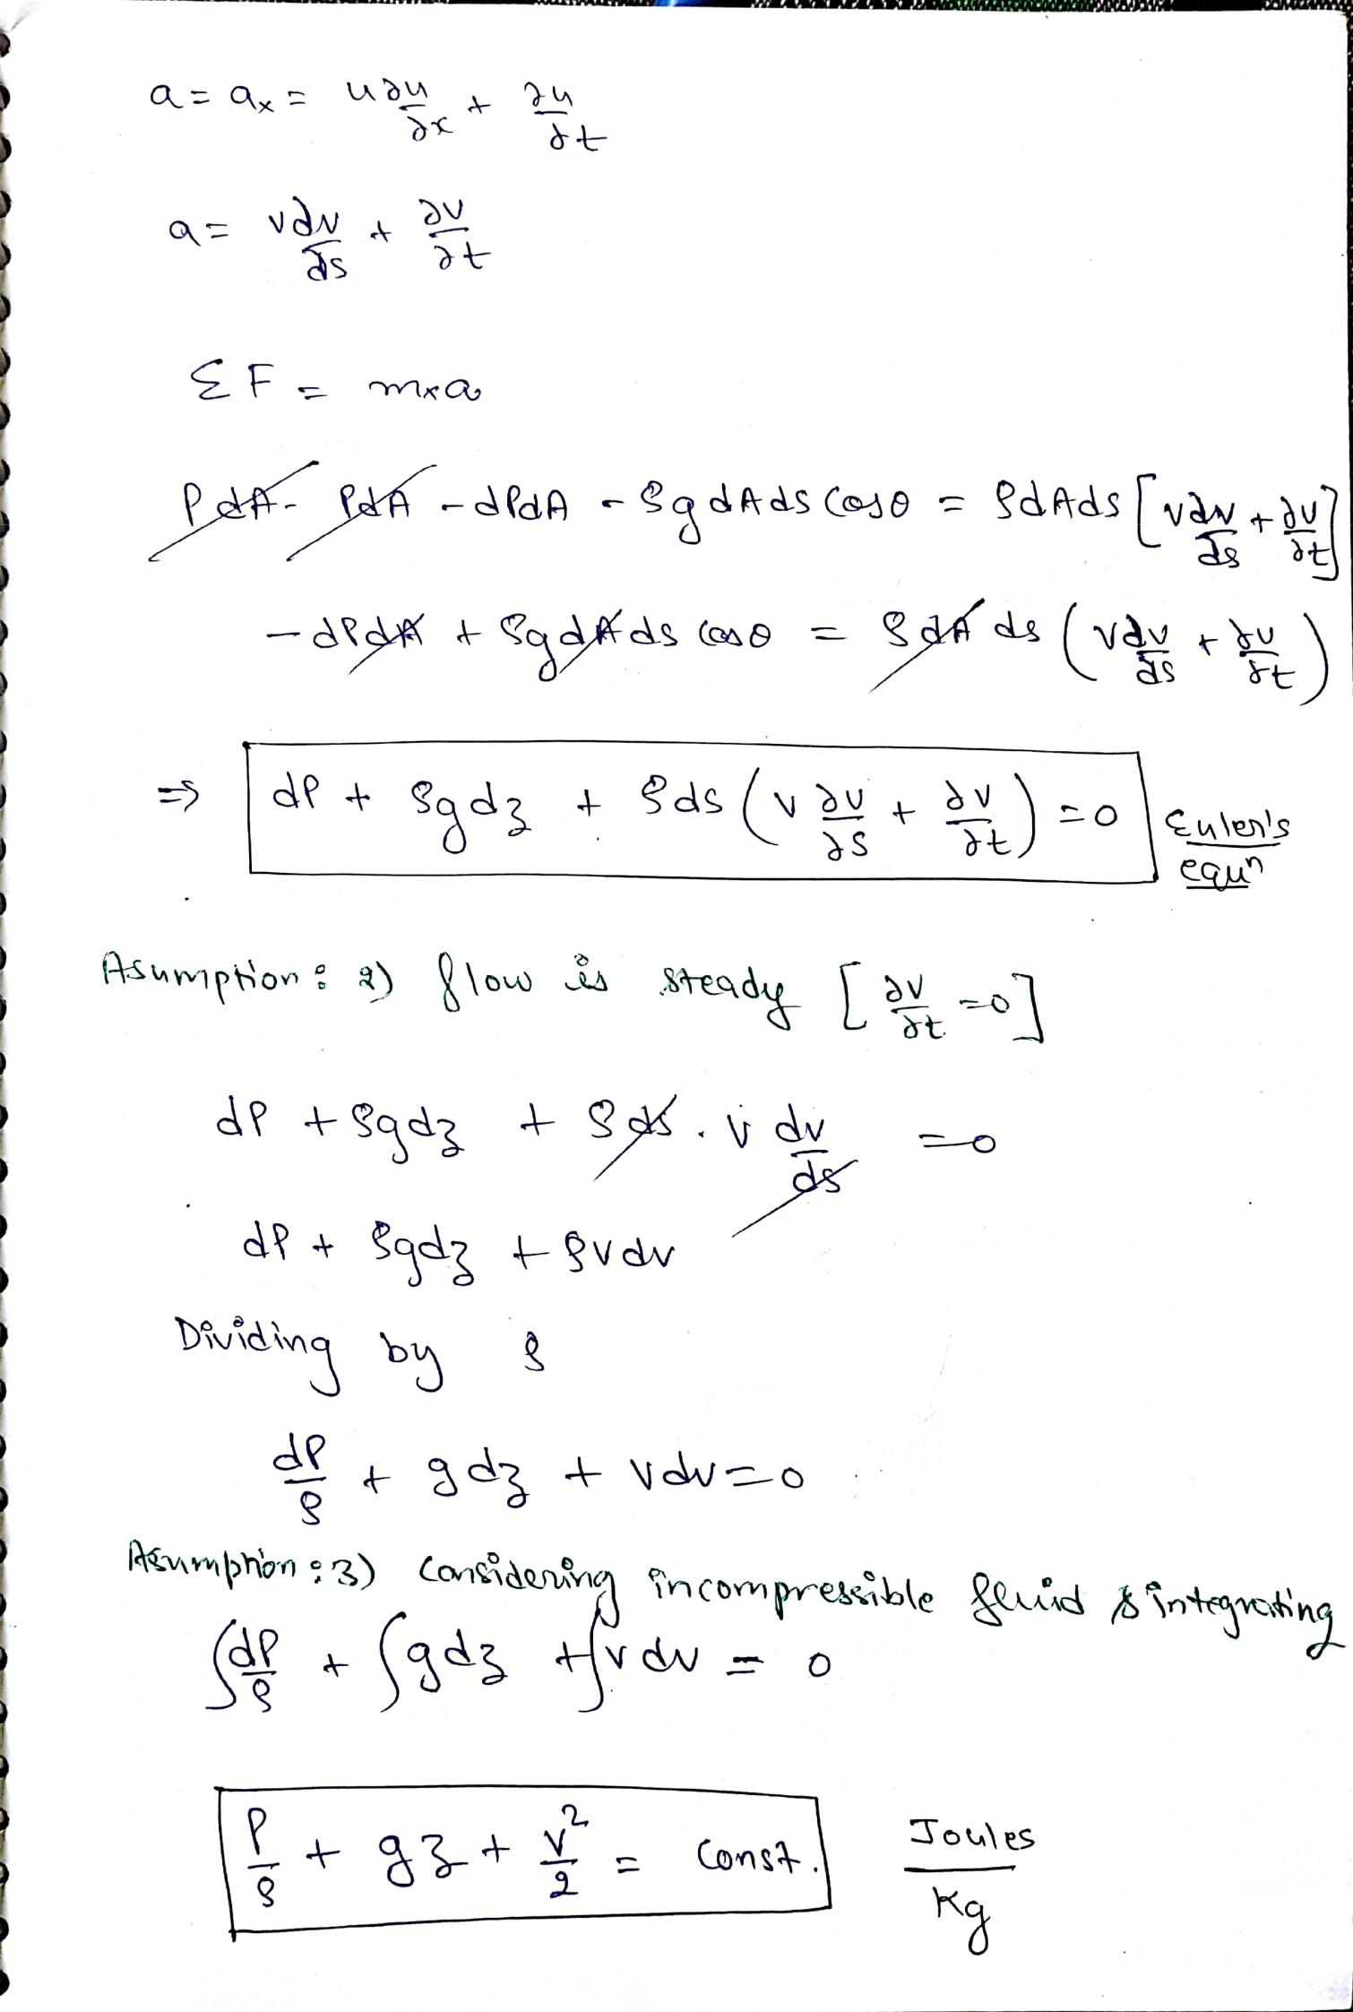
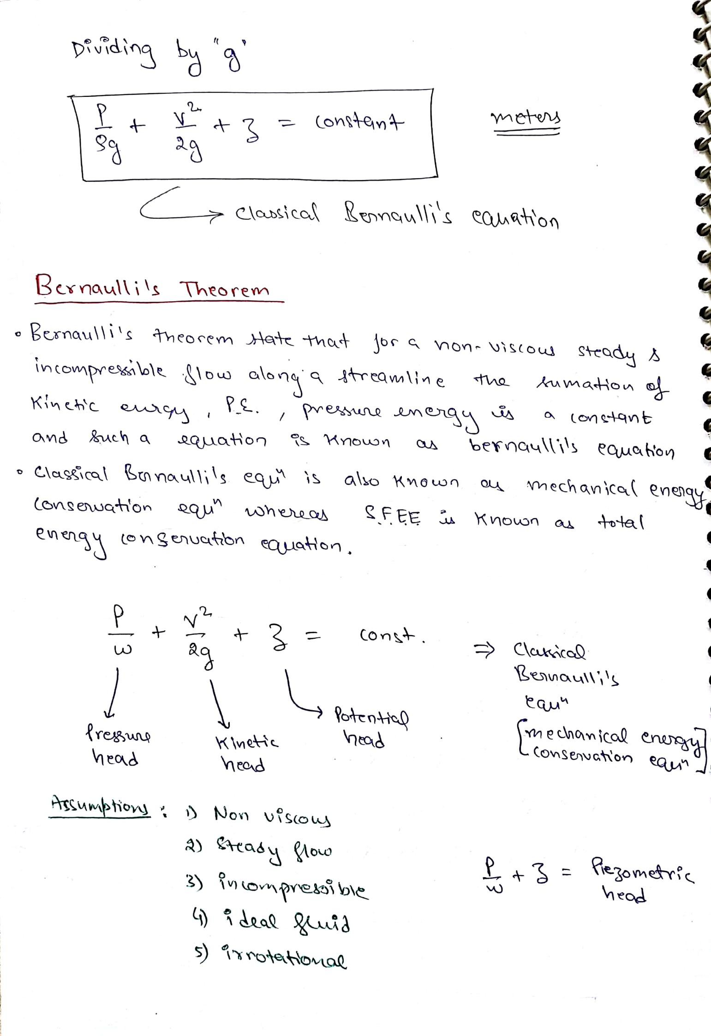
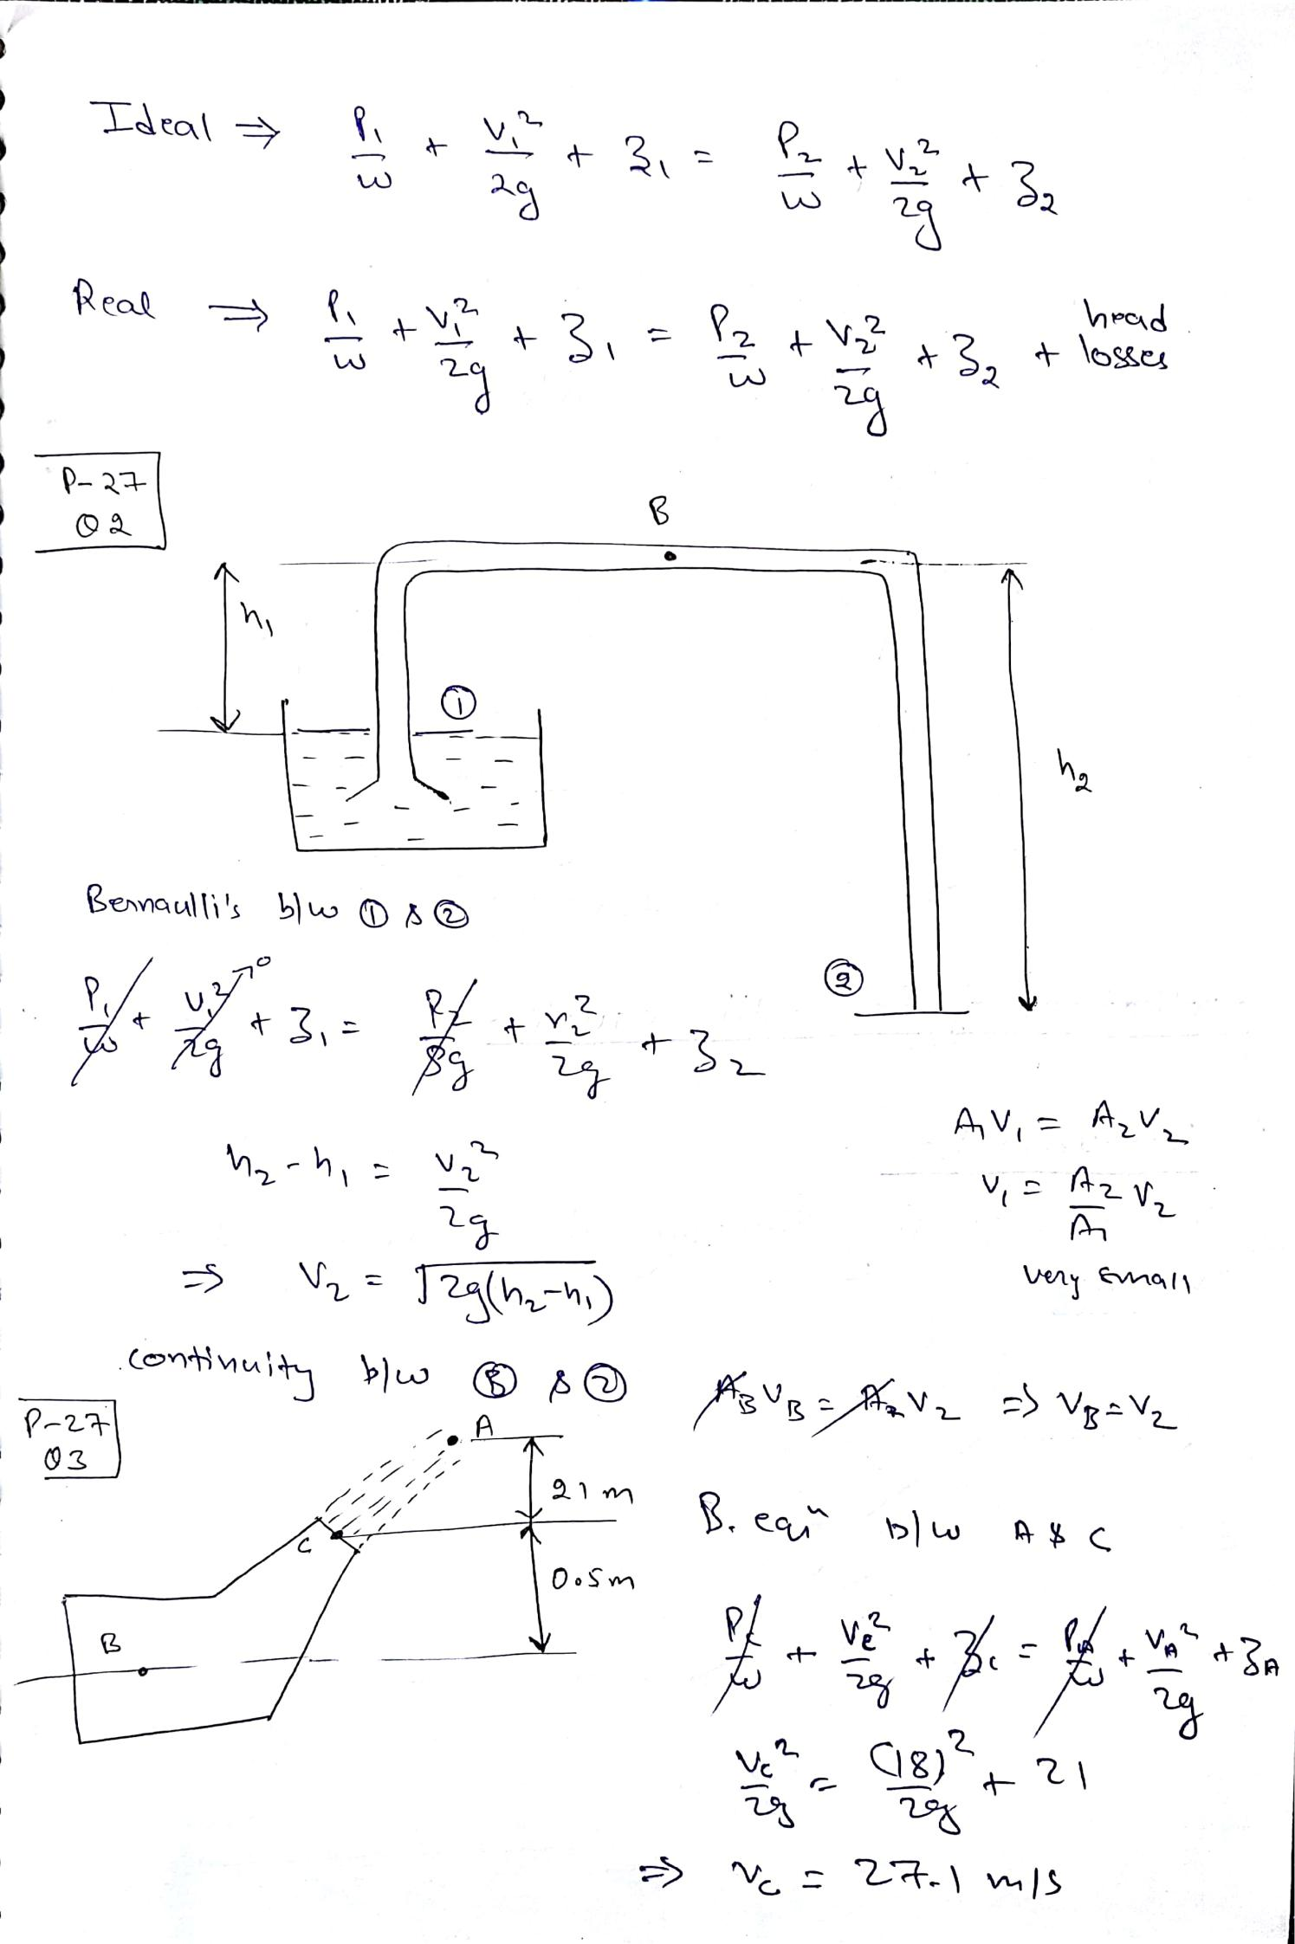
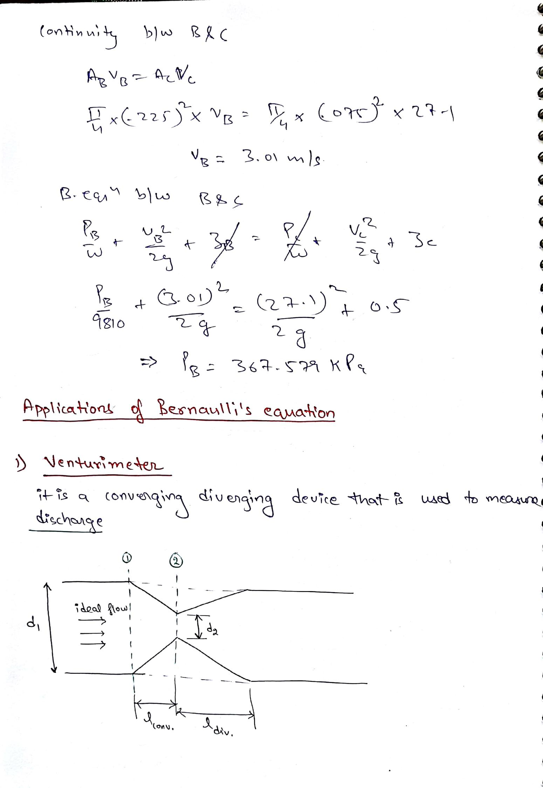
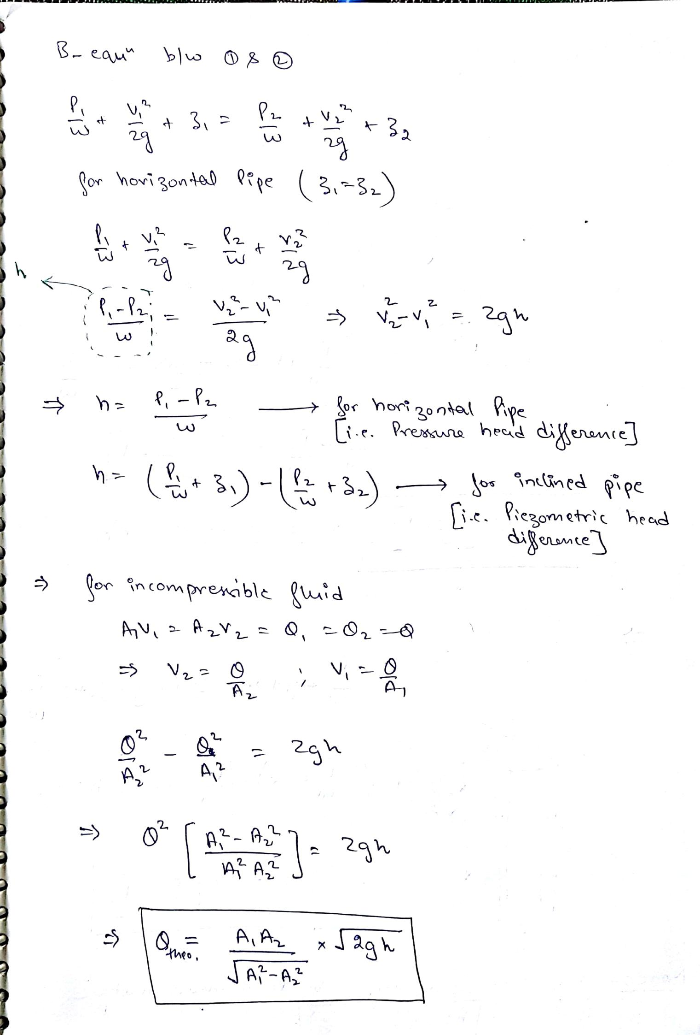
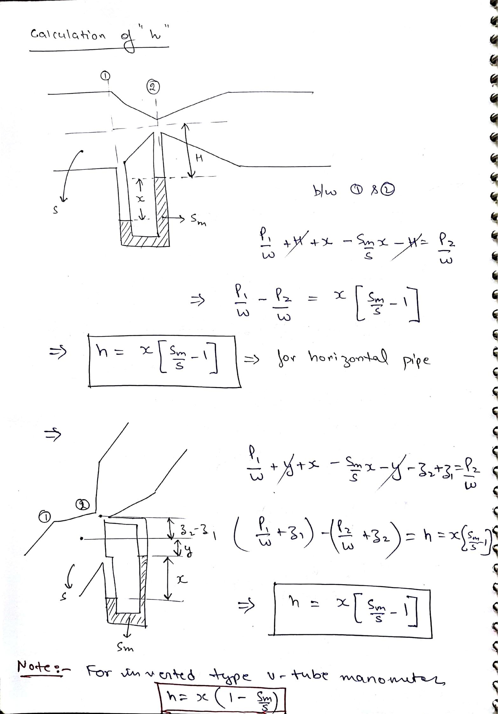
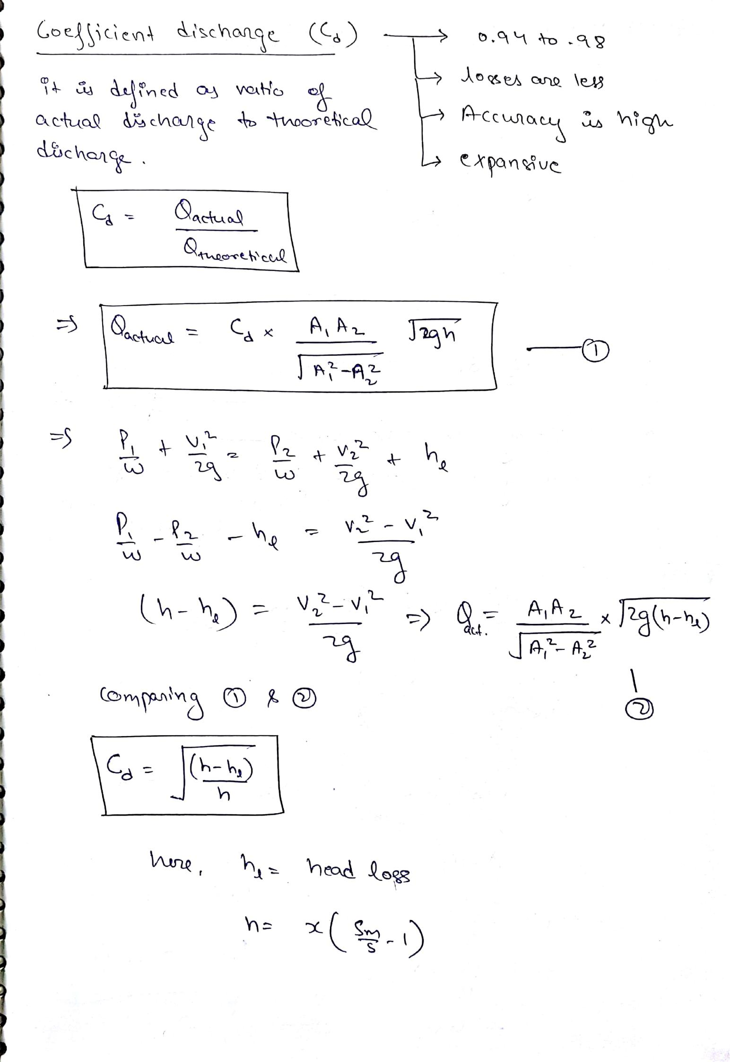
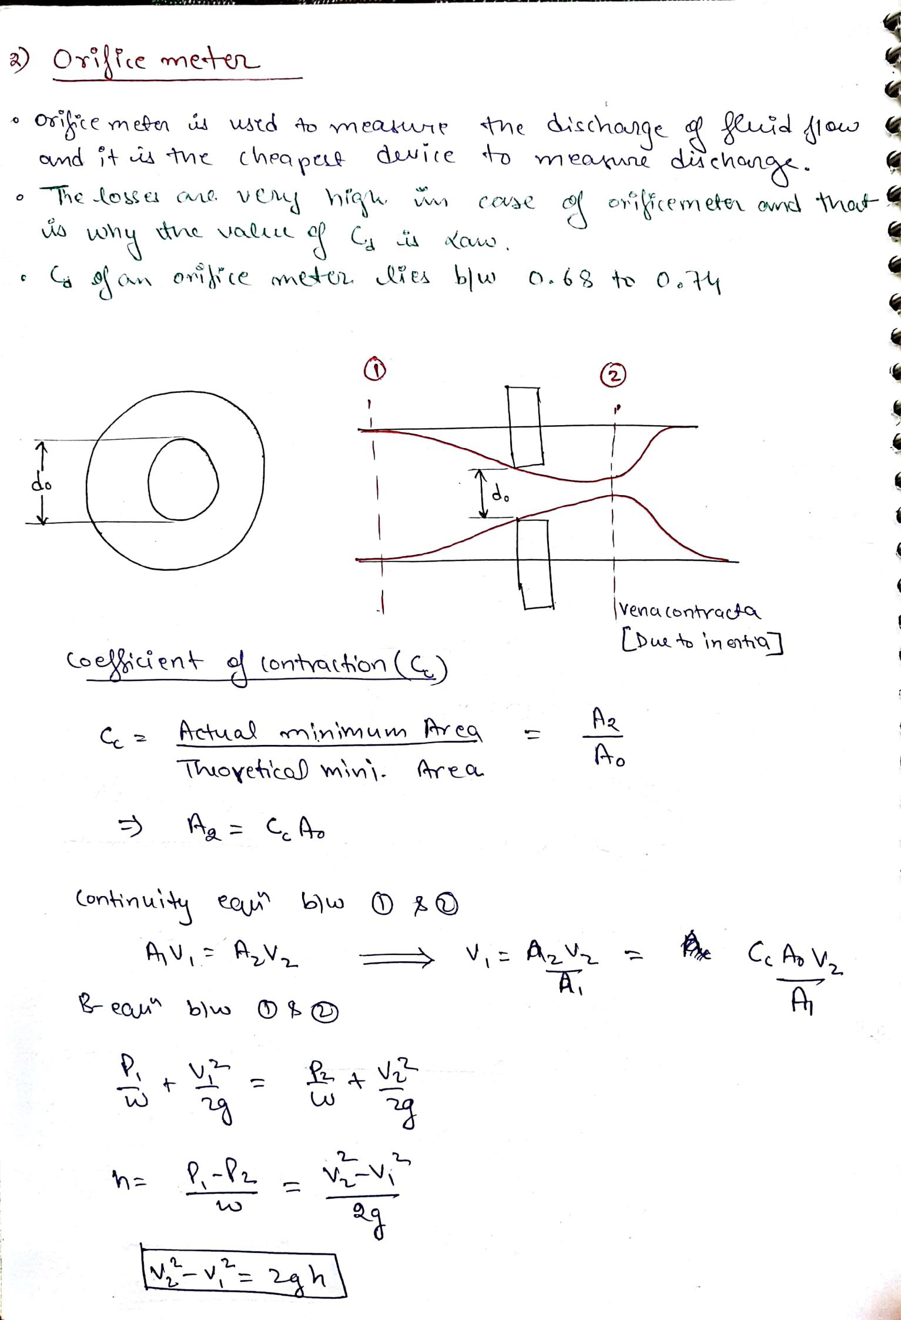
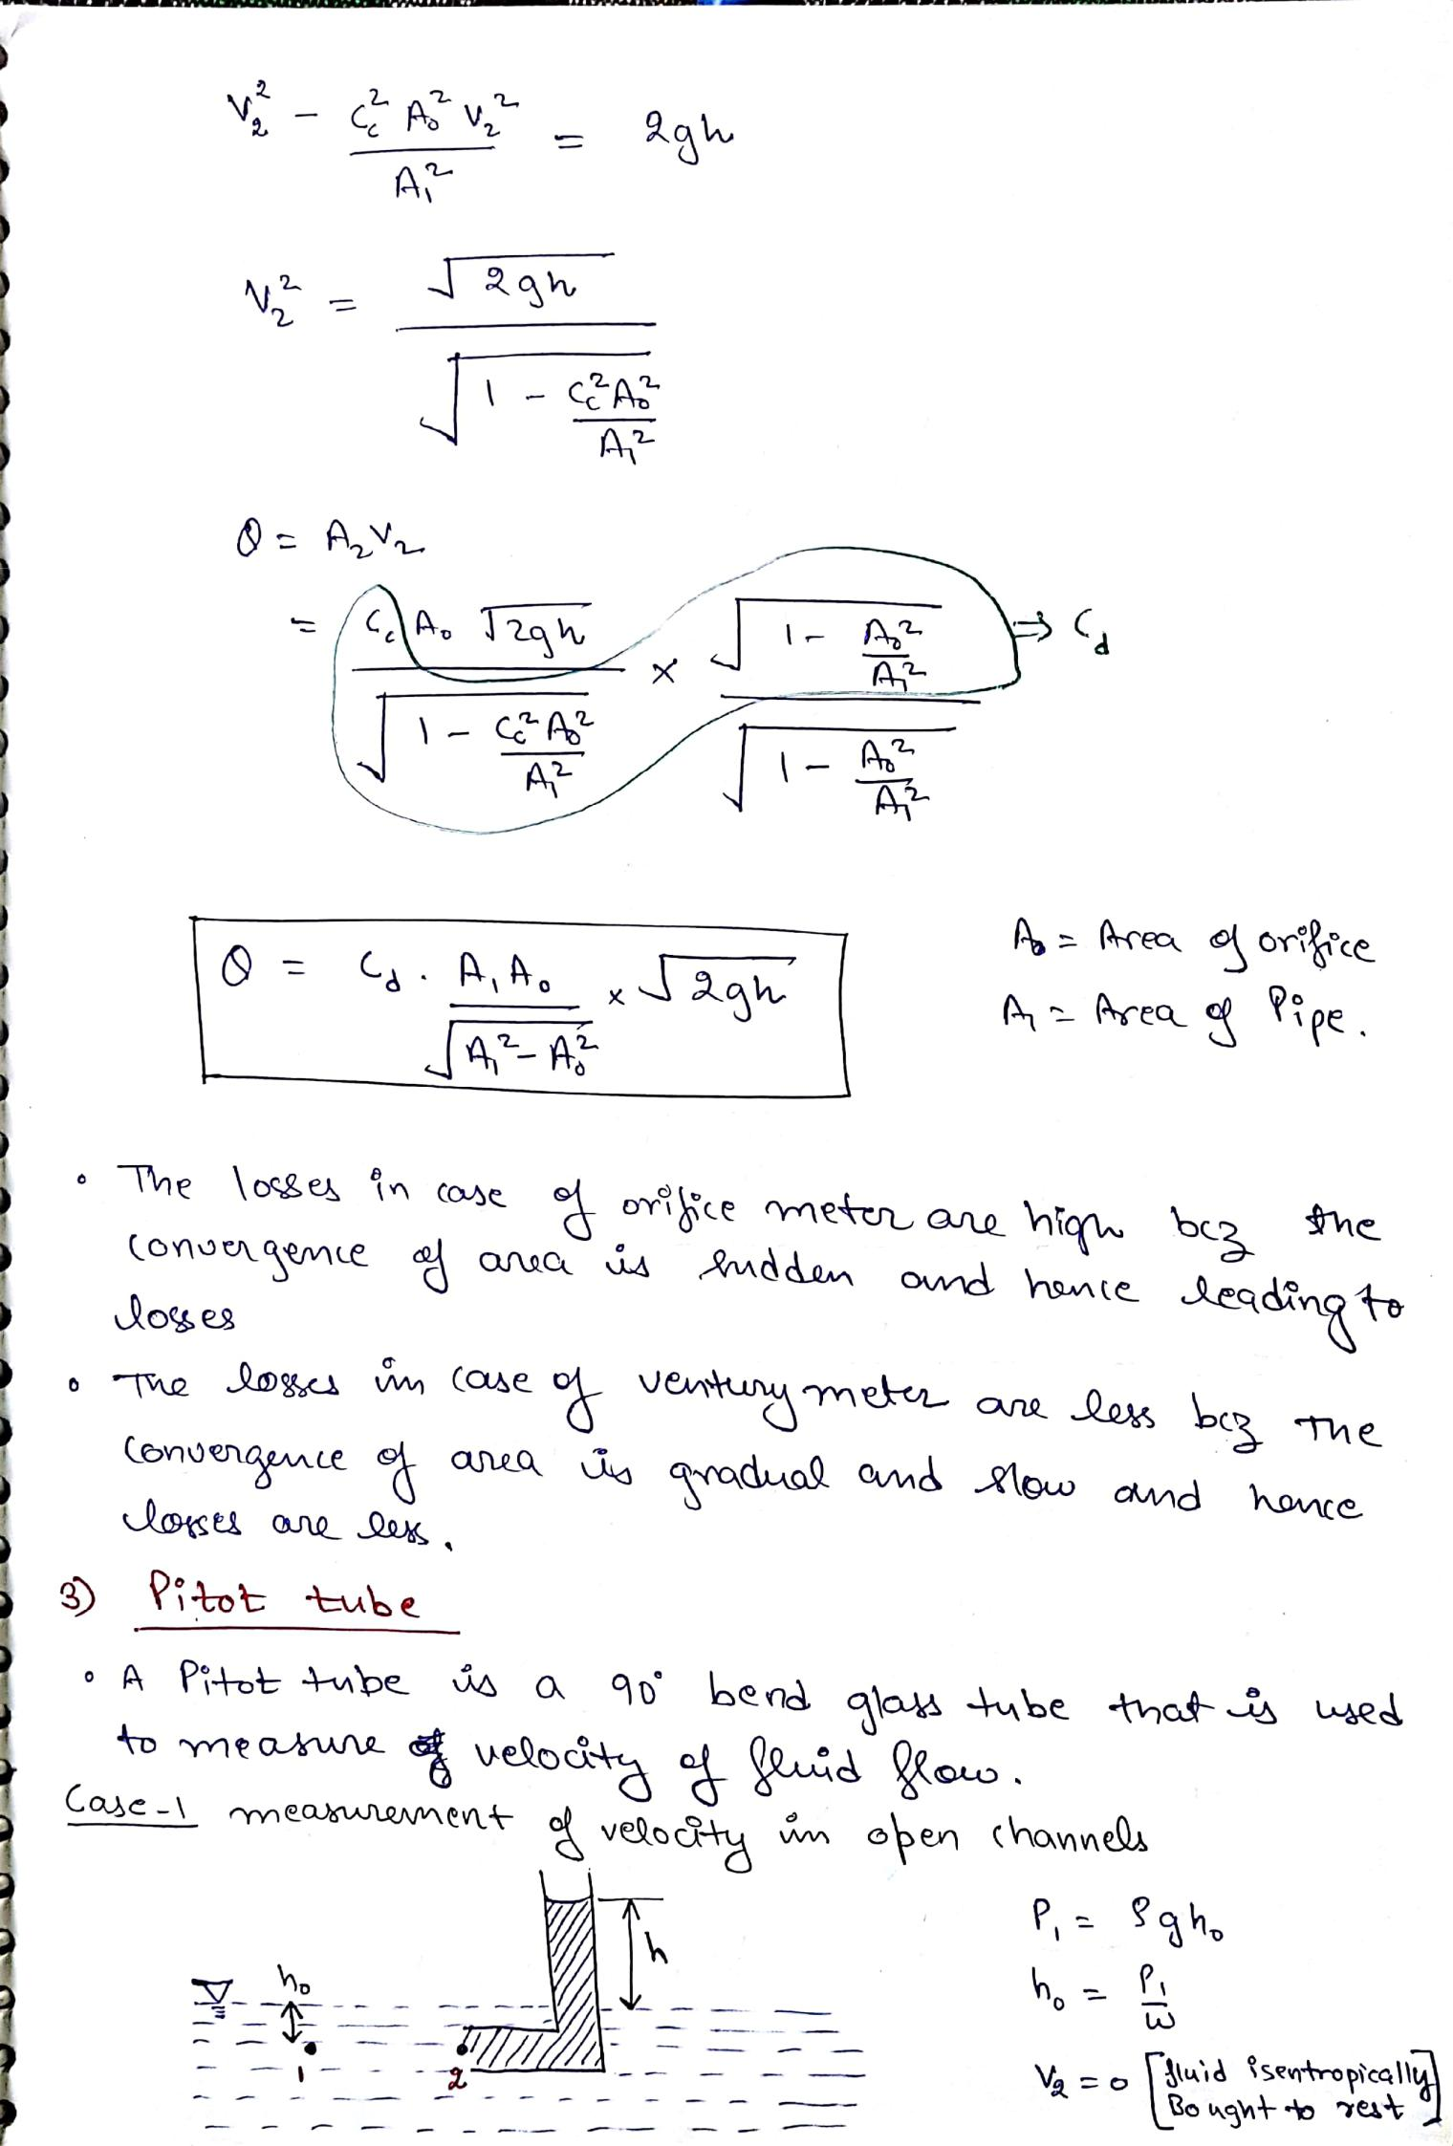
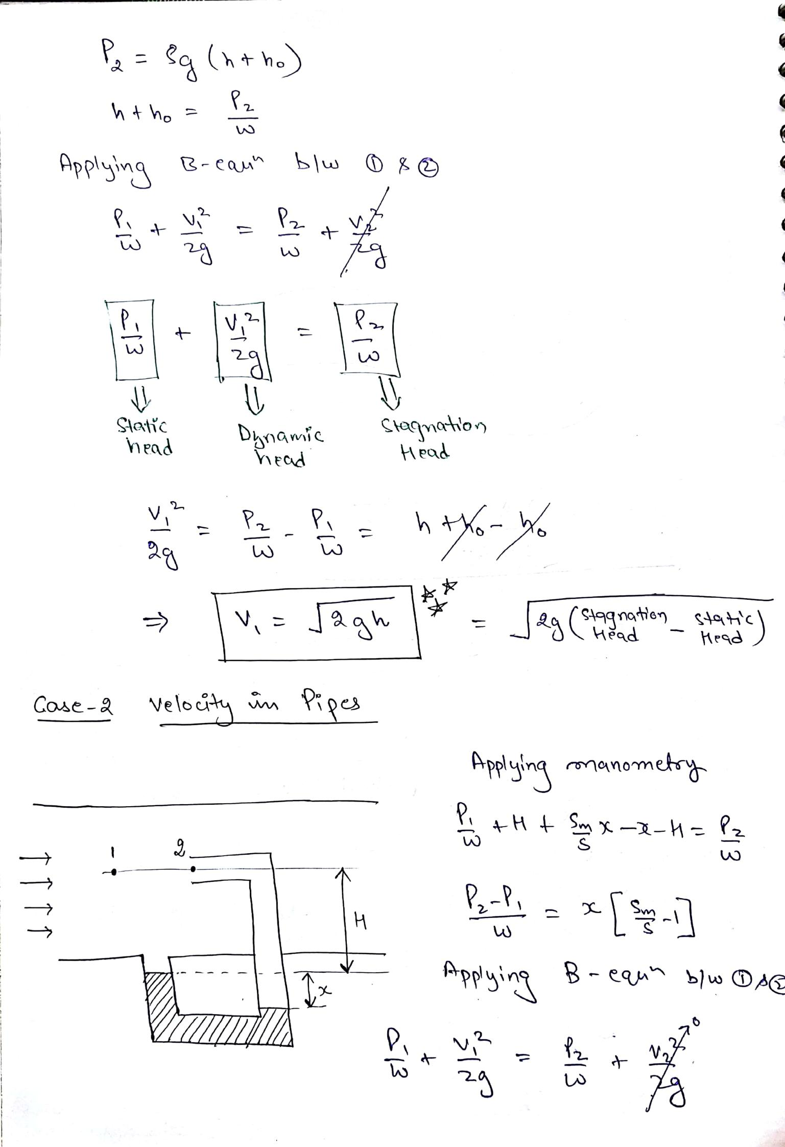
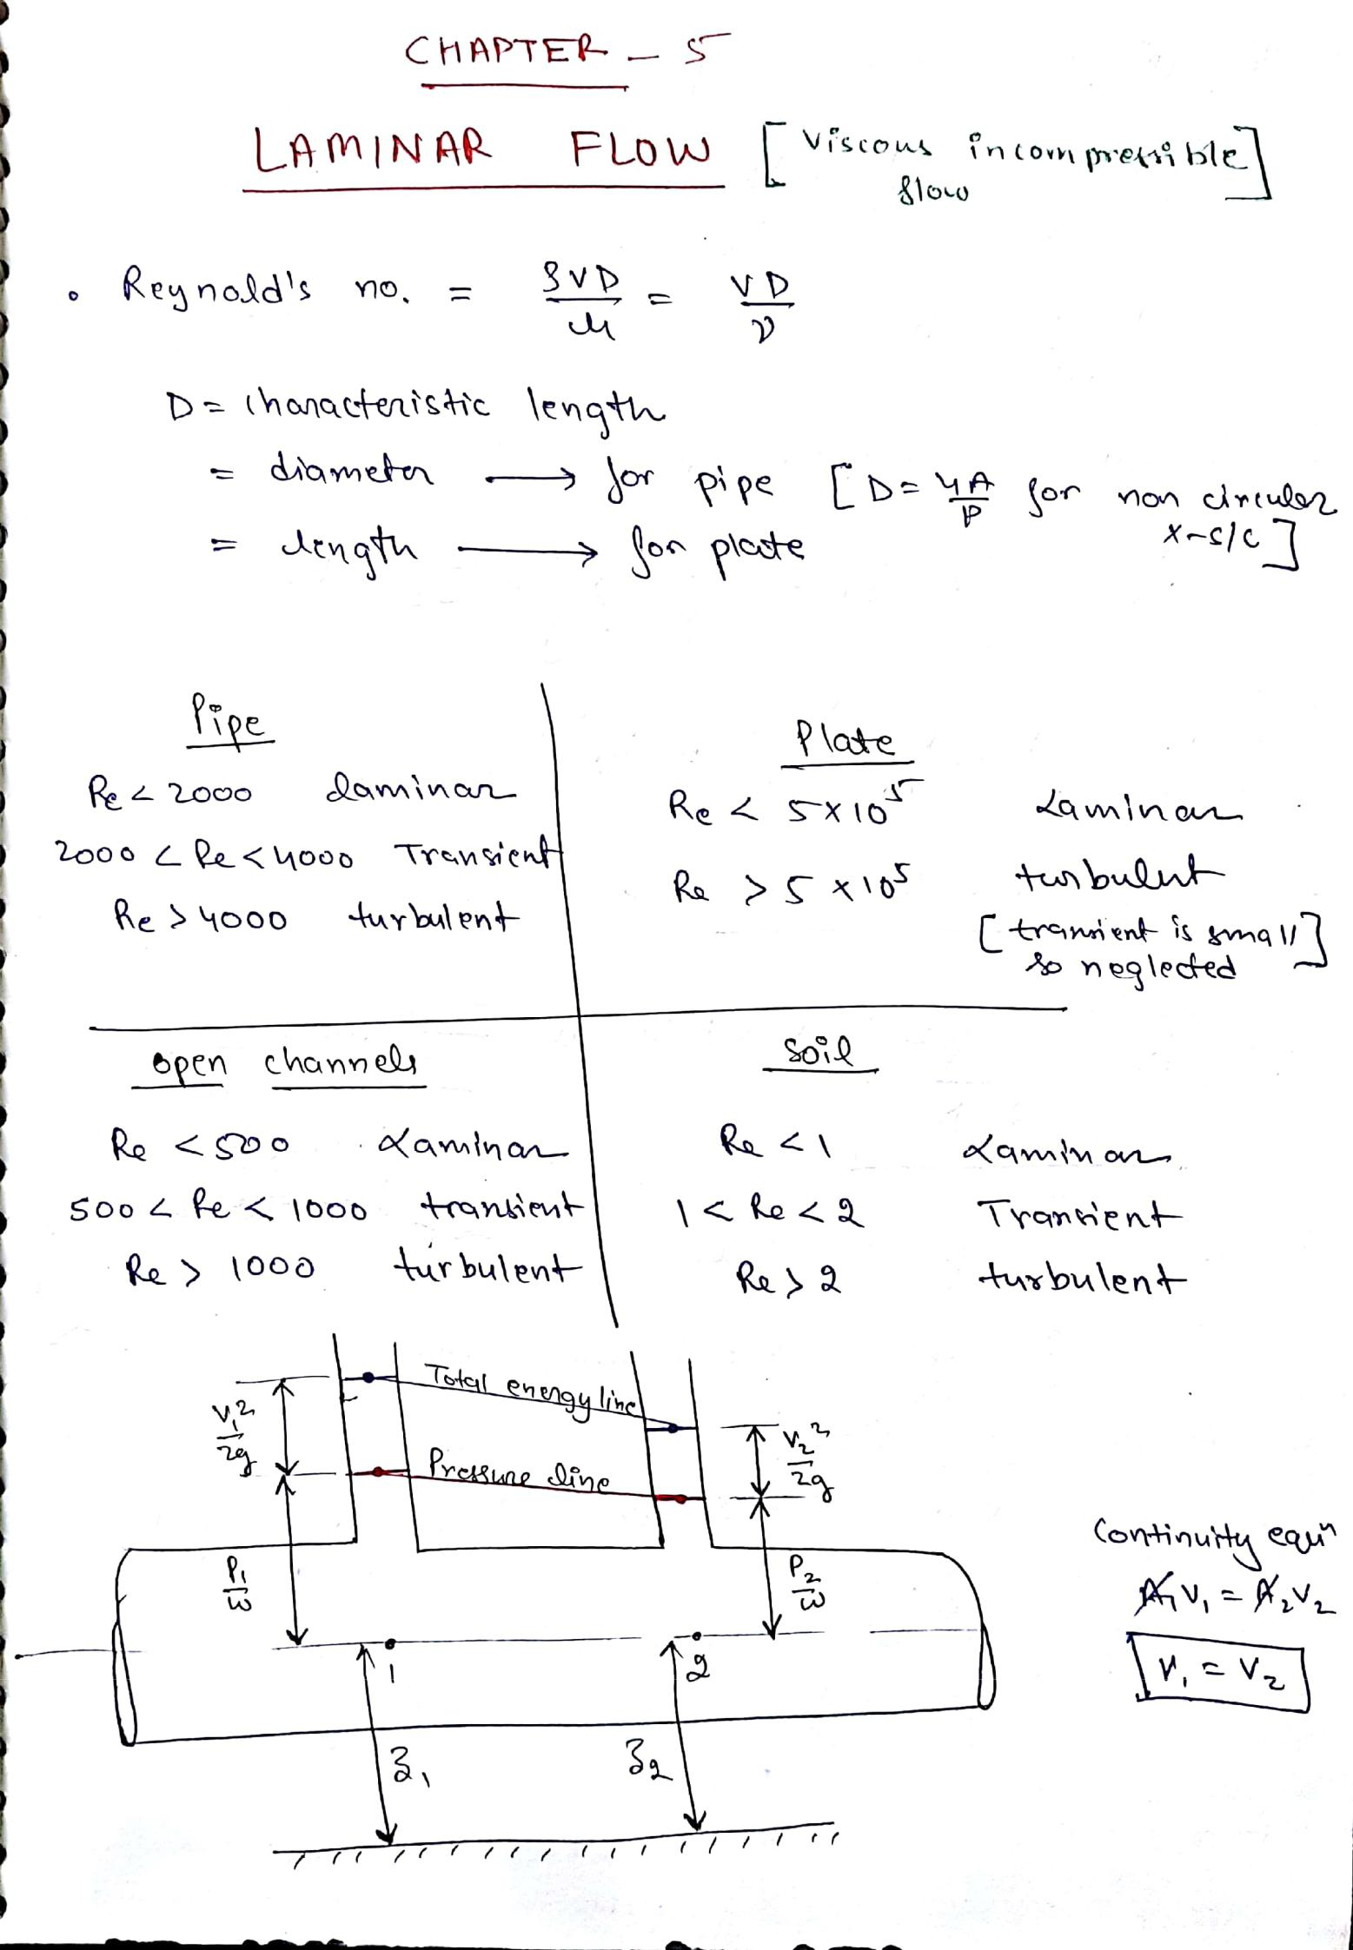
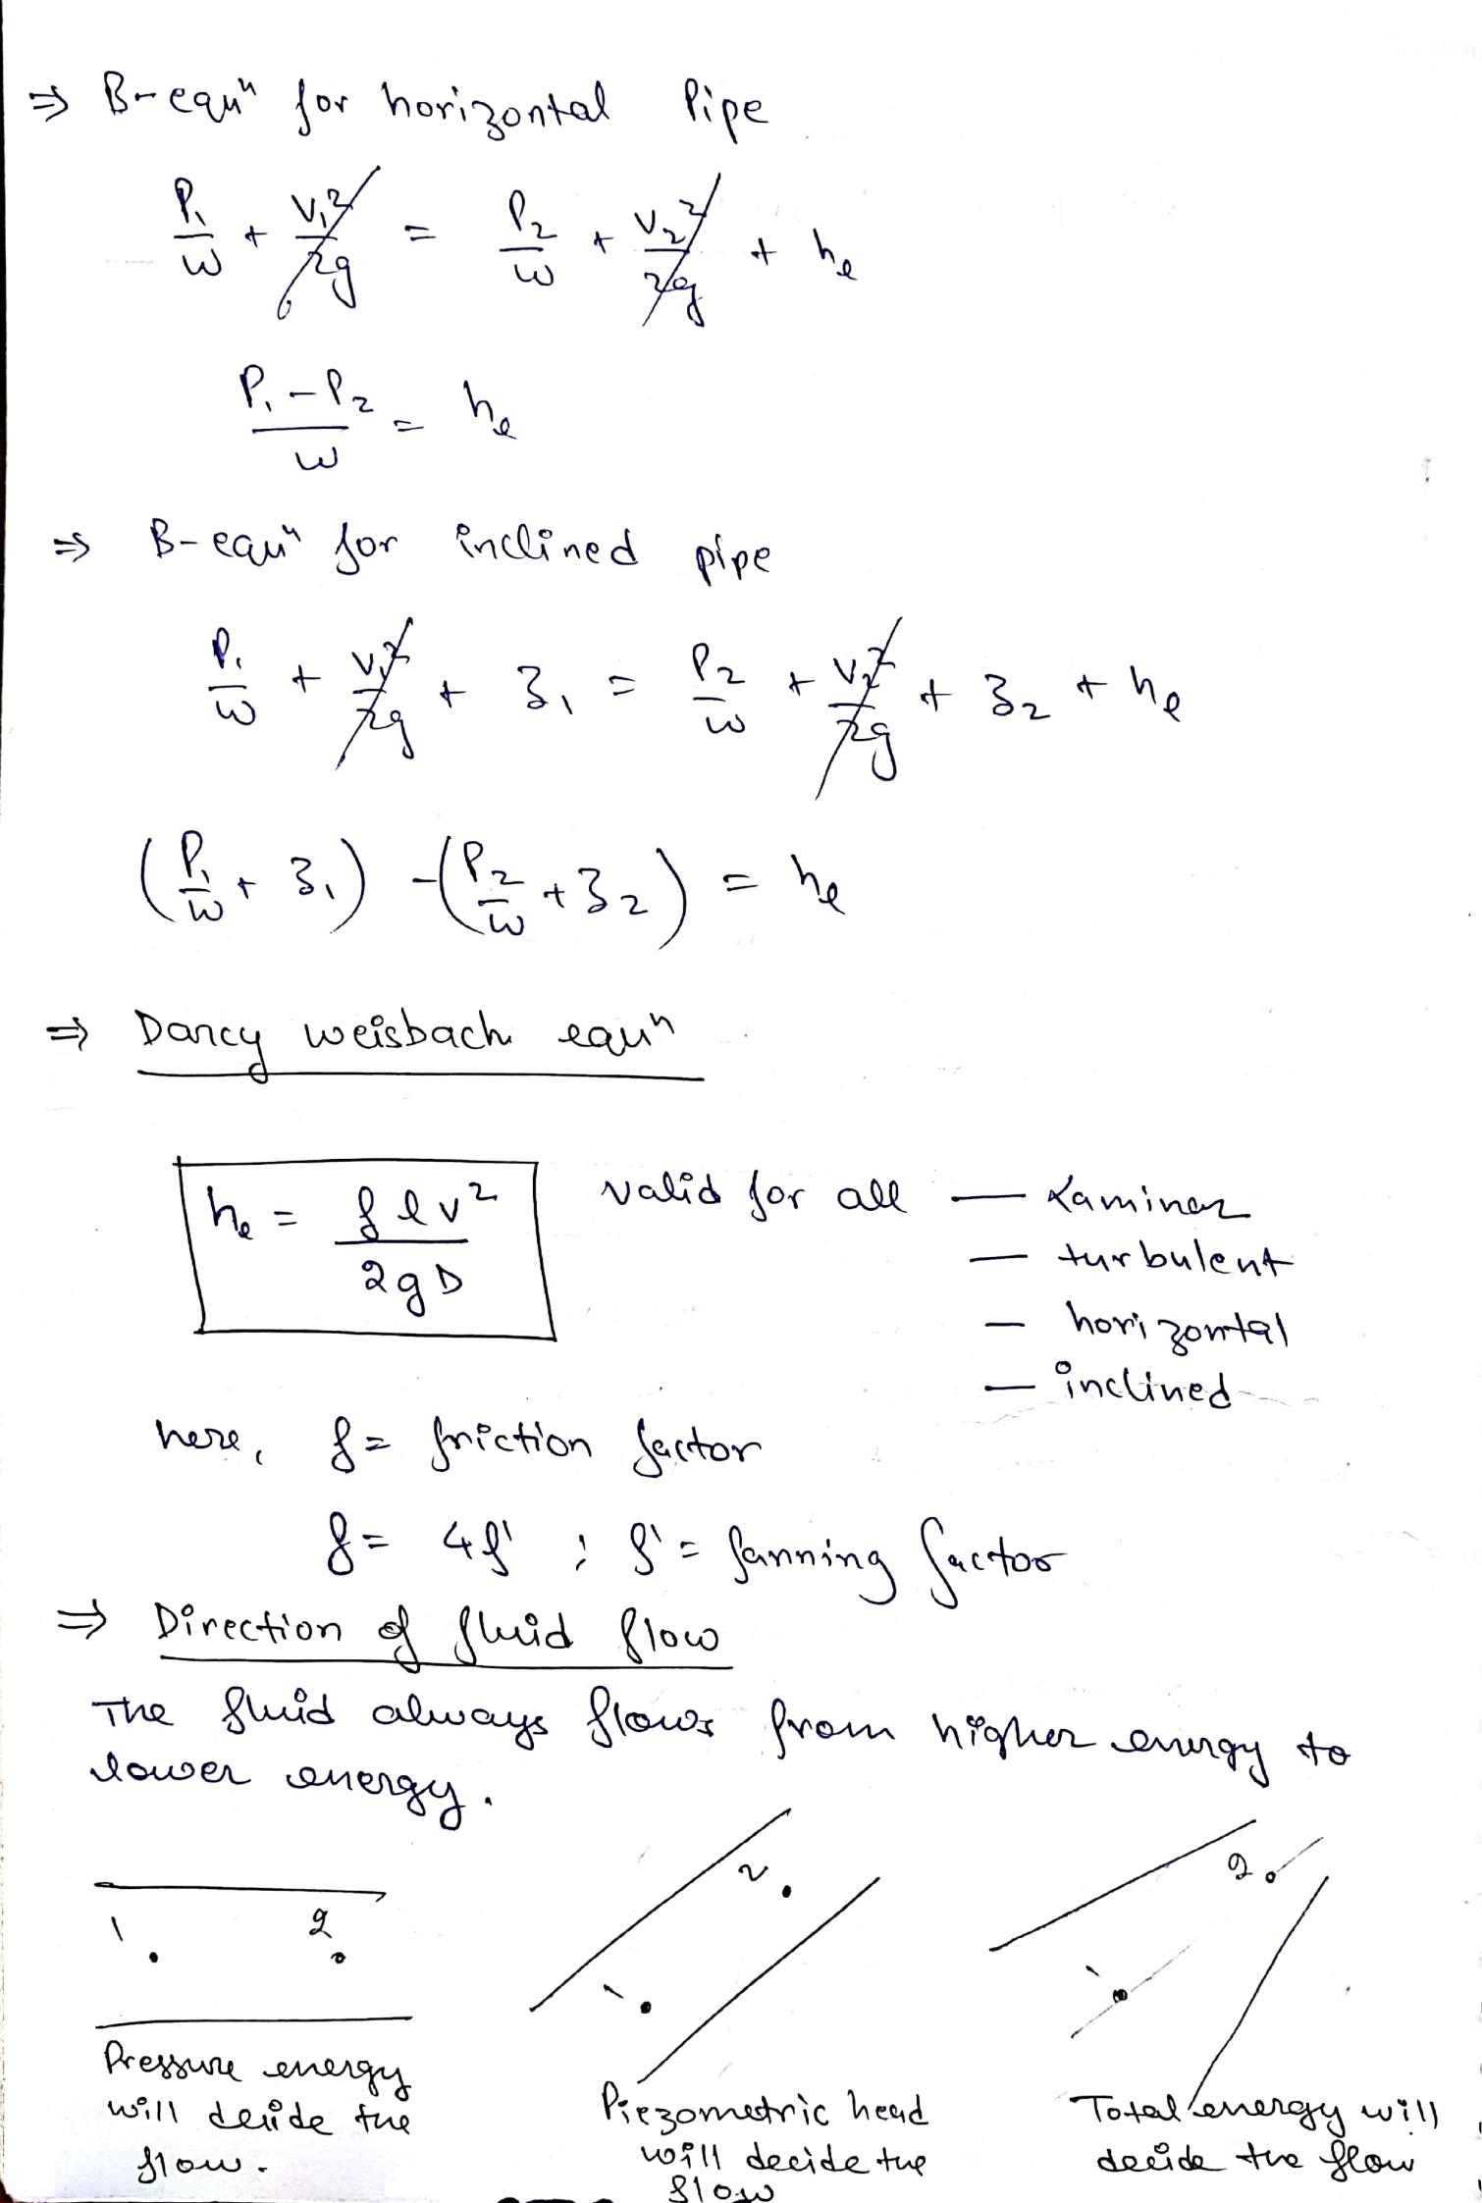
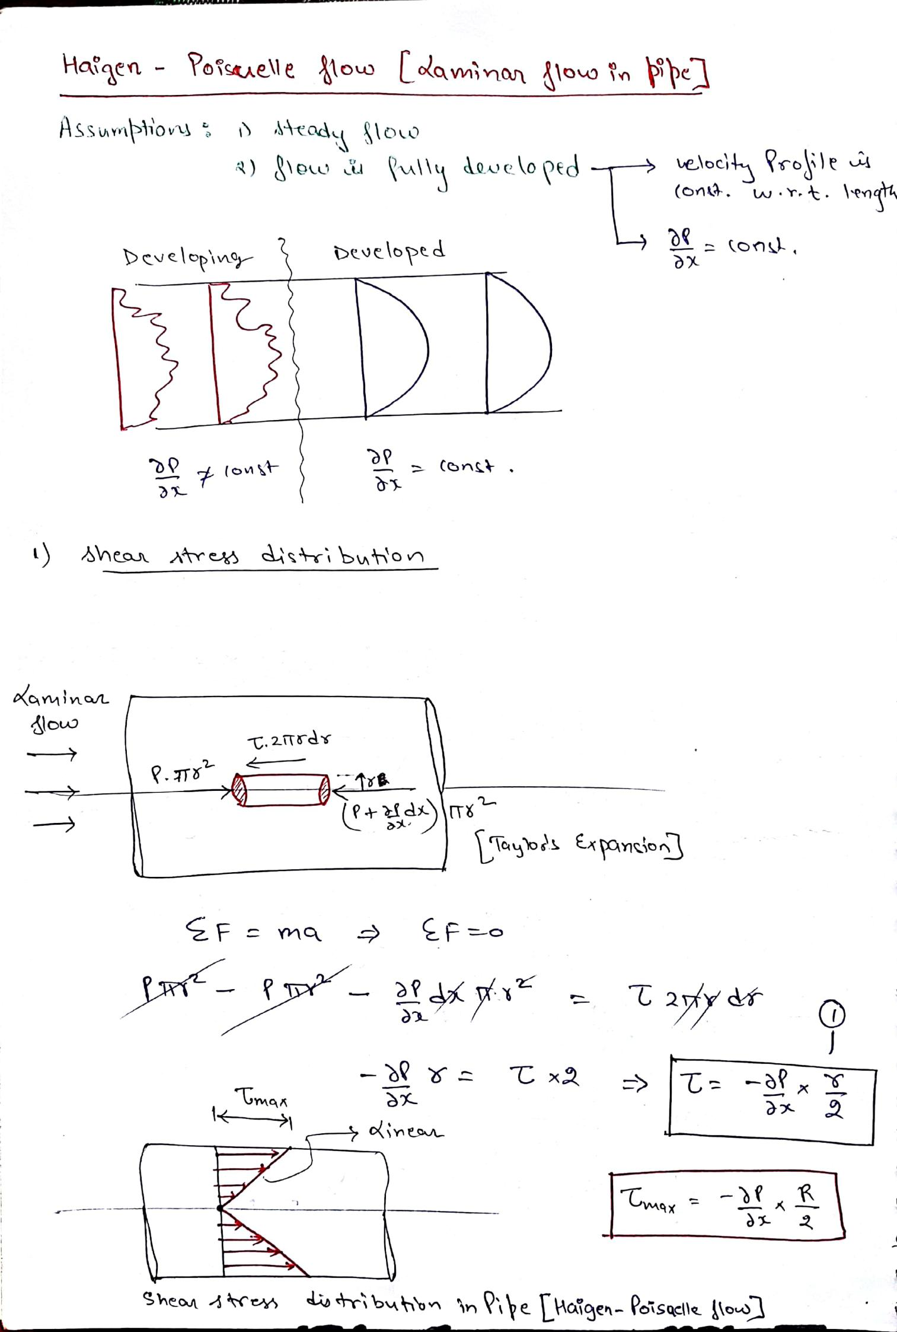
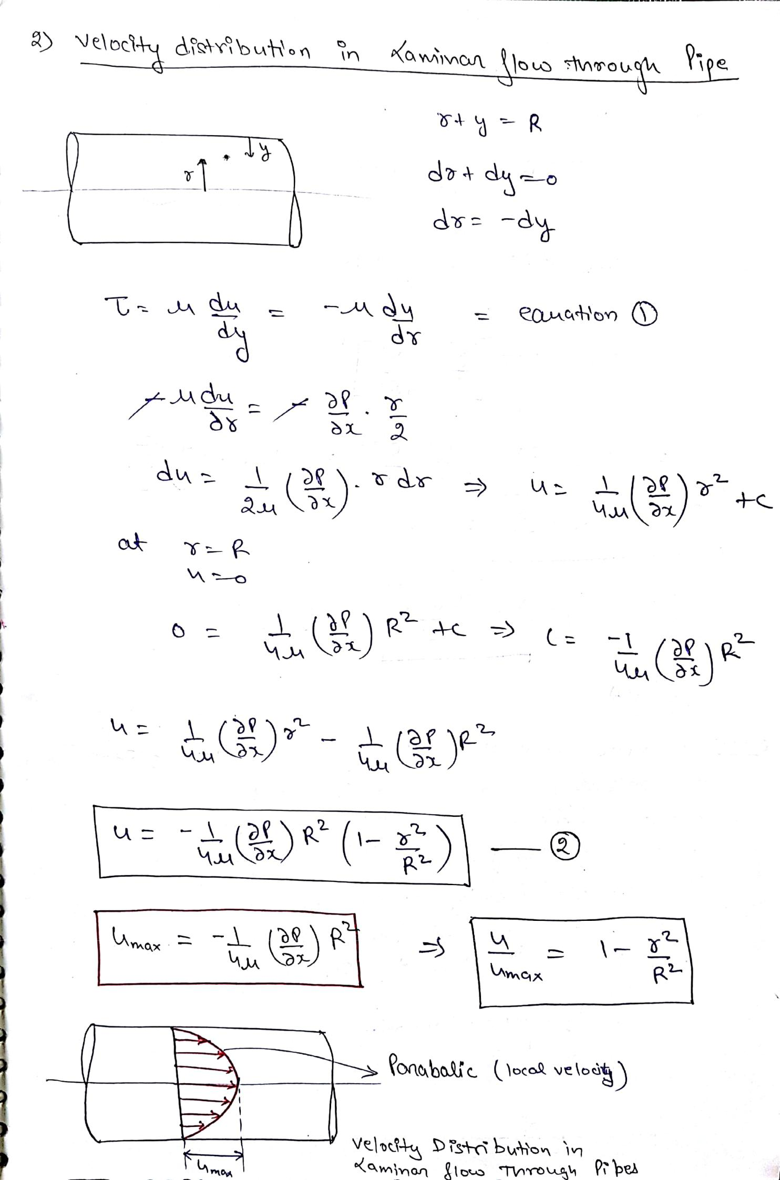
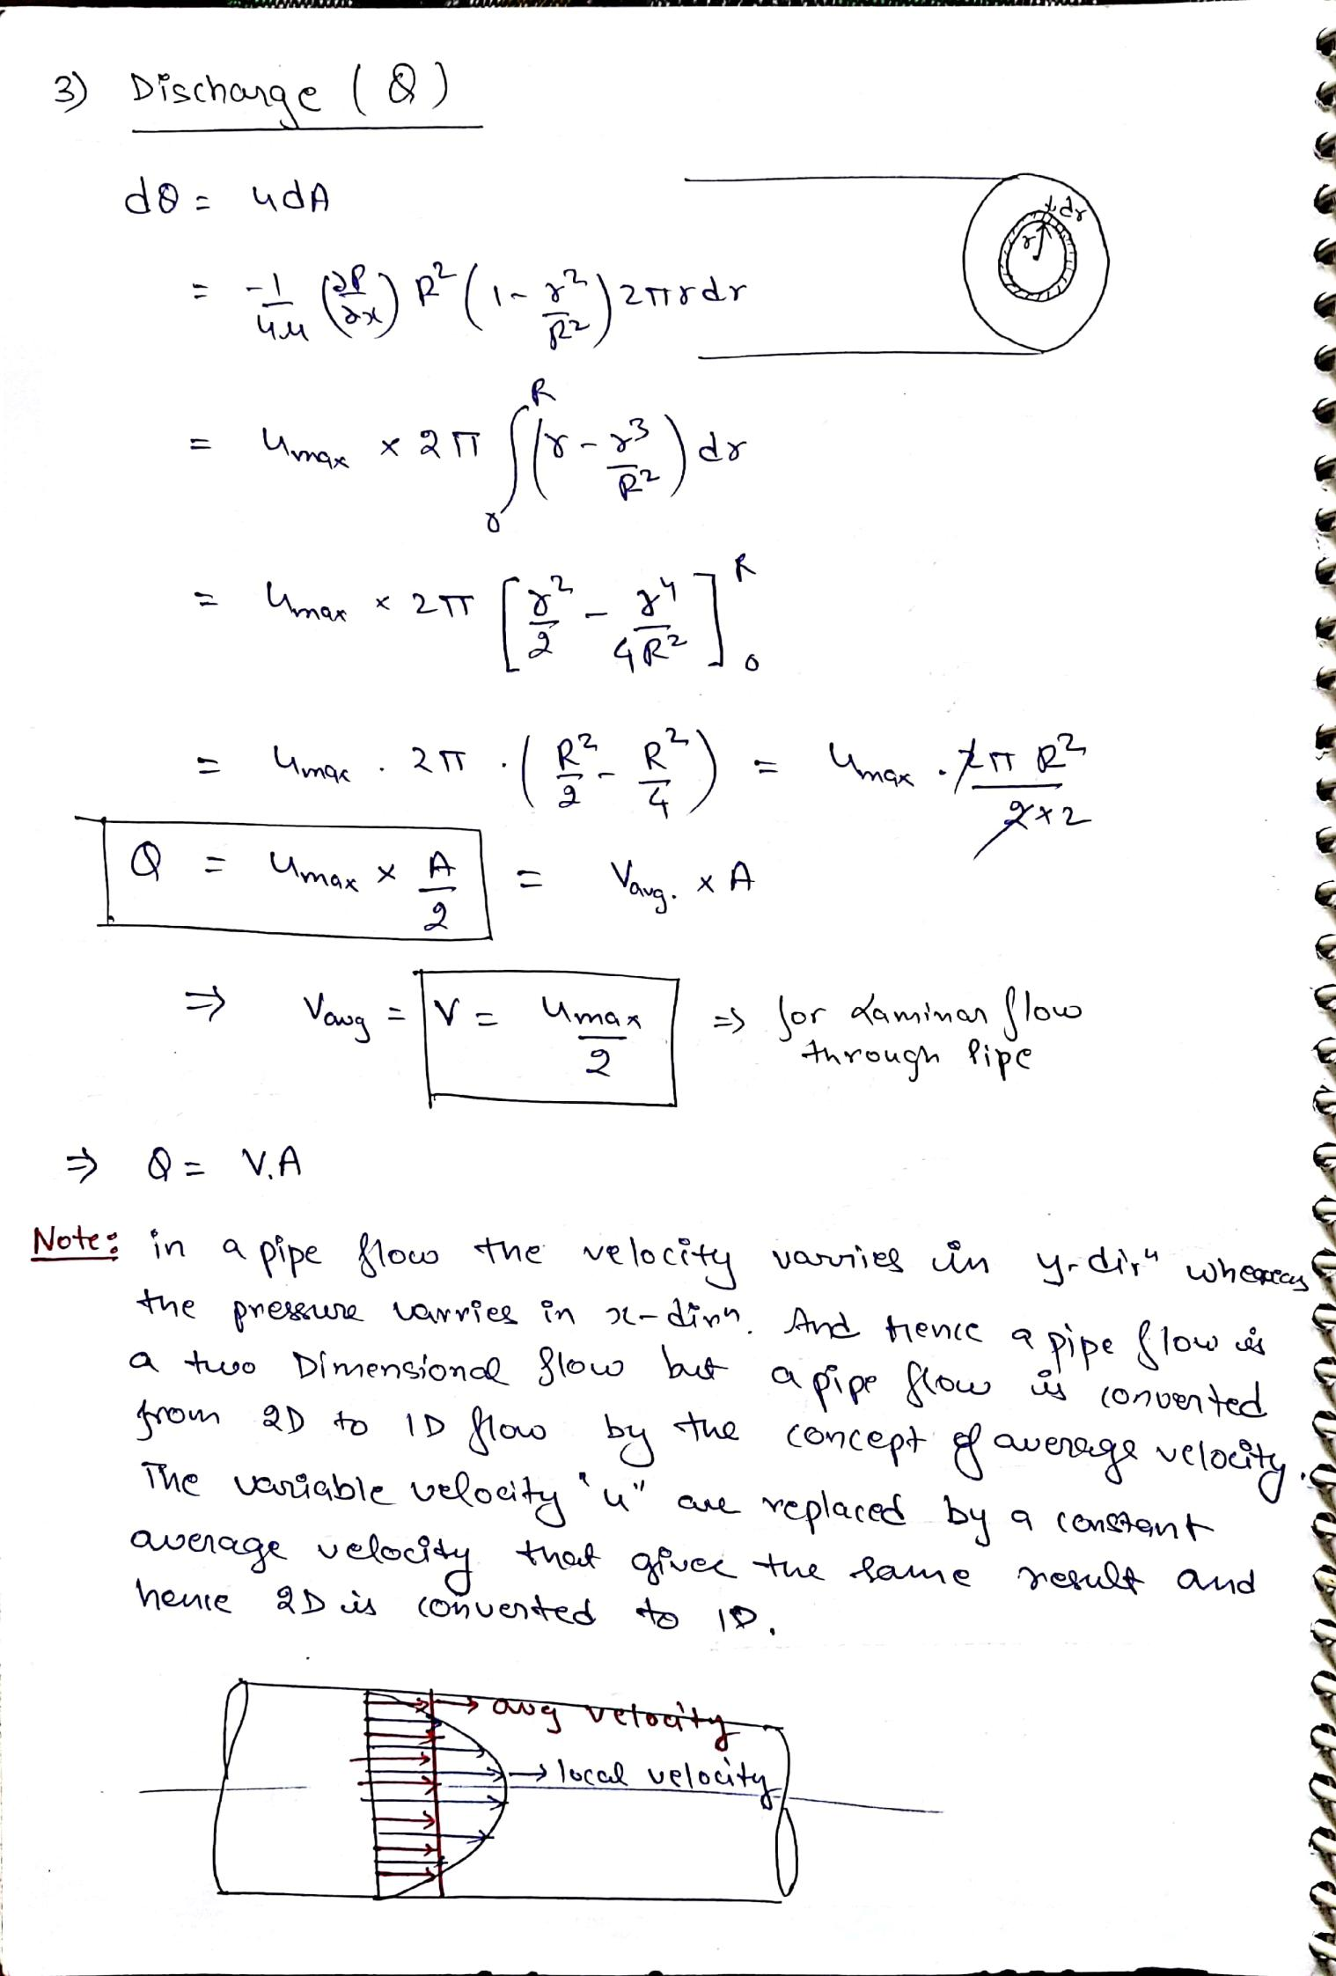
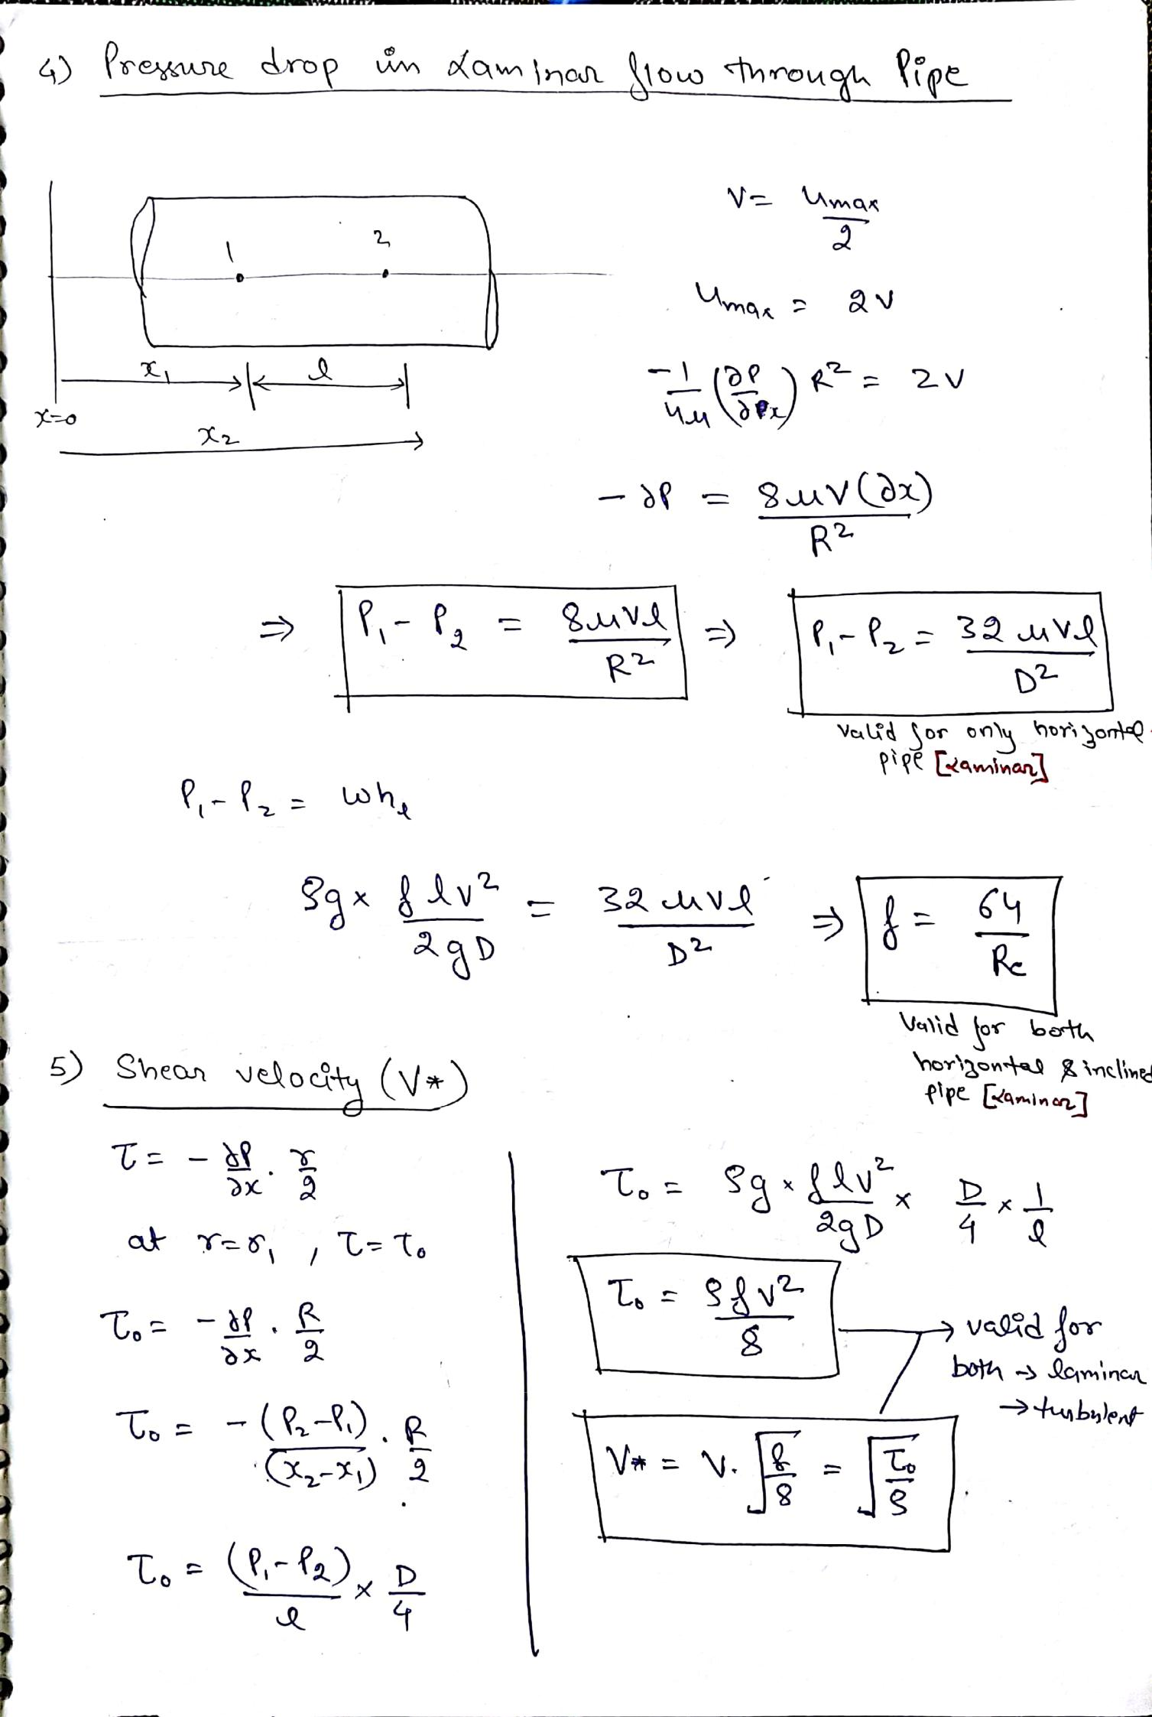

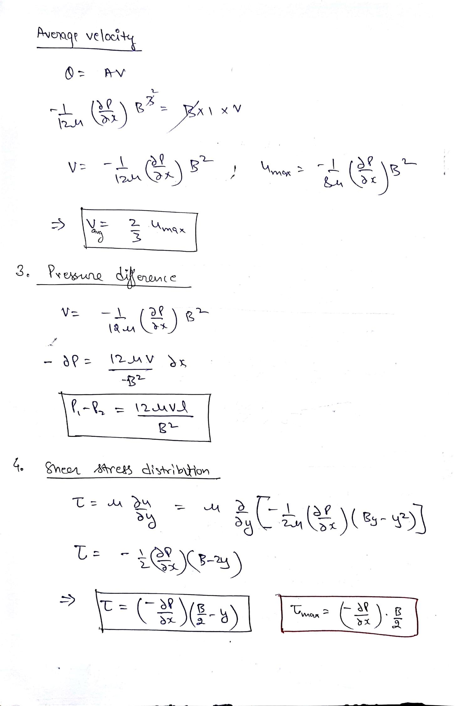
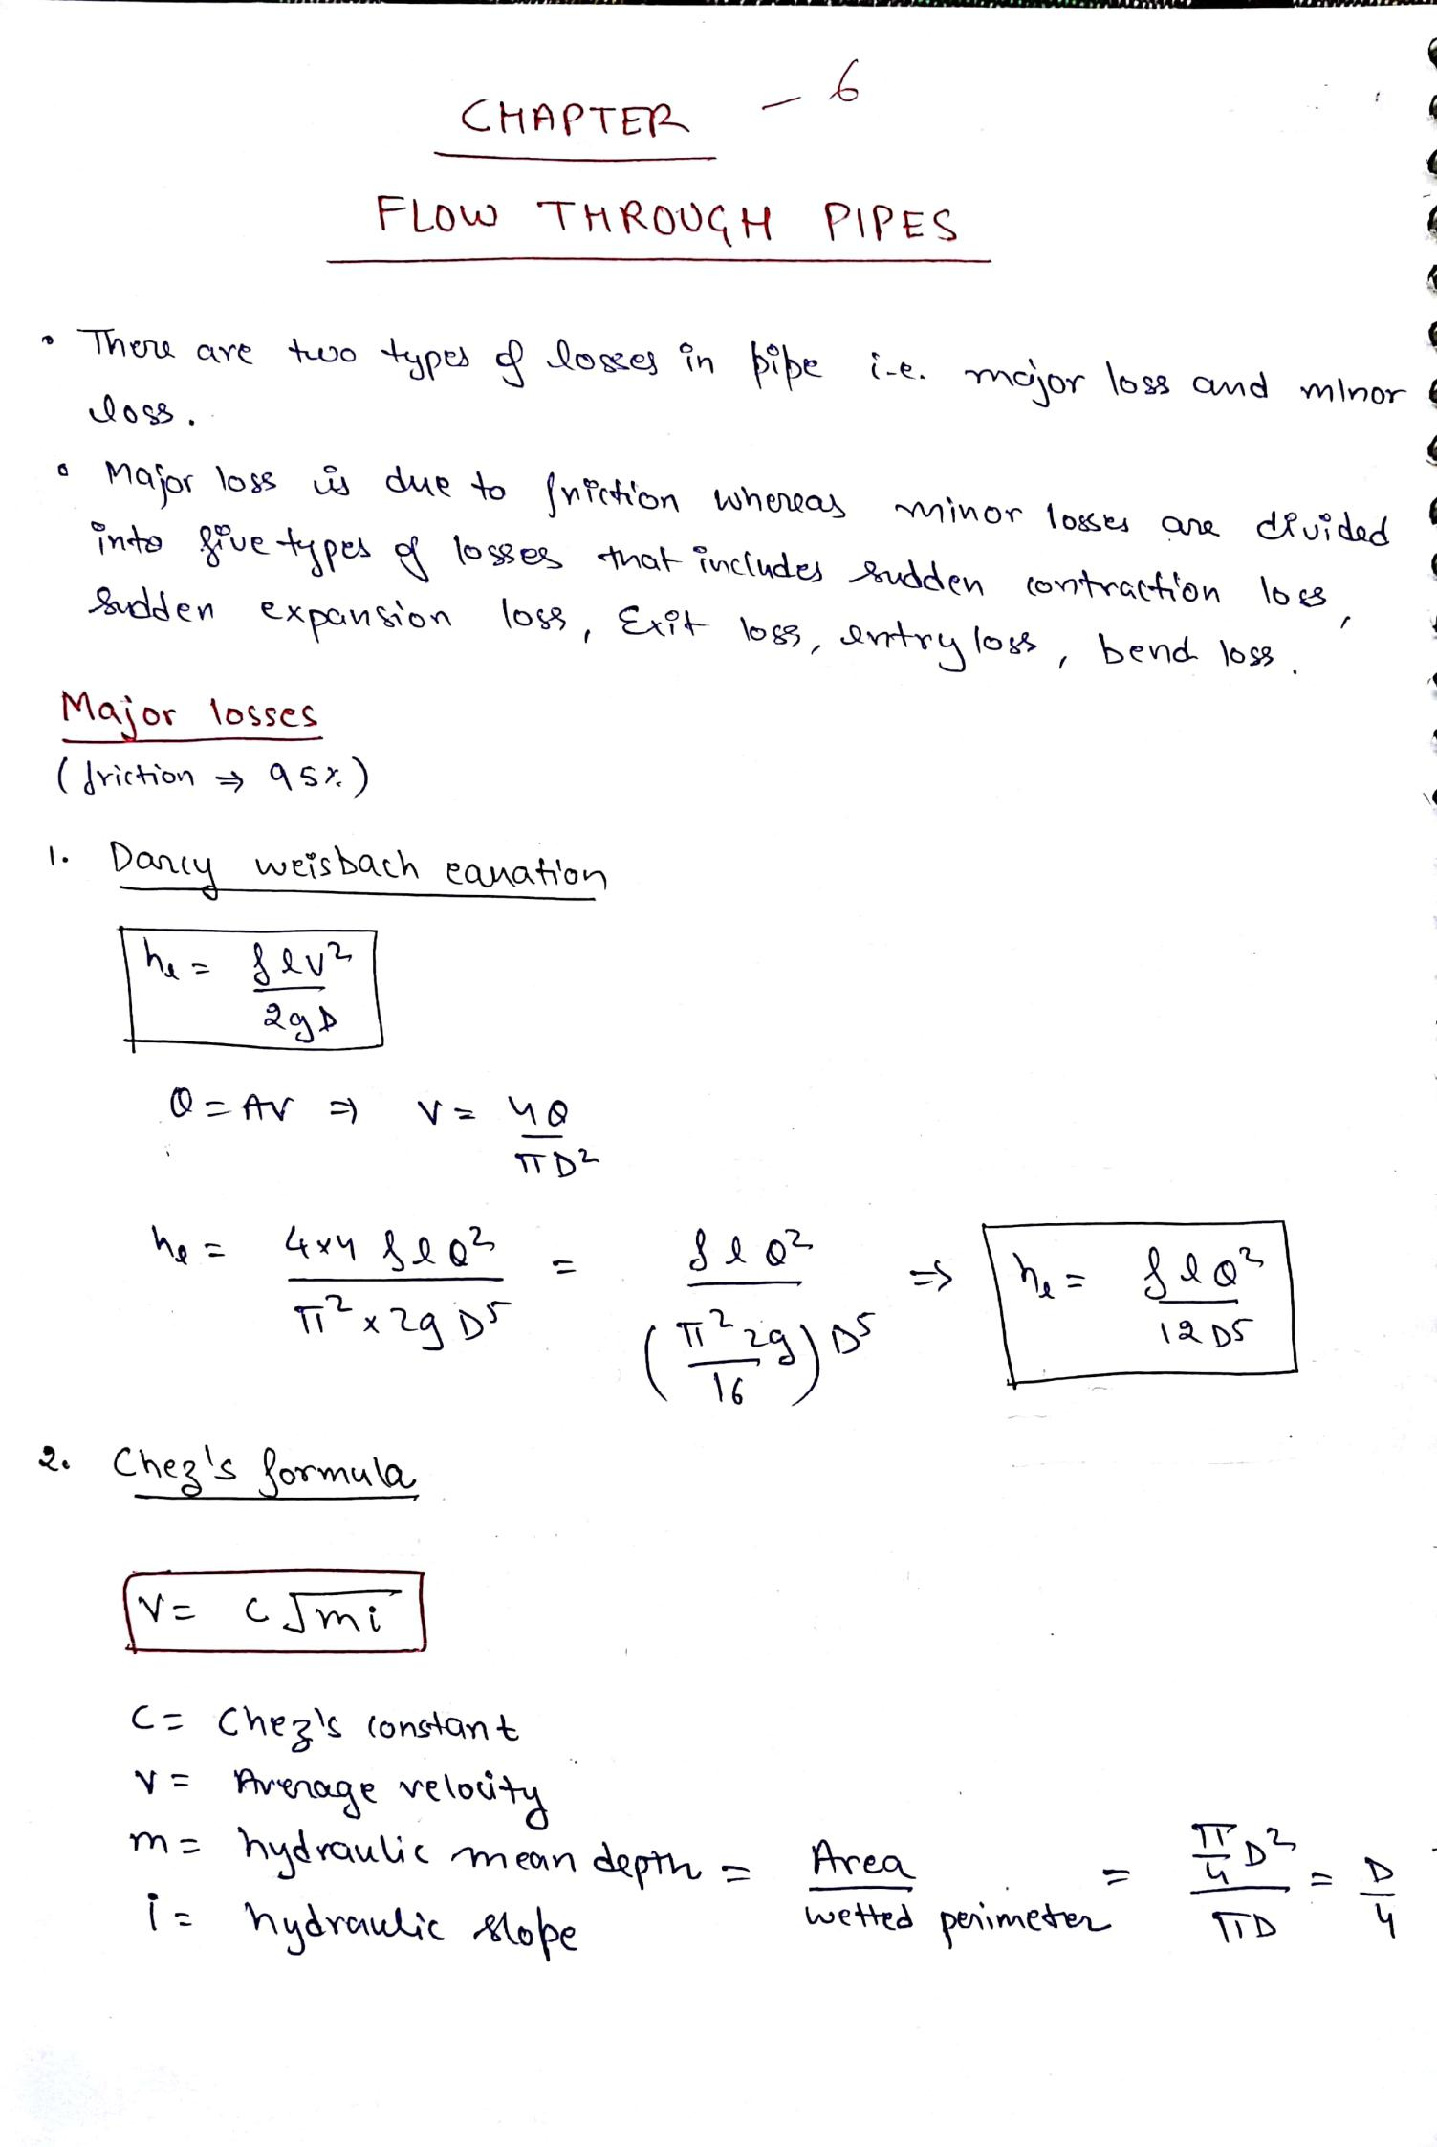
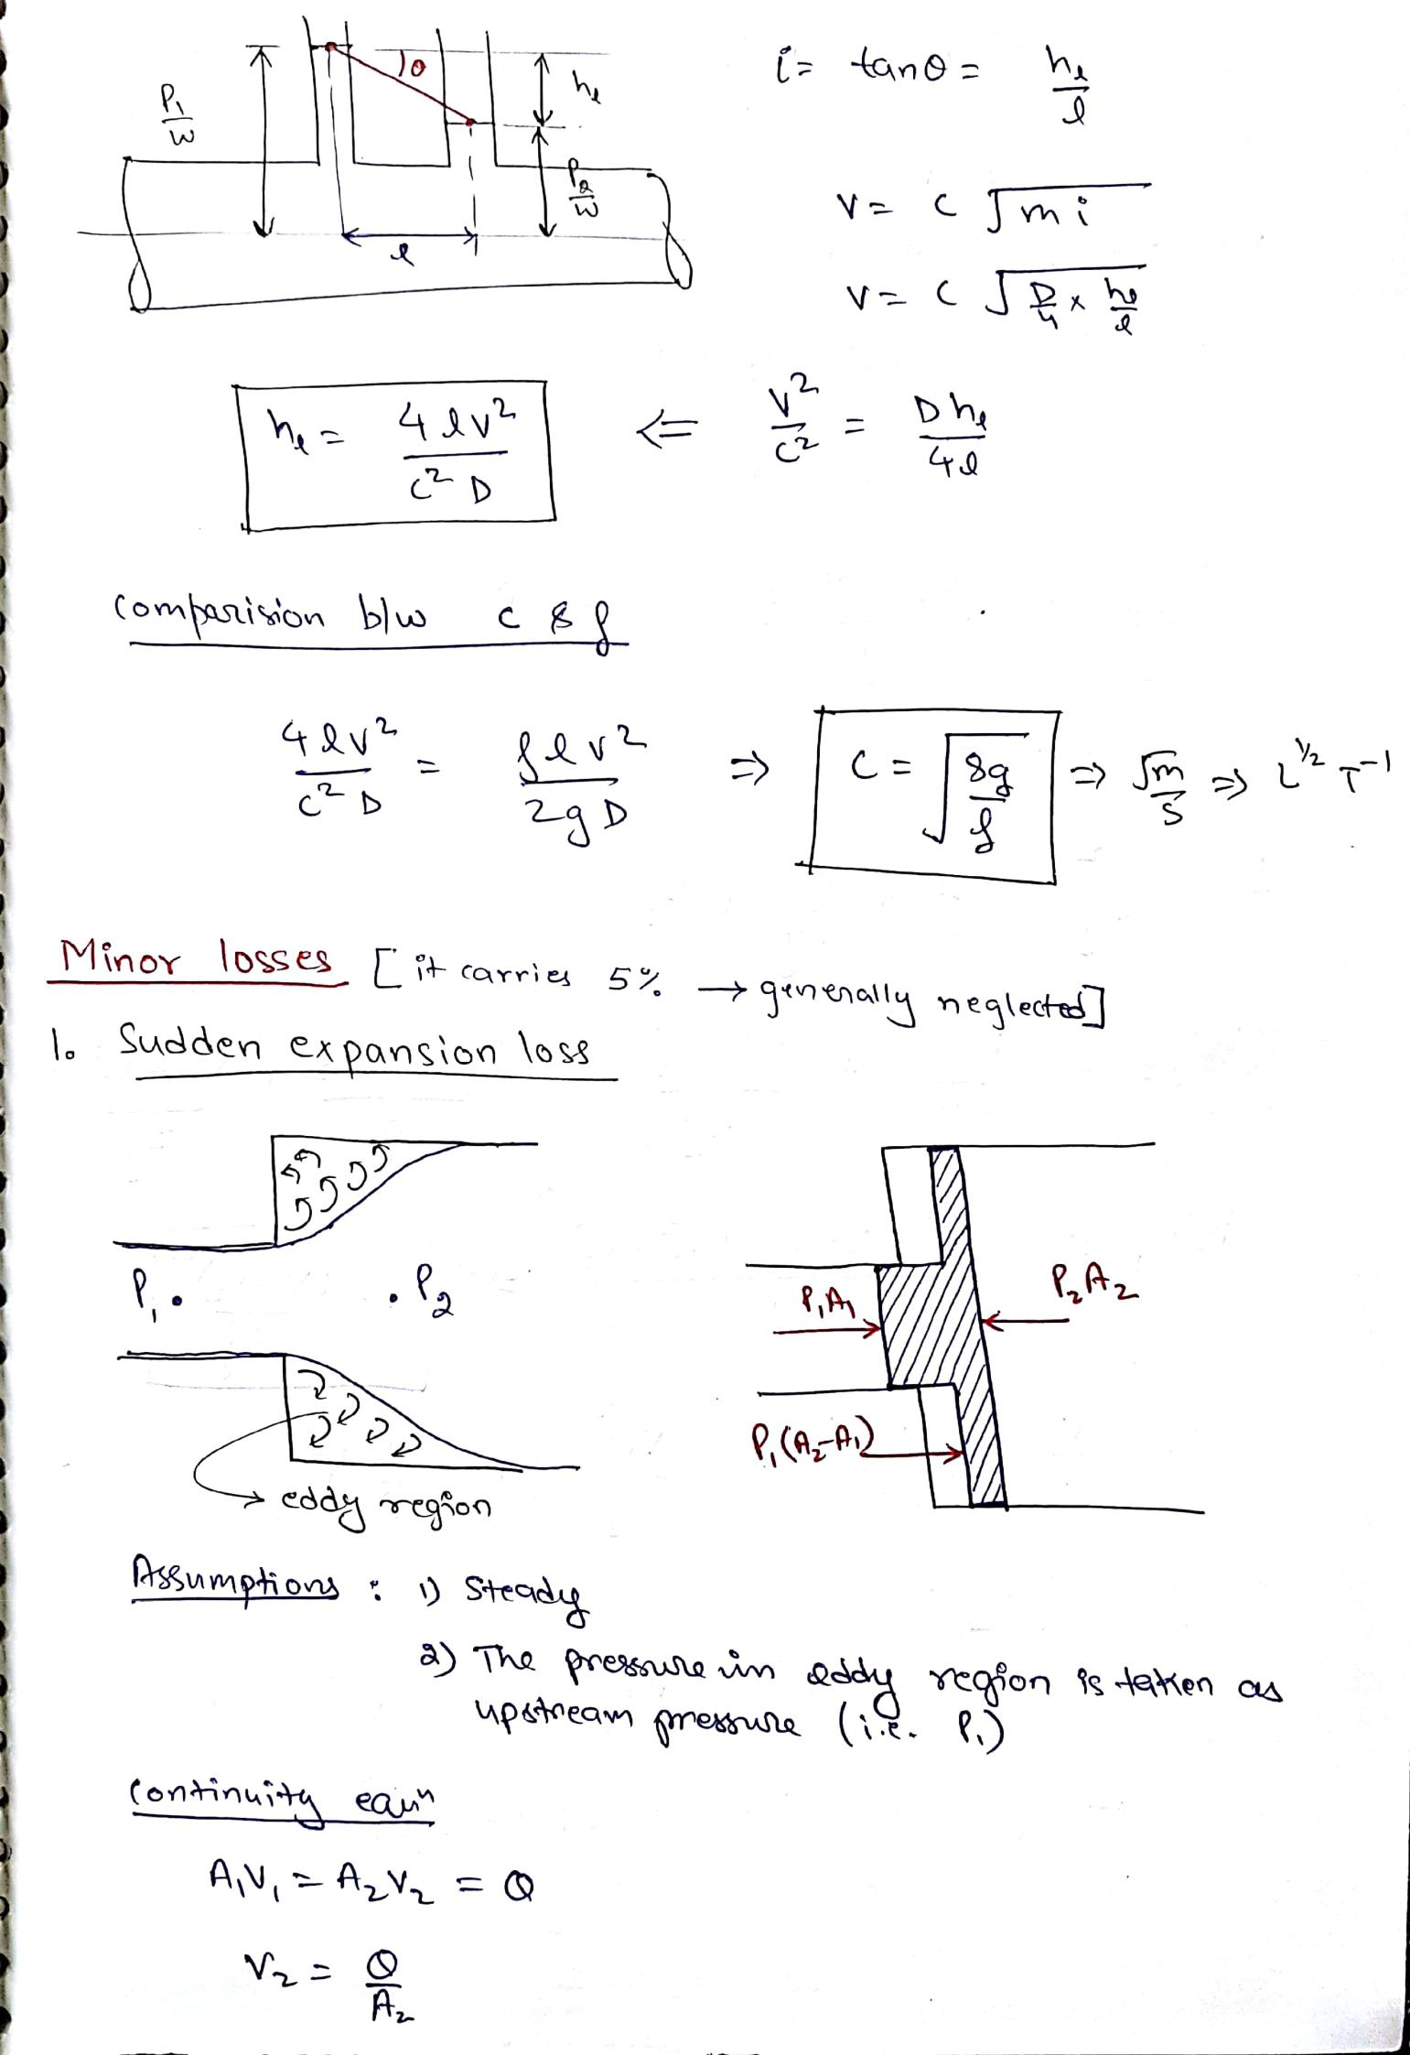

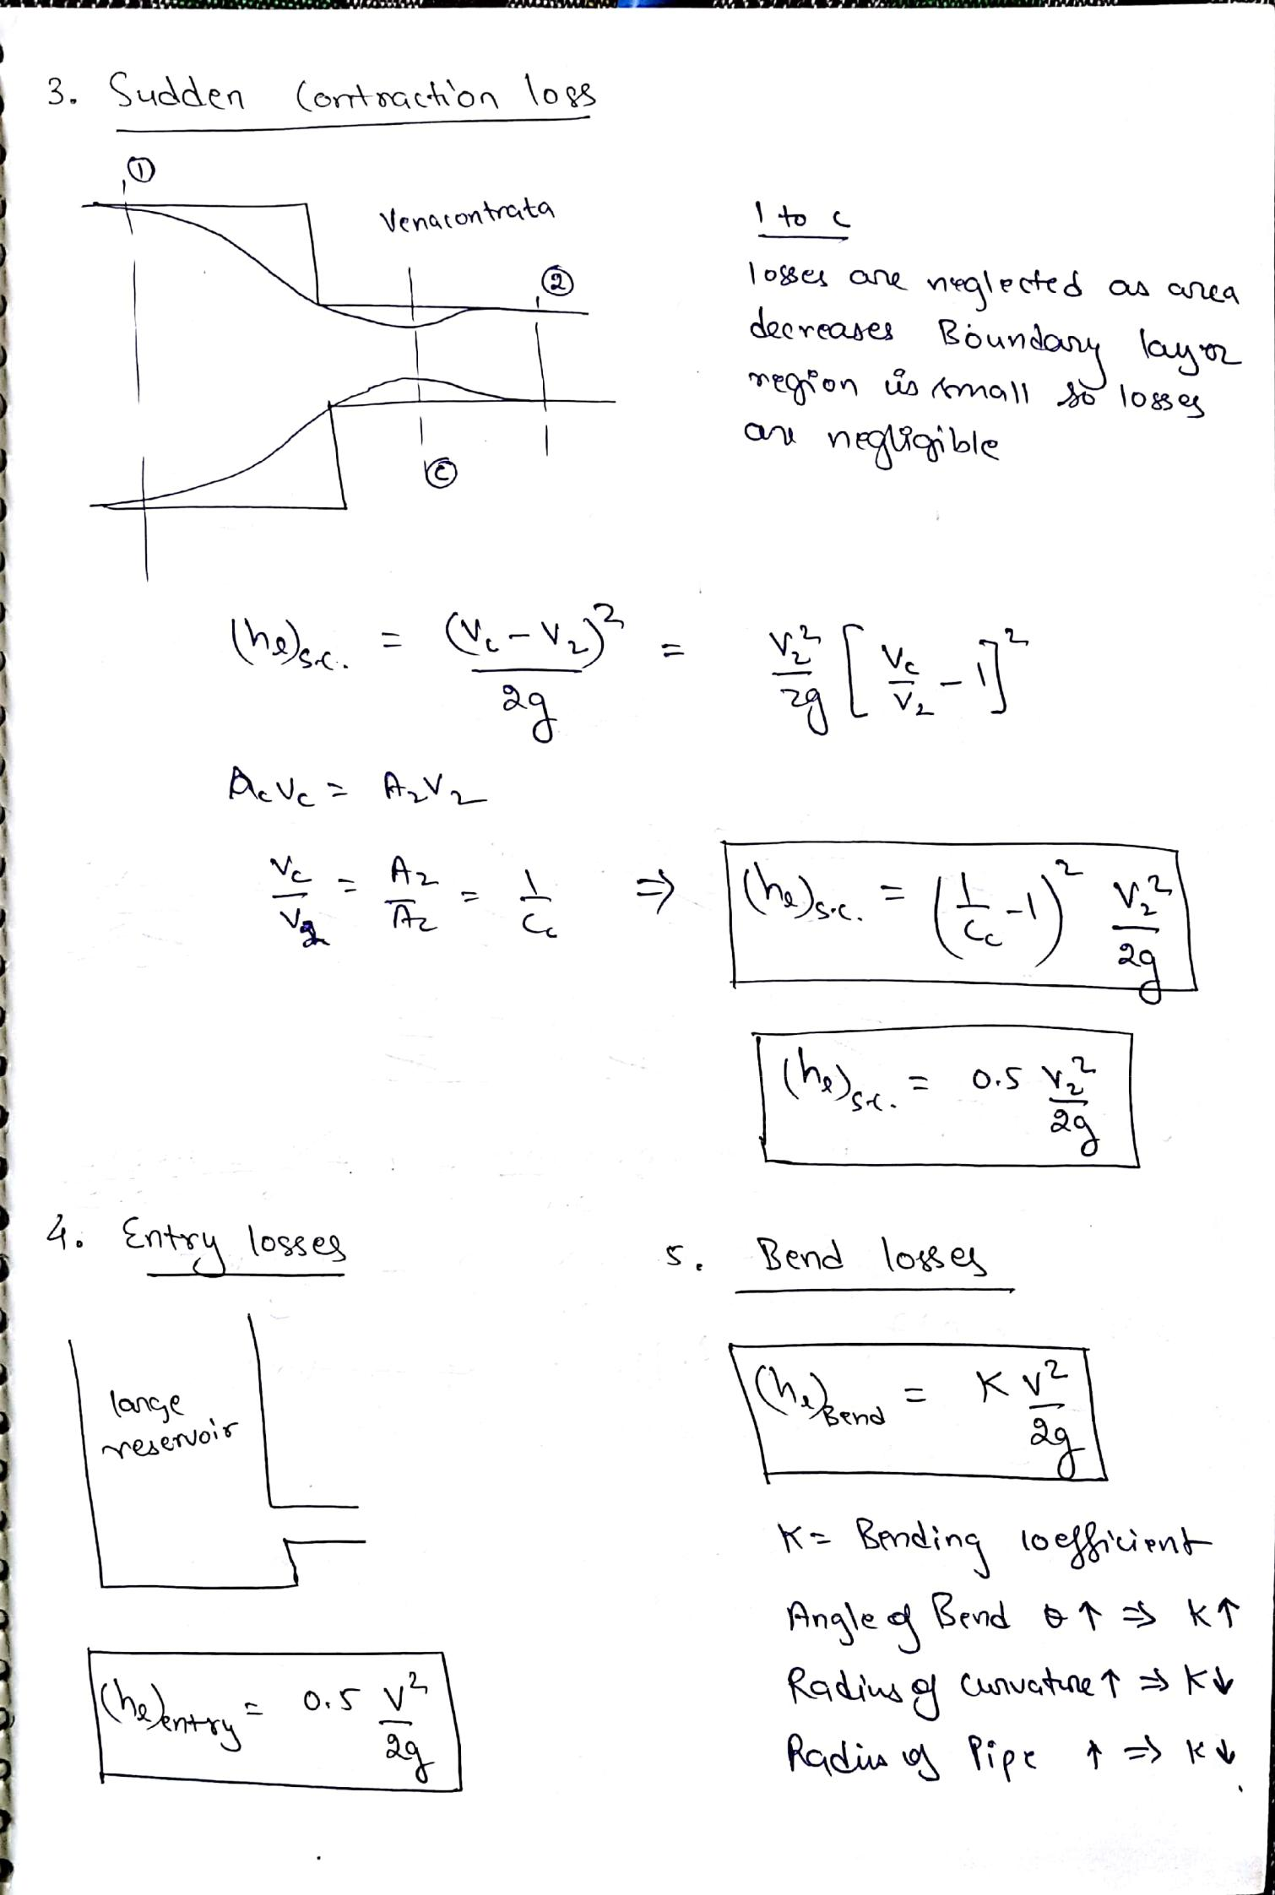
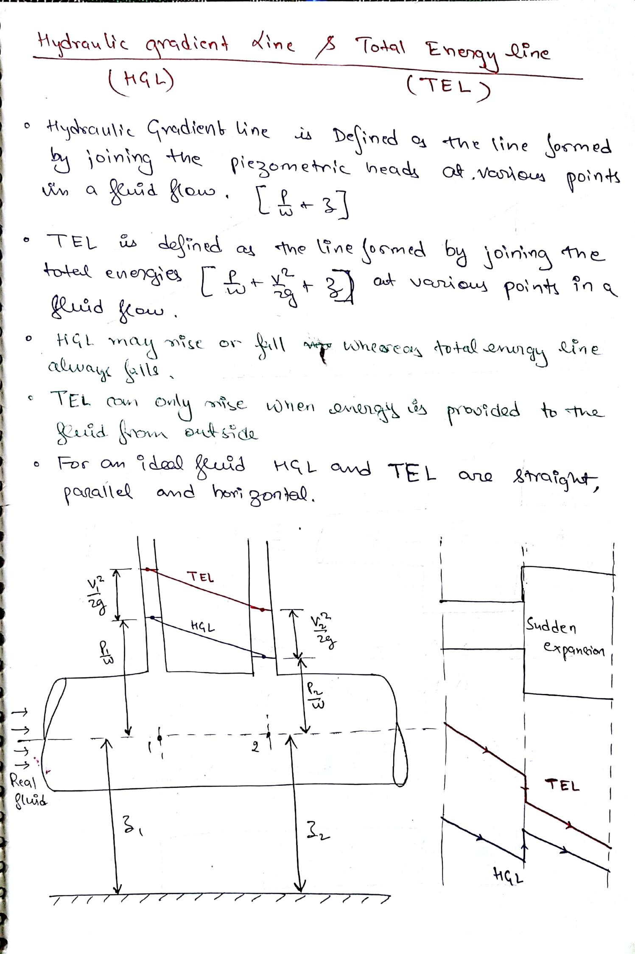
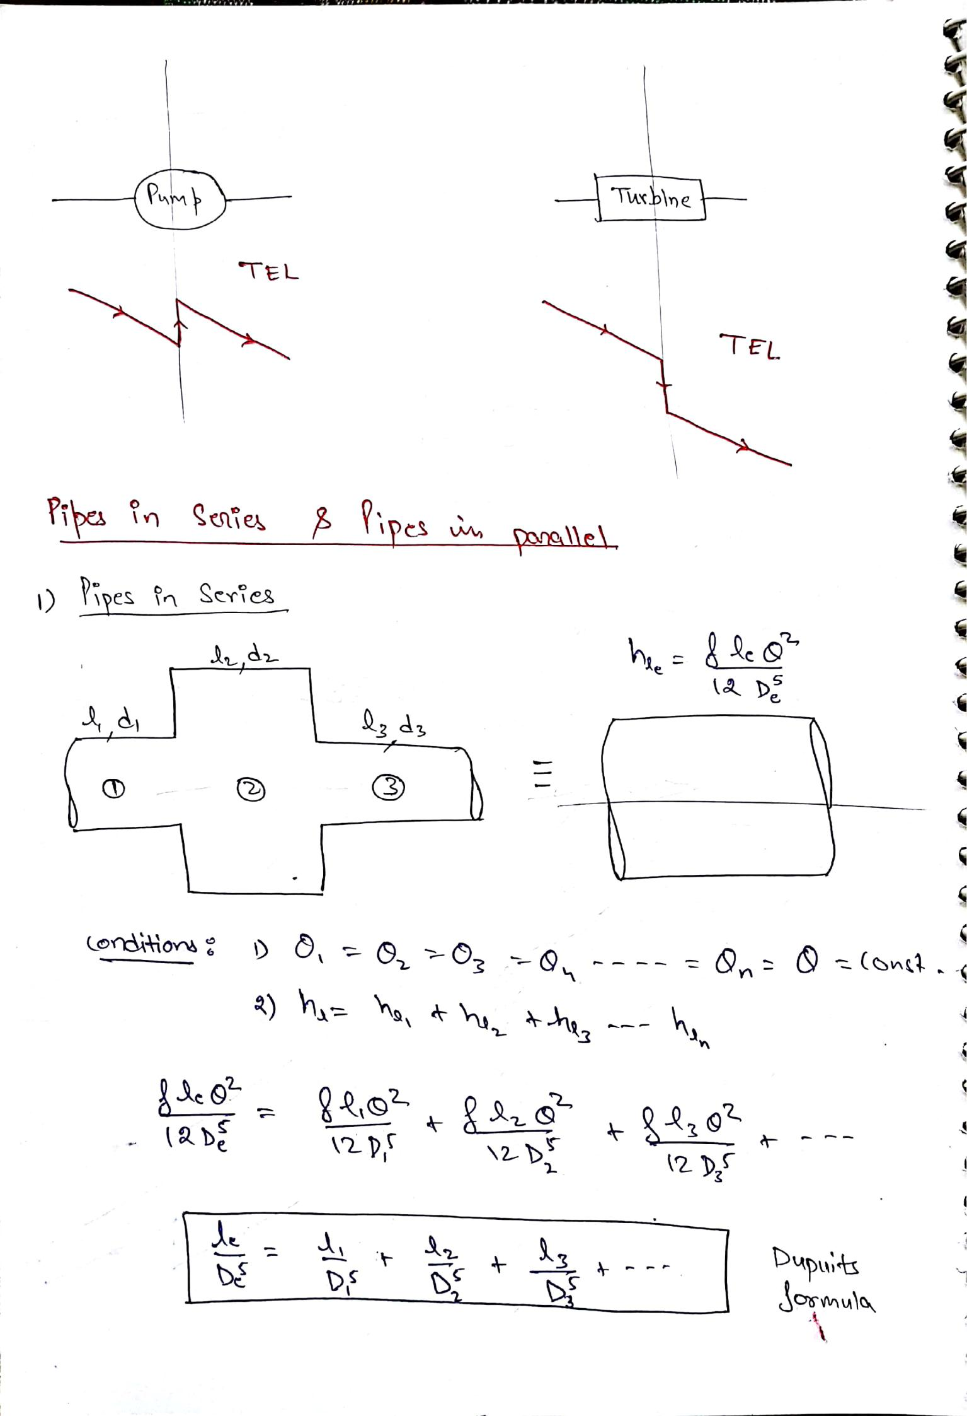
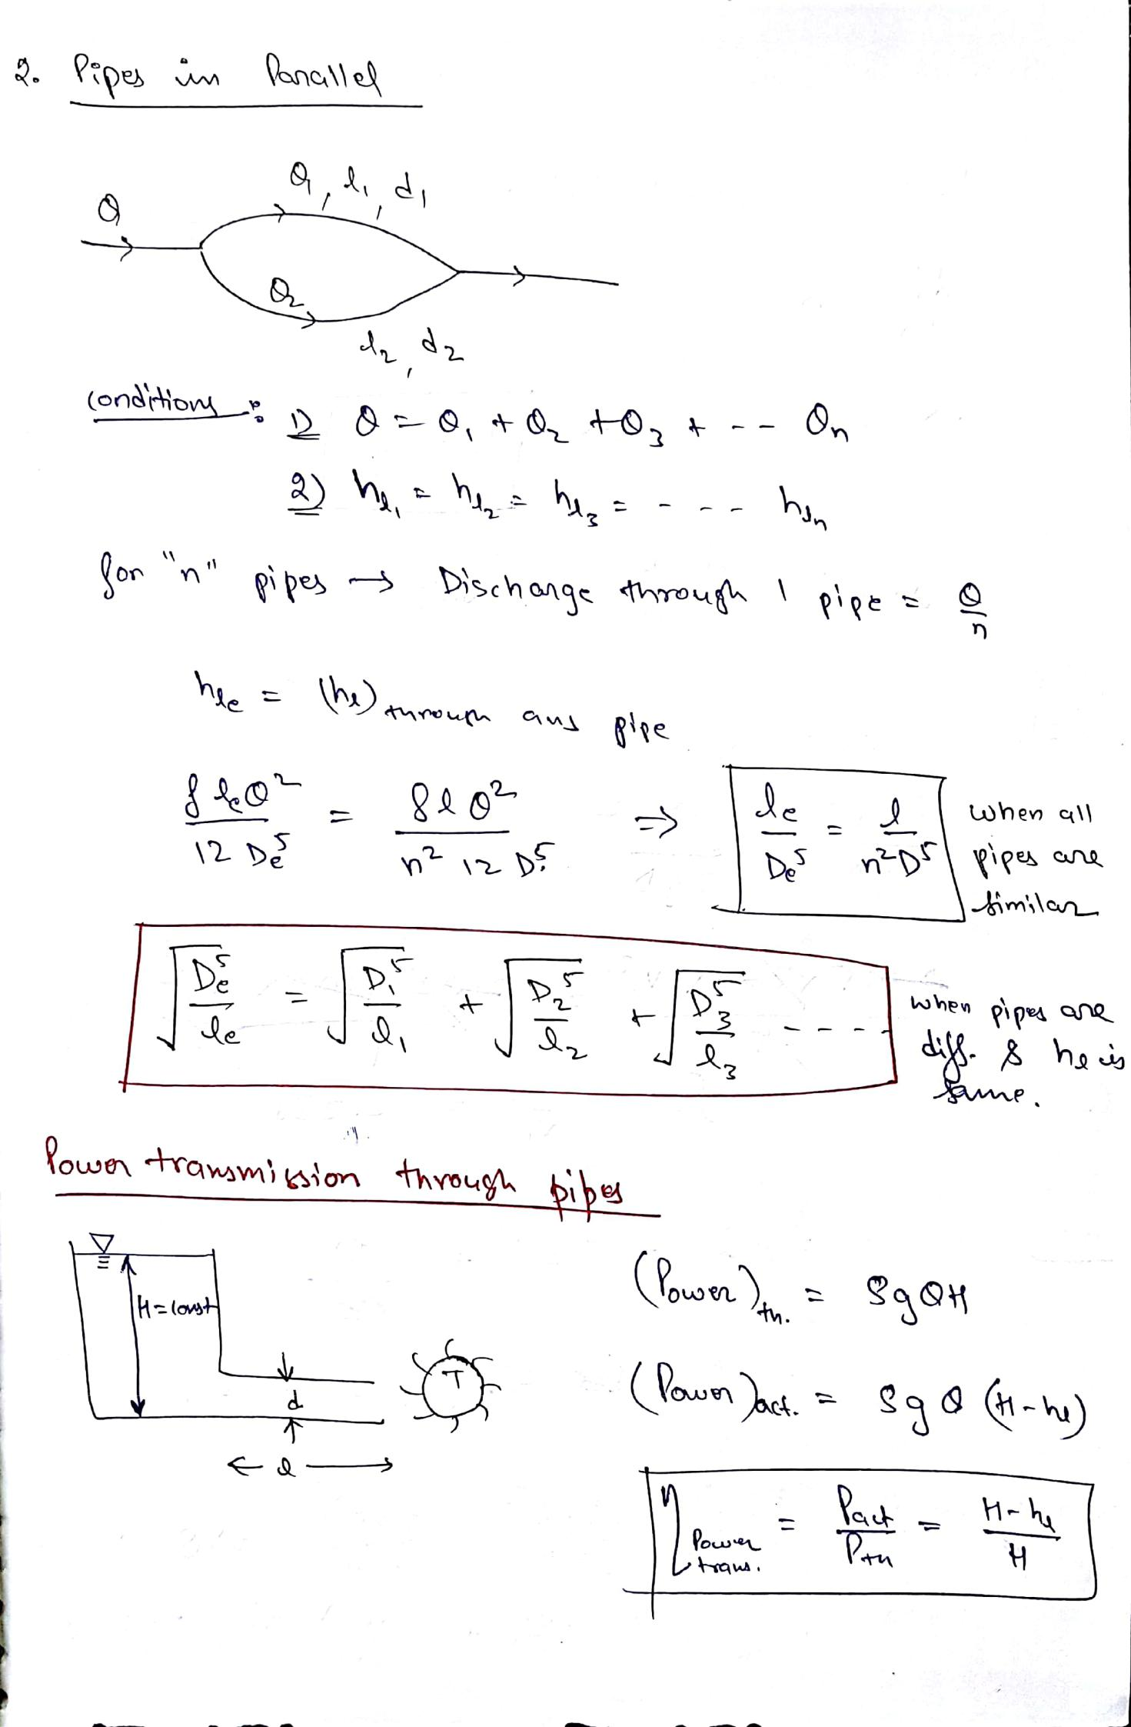
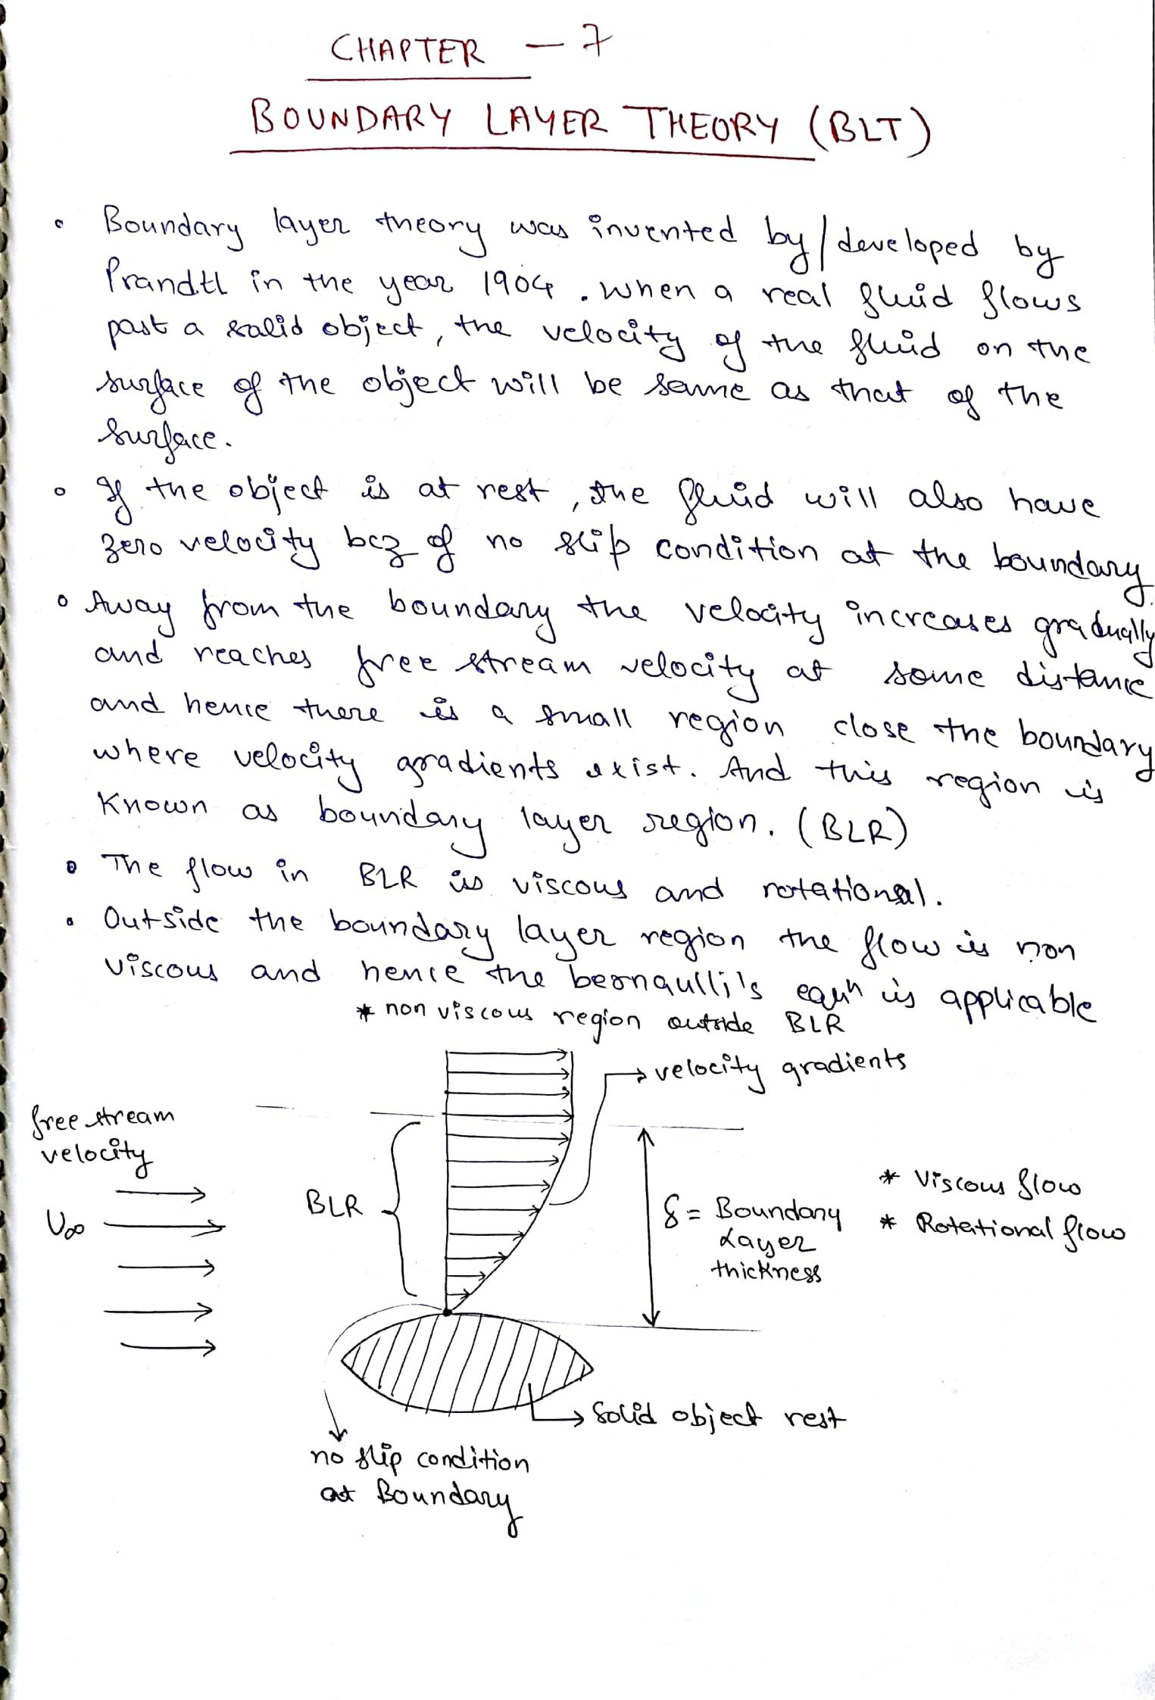
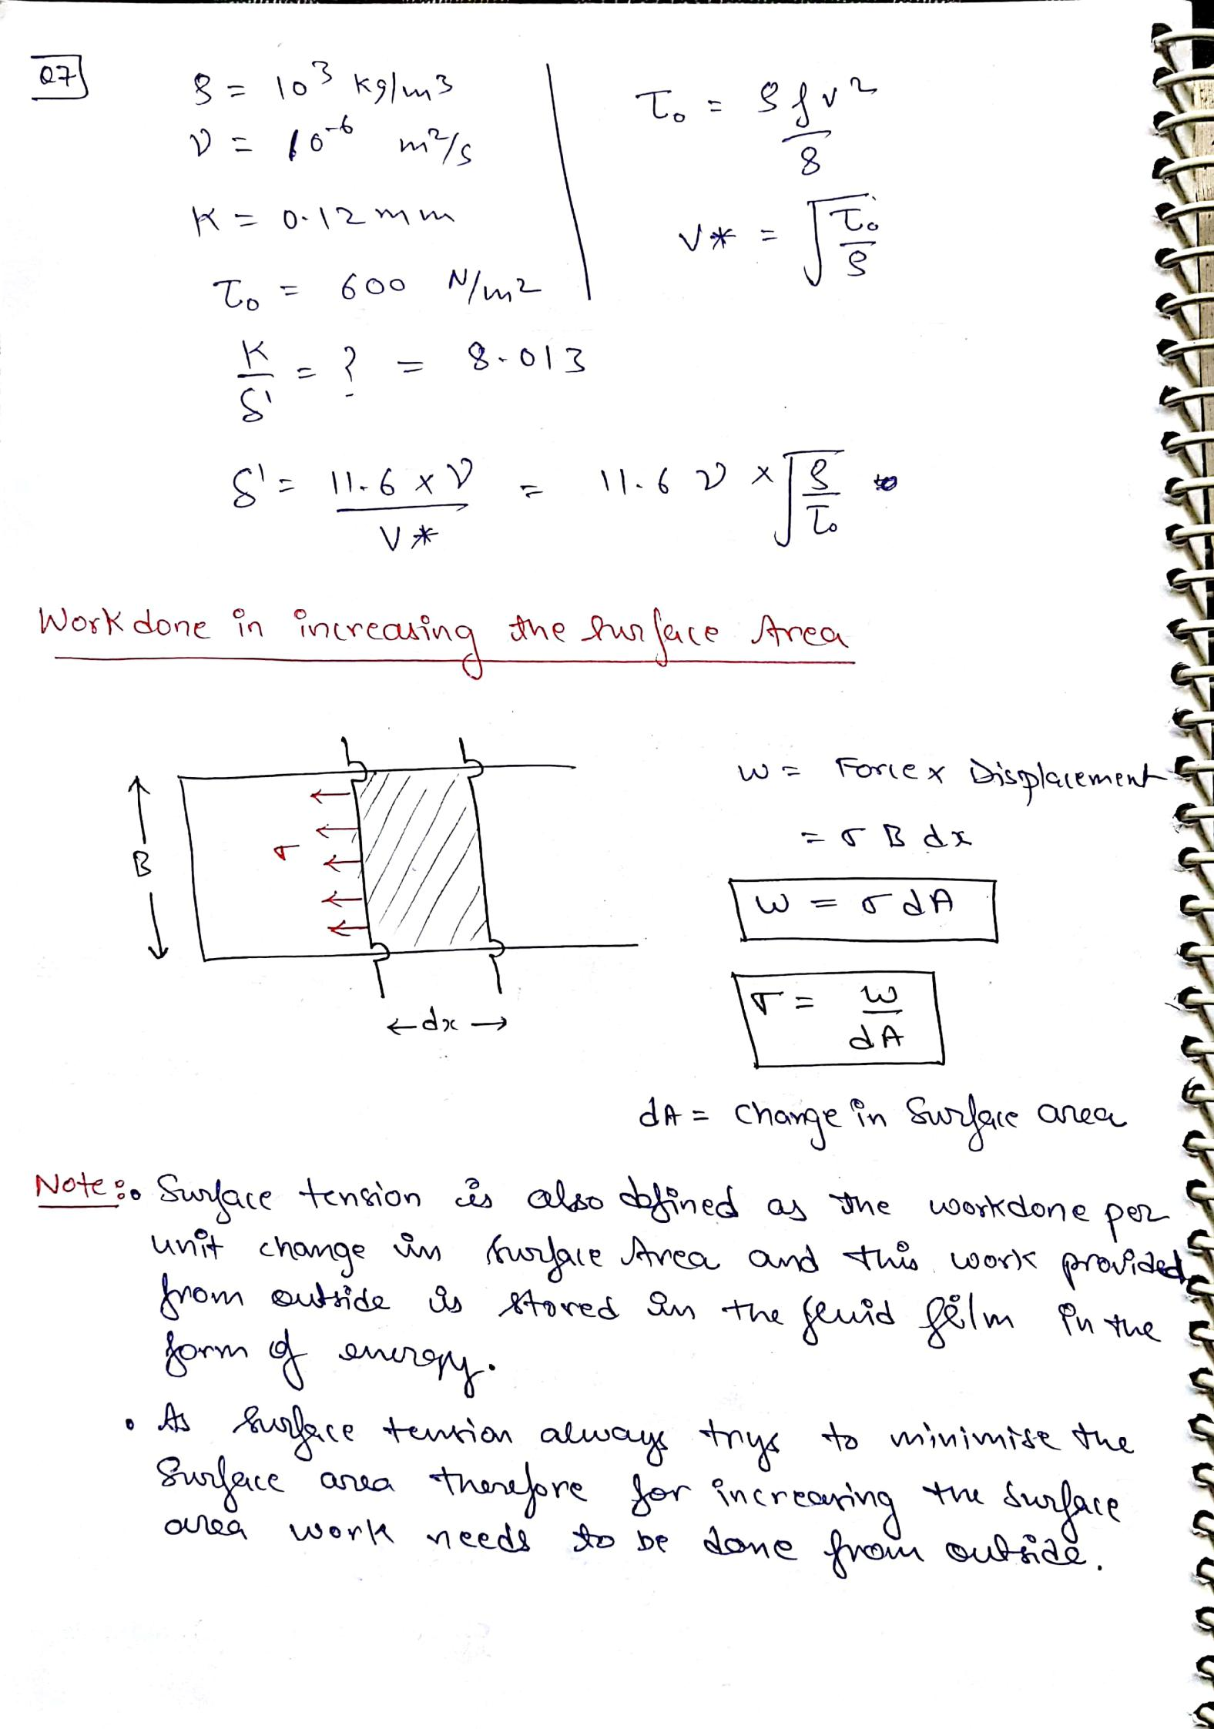
IRRIGATION ENGINEERING

Introduction:

Irrigation may be defined as the process of artificially supplying water to the soil for raising crops. It is a science of planning and designing an efficient low cost irrigation system to suite the natural conditions. It is the engineering of controlling and harnessing the various natural sources of water by the construction of dams and reservoirs, canals and head works and finally distributing the water to the agricultural fields. Irrigation engineering includes the study and design of works connected with river control, drainage of water logged areas and generations of hydro electric power.

Necessity or Importance of Irrigation:

India is basically an agricultural country and its resources on depend on the agricultural output. Prosperity of our country depends mainly upon proper development of agriculture. Even after 60 years of Independence, we have not succeeded in solving our food problems. The main reason for this miserable state of affair is that we still continue to remain at the mercy of rain and practice age old methods of cultivation.
Plants usually derive water from nature through rainfall. However, the total rainfall in a particular area may be either insufficient or ill timed. In order to get the maximum yield, it is necessary to have a systematic irrigation system for supplying optimum quantity of water at correct timing.
Importance of irrigation can be summarized under the following four aspects:

- Area of less rainfall: Artificial supply of water is necessary when the total rainfall is less than the water requirement of crops in such cases, irrigation works may be constructed at a place where more water is available and conveyed to water deficit areas.
Eg: The Rajasthan canal supplies water from the river Yamuna to the arid regions of Rajasthan where annual rainfall is less than 100 to 200 mm.
- Non-Uniform rainfall: The rainfall in a particular area may not be uniform over the entire crop period. Rainfall may be there during the early period of crops and may become scanty or unavailable at the end resulting in lesser yield or total loss of the crop. Collection of water during

periods of excess rainfall and supplying the stored water during periods of scarcity may prove beneficial to the farmers. Most irrigation projects in India are based on this aspect.
- Commercial crops with additional water: The rainfall in a particular area may be sufficient to raise the usual crops but insufficient for raising commercial and cash crops such as sugarcane and cotton. In such situations, utilizing stored water by irrigation facilities is advantageous.
- Controlled Water Supply: Dams are normally meant for storing water during excess flow periods. But in situations of heavy rainfall, flooding can be controlled by arresting the flow in the river and excess water can be released during low flow conditions.

Benefits of Irrigation:

There are many direct and indirect benefits or advantages of irrigation which can be listed as follows.

- Increase in food production: Crops need optimum quantity of water at required intervals assured and timely supply of water helps in achieving good yield and also superior crops can be grown and thus, the value of the crops increases.
- Protection from famine: Irrigation works can be constructed during famine (drought). This helps in employment generation and people also get protection from famine. After completion of such works, continuous water supply may be available for crops and people.
- Cultivation of Cash crops: With the availability of continuous water supply, cash crops such as sugarcane, indigo, tobacco, cotton etc. can be grown.
- Increase in prosperity of people: Due to assured water supply people can get good yield and returned for their crops. Land value increases and this raises the standard of living of the people and hence prosperity takes place.
- Generation of hydroelectric power: Major river valley projects are designed to provide power generation facilities also apart from irrigation needs.
- Domestic and Industrial water supply: Water stored in reservoirs can also be used to serve other purposes like domestic water supply to towns and cities and also for industrial use. Canals can also be effectively used to serve these purposes.
- Inland Navigation: In some cases, the canals are very large enough to be used as channels for inland navigation as water ways are the cheapest means of transportation.

- Improvement in communication: Main canals in large irrigation projects are provided with inspection roads all along the sides. These roads can be asphalted and used as a means of communication.
- Canal plantation: Due to continuous flow of water adjoining areas of a canal are always saturated with water. In such places, trees can be planted which increases the timber wealth of the country.
- Improvement in ground water storage: Due to constant percolation and seepage of irrigation water, ground water table rises. The ground water may percolate and may be beneficial to other areas.
- Aid in civilization: Due to introduction of river valley projects, tribal people can adopt agriculture as their profession which helps in improving the standards of living.
- General development of a country: By assured water supply, farmers can expect good yield. By exporting surplus goods, Government can get revenue. The government can then come forward to improve communications facilities such as roads and railways and also social development by providing schools, hospitals etc.,

Ill-effects of Irrigation:

If water is used in a controlled and careful manner, there would be no ill effects of irrigation. Excess and unscientific use of irrigation of water, givers raise to the following ill effects.
- Water logging: Excess water applied to the fields allows water to percolate below and ground water table rise. The ground water table may rise saturating the root zone of the crop and cutting of air supply to the roots of the crops. Such a phenomenon is called water logging.
Under such conditions fertility of land reduced and also reduction of crop yield.
- Breeding placed for mosquitoes: Excess application of water for irrigation leads to water logging and formation of stagnant water fools, which become breeding places for mosquitoes, thus helping spreading of malaria.
- Unhealthy Climate: Due to intense irrigation the climate becomes damp during summer due to humidity, the climate is sultry and in winter it becomes excessively cold. The resistance of the body to diseases is reduced. In addition to the above, careless use of water leads to wastage of useful irrigation water for which any government will have incurred huge amounts.

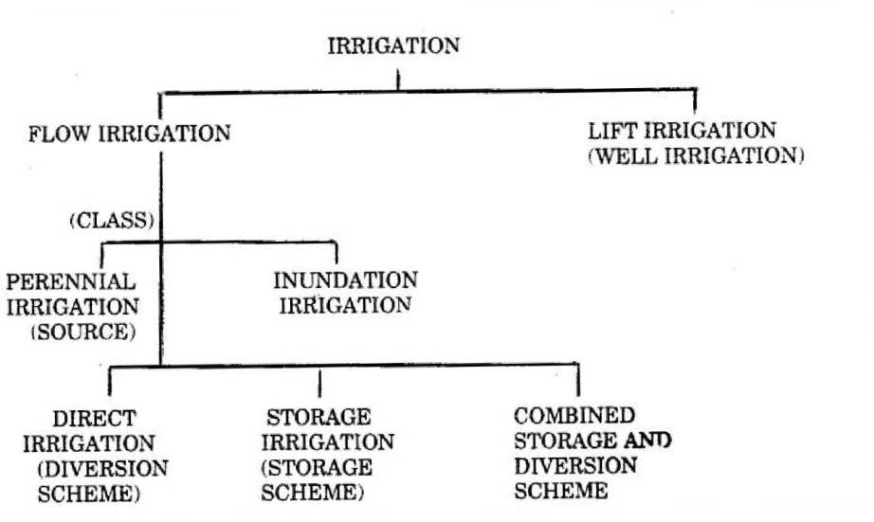
Types or Systems of Irrigation:

Lift Irrigation: It is that system of irrigation in which irrigation water is available at a level lower than that of the land to be irrigated and hence water is lifted by pumps or other mechanism (Hydraulic ram and siphon action) and then conveyed to agriculture fields by gravity flow. Irrigation through wells is an example of lift irrigation. Water from canals or any other source can also be lifted when the level of water is lower than that of the area to be irrigated.
Inundation Irrigation: It is that system of irrigation in which large quantity of water flowing in a river is allowed to flood or inundate the fields to be cultivated. The land becomes thoroughly saturated. Excess water is drained off and the land is prepared for cultivation. Moisture stored in the soil is sufficient to bring the crop to maturity. Inundation irrigation is commonly practiced in delta region of rivers. Canals may be also employed to inundate the fields when water is available in plenty.
Perennial Irrigation: It is that system of irrigation in which irrigation water is supplied as per the crop requirements at regular intervals throughout the crop period. The source of irrigation water may be a perennial river, stored water in reservoirs or ground water drawn from open wells or bore wells. This is the most commonly adopted irrigation system.

Direct Irrigation:

It is a type of flow irrigation in which water from rivers and streams are conveyed directly to agricultural fields through a network of canals, without making any attempt to store water this is practiced in areas where the rivers and streams are perennial. Small diversion dams or barrages may be constructed areas the rivers to raise the water level and then divert the water into canals.

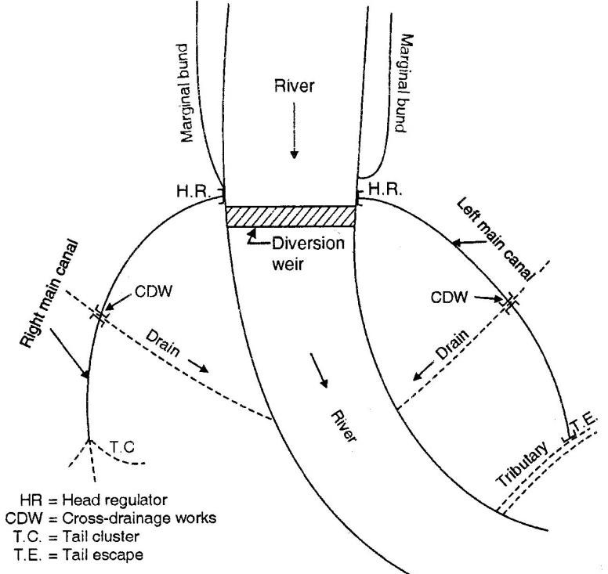

Storage Irrigation:

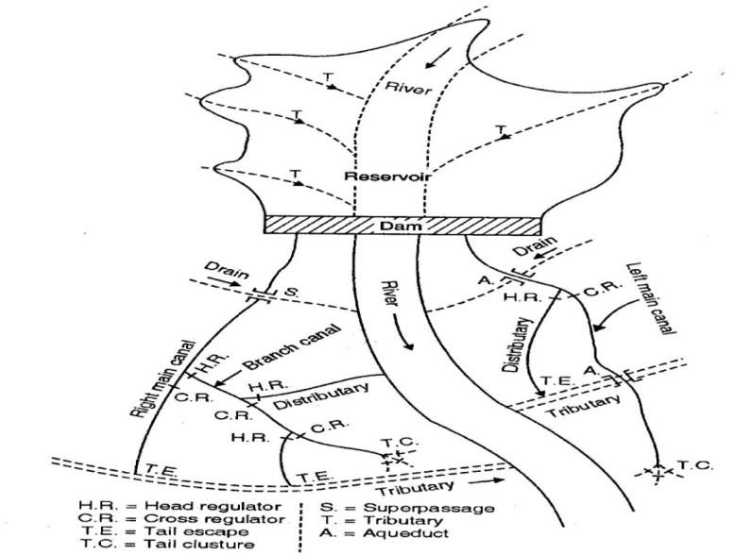
Dams are constructed across rivers which are non- perennial. The discharge in such rivers may be very high during rainy season and may become less during dry stream. By constructing dams across such rivers water can be stored as reservoir during excess flow and can be utilized or diverted to agriculture fields through canals as and when required. Such a system is known as storage irrigation.

Bandhara Irrigation: It is a special irrigation scheme adopted across small perennial rivers. This system lies somewhere between inundation type and permanent type of irrigation. A Bandhara is a low masonry weir (obstruction) of height 1.2m to 4.5m constructed across the stream to divert water into a small canal. The canal usually takes off from one side and the flow into the canal is controlled by a head regulator.
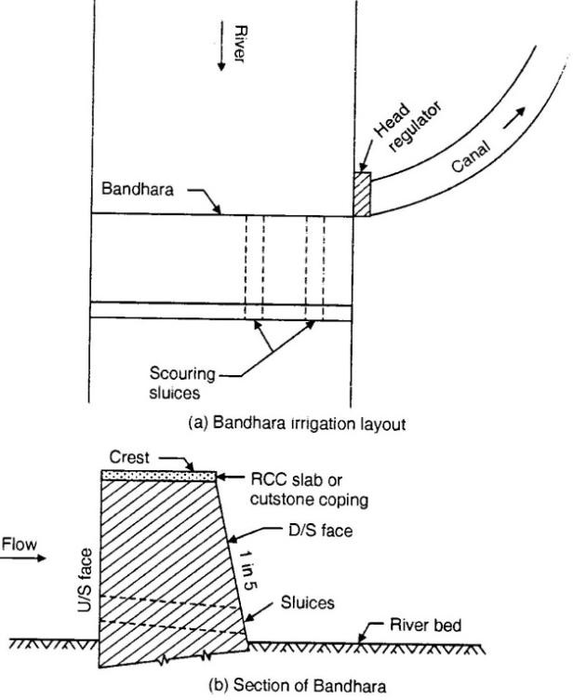

The length of the main canal is usually restricted to about 8km. A series of Bandharas may be constructed one below the other on the same stream so that water spilling over from one Bandhara is checked by another Bandhara. The irrigation capacity of each Bandhara is may be about 400 hectares. Bandharas are adopted across small streams having isolated catchments which are considered to be non feasible or uneconomical to be included under a large irrigation scheme.
This method of irrigation is followed in Central Maharashtra and is commonly known there as the `Phad‘ system.
Advantages of Bandharas:

- Small quantity of flow in streams can be fully utilized or otherwise might have gone as a waste.
- As the length of the canal is short, seepage and evaporation losses are less.
- Intensive irrigation with high duty may be achieved and the area to be irrigated is close to the source.

- The initial investment and maintenance cost of the system is low.

Disadvantages of Bandharas:

- The supply of water is unreliable when the flow in streams becomes lesser.
- Excess water available cannot be utilized as area for cultivation below each Bandhara is fixed.
- In dry seasons, people living on the downstream side of Bandharas may be deprived of water for domestic made also.

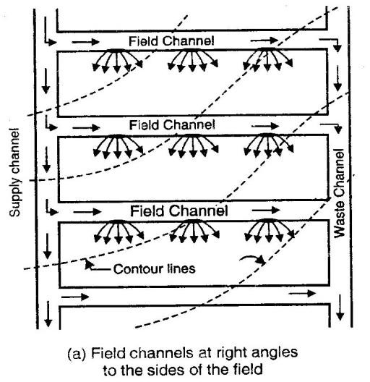
Methods of Irrigation:
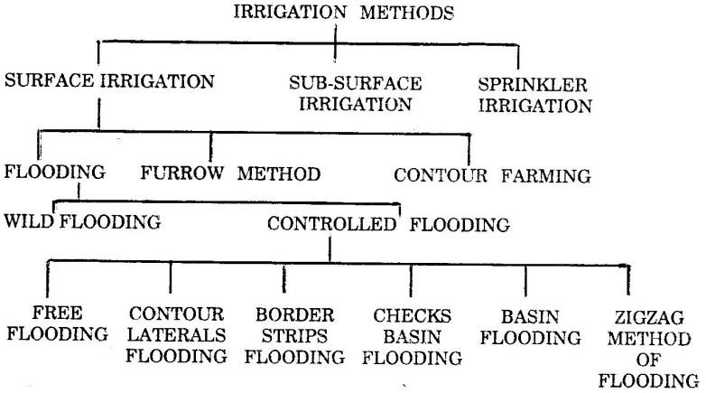
i)

Irrigation water may be applied to the crops by three basic methods, viz.

- Surface irrigation methods
- Subsurface irrigation methods
- Sprinkler irrigation

Good irrigation methods result in increased yield, conservation of soil productivity and economic utilization of water. Over irrigation results in soil erosion, water logging, salt accumulation, nutrient leeching etc. The overall objective of an irrigation method is to see that the required amount of moisture is available in the root zone of the crops.
The objectives or reasons for adopting any irrigation method for applying water to fields are as follows.
- For light irrigation uniform water distribution with a small depth of application, as small as 6 cm should be possible
- For heavy irrigation uniform water depth application of 15 to 20 cm should be possible.
- Large concentrated flow should be possible for reducing conveyance losses and labour costs.
- Mechanical farming should be facilitated.

- Surface irrigation method: In this method the irrigation water is applied by spreading water as a sheet or as a small stream on the land to be irrigated.
Various surface irrigation methods that are practiced are listed as follows.

  - Wild flooding: In this method water is applied by spreading water over the land to be irrigated without any preparation. There is no restriction for the movement of water. It follows the natural slope of the land. The water may be applied to the land directly from a natural stream during season of high flow as in inundation irrigation. This method is suitable for flat and smooth land but involves wastage of water and hence it can be practiced where water is abundant and inexpensive.
  - Controlled flooding: In this method water is applied by spreading it over the land to be irrigated with proper control over the flow of water and as well as the quantity of water to be applied. In such methods prior land preparation is essential.

Various controlled flooding methods are as follows.

Free flooding: This method is also known as irrigation by plots. Here the field is divided into a number of small sized plots which are practically level. Water is admitted at the higher end of the plots and the water supply is cut off as soon as the water reaches the lower end of the plots.
- Border strip method: In this method the land to be irrigated is divided into a series of long narrow strips separated from each other by levees (Earthen bunds) or borders. The width of the strips varies between 10 to 20 m and the length of the strip varies between 60 to 300 m depending upon the nature of the soil and rate of water supply.

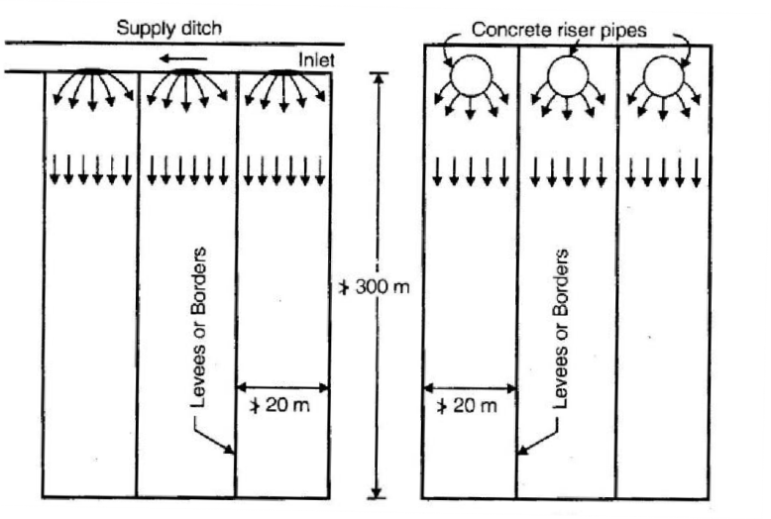

The strip of the land has no cross slope and has uniform gentle slope in the longitudinal direction. This method is suitable for forage crops requiring least labour. Mechanized farming can be adopted in this method.
- Checks or Levees: In this method a comparatively large stream of water discharged into a relatively level plot surrounded by check or levees or low rise bunds. The checks are usually 30 cm high. The checks may be temporary for a single crop season or semi permanent for repeated used as in case of paddy fields. The size of the plots depends upon the discharge of water and porosity of the soil. The usual size of the plot varies between 0.04 hectares to 0.05 hectares.

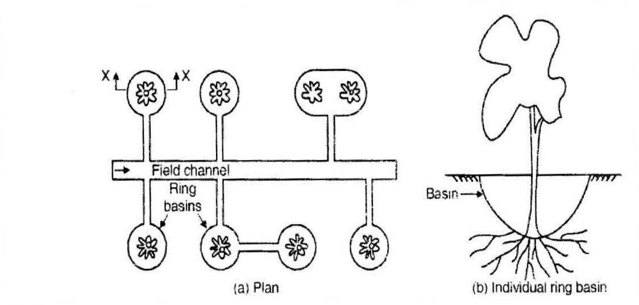
- Basin flooding: This method of irrigation is adopted for irrigating orchards (enclosures of fruit trees). For each tree, a separate basin which is circular usually is made. However, in some cases basins are made large to include two or more trees in each basin. Water is supplied through a separate field
channel, but in some cases the basins are inter connected.

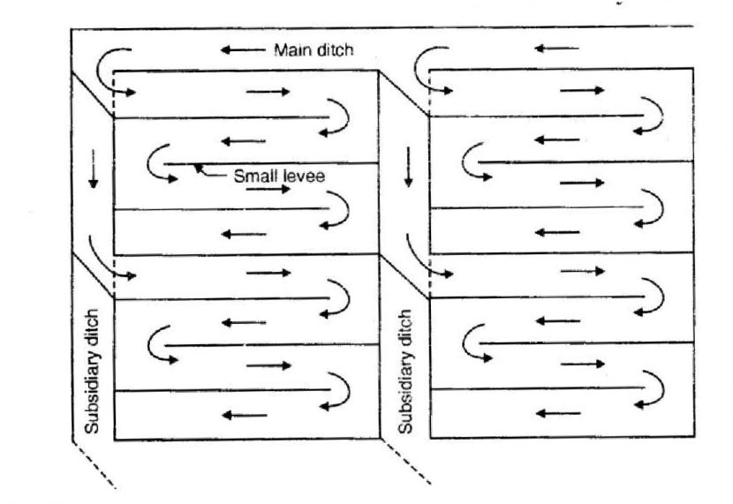
- Zigzag flooding: This is a special method of flooding where the water takes a circuitous route before reaching the dead end of each plot. Each plot is subdivided with help of low bunds. This method is adopted in loose soils to prevent erosion at the higher ends.

- Furrow method: In this method water is applied to the land to be irrigated by a series of long narrow field channels called furrows. A furrow is a narrow ditch 75 to 125 mm deep excavated between rows of plants to carry irrigation water. The spacing of furrows depends upon the spacing of the plants. The length of a furrow is usually 200metres. In this method only one fifth to one half of the surface is wetted. The evaporation losses are very much reduced.

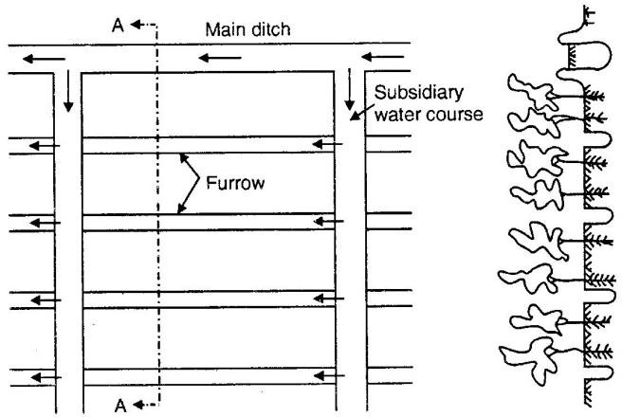

Contour farming:

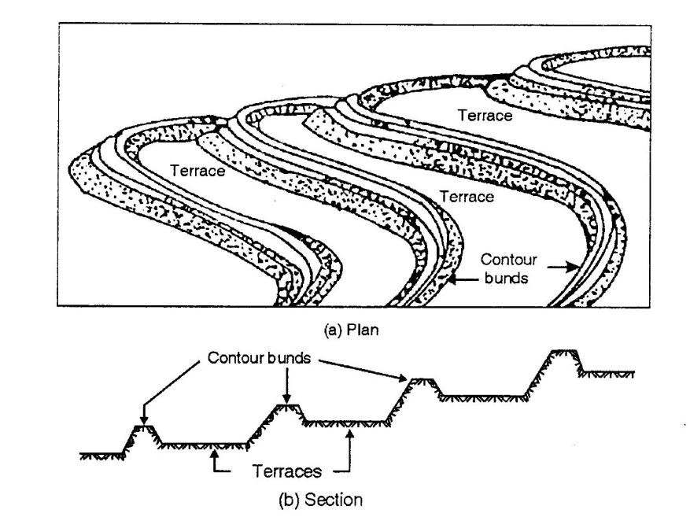
Contour farming is practiced in hilly regions where, the land to be irrigated has a steep slope. Here the land is divided into a series of strips usually known as terraces or benches which are aligned to follow the contour of the sloping area. This method also helps in controlling soil erosion.

- Sub Surface Irrigation: This method consists of supplying water directly to the route zone through ditches at a slow rate which are 0.5 m to 1 m deep and 25 to 50 cm wide. The ditches are spaced 50 to 100 m apart. Water seeps into the ground and is available to the crop in the form of a capillary fringe. Proper drainage of excess water is permitted either naturally or providing suitable drainage works, thereby preventing water logging in fields. The favourable conditions to practice subsurface conditions are,
  - Availability of imperious subsoil at a reasonable depth (2 to 3m).
  - Water table is present at shallow depth.
  - Availability of moderate slope.
  - Availability of good quality irrigation water.

With the above favourable conditions and necessary precautions it is possible to achieve higher yields at low cost.
- Sprinkler Irrigation: This method consists of applying water in the form of a fine spray as similar to rain fall. Stationary over head perforated pipes or fixed nozzle pipes installations were earlier used. However, with the introduction of light weight pipes and quick couplers, portable sprinkler systems with rotating nozzle have been developed and hence these have become popular. A pump usually lifts water from the source and supplies it through the distribution system and then through the sprinkler nozzle or sprinkler head mounted on the riser pipes. About, 80 % irrigation efficiency is possible with sprinkler irrigation, particularly in semi arid and humid regions. The efficiency of this system decreases by 5 % for every 7.5 km/hour of increase in wind velocity.

Note: Irrigation efficiency ( ) is given as,
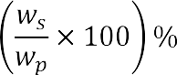

where

- represents amount of irrigation water stored in root zone

- amount of water pumped or supplied into the system.

Sprinkler irrigation method is adopted in regions where, surface irrigation methods cannot be used due to the following reasons.
  - The soil is too pervious or impervious.
  - The nature of the soil is too erosive.
  - The topography is not uniform or very steep.
  - The land is not suitable for surface irrigation method.

Advantages:

- Soil erosion is well controlled by adjusting the discharge through the nozzle.
- Uniform water application is possible.
- In case of seedlings and young plants, light irrigation is possible easily.
- Much land preparation is not essential and hence labour cost is reduced.
- More land for cropping is available since borders and ditches are not required.
- Small amounts of irrigation water in water scarcity regions can be effectively utilized.

Disadvantages:

- Wind will distort the sprinkling pattern.
- Constant water supply under pressure is required for economic use of equipment.
- Irrigation water must be free from silt, sand and impurities.
- Initial investment is high.
- Energy requirement for pumping water is high.
- Heavy soil with poor infiltration (clayey soil) cannot be irrigated efficiently.

Drip or trickle irrigation: This is the latest irrigation method, which is becoming popular in water scarcity areas and water with salt problems. In this method, small diameter plastic or PVC pipes with drip nozzles commonly called emitters or drippers are adopted to deliver water to the land surface near the base of the plant. Water can be applied at a rate varying between 2 to 10 liters per hour to keep the soil moisture within the desired range for plant growth.
The main components of a drip irrigation system are a pumping unit, main pipelines, sub main pipe lines, lateral pipelines, emitters, pressure gauges etc.,

Advantages of this method are,

- Excellent control over water application and efficiency as high as up to 95% can be achieved.
- Evaporation losses from land surface are minimum.
- Losses due to deep percolation can be avoided.
- Saline waters can be applied effectively.
- Water soluble fertilizers can be applied through drip irrigation.

The draw backs of this system are,

- It involves large investment.
- Frequent blocking of nozzles takes place.
- Tilling operation may be obstructed.

Supplemental Irrigation

Rain-fed agriculture accounts for about 80% of the world‘s farmland and two thirds of global food production. Agriculture in these areas is limited by a number of factors including water scarcity, drought and land degradation.
Shortage of soil moisture often occurs during the most sensitive stages of crop growth, i.e. flowering and grain filling. This can severely affect plant growth and yield. Supplemental irrigation – the application of limited amounts of water during critical crop growth stages – can substantially increase yield and water productivity.
Supplemental irrigation may be defined as the addition of limited amounts of water to essentially rain-fed crops, in order to improve and stabilize yields during times when rainfall fails to provide sufficient moisture for normal plant growth.
Supplemental irrigation in rain-fed areas is based on the following three basic aspects

- Water is applied to a rain-fed crop that would normally produce some yield without irrigation

- Since rainfall is the principal source of water for rain fed crops, supplemental irrigation is only applied when the rainfall fails to provide essential moisture for improved and stable production

- The amount and timing of supplemental irrigations are optimally scheduled not to provide moisture stress-free conditions throughout the growing season, but rather to ensure that a minimum amount of water is available during the critical stages of crop growth that would permit optimal yield.
Amounts of water to be applied and time depends on crop water requirements and the water available in the root zone after the rainy season. However, 100-200 mm of supplemental irrigation may be enough in most of the areas and years.

Sewage Irrigation

Sewage is a water-carried waste, in solution or suspension, that is intended to be removed from a community. Also known as waste water, it is more than 99% water.
In agriculture untreated wastewater is increasingly being used for irrigation . Cities provide lucrative markets for fresh produce and are also beneficial to farmers. However, because agriculture is increasingly facing scarcity of water and competence for water resources with industry and municipal users, there is often no alternative for farmers but to use water polluted with urban waste, including sewage, directly to water their crops.
There can be significant health hazards related to using water loaded with pathogens in this way, especially if people eat raw vegetables that have been irrigated with the polluted water.

Infiltration Galleries
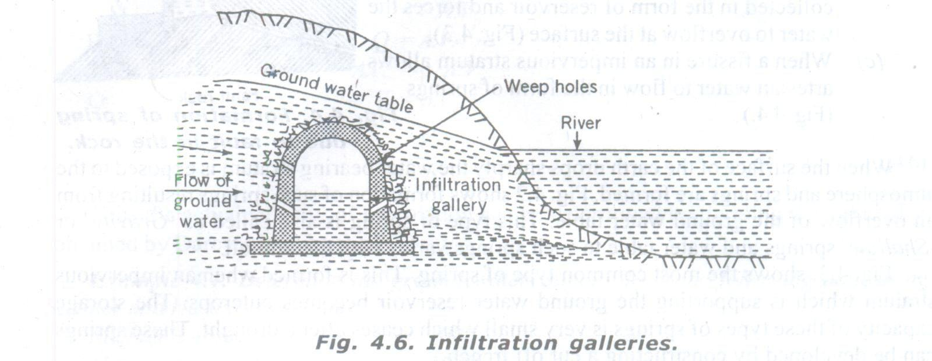

Infiltration galleries are horizontal tunnels (with holes on sides) constructed of masonry walls with roof slabs to tap ground water flowing towards rivers or lakes. These are constructed at shallow depths (3-5m) along the banks of river either axially along or across ground water flow. If large ground water quantity exists, porous drain pipes are provided and they are surrounded by gravel and broken stone. The yield from infiltration galleries may be 15,000 L/day / Meter length. A collecting well at shore end of gallery serves as sump from where water can pumped out to required destination.

UNIT-6

SOIL – WATER - CROP RELATIONSHIPS

Introduction

The aim of the irrigation practice is to ensure that the plants have an adequate supply of water in their root zone for achieving optimum yield of crops without damaging the quality of the soil. This necessitates a clear understanding of the interaction among the soil, water and plants in the root zone of the plants. The soil provides the structural base to the plants and allows the root system t get firmly embedded in the soil. Further the soil also provides water as well as the nutrients required by the plants for their growth.
Water is required by plants in small quantities for metabolism and transportation of plant nutrients, and in much larger quantities in the physiological process of transpiration which protects the plants against the injurious effects of high temperature. In addition to water, air must also be present in the root zone for the respiration of the microorganisms to occur and to provide a favorable environment for root development and the absorption of nutrients. As such the excess water must be drained out from the soil to enable free circulation of air in the root zone.
For proper growth of the plants requisite quantities of water, air and nutrients must be available in the soil. Therefore while practicing irrigation it must be ensured that there quantities are available in correct proportions.

Composition of Soil, soil texture.

A soil is usually classified according to the size of its particles. The material having particles of diameter between 20 mm and 2 mm is called gravel, while that having particles smaller than 2 mm in diameter is called fine earth. The term soil in general refers to fine earth, which has three components sand, silt and clay. According to International Soil classification the range of diameters of particles of each or these components of the soil are as indicated below.

Type of soil Range of particle diameter in millimetre

Coarse sand 2 to 0.2

Fine sand 0.2 to 0.02

Silt 0.02 to 0.002

Clay Less than 0.002

Soil Texture.

Soil texture refers to the composition of the soil and it is reflected by the particle size, hape and gradation. Generally the soils occurring in nature are a combination of sand, silt and clay. The relative proportions of sand, silt and clay in a soil mass determines the soil texture. According to textural g radations the soils may be broadly classified as (1) 'open' or 'light' textured soils, (2') 'medium' textured SOILS, and (Hi) 'tight' or 'heavy' textured soils. The 'open' or 'light' textured soils contain very low content of silt and clay, and hence these soils are coarse or sandy. The 'medium' textured soils contain sand, silt and clay in sizable proportions. In general loam is a soil which has all the three major size actions in sizable proportions, and hence the loams are medium textured soils. The 'tight' or 'heavy' textured soil contains high content of clay. Thus clayey soils are tight or heavy textured soil Fig 3.1represents the textural classification chart for 12 main textural classes of soils which is given by united states department of agriculture ,(USDA)

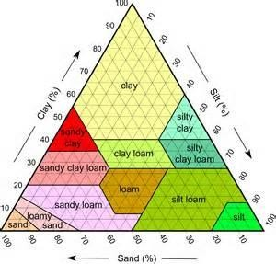

Soil groups in India

The Indian soils may be divided into four major groups viz., (i) alluvial soils, (ii) black soils, (iii) red soils, and
- laterite soils. In addition to these four groups there exist another group of soils which includes forest soils, desert soils, and saline and alkali soils.

Alluvial soils

Alluvial soils are formed by successive deposition of silt transported by rivers during floods, in the flood plains and along the coastal belts. The silt is formed from the weathering of the rocks by river water in the hilly terrain through which it flows. These soils form the largest and the most important group of soil in India. The alluvial soils occur in the Indo-Gangetic plains and Brahamputra plains in north India and also in the plains of various rivers in other parts of the country. These are in general deep soils that is having more that 1 metre depth above a hard stratum, but the properties of these soils occurring in different parts of the country vary mainly because the parent material from which they have been derived are different. These soils vary from clayey loam to sandy loam. The values of pH for these soils usual range between 7.0 and 9.0, and hence these soils may be neutral or alkaline in character. The water holding capacity of these soils is fairly good and they give good response to irrigation.

Black Soils

Black soils have evolved from the weathering of rocks such as basalts, traps, granites and gneisse. These soils occur chiefly in the states of Andhra Pradesh, Gujrat, Madhya Pradesh, Tamil Nadu, Maharashtra and Karnataka. The colour of these soils ranges from dark brown to black. Furth< irrespective of the nature of the parent rock from which black soils have developed, they do not differ much in general physical and chemical properties. These soils are highly argillaceous and very fine grained. Thus these are heavy textured soils and their clay content varies from 40 to 60 percent. The values of pH for these soils vary from 8.0 to 9.0 or higher in different states, and hence these soils are alkaline in character. A special feature of the black soils is that they are plastic and sticky when wet, an very hard when dry. These soils possess a high water holding capacity but poor drainage. Black soils ai sub-divided as (i) shallow black soils which have a depth of 0.3 metre or less, (ii) medium black soil which are 0.3 metre to 1.0 metre in depth, and (Hi) deep soils which are over 1 metre deep. Deep black soils are also referred to as black cotton soils since cotton is the most important crop in these soils.

Red Soils

Red soils are formed by the weathering of igneous and metamorphic rocks comprising gneisses an schists. These soils mostly occur in Tamil Nadu, Karnataka, Maharashtra, Andhra Pradesh, Madhya Pradesh and Orissa. They also occur in Bihar, West Bengal and some parts of Uttar Pradesh. These soil are in general light textured loams, but the properties of these soils vary from place to place. These are in general deep soils with values of pH ranging between 5.0 and 8.0, and hence in most of the cases these soils are acidic in character. The red soils have low water holding capacity. These soils react well to the application of irrigation water and on account of low water holding capacity they are well drained.

Laterite Soils

Laterite soils are derived from the weathering of the laterite rocks. These soils occur mostly ii Karnataka, Kerala, Madhya Pradesh, the Eastern Ghat region, Orissa, Maharashtra, Malabar and in some parts of Assam. These soils are reddish or yellowish-red in colour. The laterite soils have values of pH between 5.0 and 6.0 and hence these soils are acidic in character. These soils have low clay content and hence possess good drainage characteristics.

Forest Soils

Forest soils are formed by the deposition of organic matter derived from forest growth.

Desert Soils

These soils are found in the arid areas in the north-western region in the states of Rajasthan, Haryana and Punjab and are lying between the Indus river on the west and the range of Aravali Hills on the east. These soils are blown in from the coastal region and Indus valley, and are also derived from disintegration of rocks in the adjacent areas. These are light textured sandy soils of depth extending beyond 0.5 metre and react well to the application of irrigation water. However, these soils have a fairly high values of pH, and some of these soils contain a high percentage of soluble salts.

Saline and Alkali Soils

These are the soils which have appreciable concentration of soluble salts and exchangeable sodium content. These salts usually appear in the form of a white efflorescent crust on the surface of the soil. These soils are formed due to inadequate drainage of the irrigated lands, and hence these are found among the groups of alluvial, black and red soils. These soils are not suitable for cultivation, unless these are reclaimed by adopting suitable methods.

Functions of the Soil:

Soil provide the following for the life and development of plants

  - Anchor for plants roots
  - Water for transpiration and metabolism
  - Minerals and nutrients for metabolism
  - Oxygen for metabolism

Factors affecting suitability of soil for irrigation:

The following properties play an important role in determining the depth of water available in the root zone of the soil in a single application of water and in turn the frequency of watering.
- Size of soil particles
- Compactness

- Depth
- Organic matter content
- Position of water table Classification of soils
- Classification according to age of formation: In this method soil has subdivided as
  - Youth full: Soil which is fully pervious
  - Mature soil: Soil which is less permeable
  - Senile Soil: Soil which has little or no productivity. It has become hard and impermeable

- Classification according to geological forces of formation
  - Residual soil: Soil formed by disintegration of rocks by various actions in the same place.
  - Alluvial soil: soils formed by deposition of water borne (carried by water) material.
  - Eolian soil: Solis formed by deposition of wind action.
  - Colluvial soil: soils formed by deposing by rain water below foot hills.
  - Glacial soil: Solis formed by transportation and deposition by glaciers.
  - Volcanic ash: Ash deposits due to volcanic eruptions.
  - Solis of aggradations: soils formed accumulation in layers.
  - Soils of degradation: soils which are continuously zoning out due to erosion.
  - Pan clay pan: Impervious soils deposited on hard layers to form new set of soils & cemented by calcium carbonate, Iron oxide, silica etc.

- Classification based on salt content
  - Ped-O- Cal: Soil rich in calcium carbonate
  - Ped-Al-Fer: Soil rich in aluminum and iron salts
  - Humus: Soil rich in organic matter or salts.

- Soil classification based on particle size
A composed soil can be classified on the basis of particular soil as coarse , medium, fine grain depending upon the percentage of sand, silt, and clay.

- Soil classification according to regional basis
  - Regions of autogenous of soil development
  - Regions of balanced decomposition
  - Regions of excessive denudation
  - Regions of eroded eolian accumulation

- Classification of Indian soil
  - Alluvial soils: These are soils formed due to deposition by water in Indo-Gangetic plains. These soils are very fertile and also absorb good amount of rainfall.
  - Red soil: It is a residual soil which is left over in a same place as a result of decay of underlying parent rock & covering parent rock. These have light texture and good porosity varying fertility and low soluble salt content. Such soils are found in central and peninsular India.
  - Lateral soil: These are residual soils commonly found in coastal region. These are usually porous and well drained & they do not contain common nutrients required for plant growth in sufficient quality.
  - Black soil: The texture of this varies from clay to loamy

Functions of Irrigation Water:

Water and nutrients are the most important requirements of plants. Following are the main functions of irrigation water
- Water dissolves the nutrients, forms a solution of the nutrients and which are absorbed by the roots and thus water acts as a nutrient carrier.
- The irrigation water supplies moisture which is essential for the life of bacteria which are beneficial to plant growth.
- Irrigation water supplied moisture which is essential for the metabolism within the plant leading to plant growth.
- Some essential salts present in soil react in presence of water to produce nourishing food products.
- Water cools the soil and atmosphere, thus creating a healthy environment for plant growth.
- It softens the tillage pans (area to be irrigated).

Suitability of water for irrigation:

In order to perform the required functions, for optimum growth of plants, the water may be turned as unfit if,
- Sediment concentration is excessive
- Total concentration of salts of sodium (Na), calcium, magnesium and potassium is excessive.
- Percentage of sodium ions to that of other ions is excessive.
- Percentage of bicarbonates of calcium and magnesium becomes excessive.
- Bacteria harmful to plant growth are present.
- Contains chemicals toxic to plants, animals and humans.

Classes of soil water:

Water in the soil may be present in the following forms

- Hygroscopic water:
- Capillary water
- Gravitational water

Hygroscopic water: When an over dried soil sample is exposed to atmosphere, the soil absorbs some amount of water from the atmosphere. This water absorbed by the soil is called hygroscopic water and it is not capable of moving either under capillary action or gravitation.
Capillary water: It is that part of water in excess of hygroscopic water, which exists in the pore spaces (voids) of the soil due to molecular attraction.
Gravitational water is that part of water in excess of hygroscopic and capillary water which will drain out under favourable conditions.

Soil moisture constants:
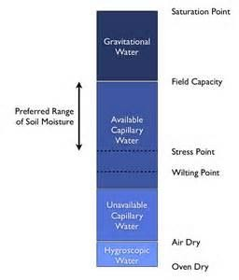

Saturation Capacity (Maximum moisture holding capacity): It is defined as the amount of water required to fill all the pore spaces between soil particles by replacing all the air. It is inclusive of hygroscopic water, capillary water and gravitational water. When the porosity of a soil sample is known the saturation capacity can be expressed as equivalent depth of water in cm per meter of soil depth.
Ex: If porosity of a soil sample is 50% by volume, the moisture in each meter of a saturated soil is equivalent to 50 cm on the field surface.
Field Capacity: It is defined as the maximum amount of moisture which can be held by a soil against gravity, thus immediately after the gravitational water has drained off from a saturated soil mass. Field capacity is the upper limit of the capillary water of moisture content available to the plants. The field capacity is usually given as the weight of the maximum amount of moisture held by the soil against gravity per unit weight of dry soil and is expressed as a percentage.

Permanent wilting point or coefficient: It is that water content at which plants can no longer extract sufficient water from the soil for growth and become permanently wilted. At permanent wilting point, the film of water around the soil particles is held so tightly that plant roots cannot extract enough moisture for metabolism.
It is the lower limit of available or capillary water and is usually expressed as the weight of water held in soil per unit weight of dry soil when the plants are permanently wilted.
Permanent wilting point differs from soil to soil but is the same for different plants grown in the same soil.
The permanent wilting point is expressed as a percentage. It is as low as 2% for light sandy soils and may be as high as 30% for heavy clayey soils.
Available moisture: It is the different in water content of the soil between field capacity and permanent wilting point.
Readily available moisture: It is that portion of available moisture which is most easily extracted by plant roots. Only about 75% of available moisture is readily available.

Expression for Depth of Water held by soil in root zone:

The water held by soil, in root zone may be expressed in terms of depth of water as indicated below. Let, = depth of water available in root zone
= depth of root zone in meters

= field capacity of soil expressed as a ratio

= Density or unit weight of soil

= Density or unit weight of water

Consider one square meter or unit area of soil mass, We know that,

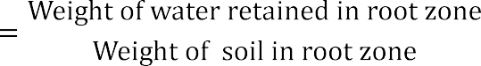

=

Similarly, depth of water stored in root zone at permanent wilting point,

Also depth of available water in root zone is equal to

Also depth of readily available water in root zone

Problem1:

Find the field capacity of a soil for the following data. Depth of root zone = 2m
Existing moisture content = 5% Dry density of soil =15 kN/m³ Water applied to soil = 600 m³

Water lost due to evaporation and deep percolation = 10% Area of land irrigated = 900 m²
Solution:

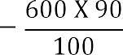
Total water applied = 600 m³ Loss of water = 10

= 540 m³

Weight of water retained in the soil = 540 m³ x

= 540 x 10 = 5400 kN

Total weight of dry soil = (V x 900 x 2 x 15 =2700 kN

= 20%

Field capacity = Available water + Existing or Hydroscopic water = 20% + 5% = 25%

Problem2:

A loam silt soil has field capacity of 25% and permanent wilting coefficient of 10%. The dry unit weight of soil is 1.5g/cc. If the depth of root zone is 0.75m, determine the storage capacity of the soil. If the moisture content drops to 14% determine the depth of irrigation water to be applied to maintain available water, also take application efficiency as 75%.
Solution:

- Storage capacity of soil is nothing but the depth of available water in root zone.

- Depth of irrigation water required to raise moisture level from minimum level to field capacity

= 0.165m.

Consumptive use of water:

It is defined as the total quantity of water used by plants in transpiration; tissues build up, evaporation from adjacent or exposed soil in an area at any specific time.
Transportation is the process by which plants dissipate the water absorbed from the soil through the roots into the atmosphere through the surface of leaves, stalks and trunk.
Evaporation is the process by which soil loses water in the form of vapours.

Consumptive use also includes water consumed by accompanying could growth, water deposited by dew or rainfall and subsequently evaporation without entering the plant systems.
The following factors affect the consumptive use of water,

- Direct evaporation from soil
- Relative humidity of air
- Wind velocity
- Temperature
- Precipitation

- Intensity of sunlight
- Soil and topography
- Type of crop
- Cropping pattern
- Method of irrigation
- Nature of plant leaves
- Cropping reason

Water Requirement of crops

Water requirement of a crop is the total quantity of water required by the crop from the time it is sown to the time it is harvested. Different crops require different amounts of water. It is essential to maintain the quantity of water (readily available moisture) in soil by supplying water more or less at fixed intervals throughout the plant growth. The growth of crops is retarded, if the moisture content becomes, excessive or deficient. Excessive soil moisture results in filling the pore spaces and there by drawing out the air in root zone, which is also essential for plant growth. In case of moisture deficiency, plants require extra energy to extract the moisture in soil.

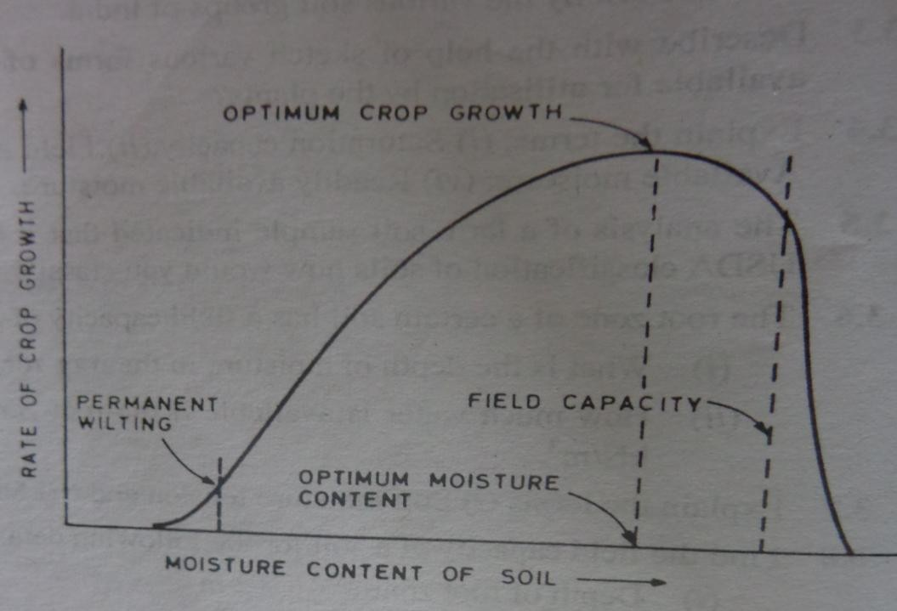

As seen from the above graph, in a soil there exists a moisture content known as optimum moisture content at which plants grow most rapidly. OMC is usually lesser than field capacity for all crops in any soil. Hence, it is required to maintain OMC by supplying water at regular intervals.

Depth and frequency of irrigation:

The amount of irrigation water applied should be such that the moisture content is raised to the field capacity. The moisture content in soil reduces due to consumptive use by plants. However, the moisture content should not be allowed to fall below lower limit of readily available moisture. When the moisture content reaches the lower limit of readily available moisture, water should be supplied by irrigation method to rise it to the field capacity or optimum moisture content.
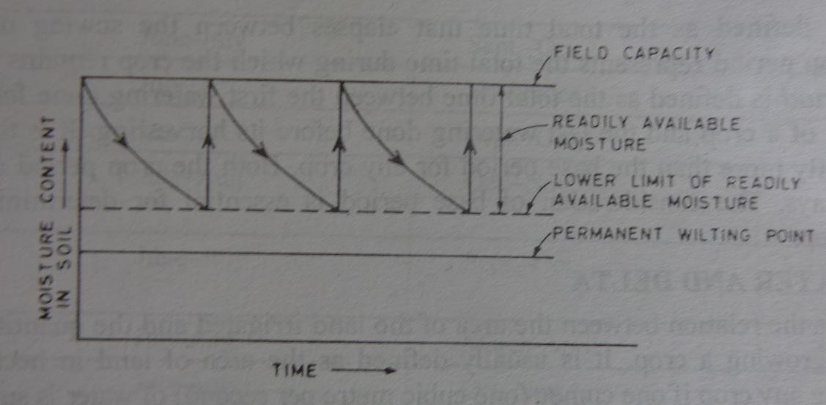

The minimum depth of water to be applied during irrigation to maintain field capacity is given by,

Dw= Ws/wxd(field capacity – weight of moisture content held by soil at lower limit of readily
available moisture per unit weight of dry soil) The frequency of irrigation is given by,
Fw= Dw/Cu (days)

Where Cu represents the consumptive use of water by crops expressed as depth of water in cm/day

Problems 3:

The root zone of a certain soil has a field capacity of 30% and permanent wilting percentage is 10%
(i)What is the depth of moisture in the root zone at field capacity and permanent wilting point?

- How much water is available if the root zone depth is 1.2 m . The dry weight of the soil is 13.73kN/m³

Solution:

  - The depth of moisture in root zone at field capacity per metre depth of soil 1 =Sp. gr. of soil x Field capacity
= (13.73x 10³/9810) X 30/100

= 0.42 m/m = 420 mm/m

The depth of moisture in root zone at permanent wilting point per metre depth of soil

= Sp. gr. of soil x Permanent wilting point

=(13.73x 10³/9810) X 10/100

= 0.14 m/m = 40 mm/m

(ii ) Depth of available water per metre depth of soil.

= Ws/w (Field capacity—Permanent wilting point)

= (13.73x 10³ /9810) X (30/100 – 10/100) =
= 0.28m/m = 280mm/m

Total water available in the root zone
= 280 x 1.2 = 336 mm

Problems 4:

The field capacity of a certain soils is 18.3% and its specific gravity is 1.25. A wet sample of the soil taken before irrigation weighs 153gm and weight after drying in the oven is 138gm. What depth of water must be applied to irrigate the soil to a depth of 1.2m
Solution: The moisture content before irrigation

= ( 153-138/ 138 ) x 100= 10.9% by weight

Depth of water required to be applied to bring the moisture upto its field capacity

= 1.25 x 1.2 ( ) = 0.111m = 111mm

Problems 5:

The field capacity of a certain soil is 12.6% and its specific gravity is 1.42. If the moisture content of present in the soil before irrigation is 8.2%. How deep the soil profile will be welted with an application of 50mm of irrigation water.
Solution :

Depth of irrigation water applied=Sxd (field capacity–Moisture content before irrigation )
Thus by substitution we have
50/1000= 1.42 x d (12.6/100 – 82/100)

D= 50/1000x 1/1.42x 100/4.4
= 0.80m = 800mm

Problems : 6

Determine the area which can be irrigated using surface method of irrigation with a source of water having a discharge of 10000 litres per minute. The available moisture holding capacity of the soil is 180mm per metre and depth of root zone is 1.1m. Irrigation is done when 40% of available moisture is used. The total losses during irrigation are 35% and peak daily moisture use is 4.5mm.

Solution:

Effective discharge of the source for irrigation

=(10000 x 0.65) = 6500 litres/minute Depth of water available for the useofplants
= (180x0.40) = 72mm/m

Depth of root zone = 1.1 m

Depth of water available for the entire root zone

= ( 72x1.1 ) = 79.2mm

Peak dailymoisture use = 4.5 mm

Watering interval = 79.2 / 4.5 = 17.6 days = 17 days

Thus if a is the area in hectares which can be irrigated then we have (6500/1000) x 17x 24x 60 = a x 10⁴ x 79.2/1000
a= 201ha

Problems 7:

The following data pertains to healthy growth of crop.

- Field capacity = 30%
- Permanent wilting percentage = 11%
- Density of soil=1300kg/m³
- Effective depth of soil= 700mm
- Daily consumptive use of water for given crop= 12mm

For healthy growth moisture content must not fall below25% of the water holding capacity between the field capacity and permanent wilting point. Determine the watering intervals in days.

Solution :

Maximum storage capacity of soil= (Ws/w)x d(field capacity–Moisture content before irrigation ) Ws - 1300 kg/m³; w- 1000 kg/m³; d= 700 mm = 0.7 m;
Field capacity =30/100 = 0.30; and Permanent wilting percentage = 11% = 0.11 Thus, by substitution, we get
Maximum storage capacity of soil= 1300 /1000 x 0.7(0.30-0.11) = 0.1729m= 172.9mm

Since for healthy growth moisture content must not fell below 25% of the maximum water holding capacity
of soil, °

Available moisture = 172.9 x75 /100= 129.675 mm Daily consumptive use of water = 12 mm
Watering interval = 129.675 /12= 10.891 days = 10days

UNIT 7

WATER REQUIREMENT OF CROPS

INTRODUCTION

Water requirement of a crop is the total quantity of water required by the crop from the time it is sown to the time it is harvested. Different crops require different quantities of water. Since the growing crops use water continuously, it is essential to maintain the quantity of readily available moisture in the soil by irrigation. As such the total quantity of water required by a crop is so distributed that a part of it is applied each time at a more or less fixed interval throughout the period of growth. The quantity of water applied at each irrigation should be such that water sufficient to meet the needs of the crop for a period between two successive irrigations is stored in the soil. Therefore in addition to the total quantity of water required by a crop, it is also essential to determine the frequency of irrigation as well as the quantitv of water required to be applied during each application.

LIMITING SOIL MOISTURE CONDITIONS

The growth of most crops is retarded by either excessive or deficient amounts of soil moisture content. The excessive moisture content in the soil results in filling the soil pore spaces completely with water, thus driving out air from the soil in the root zone J Since for satisfactory plant growth the presence of air in the root zone is essential the absence of the same retards the plant growth. On the other hand soils having deficient amounts of moisture hold it so tightly that plants are required to spend extra energy to obtain it. Moreover, if the rate of intake by the plants is not sufficient to maintain turbidity of the leaves, permanent wilting follows. In between these two extreme soil moisture conditions, there is a moisture content designated as optimum moisture content at which plants grow most rapidly , resulting in the optimum growth of crops.

Duty of Water:

Duty represents the irrigating capacity of a unit of water.

It is usually defined as the area of land in hectares which can be irrigated to grow a crop of one cumec of water is continuously supplied for the entire period of the crop.

Ex: If 5100 hectares of land can be irrigated for growing a crop with a available discharge of 3 cumec continuously for the entire crop period, then the duty of water for this crop = 5100/3 = 1700 hectares/cumec.
Different crops require different amounts of water before their harvesting and hence duty of water varies with the crops. Duty of water is said to be high, if the area of land irrigated per cumic is large.
Duty of water can be expressed in different ways as follows.

- By the number of hectares that one cumec of water can irrigate during the base period.
- By the total depth of water (Delta) applied
- By the numbers of hectares can be irrigated by one million m³ of stored water
- By the number of hectare-meters of water expended (used) per hectare of land irrigated.

As in case 1, the duty expressed is called flow duty of water and commonly used in canal irrigation.

As in case 3, duty of water is suitable for tank irrigation because the area that can be irrigated is less and amount of water stored in tanks is less. It is also known as quantity duty or storage duty.
Case 4 is applicable for large storage volumes available in multi-purpose reservoirs.

The duty of water varies with the place of its measurement due to losses such as percolation; evaporation etc. The quantity of water delivered to the fields is different to the quantity of water leaving the head of the canal.
Figure:

Ex: Let ‗C‘ be the head of the field, ‗B‘ be the head of field water course. ‗A‘ be the head of the distributory (Starting point).
If the area of the field to be irrigated is 1200 hectares and If 1 cumec of water be required at the point ‗C‘ then the duty of water at point ‗C‘ is equal to 1200/1 = 1200 hectares/cumec.
Similarly let conveyance loss between B and A be 0.2 cumec
Discharge required at A = (1.0 + 0.1 + 0.2) cumec = 1.3 cumec Duty of water at A = 1200/1.3 = 923 hectare/cumec.

Hence, the duty of water increases as we move from the lead of the canal system to the field. Therefore, it is necessary to mention the place of measurement of duty.

Factors affecting duty:

The duty water of a canal system depends on the following factors.

- Methods and systems of irrigation: Perennial system of irrigation has more duty of water than inundation irrigation system the loss of water by deep percolation is minimum in the first case. In flow irrigation by channels the duty is less as conveyance losses are more. In lift irrigation the lands to be irrigated are very near to the source of water than any surface irrigation method.
- Type of Crop: Different crops require varying quantities of water and therefore duty of water varies from crop to crop. Crops requiring large quantity of water have lower duty than crops requiring lesser quantity of water.
- Climate conditions of the area:The climatic condition such as wind, temperature, humidity and rainfall affect the duty of water. At high temperature losses due to evaporation and transpiration are more and hence duty decreases. At higher wind velocity, rate of evaporation and transpiration are more thereby, duty decreased. But in humid conditions evaporations and transpiration losses are minimum, there by duty increases.
- Canal conditions: In earthen canals, seepage losses are high resulting low duty. If canal is lined, losses are minimum and hence duty increases. If the length of the canal is very large before it reaches the irrigation fields (as in hilly areas) the duty of water decreases.
- Quality of Water: If water contains harmful salts and alkali contents, then more water is to be applied liberally to leach out these salts and in turn duty of water decreases.
- Characteristics of soil and subsoil in field and canals: If the soil and subsoil of the field and canals are made of coarse grained soils the seepage and percolation losses are more and hence the duty of water decreases.
- Topography of land: If the area to be irrigated is level, uniform water application is possible which will result in economical views and hence duty of water increases.
- Method of Cultivation: If the land is properly tilled up to the required depth and soil is made loose before irrigation, water retaining capacity of soil increases. This reduces the number of watering or frequency of watering and hence duty increases.

Delta:
It is the total depth of water required by a crop during the entire crop period and is denoted as ‗∆‗

Ex: A crop require 12 waterings at an interval of 10 days and depth of water required in each watering is 10cms, the delta for the crop is 12x10cms=120cms=1.2m
If the crop is grown in an area of ‗A‘ hectares, then the total quantity of water required is = 1.2 x A hectares-meter in a period of 120 days.

Some definitions:

- Crop Period: It is the time in days that a crop takes from the instant of its sowing to that of its harvesting.
- Base period: It refers to the whole period of cultivation from the time when irrigation water is first applied for preparation of the ground for planting the crop to its last watering before harvesting.
- Gross command area: It is the total area laying between the drainage boundaries which can be commanded or irrigated by a canal system.
- Culturable command area: Gross command area may also contain villages, ponds, barrel lands, alkaline lands etc., and such areas are turned as unculturable area. The remaining area on which crops can be grown satisfactory is known as culturable command area.

Relationship between Duty and Delta:

Let D = Duty of water in hectares/cumec

∆ = Total depth of water required during base period in ‗m‘ B = Base period in days,
Consider a field of ‗D‘ hectare to be irrigated and ∆ be the corresponding depth of water.

The total volume of water required to be supplied for the field of ‗D‘ hectares, if cumec is to be supplied during the entire base period ‗B‘

Problems 1:

Find the delta for a crop if the duty for a base period of 110 days is 1400 hectares/cumec. Solution:

= 0.68m = 68cm

Problems 2:

A crop requires a total depth of 9.2cm of water for a base period of 120 days. Find the duty of water.
Solution :

= 1300 hectare/ cumec

Crop seasons of India:

Sowing of crops in irrigation of crops in India is usually done in 2 seasons, known as Crop seasons. They are
- Kharif season
- Rabi season

Kharif season begins with the onset of south west monsoons sowing of crops in Kharif season is done during June-July and these crops are harvested in October-November. In Rabi season the crops are sown during September-October and harvested during march-April. The various crops grown in different seasons and Delta for these crops are tabulated as follows

Kharif Crops - |  | Rabi Crops-
Paddy | 120cms | Wheat | 40cms
Maize | 45cms | Barley | 45cms
Millets | 30cms | Peas | 50cms
Jowar | 30cms | Mustard | 45cms
Pulses | 30cms | Tobacco | 60cms
Groundnut | 45cms | Potato | 75cms
 |  | Grains | 30cms

Sugarcane has a delta of about 90cms but has a period of 1 year or more. It is as such termed as a perennial crop.

Assessment of Irrigation water:

Multipurpose river projects are constructed to serve irrigation purposes also. They involve huge amounts of money which has to be borne by the government or authority. Hence charges have to be levied on farmers for consuming water and for other reasons as follows.
- To recover the cost of construction of the project
- To recover the maintenance cost of project
- To collect revenue for the nation
- To control the cultivators against uneconomical and careless use of water.

Methods of charging the farmers /Assessment of irrigation water are done by the following methods:

- Assessment on area basis/crop rate basis: In this method farmer is charged depending upon the area cultivated by him and the type of crop grown by him.
- Volumetric assessment: In this method the actual amount of water utilized by the farmers to grow crops is done by measuring the discharge entering the field by device and then charges are levied per unit of water.
- Assessment on seasonal basis: Depending upon the cropping season the farmers are also charged for the cropping area. In ruby season, availability of water is less and demand is more and hence in Rabi season farmers are charged higher rates.

- Composite rate basis: In addition to water consumed by farmers for cultivation, they are required to pay land revenue. Hence in this basis both these charges are collected together by one single agency based on the extent of the area cultivated.
- Permanent assessment: In some cases farmers have their own source of water supply such as an open well or tube well. They may require water from a canal system only during droughts. Hence, in such cases they are charged a nominal amount on a permanent basis.

Crop rotation:
In a given plot of land different crops are grown one after the other in service in different seasons such a practice is known as crop rotation. Crop rotation is necessary for the following reasons.
- Different crops require different types of nutrients available in soil If crop rotation is adopted all nutrients are utilized beneficially
- By growing the same crop in the field continuously diseases and pests cannot be controlled easily. By crop rotation such a hazard can be minimized.
- Different crops have different depths of root zones hence the nutrients at different levels can be well utilized by crop rotation.
- By growing grams which are leguminous (they absorb more nitrogen) a plant, the nitrogen content is soil is increased and becomes beneficial for subsequent crops.
The usual crop rotations adopted in India are,
- Wheat-Millet-gram
- Paddy-gram
- Cotton-wheat-gram
- Cotton-wheat-sugarcane
- Cotton-millet-gram

CONSUMPTIVE USE OF WATER (EVAPO-TRANSPIRATION

Evapo-transpiration or consumptive use of water by a crop is the depth of water consumed by evaporation and transpiration during crop growth, including water consumed by accompanying weed growth. Water deposited by dew or rainfall, and subsequently evaporating without entering the plant system is part of consumptive use. When the consumptive use of the crop is known, the water use of Large units can be calculated.

Evaporation

Evaporation is the transfer of water from the liquid to the vapour state. The rate of evaporation from water surface is proportional to the difference between the vapour pressure at the surface and the vapor pressure in the overlaying air (Dalton's law). When irrigation water is applied by flooding methods, large amounts of water are lost by direct evaporation from soil surface without having passed through the roots, stems and leaves of the plants.

Transpiration and Transpiration Ratio

Transpiration is the process by which plants dissipate water from the surface of their leaves, stalks and trunks in the process of growth. As much as 99% of total water received by a plant through its roots is
,lost to the atmosphere by this process.

Transpiration is associated with photosynthesis of plants; it is therefore, a process ofday light hours. Water from soil is taken up by plant roots through a membrane by a process called osmosis. Green cells, called chloroplasts in plant leaf prepare food in presence of sun light and C0₂ and leave water through tiny openings called stomata the density of which may vary from 8000 to 12000 per sq. cm. The transpiration ratio is the ratio of the weight of water transpired by the plant during its growth to the weight of dry matter produced by the plant exclusive of roots. The average values of transpiration ratio for wheat and rice are 560 and 680 respectively.

Factors affecting Consumptive Use of Water

- Evaporation, which depends upon humidity.
- Mean monthly temperature.
- Growing season of crop and cropping pattern.
- Monthly precipitation in the area.
- Irrigation depth or the depth of water applied for irrigation.
- Wind velocity in the locality.
- Soil and topography.
- Irrigation practices and methods of irrigation

Direct measurement of consumptive use

The consumptive use or evapotranspiration can be measured by five principal methods.

  - Tank and lysimeter methods
  - Field experiments plots
  - Soil moisture studies
  - Integration method
  - Inflow and outflow studies for large area

    - Tank and Lysimeter Method

Tanks are containers set flush with the ground level having an area of 10m

and 3 m deep. Larger the size of the tank greater is the resemblance to root development. The tank is filled with soil of the field and crop is grown in it. Consumptive use is determined by measuring the quantity of water required to maintain constant moisture conditions within the tank for satisfactory proper growth of the crop. In Lysimeters, the bottom is pervious. Consumptive use is the difference of water applied and that draining through pervious bottom and collected in a pan.
    - Field Experimental Plots

This method is more dependable than the tank and lysimeter method. In this method, irrigation water is applied to the selected field experimental plots in such a way that there is neither runoff nor deep percolation. Yield obtained from different fields are plotted against the total water used, and, as basis for arriving at the consumptive use, those yields are selected which appear to be most profitable. It is seen from observations that for every type of crop, the yield increases rapidly with an increase of water used to a certain point, and then decreases with further increase in water. At the 'break in the curve the amount of water used is considered as the consumptive use.
    - Soil Moisture Studies

This method is specially suited to those areas where soil is fairly uniform and ground water is deep enough so that it does not affect the fluctuations in soil moisture within the root zone of the soil. Soil moisture measurements are done before and after each irrigation. The quantity of water extracted per

day from soil is computed for each period. A curve is drawn by plotting the rate of use against time and from this curve, seasonal use can be determined.
    - Integration Method

In this method, it is necessary to know the division of total area under irrigation crqps, natural vegetation, water surface area and bare land area. The integration method is summation of the products of (i) unit consumptive use for each crop times its area, (w)^unit consumptive use of native vegetation times its area, (Hi) water surface evaporation times the water surface area, and (iv) evaporation from bare land times its area. Thus, in this method, annual consumptive use for the whole of the area is found, in hectare-metre units.
    - Inflow-Outflow Studies for Large Areas

In this method also, annual consumptive use is found for large areas, is the valley consumptive use, its value is given by
U=(I + P) + (G_{s}-Ge)-R

where, £7= Valley consumptive use (in hectare-metre) /= Total inflow during 12-months year P = Yearly precipitation on valley floor G_{s} = Ground storage at the beginning of the year

IRRIGATION EFFICIENCIES

Efficient use of irrigation water is an obligation of each user as well as of the planners Even under the best method of irrigation, not all the water applied during an irrigation & is stored in the root zone. In general, efficiency is the ratio of water output to the water input and is expressed as percentage. The objective of efficiency concepts is to show when improvements can be made which will result in more efficient irrigation. The following are the various types of irrigation efficiencies : (i) water conveyance efficiency, (u) water application efficiency, (Ui) water use efficiency, (iv) water storage efficiency, (v) water distribution efficiency and (vi) consumptive use efficiency.

Water Conveyance Efficiency (ὴ _{s} )

This takes into account the conveyance or transit losses and is determined from the following expression :

where (ὴ _{s} )

= water conveyance efficiency

Wf= water delivered to the farm or irrigation plot

Water Application Efficiency (ὴ _{a} )

The water application efficiency is the ratio of the quantity of water stored intothe root zone of the crops to the quantity of water delivered to the field. This focusesthe attention of the suitability of the method of application of crater to the crops.
It is determined from the following expression

where = water application efficiency
W_{s}= Water stored in the root zone during the irrigation Wf= water delivered to the farm.

The common sources of loss of irrigation water during water application are (i) surface run off R_{f} from the farm and (ii) deep percolation D_{f} below the farm root-zone soil. Hence
W_{f}=W_{s}+Rf+D_{f}

In a well designed surface irrigation system, the water application efficiency should be atleast 60% . In the sprinkler irrigation system this efficiency is about 76%.

3, Water Use Efficiency (ὴ _{u})

It is the ratio of water beneficially used, including leaching water, to the quantity water delivered, and is determined from the following expression :

ὴ _{u} = Wu/Wdxl00

here ὴ _{u} = water use efficiency

W_{u} = water used beneficially or consumptively Wd= water delivered.

Water Storage Efficiency (ὴ _{s} )

The concept of water storage efficiency gives an insight to how completely the required water has been stored in the root zone during irrigation. It is determined from the following expression:

(ὴ _{s})= Ws/Wnx100 ...

vhere ὴ _{s} = water storage efficiency

W_{s} = water stored in the root zone during irrigation

W_{n} = water needed in the root zone prior to irrigation
=(Fieldcapacity - Available moisture).

Water Distribution Efficiency ((ὴ _{d})

Water distribution efficiency evaluates the degree to which water is uniformly distributed throughout the root zone. Uneven distribution has many undesirable results, the more uniformly the water is distributed, the better will be the crop response, It is determined from the following expression4
ὴ _{d}=100
where ὴ _{d} = water distribution efficiency

y = average numerical deviation in depth of water stored from average depth stored during irrigation.
d = average depth of water stored during irrigation.

The efficiency provides a measure for comparing various systems or methods of water application, i.e. sprinkler compared to surface, one sprinkler system compared to the other system or one surface method compared to other surface method.

Consumptive Use Efficiency (ὴ _{CU} )

It is given by

ὴ cu= W_{cu}/W_{d}xl00

where W_{cu} or C_{u} = normal consumptive use of water W_{d}= net amount of water depleted from root zone of soil.
The efficiency, therefore evaluates the loss of water by deep percolation and by excessive surface evaporation following an irrigation.

DETERMINATION OF IRRIGATION REQUIREMENTS OF CROPS

In order to determine the irrigation requirements of certain crop, during its base period, the tollowmg terms are required :

Effective Rainfall (R_{e})

Effective rainfall is that part of the precipitation falling during the growing period of a crop that is available to meet the evapo-transpiration needs of the crop.

Consumptive Irrigation Requirement (CIR)

Consumptive irrigation requirement is defined as the amount of irrigation water that is required to meet the evapo-transpiration needs of the crop during its full growth. Therefore,
CIR = C_{U}-R_{e}

where C_{u} is the consumptive use of water.

Net Irrigation Requirement (NCR)

Net irrigation requirement is defined as the amount of irrigation water required at the plot to meet th evapo-transpiration needs of water as well as other needs such as leaching etc.

Thus NIR= C_{u} - R_{e} + water lost in deep percolation for the purpose of leaching etc.

Field Irrigation Requirement (FIR)

Field irrigation requirement is the amount of water required, to meet 'net irrigation requirements, plu the water lost in percolation in the field water courses, field channels and in field applications of water. If ὴ is water application efficiency, we have
FIR=NIR/ὴ

- Gross Irrigation Requirement (GTR)

Gross irrigation requirement is the sum of water required to satisfy the field irrigation requirement an the water lost as conveyance losses in distributaries upto the field. If ὴ a is the water conveyance efficiency we have

GIR=FIR/ὴ c

CROP ROTATION

The term rotation of crops is somewhat self explanatory. It implies that nature of the crop sown in a particular field is changed year after year.
Necessity for rotation

The necessity for rotation arises from the fact that soil gradually losses its fertility if the same crop is sown every year and the field has to be allowed to lie fallow in order to regain its fertility. The effect of fallow is obtained by rotation of crops.
All crops require similar type of nutrients for their growth but all of them do not take in the same quantities or proportions; some crop favours certain plant nutrients and take them more than the others. Thus if a particular crop is grown year after year, the soil gets deficient in the plant food favored by that crop. If different crops are to be raised there would certainly be more balanced flooding and soil deficient in one particular type of nutrient is allowed to recoupled.
Crop diseases and insect pests will multiply at an alarming rate, if the same crop is to be grown continuously. Rotation will check this disease.
A leguminous crop (such as gram) if introduced in rotation will increase nitrogen content of the soil thus increasing its fertility.
Problems 3:

A certain crop is grown in an area of 3000 hectares which is fed by a canal system. The data pertaining to irrigation are as follows : Field capacity of soil= 26%
Optimum moisture= 12 Permanent wilting point-10%
Effective depth of root zone -80 cm Relative density of soil=1.4

If the frequency of irrigation is 10 days and the overall efficiency is 23%,fina
- the daily consumptive use (ii) The water discharge in m²/sec required in the canal feeding the area.
Solution

d_{w} = S_{g}.d [F_{c} - m₀] = 1.4 x 80 [0.26 - 0.12]=15.68 cm

Frequency of irrigation = 10 days.

Daily consumption use= 15.68/10= 1.568cm= 15.68mm

Total water required in 10 days= Ax dw= 3000x 10⁴x 15.68/100= 4704000m³ Discharge in the canal= 4704000/(10x24x3600) = 5.45 cumecs
Problems 4.

The gross commanded area for a distributory is 20000 hectares,75% of which can be irrigated. The intensity of irrigation for Rabi season is 40% that for Kharif season is 10%. If kor period is 4 weeks for rabi and 2.5 weeks for rice, determine he outlet discharge . Outlet factors for rabi and rice may be assumed as 1800 hectares/ cumec and 775 hectares/ cumec. Also calculate delta for each crop.

Gross commanded area = 20000 hectares

Culturable commanded area = 0.75 x 20000 = 15000 hectares.

Area under irrigation in Rabi season at 40% intensity = 15000 x 0.4 = 6000 hectares Area under irrigation in Kharif season at 10% intensity = 15000 x 0.1 = 1500 hectares. Outlet Discharge for Rabi = 6000/1800= 3.33 cumec
Outlet Discharge for Kharif = 1500/775= 1.94cumec From the equation
Similarly for rabi

Similarly for rice

Problems 5.

The base period, duty at the field of difference crops, and area under each crop in the command area are given below. Find the required reservoir capacity to cater to the needs of the crops.
Crops | Base period  (days) | Duty @ field (Ha/cumec) | Intensity of irrigation  (%)
Wheat | 120 | 1800 | 20
Sugar cane | 360 | 1700 | 20
Cotton | 180 | 1400 | 10
Rice | 120 | 800 | 15
Vegetables | 120 | 700 | 15

Crops | Duty @ field (Ha /cumec) | Base period (days) | Delta (m) | Area under each crop(hectares) | Volume of  water required (Ha-m)
Wheat | 1800 | 120 | 0.576 | 8000= (40000x.2) | 4608
Sugar cane | 1700 | 360 | 1.830 | 8000= (40000x.2) | 14640
Cotton | 1400 | 180 | 1.111 | 4000= (40000x.1) | 4444
Rice | 800 | 120 | 1.296 | 6000= (40000x.15) | 7776
Vegetables | 700 | 120 | 1.481 | 6000= (40000x.15) | 8886
Total=40354

Total volume of water required by the crops
= 40354 Hectare- meters
Required capacity of the reservoirs=40354/0.8x0.9 = 5.605x10⁴ hectare- metre

Problems 6.

A water course has a culturable command area of 1200 hectares. The intensity of irrigation for crop A is 40 % and for B is 35%, both the crops being rabi crops. Crop A has a kor period of 20 days and crop B has kor period is 15 days. Calculate the discharge of the water course if the kor depth for crop A is 10cm and for it is 16cm.
Solutions:

  - For Crop A
Area under irrigation =1200 x0.4 = 480 hectares Kor period = b= 20days
Kor depth = D= 10cm= 0.1m
Duty = = 8.64 x20/0.1 =1728 hectares/cumec

Hence discharge required = Area under irrigation/ outlet factor=480/1728 = 0.278 cumec

  - For Crop B

Area under irrigation =1200 x0.35 = 420 hectares Kor period = b= 15 days
Kor depth = D= 16cm= 0.16m
Duty = = 8.64 x15/0.16 =810 hectares/cumec
Hence discharge required = Area under irrigation/ outlet factor=420/810 = 0.519 cumec Thus, the design discharge of water course= 0.276 +0.519= 0.8 cumec

Problems 7

A water course commands an irrigated area of 1000 hectares. The intensity of irrigation for rice in this area is 70 %. The transplantation of rice crop takes 15days and during the transplantation period the total depth of water required by the crop on the field is 500mm. During the transplantation period , the useful rain falling on the field is 120mm. Find the duty of irrigation water for the crop on the field during transplantation, at the head of the field is and also at the head of the water course assuming losses of water to be 20% in the water course. Also calculate the discharge required in the water course.
Solutions:
Depth of water required on the field during transplantation = 500mm Useful rainfall during this period= 120mm
Depth of water required to be supplied by the water course= 500-120= 380mm= 0.38m

Duty =
Duty of water on the field is = Duty = = 341 hectares/ cumec
Since the losses of water in the water course are 20%, a discharge of 1 cumec at the head of the water course will be reduced to 0.8cumec at the head of the field and hence will irrigate.
= 381x 0.8= 272.8 hectares.
Duty of water at the head of the water course = 272.8 hectares. Discharge at the head of water course = 700 / 272.8

= 2.57 cumecs

Unit -8

CANALS

Canals

A canal is an artificial channel, generally trapezoidal in shape, constructed on the ground to carry water to the fields either from a river or tank or reservoir.
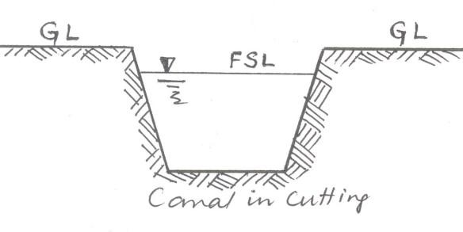
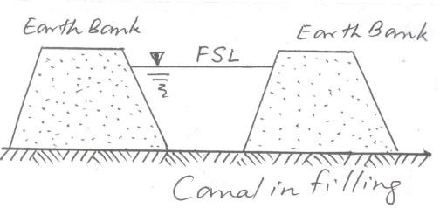

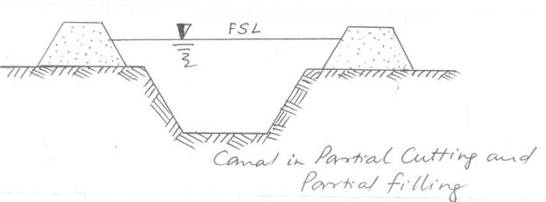

If the full supply level (FSL) of a canal is below the natural ground surface, an open cut or excavation is necessary to construct a canal. If the FSL of the canal is above the existing ground level, the canal is constructed by providing earthen banks on both sides. In the first case the channel is called a canal in cutting and in the second case it is called a canal in filling. Sometimes a canal can be of the intermediate type and the channel is called a canal in partial cutting and Partial filling.
Classification of Canals:

The irrigation canals can be classified in different ways based on the following considerations.

- Classification based on the nature of source of supply:

In this method canals may be classified as

- Permanent canals

- Inundation canals

A permanent canal is one which draws water from a permanent source of supply. The canal in such cases is made as a regular graded canal (fixed slope). It is provided with permanent regulation and distribution works. A permanent canal may also be perennial canal or non-perennial canal depending on whether the source supplying water is a perennial one or a non-perennial.
An inundation canal is one which draws water from a river when the water level in the river is high or the river is in floods. These canals are not provided with any regulatory works, but an open cut is made in the banks of the canal to divert water.
- Classification based on the function of the canal:

Here the canals may be classified as

- Feeder canals

- Carrier canals

- Navigation canals

- Power canals

A feeder canal is constructed for the purpose of supplying water to two or more canals only but not directly irrigating the fields.
A carrier canal carries water for irrigating the fields and also feeds other canals for their needs. A canal serving the purpose of in-land navigation is called a navigation canal.
A power canal supplies water to a hydro electric power generation plant for generation of electrical power.
- Classification based on the discharge and its relative importance in a given network of canals:

On this basis an irrigation canal system consists of

- Main canal

- Branch canal

- Major distributory

- Minor distributory

- Water course or Field channel

A main canal is the principal canal in a network of irrigation canals. It directly takes off from a river, reservoir or a feeder canal. It has large capacity and supplies water to branch canals and even to major distributaries.
Branch canals take off from a main canal on either side at regular intervals. They carry a discharge of about 5 cumec and are not usually used to directly irrigate the fields.
A major distributory takes off a branch canal or a main canal. It has a discharge capacity of 0.25 to 5 cumec. They are used for direct irrigation and also to feed minor distributaries.
Minor distributaries are canals taking off from the branch canals and major distributaries. They carry a discharge less than 0.25 cumec. These canals supply water to field channels.
A water course or field channel takes off from either a major or minor distributory or a branch canal also. These are constructed and maintained by the cultivators/farmers. The other canals are constructed and maintained by the government or the Command Area Development Authority.
- Classification based on Canal alignment:

On the basis of canal alignment, the canals are classified as

- Ridge canal or watershed canal

- Contour canal

- Side slope canal

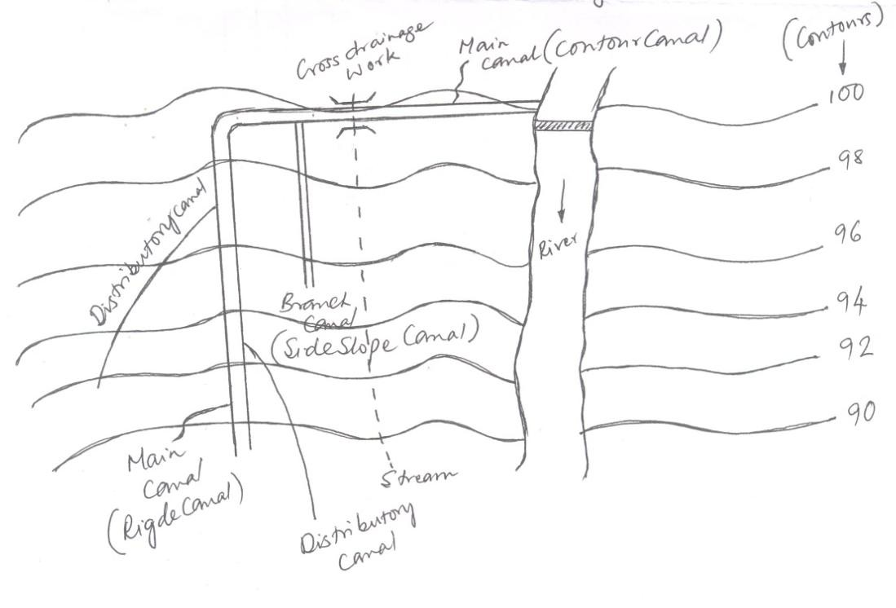

A Ridge canal or watershed canal is one which runs along the ridge or watershed line. It can irrigate the fields on both sides. In case of ridge canals the necessity of cross drainage works does not arise as the canal is not intercepted by natural streams or drains.
A contour canal is one which is aligned nearly parallel to the contours of the country/area. These canals can irrigate the lands on only one side. The ground level on one side is higher and hence bank on the higher side may not be necessary. A contour canal may be intercepted by natural streams/drains and hence cross drainage works may be essential.
A Side slope canal is one which is aligned at right angles to the contour of the country/area. It is a canal running between a ridge and a valley. This canal is not intercepted by streams and hence no cross drainage works may be essential. This canal has steep bed slope since the ground has steep slope in a direction perpendicular to the contours of the country/area.
- Classification based on the financial output:

On the basis of the financial output /revenue from the canals, the canals are called as

- Productive canals

- Protective canals

A productive canal is one which is fully developed and earns enough revenue for its running and maintenance and also recovers the cost of its initial investment. It is essential the cost of its initial investment is recovered within 16 years of construction.

Protective canals are those constructed at times of famine to provide relief and employment to the people of the area. The revenue from such a canal may not be sufficient for its maintenance. The investment may also not be recovered within the stipulated time.
- Classification based on the soil through which they are constructed:

On the above basis the canals are classified as

- Alluvial canals

- Non-alluvial canals.

Canals constructed in alluvial soils are known as alluvial canals. Alluvial soils are found in the Indo- Gangetic plains of North India. The alluvial soils can be easily scoured and deposited by water.
Canals constructed through hard soils or disintegrated rocks are called non-alluvial canals. Such soils are usually found in Central and South India.
- Classification based on Lining being provided or not:

On the above basis the canals are classified as

- Unlined canals

- Lined canals

An unlined canal is one which the bed and banks of the canal are made up of natural soil through which it is constructed. A protective lining of impervious material is not provided. The velocity of flow is kept low such that bed and banks are not scoured.
A lined canal is one which is provide with a lining of impervious material on its banks and beds, to prevent the seepage of water and also scouring of banks and bed. Higher velocity for water can be permitted in lined canals and hence cross sectional area can be reduced.

Canal alignment: In aligning an irrigation canal, the following points must be considered.

- An irrigation canal should be aligned in such a way that maximum area is irrigated with least length of canal.
- Cross drainage works should be avoided as far as possible, such that the cost is reduced.

- The off taking point of the canal from the source should be on a ridge, such that the canal must run as a ridge canal and irrigate lands on both sides.
- Sharp curves in canals must be avoided.

- In hilly areas, when it is not possible to construct ridge canals, the canal must be made to run as a contour canal.
- The canal should be aligned such that the idle length of the canal is minimum.

- The alignment should be such that heavy cutting or heavy filling are avoided. If possible balanced depth of cutting and filling is achieved.
- It should not be aligned in rocky and cracked strata.

- The alignment should avoid villages, roads, places of worship and other obligatory points.

Design of unlined canals in alluvial soils

When water from the catchment or drainage basin enters the river it carries huge amounts of silt or sediments along with it. The sediment is carried either in suspension or dragged along the rivers bed. A portion of this silt or sediment also entire the canals. These sediments can cause a problem in the design of unlined canals in alluvial soils.
If the velocity of flowing water in the canal is less, the sediments get deposited on the bed of the canal, thereby reducing the cross sectional area of flow and in turn the irrigating capacity of the canal reduces. On the other hand, if the velocity is increased too much, erosion of the bed and sides of the canal takes place. Thus the area of the channel increases, full supply depth in canals decreases and also causing other damages. Hence, in case of unlined canals, the velocity of flow should be such that

it is neither silting nor scouring. Such a velocity is called non-silting and non scouring velocity or also called as critical velocity.
To carry the required design discharge (Q), knowing the surface and soil properties such as (N) and silt factor (f), the design of an irrigation channel includes determining
  - Cross sectional area of flow (A)
  - Hydraulic mean radius ( R )
  - Velocity of flow (V)
  - Bed slope (S)
R G Kennedy, former Executive Engineer, Punjab Irrigation Department and Gerald Lacey, former Chief Engineer, U P Irrigation Department made a lot of investigations in this area and put forward theories named after them such as,
- Kennedy‘s theory

- Lacey‘s Regime theory.

1. Kennedy’s theory of designing unlined Canals: Kennedy selected a number of canal sections in the upper Bari-Doab region which did not required any silt clearance for more than 35 years and were supposed to be flowing with non-silting and non-scouring velocity. Kennedy put forward the following facts out of his study.
 The bed of the canal offers frictional resistance to the flow of water, as a result critical eddies (Turbulences) arise from the bottom of the bed. These eddies keep the sediments carried by water in suspension. Some eddies also arise from the sides of the canal, but do not support the sediments. Hence, the sediment supporting capacity is proportional to the bed width of the canal.
The critical velocity or non-silting and non scouring velocity (V_{o}) is a function of the depth of the flowing water (D). It is given by the relationship V_{o} = c m D^{n}
Where, `c‘ is and `n‘ are coefficients suggested by Kennedy for canals of Bari-Doad region. The values of `c‘ differs for different materials are
Light Sandy silt – c = 0.53

Coarse light sandy silt - c = 0.59 Sandy loan - c = 0.65
Coarse silt - c = 0.70

Note: Unless otherwise specified, values of c and n can be taken as c = 0.55 and n = 0.64 Thus, the equation for critical velocity becomes V_{o} = 0.55 m D ^{0.64}
In this above, ‗m‘ represents critical velocity ratio which is given as Where, V represents mean velocity of flow. The value of ‗m‘ also varies with the silt
material

Types of Silt | Value of ‗m‘
Silt of Indus rivers | 0.7
Light Sandy silt of north India | 1.0
Coarse-sandy silt | 1.1
Sandy, Loamy silt | 1.2
Coarse silt of hard rock | 1.3

Note: Unless, otherwise specified m = 1.0 The mean velocity of flow is given by
Where C represents Chezzy‘s constant and is given by


Where N represents Kutter‘s Rugosity coefficient,

S represents Bed slope of the canal

R represents Hydraulic mean radius and is given by R= A/P Where A is cross sectional area of canal and P is wetted perimeter.
When a canal is designed by Kennedy‘s method it is required that V_{o} is equal to V. i.e., Critical velocity ratio m = 1
Note: The cross section for an irrigation canal is assumed as a trapezoidal channel as follows.
FSL

Cross Sectional Area of flow A= BD+KD²
1
D
1
K K

B Wetted Perimeter

Kennedy’s procedure for designing unlined canals:

In designing the required canal section, the following equations are adopted.

V_{o} = 0.55 m D ^{0.64}

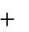
23 1
0.0015


C N S
0.0015 N
S R
1 23

Knowing the different quantities such as
- Discharge (Q)

- Rugosity coefficient (N) (if the value of ‗N‘ is not specified, it is assumed as 0.025)

- Critical velocity ratio (m)

- Bed slope (S) or B/D ratio

the properties of the canal such as cross sectional area of flow, hydraulic mean radius, mean velocity of flow are determined.
Case 1: When bed slope ‘S’ is given

- For the given discharge (Q) assume a trail value of the depth of flow (D)

For different values of discharge (Q) the trail values of depth of flow (D) are given as follows.

Q(m³/s) | 0.283 | 0.708 | 1.416 | 2.832 | 7.079 | 14.158 | 28.317 | 56.634
D(m) | 0.49 | 0.66 | 0.84 | 1.04 | 1.43 | 1.73 | 1.98 | 2.26

- Calculate V_{o} from V_{o} = 0.55 m D ^{0.64}
- Determine ‗A‘ from
- Knowing ‗D‘ and ‗A‘ calculate the ‗Bed width‘ ‗B‘
- Knowing ‗B‘ and ‗D‘ calculate the wetted perimeter ‗P‘
- Knowing ‗A‘ and ‗P‘ calculate hydraulic mean radius ‗R‘
- Calculate mean velocity of flow from the equation .
- If critical velocity ratio is equal to 1 (m=1), then the assumed value of ‗D‘ is correct.
- If not revise the depth ‘D‘.

Case-2: When B/D ratio is given

- Let B/D = x B = D x
- Calculate cross sectional area in terms of ‗D‘ A = B D + K D²
- Calculate critical velocity in terms of ‗D‘ by substituting in V_{o} = 0.55 m D ^{0.64}
- Substituting for ‗A‘ and ‗ ‘ in , ‗D‘ can be determined.
- Knowing ‗D‘, ‗A‘ and ‗B‘ calculate ‗P‘ and ‗R‘
- Calculate V_{o} from equation V_{o} = 0.55 m D ^{0.64}
- Assuming a trial value for ‗S‘, Calculate Chezzy‘s constant from equation

23 1
0.0015

C N S
0.0015 N
S R
1 23

- Calculate mean velocity of flow from equation
- Calculate critical velocity ratio ‗m‘. If m = 1 the bed slope provided is adequate.
- If not, revise the bed slope ‗S‘.
Note: The trial values of bed slope S are assumed depending upon the discharge (Q) as follows.

Q (m³/s) | 0.283 | 0.708 | 1.416 | 2.832 | 7.079 | 14.158 | 28.317 | 56.634
S (1 in ) | 3333 | 3636 | 4000 | 4444 | 4444 | 5000 | 5000 | 5714

Draw backs in Kennedy‘s theory

- Kutters equation is used for determining the mean velocity of flow and hence the limitations of kutter‘s equation are incorporated in kennedy‘s theory.
- The significance of B/D ratio is not considered in the theory
- No equation for the bed slope has been given which may lead to varied designs of the channel with slight variation in the bed slope.
- Silt charge and silt grade are not considered. The complex phenomenon of silt transportation is incorporated in a single factor are called critical velocity ratio.
- The value of m is decided arbitrarily since there is no method given for determining its value.
- This theory is aimed to design only an average regime channel.
- The design of channel by the method based on this theory involves trial and error which is quite cumbersome.

Problems

1. Design and sketch an irrigation channel to carry 5 cumec. The channel is to be laid on a slope of 0.2m per kilometer. Assume N=0.025 and m=1
Solution:

1. Assume a trial depth D equal to 1.0m

2. V= V_{o} = 0.55 m D ^{0.64}
= 0.55x 1.0x 1.0 ^{0.64}
- Area =
A= Q/ V = 5/0.55= 9.09m²
- A = B D + K D²
= 9.09 = Bx1.0 +1.0²/2 B= 8.59m
- Perimeter = P= B+ D 8.59+1.0 =10.83m R= A/P= 9.09/10.83
= 0.84m
- Mean velocity flow

23 1
0.0015

C N S
0.0015 N
S R
1 23

R= 0.84m , S= 0.2/1000 , N= 0.0225

C= 42.85

= 42.85 /1000

= 0.555m/s

- Ratio of velocities found in step 6 and step2
= 0.555/0.55 = 1.009= 1.0
Hence assumed d is satisfactory.

2. Determine the dimensions of the irrigation canal for the following data B/D ratio = 3.7, N= 0.0225, m=1.0 and S= 1/ 4000 side slopes of the channel is ½ H : 1V. Also determine the discharge which will be flowing in the channel.

Solution: B/D = 3.7

B= 3.7D

For the channel with side slopes of 1/2H : 1V

R= 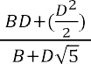 = 0.708D
From kennedy‘s equation V_{o} = 0.55 m D ^{0.64}
V_{o} = 0.55 D ^{0.64}

23 1
0.0015

C N S
0.0015 N
S R
1 23

Equating the two values of V, we get 0.55 D ^{0.64} = 0.975D^{1/2} / (1+0.781D^{-1/2})
0.55 D ^{0.64} + 0.4296D^{0.14} = 0.9795D^{1/2}

Solving the above equation by trial and error , we get D= 1.0m
B= 3.7m

V= 0.55m/s

A = B D + D²/2

A= 4.2m Q= Ax V=4.2 x0.55
= 2.31 cumes

Lacey’s Regime Theory: Lacey carried out a detailed study in designing suitable channels in alluvial soils. He developed the regime theory and formulated a number of expressions based on his observations. The salient features of Lacey‘s theory are stated as follows.
- In a channel constructed in alluvial soil to carry a certain discharge, the bottom width, depth and bed slope of the channel will undergo modifications by silting and scouring till equilibrium is attained. The channel is now said to be a regime channel. (A regime channel is defined as a stable channel whose bed width, depth and side slopes have undergone modifications by silting and scouring and are so adjusted that equilibrium is attained.)
A channel is said to be in regime when the following conditions are satisfied.

  - The Channel is flowing in unlimited incoherent alluvium of the same character as that of the transported sediment. (Incoherent alluvium is a soil composed of loose granular material which can be scoured and deposited with the same ease.)
  - Silt grade (silt size) and silt charge (silt concentration) is the same throughout the channel.

  - Discharge in the canal is constant.

- The silt carried by the flowing water in the canal is kept in suspension by vertical eddies generated from the bed as well as from the sides of the canal.
- The silt grade also plays an important role in controlling the regime conditions of the channel. The silt factor is given by the relationship where represents diameter of silt particle in mm.

Lacey’s procedures for designing unlined canals:

In Lacey‘s method for designing unlined canals in alluvial soils for a known discharge ‗Q‘ and a mean diameter of silt particle ‗d‘, the required quantities are calculated as follows.
- The mean velocity of flow is computed from the relation.


V m/s
Qf ²
140
1
6

Where Q is discharge in m³/s, f is silt factor given by , d is diameter of silt particle in mm.

- Calculate the cross sectional area of flow

- Knowing the side slope express ‘A‘ in terms of B and D A = B D + K D²

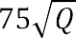
- Determine the required wetted perimeter from the relationship (1)

- Express the wetted perimeter in terms of B and D (2)

- From equations 1 and 2 solve for values of B and D

- Calculate ‗Hydraulic mean radius‘ (R) from the relationship R (3)
5 V ²
2 f

- Also calculate hydraulic mean radius ‗R‘ from the relationship

= ----- (4)


- If the values of hydraulic mean radius ‗R‘ worked out from equations 3 and 4 are the same then the design is OK.
5
f 3
1
3340Q 6

- Calculated the Bed slope from the equation S

Draw backs in Lacey‘s theory

- The theory does not give a clear description of physical aspects of the problem.
- It does not define what actually governs the characteristics of an alluvial channel.
- The derivation of various formulae depends upon a single factor f and dependence on single factor f is not adequate.

- There are different phases of flow on bed and sides and hence different values of silt factor for bed and side should have been used.
- Lacey‘s equations do not include a concentration of silt as variable.
- Lacey did not take into account the silt left in channel by water that is lost in absorption which is as much as 12 to 15% of the total discharge of channel.
- The effect of silt accumulation was also ignored. The silt size does actually go on decreasing by the process attrition among the rolling silt particles dragged along the bed.
- Lacey did not properly define the silt grade and silt charge.
- Lacey introduced semiellipse as ideal shape of a regime channel which is not correct.
Problems

  - Design a irrigation channel in alluvial soil according to Lace’s silt theory for the folloeing data.
Full supply discharge= 10cumecs Lacey’s silt factor= 0.9
Side slopes of channel= 1/2H: 1V
Solution:

1. Velocity =

V
Qf ²
140
1
6
m/s

V= (10x 0.9²/140)^{1/6} = 0.62m/s 2. Area= A= Q / V= 10 / 0.62= 16.13m²
3. Hydraulic mean radius= R
5 V ²
2 f

= 5/2(0.62²/0.9) = 1.07m
4. Perimeter= = A/R= 16.13/1.07= 15.07m

5. Bed slope= S
5
f 3
1
3340Q 6

S

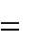
S= 1/ 5844= 1/5850
5
0.93
1
3340(10) 6

